**PRACTICE:- (19-08-2025)**

***Programs & Output:***

**4.Find the Sum of N Natural Numbers.**

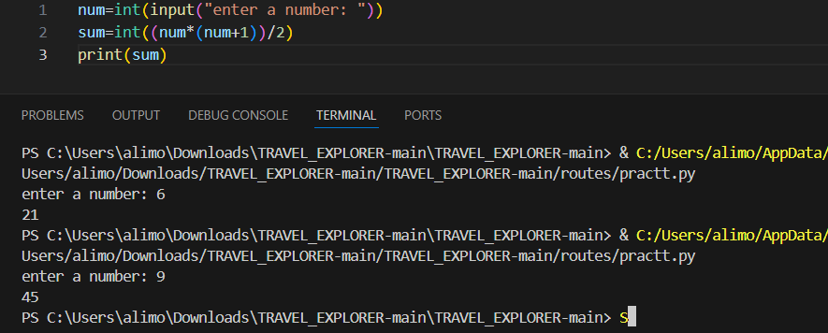

**5. Find the Sum of the Numbers in a Given Interval in Python.**

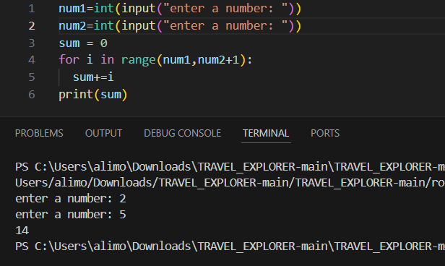

**6. Find the Greatest of the Two Numbers in Python.**

