**PRACTICE:- (20-08-2025)**

***Programs & Output:***

**7. Find the Greatest of the Three Numbers in Python.**

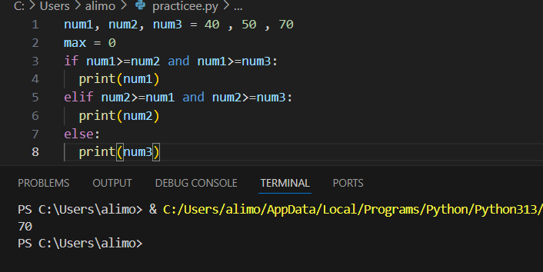

**8. Check Whether a Year is a Leap Year or Not in Python.**

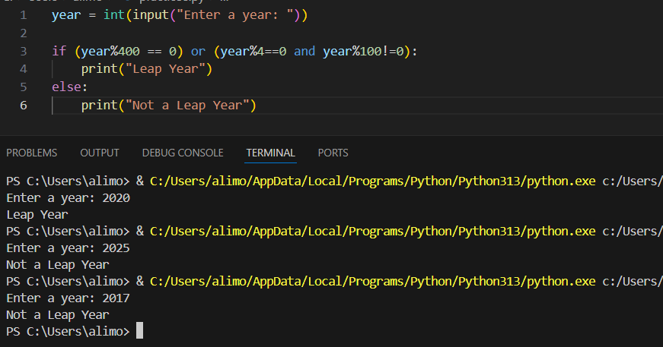

**9. Check Whether a Number is a Prime or Not.**

