**PRACTICE:- (21-08-2025)**

***Programs & Output:***

**10.Find the Prime Numbers in a Given Interval in Python.**

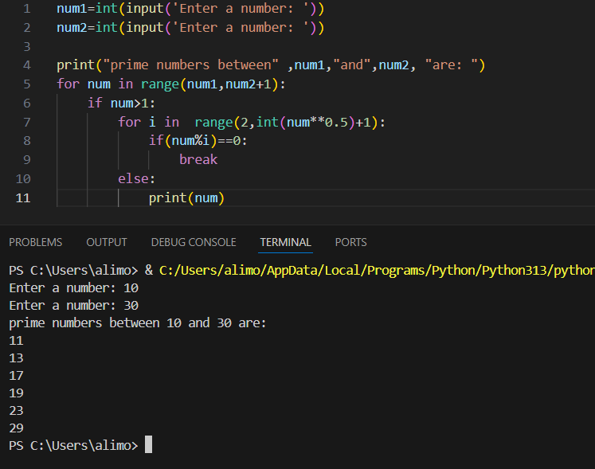

**11. Find the sum of the Digits of a Number.**

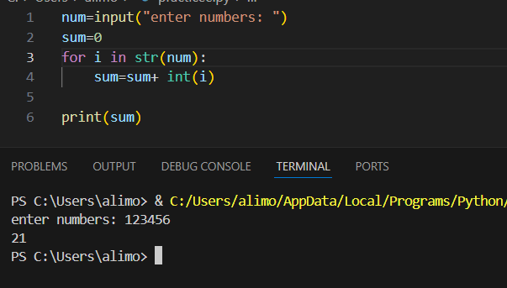

**12. Find the Reverse of a Number in Python.**

