**PRACTICE:- (22-08-2025)**

***Programs & Output:***

**13. Check Whether or Not the Number is a Palindrome in Python.**

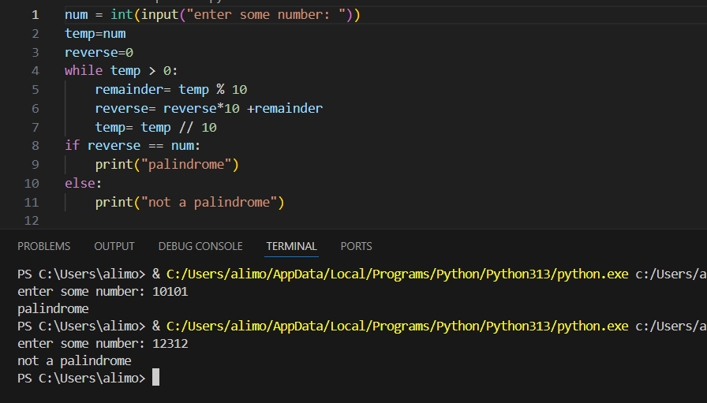

**14. Check Whether a Given Number is an Armstrong Number or Not**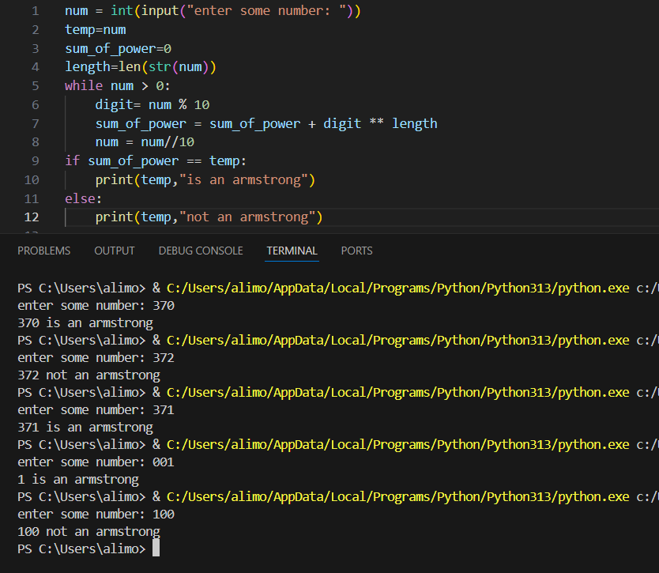

**15. Find the Armstrong Numbers in a given Range in Python.**

