**12-06-2025**

Step 1:

Creating directories

1. C:\data\db0
2. C:\data\db1
3. C:\data\db2

Step 2:

Starting MongoDB instances

Instance 1

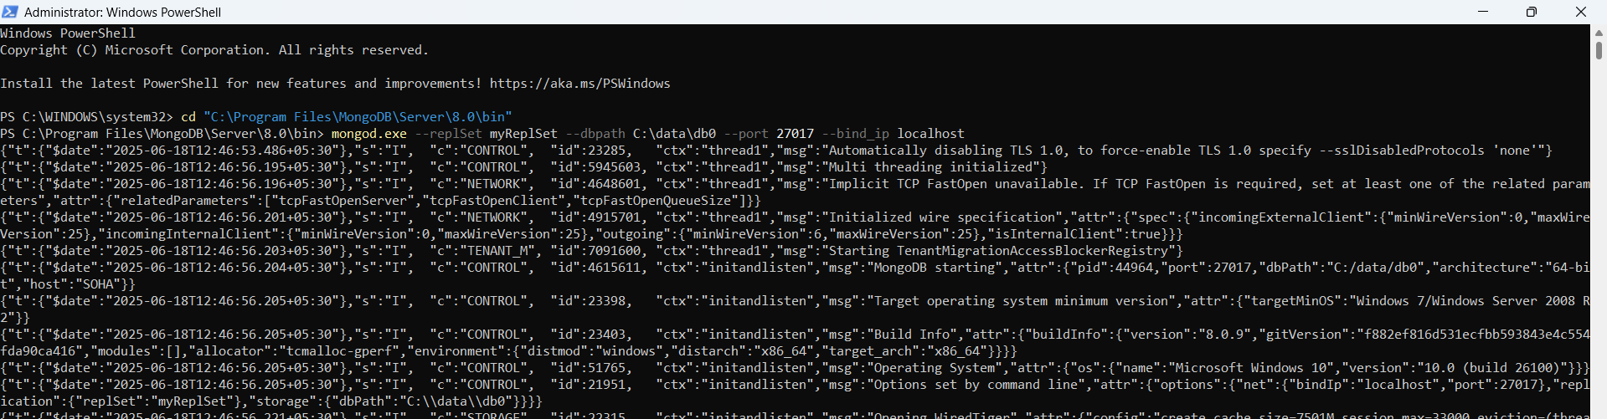

Instance 2

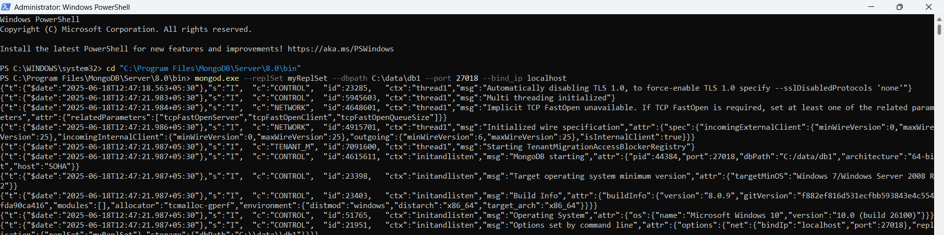

Instance 3

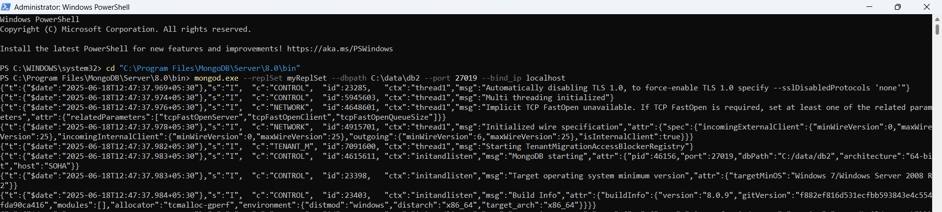

Step 3

Connecting to MongoDB shell and initiate

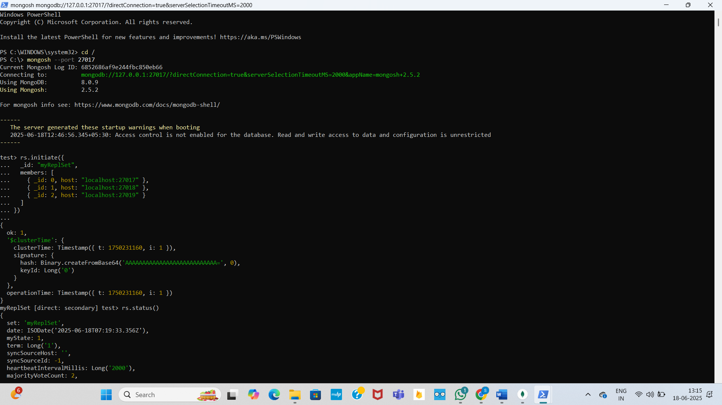

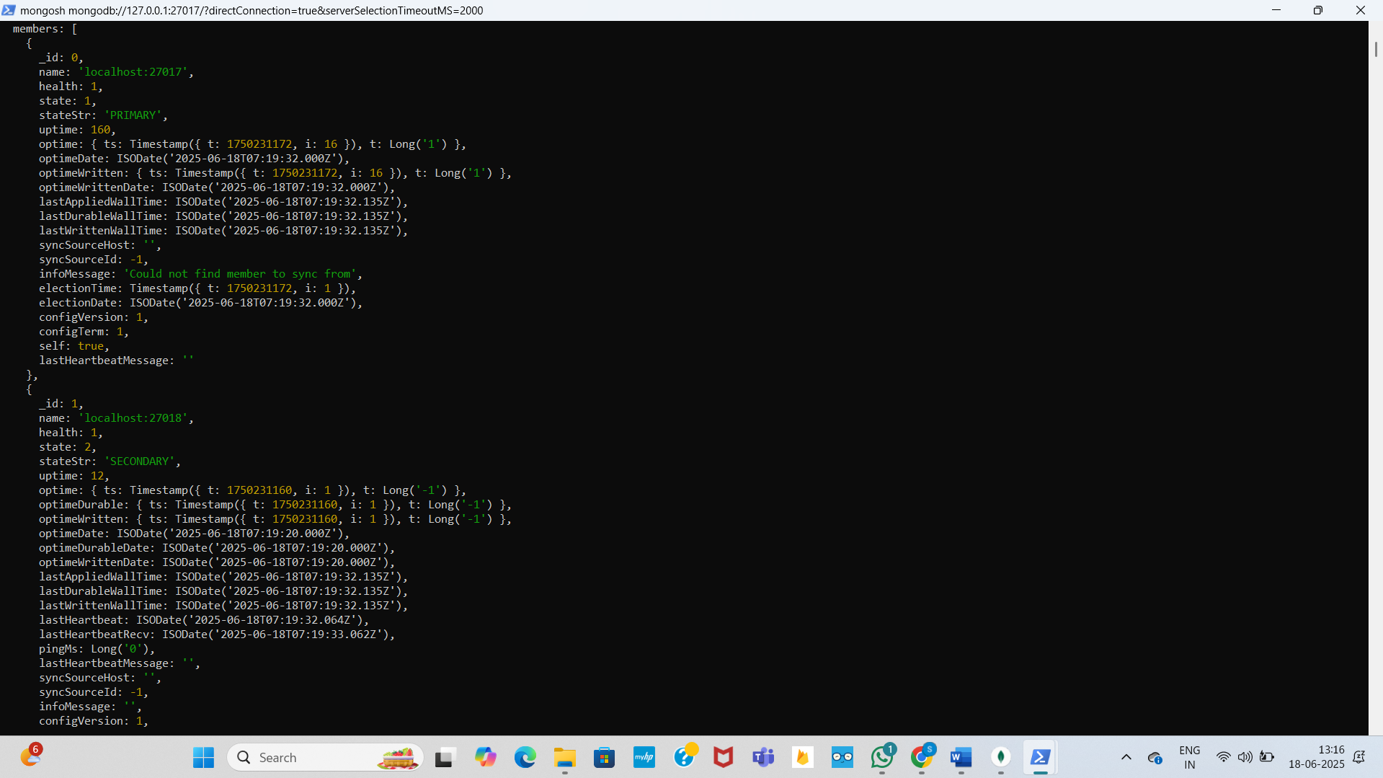

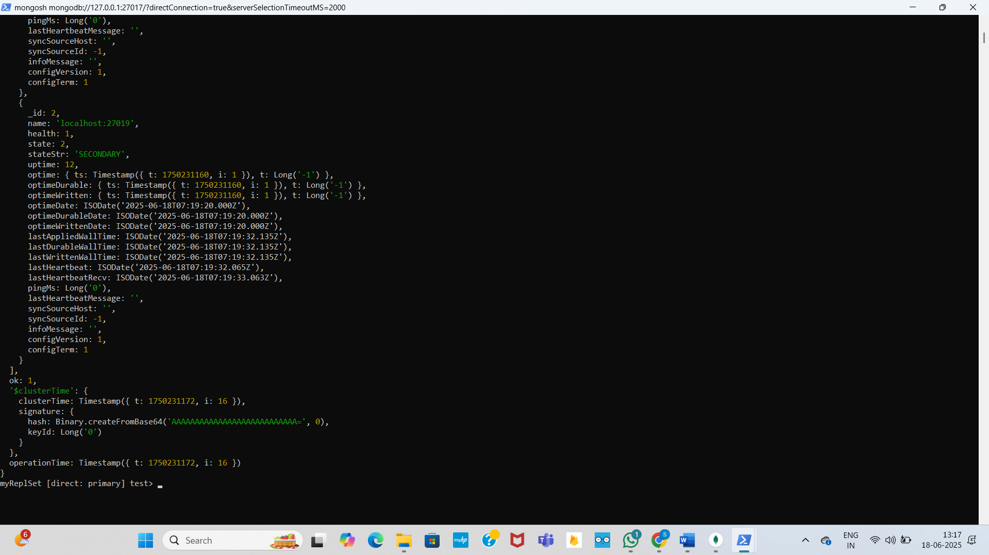

To check how whether replication is happening in all the instances

