AMTGC
Adaptive Multi-Junction Traffic Grid Controller
FINAL INTERNSHIP TECHNICAL DOCUMENTATION
Complete RTL Design • Architecture • FSM • Integration • Verification • Simulation Evidence
Verilog RTL | ModelSim Intel FPGA Edition 10.5b

Student Name: ______Sadhvi Sri Yarrabarla________________________
College / University: ______RGUKT ONGOLE___________________
Internship Organization: ________ELEVANCE SKILLS______________

TABLE OF CONTENTS

1.ABSTRACT 4
2. Document Control and Report Map 5-6
3. Project Overview 7-8
4. Problem Statement and Motivation 9-10
5. Objectives and Success Criteria 11
6. Requirements Traceability 12
7. Scope and Operating Model 14-15
8. System Architecture 16
9. Module Decomposition 17-18
10. RTL Interfaces and Signal Organization 19-20
11. Generic Timer Design 21
12. Generic Timer — RTL Review 22
13. Junction Controller FSM 23-24
14. FSM State Definitions and Transitions 25-26
15. Junction Controller — RTL Review 27
16. State-by-State Operating Sequence 28-29
17. Parameterization and Reuse 30
18. Pedestrian Arbitration 31-32
18. Pedestrian Arbitration 33
20. Emergency Override 34
21. Green-Wave Coordination 35
22. Traffic-Density Adaptive Timing 36
23. Task 4 Verification Evidence 37
24. Task 3 Integration Evidence 38-39
25. Verification Methodology 40-41
26. Directed Verification Scenarios 42
27. Randomized Verification 43
28. Final Task 5 Verification Transcript 44
29. Quantitative Simulation Results 45-46
30. Integrated System Waveform 47
31. Traffic-State Waveform 48
32. Challenges Faced and Resolutions 49-50
33. Bug Log and Verification Lessons 51-52
34. Conclusion and Final Review Checklist 53

1.ABSTRACT
The Adaptive Multi-Junction Traffic Grid Controller (AMTGC) is a parameterized digital traffic-control system developed using Verilog HDL to coordinate the operation of two four-way traffic junctions. The primary objective of the project is to provide a structured, modular, and adaptive approach to traffic-signal control while addressing important requirements such as safe traffic sequencing, pedestrian request handling, emergency response, coordinated junction operation, and traffic-density-based timing. The proposed system is implemented as a synchronous RTL architecture and is designed to provide deterministic and reusable control behavior suitable for simulation and future FPGA implementation.
The AMTGC architecture consists of multiple functional modules, including a Generic Timer, Junction Controller, Pedestrian Arbiter, and Top-Level Integration Controller. The Junction Controller uses a Moore Finite State Machine (FSM) to control the traffic phases. The implemented sequence includes North-South Green, North-South Yellow, All-Red, East-West Green, East-West Yellow, and another All-Red interval, with a pedestrian phase incorporated into the control operation. The use of explicit all-red intervals provides separation between conflicting traffic movements and supports safe state transitions. The timing functionality is separated into a reusable generic timer module so that timing parameters can be configured without changing the fundamental timer architecture.
A significant feature of AMTGC is its traffic-density adaptive timing mechanism. Traffic-density inputs ranging from 0 to 7 are used by the junction controller to determine the target green duration. In the verified configuration, the green duration is bounded between a minimum of 2 cycles and a maximum of 5 cycles. The traffic-density value is sampled at the entry of the green phase, allowing the selected duration to remain stable during the active phase. This provides a controlled adaptive mechanism while maintaining predefined timing limits.
The system also incorporates a shared pedestrian arbitration mechanism to handle pedestrian requests from the two junctions. When requests compete for service, the arbitration mechanism provides alternating access to maintain fairness. The final verification included 120 pedestrian grants, resulting in 60 grants for Junction A and 60 grants for Junction B. The project further implements an emergency override mechanism that provides higher-priority control during emergency conditions. Emergency operation was tested during all six traffic phases in the final verification process, and all tested cases passed successfully.

Engineering scope
Two-junction synchronous traffic control with parameterized timing, pedestrian arbitration, emergency override, green-wave coordination and density-adaptive green timing.
Evidence basis
The report is tied to the submitted RTL, testbenches, ModelSim script, waveform captures and final verification transcript. It distinguishes implemented behavior from future deployment considerations
2. Document Control and Report Map
A professional technical report benefits from controlled scope, traceability and a predictable navigation structure. The forty sections below are organized so that a reviewer can move from system intent to implementation and finally to verification evidence.
Section range | Coverage
1–7 | Project identity, overview, problem, objectives, requirements and operating scope
8–17 | Architecture, modules, interfaces, timer, FSM and parameterization
18–24 | Pedestrian arbitration, emergency behavior, green-wave coordination and adaptive timing
25–31 | Verification methodology, directed/randomized tests, transcript, metrics and waveform evidence
32–35 | Debugging, assumptions, engineering decisions and trade-offs
36–40 | Reproducibility, repository structure, delivery, limitations and conclusion

Document-control rules
The report uses the same module names and signal names as the source tree. Parameter values used for final integration verification are stated where relevant. This avoids the common documentation failure in which a report describes a different implementation from the submitted repository.

Submission mapping
Artifact | Location in package
RTL | rtl/
Testbenches | tb/
ModelSim script | sim/run_all.do
Architecture/FSM figures | diagrams/
Waveform evidence | waveforms/
Verification transcript | verification/ and docs/
Technical report | docs/

Review approach
A reviewer can follow the report in three passes. First, inspect the architecture and state model. Second, inspect the RTL and testbenches that implement those requirements. Third, compare the recorded ModelSim evidence with the acceptance criteria. This sequence avoids relying on a screenshot without understanding the underlying stimulus.

3. Project Overview
AMTGC is a modular RTL controller for coordinating two traffic junctions. Each junction follows a deterministic finite-state sequence, while the top-level module adds shared pedestrian arbitration, emergency override behavior, green-wave coordination and traffic-density inputs.
The architecture separates reusable timing logic from junction sequencing. A generic timer provides a phase-completion indication. The junction controller converts that indication into traffic-light states. The top-level controller instantiates two junctions and coordinates events between them.
Capability | Implementation concept | Verification evidence
Traffic phases | Six traffic phases plus pedestrian state | Junction FSM test; Task 5
Adaptive green | Density sampled at green entry and mapped to bounded duration | Task 4 density sweep
Pedestrian access | Central two-request arbiter with alternating tie-break 120-grant fairness test | 120-grant fairness test
Emergency | Top-level override drives emergency behavior in both junctions | All six phases tested
Green wave | A NS-green entry starts a parameterized delay for B | Five density combinations
Reset | Synchronous reset clears controller state/timers | Reset during active operation

Design philosophy
The design favors explicit state transitions, bounded timing and parameterization. These properties make the RTL easier to inspect and make the simulation evidence easier to interpret than an implementation that relies on hidden timing assumptions.
Primary implementation files
rtl/generic_timer.v rtl/junction_controller.v rtl/ped_arbiter.v rtl/amtgc_top.v
System-level interpretation
The important architectural property is separation of concerns. Timing is delegated to the timer, traffic sequencing to the junction controller, fairness to the pedestrian arbiter and inter-junction coordination to the top-level scheduler. That structure makes individual behaviors testable while still allowing full-system verification.

Technical review note
A professional review should compare the narrative, RTL and verification artifacts as one chain of evidence. The report deliberately avoids turning a simulation observation into a broader hardware or real-world claim. Where timing is discussed, the reference is the configured simulation clock and the measured event definition used by the testbench.
Review focus | Technical interpretation
Implementation evidence | Use the named RTL module and signal definitions for “Project Overview”; do not infer behavior from the report alone.
Verification evidence | Use the corresponding testbench, waveform or final transcript to confirm the stated behavior.
Scope control | Results reported here are simulation-level unless the package contains explicit hardware evidence.

4. Problem Statement and Motivation
A multi-junction controller must coordinate conflicting traffic movements while also responding to pedestrians, emergency conditions and changing traffic demand. The project addresses this as a synchronous digital-control problem.
At each junction, mutually exclusive traffic directions require a safe sequence: North–South green, North–South yellow, an all-red interval, East–West green, East–West yellow and a second all-red interval. A pedestrian phase is inserted only when a request has been granted. The sequence must return to normal operation without producing simultaneous conflicting grants.
The adaptive feature adds a controlled response to traffic density. Instead of allowing arbitrary phase extension, the implementation computes a green target from a minimum, a per-density increment and a maximum bound. This makes the behavior predictable for verification.
The green-wave feature addresses coordination between two junctions. Junction A produces a one-clock green-entry pulse. The top-level scheduler counts the configured delay and supplies a start event to Junction B. The verification target is therefore an observable cycle offset, not a subjective claim about traffic flow.
Engineering challenge | Required property
Conflicting movements | Deterministic FSM and all-red separation
Variable demand | Bounded adaptive green duration
Two pedestrian inputs | Mutual exclusion and fairness
Emergency input | Immediate override path with reset-like clearing of coordination
Inter-junction timing | Measured cycle offset
Reproducibility | Single ModelSim command scrip

Engineering rationale
The problem is deliberately expressed in terms of deterministic digital control rather than attempting to model an entire city traffic network. This keeps the project implementable in Verilog and allows measurable properties such as state visitation, cycle offsets, grant counts and bounded timing to be verified objectively.
Technical review note
A professional review should compare the narrative, RTL and verification artifacts as one chain of evidence. The report deliberately avoids turning a simulation observation into a broader hardware or real-world claim. Where timing is discussed, the reference is the configured simulation clock and the measured event definition used by the testbench.
Review focus | Technical interpretation
Implementation evidence | Use the named RTL module and signal definitions for “Problem Statement and Motivation”; do not infer behavior from the report alone.
Verification evidence | Use the corresponding testbench, waveform or final transcript to confirm the stated behavior.
Scope control | Results reported here are simulation-level unless the package contains explicit hardware evidence.

5. Objectives and Success Criteria
The project objectives are stated as observable engineering properties. Each objective is connected to source code and to at least one simulation scenario in the submission.
Objective | Acceptance criterion | Evidence
Reusable timing | Timer accepts configurable target and asserts done predictably | tb_generic_timer.v
Correct FSM | All six traffic states are visited | tb_junction_controller.v
Pedestrian fairness | Equal service under repeated simultaneous requests | Task 3 / Task 5
Emergency handling | Emergency behavior verified from each traffic phase | Task 5
Green-wave timing | Configured two-cycle offset observed | Task 3/ Task 5
Adaptive timing | Density 0–7 produces bounded green timing | Task 4
Reset robustness | Reset during active operation returns system safely | Task 5
Regression cleanliness | No ModelSim errors or warnings in final run | Task 5 Task 5 transcrip

Success is measured by simulation evidence rather than by visual inspection alone. The final Task 5 transcript records 200 randomized density cycles, 120 pedestrian grants, emergency checks during all six traffic phases, five green-wave combinations and a reset-during-operation case.
The report therefore distinguishes three layers: intended behavior, implementation mechanism and measured result. This distinction is important when reviewing RTL because a design can be syntactically correct while still failing a timing or fairness property.
Acceptance interpretation
Each success criterion is deliberately observable. A reusable timer can be checked at exact targets; an FSM can be checked for state visitation; fairness can be counted; emergency response can be exercised from every phase; adaptive timing can be swept over all density codes; and the final regression can be checked for errors and warnings. This makes the project auditable rather than presentation-only.
Technical review note
A professional review should compare the narrative, RTL and verification artifacts as one chain of evidence. The report deliberately avoids turning a simulation observation into a broader hardware or real-world claim. Where timing is discussed, the reference is the configured simulation clock and the measured event definition used by the testbench.

Review focus | Technical interpretation
Implementation evidence | Use the named RTL module and signal definitions for “Objectives and Success Criteria”; do not infer behavior from the report alone.
Verification evidence | Use the corresponding testbench, waveform or final transcript to confirm the stated behavior.
Scope control | Results reported here are simulation-level unless the package contains explicit hardware evidence.

6. Requirements Traceability
Traceability links a requirement to the module that implements it and the test that demonstrates it. The following matrix is the central review map for the project
ID | Requirement | RTL location | Verification
R1 | Clocked synchronous control | All modules | All testbenches
R2 | Configurable phase timing | generic_timer + junction_controller | Timer and FSM tests
R3 | Six traffic states | junction_controller | FSM sequence test
R4 | Pedestrian mutual exclusion | ped_arbiter | Fairness tests
R5 | Alternating tie-break | ped_arbiter.last_grant | A=60, B=60
R6 | Emergency override | junction_controller / top | All six phases
R7 | Green-wave delay | amtgc_top | 2-cycle offset
R8 | Density-adaptive green | junction_controller.calc_green_time | Density 0–7
R9 | Reset recovery | all sequential logic | Task 5
R10 | Reproducible simulation | sim/run_all.do | Final run

Traceability interpretation
Final run R1–R10 are functional design requirements used in the project. A verification result is considered strong when the test observes an externally meaningful signal or a measurable counter, rather than only checking that simulation completes.
The final package preserves the testbench source, so a reviewer can inspect how each acceptance criterion is generated and checked.
Traceability note
Traceability is strongest when a requirement points to both implementation and verification. For example, adaptive timing is not merely described in prose: the calculation function exists in junction_controller.v and tb_task4_adaptive.v exercises density values 0 through 7. The same pattern is used for pedestrian, emergency and green-wave behavior.
Technical review note
A professional review should compare the narrative, RTL and verification artifacts as one chain of evidence. The report deliberately avoids turning a simulation observation into a broader hardware or real-world claim. Where timing is discussed, the reference is the configured simulation clock and the measured event definition used by the testbench.

Review focus | Technical interpretation
Implementation evidence | Use the named RTL module and signal definitions for “Requirements Traceability”; do not infer behavior from the report alone.
Verification evidence | Use the corresponding testbench, waveform or final transcript to confirm the stated behavior.
Scope control | Results reported here are simulation-level unless the package contains explicit hardware evidence

7. Scope and Operating Model
The submitted AMTGC is an RTL simulation model. Its scope is digital traffic-control logic; it does not claim to implement physical lamps, vehicle detectors, radio communication, GPS, camera analytics or certified road-safety hardware.
Included | Not claimed as implemented
Two-junction synchronous control | Physical traffic signal hardware
Parameterized timing | Real-world calibrated traffic models
Pedestrian request/grant logic | Certified pedestrian sensing
Emergency override path | External emergency-service network
Green-wave timing offset | Urban traffic optimization study
Density input interface | Physical vehicle-counting sensor
ModelSim regression | FPGA-board deployment evidence

Operating assumptions
FPGA-board deployment evidence Clock, reset, request and density signals are assumed to meet the synchronous interface expected by the RTL. Traffic density is represented by a three-bit value from 0 to 7. The adaptive calculation is intentionally bounded by the configured minimum and maximum green times.
The project is best understood as a reusable control kernel that can later be connected to physical interfaces. The current report avoids claiming hardware-level certification or real-world traffic performance.
Configuration used for final integration
MIN_GREEN_TIME=3, MAX_GREEN_TIME=6, GREEN_STEP=1 YELLOW_TIME=1, RED_TIME=1, PED_TIME=2 WAVE_DELAY=2, EMERGENCY_RESPONSE=2, COUNTER_WIDTH=8
Boundary statement
The model should be evaluated as an RTL control system. It is appropriate to discuss state sequencing, cycle timing, arbitration and simulation coverage. It is not appropriate to infer real-road safety, sensor accuracy or traffic throughput from these simulations alone. Those claims would require hardware interfaces, calibration and field validation.
Technical review note
A professional review should compare the narrative, RTL and verification artifacts as one chain of evidence. The report deliberately avoids turning a simulation observation into a broader hardware or real-world claim. Where timing is discussed, the reference is the configured simulation clock and the measured event definition used by the testbench.
Review focus | Technical interpretation
Implementation evidence | Use the named RTL module and signal definitions for “7. Scope and Operating Model”; do not infer behavior from the report alone.
Verification evidence | Use the corresponding testbench, waveform or final transcript to confirm the stated behavior.
Scope control | Results reported here are simulation-level unless the package contains explicit hardware evidence

8. System Architecture
The system is organized around two instances of the junction controller and a small amount of shared coordination logic. This decomposition keeps local phase control inside each junction while keeping shared policies at the top level.

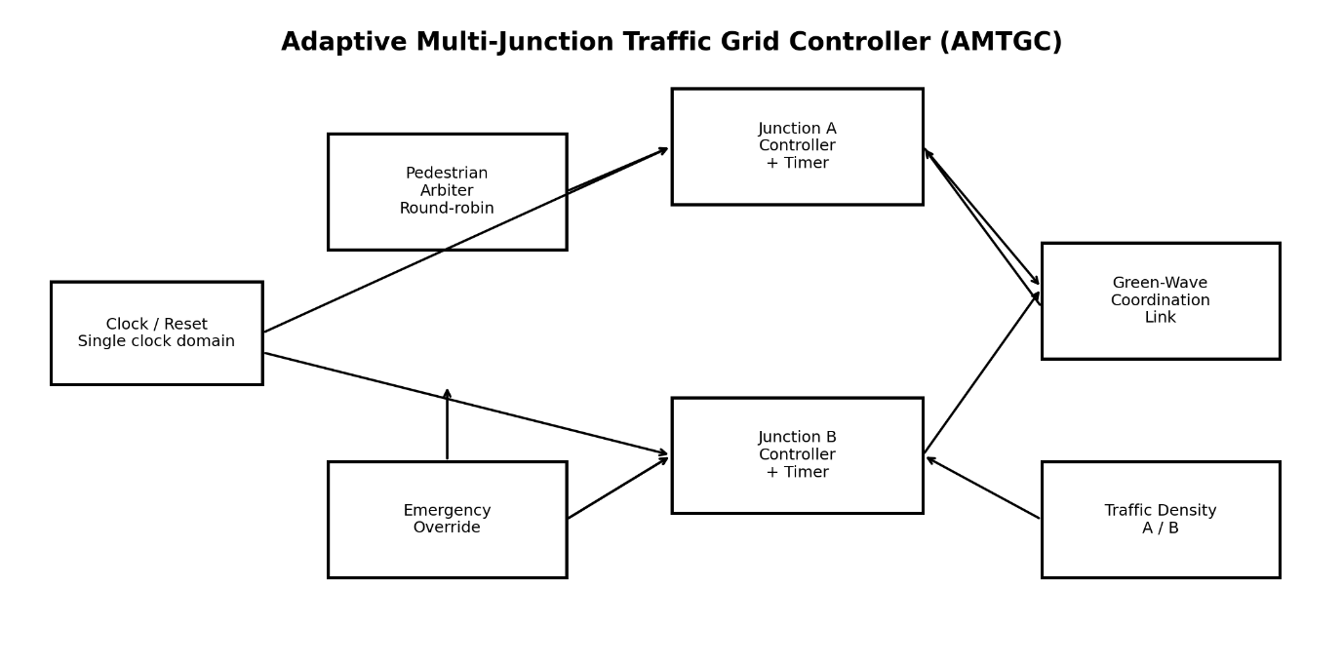

The top level receives the clock, reset, emergency override, pedestrian requests and density inputs. It exposes the light states and status signals required for waveform inspection. The green-wave scheduler observes Junction A's NS-green entry pulse and generates a delayed start event for Junction B.
The architecture is intentionally modular: timer behavior is isolated, pedestrian arbitration is isolated, and the junction controller is parameterized. This supports reuse and targeted unit tests.

Technical review note
A professional review should compare the narrative, RTL and verification artifacts as one chain of evidence. The report deliberately avoids turning a simulation observation into a broader hardware or real-world claim. Where timing is discussed, the reference is the configured simulation clock and the measured event definition used by the testbench
Review focus | Technical interpretation
Implementation evidence | Use the named RTL module and signal definitions for “8. System Architecture”; do not infer behavior from the report alone.
Verification evidence | Use the corresponding testbench, waveform or final transcript to confirm the stated behavior.
Scope control | Results reported here are simulation-level unless the package contains explicit hardware evidence

9. Module Decomposition
The RTL hierarchy consists of four synthesizable modules. Each module has a narrow responsibility and a corresponding verification surface.

Module | Responsibility | Key outputs
generic_timer | Counts a requested number of cycles and asserts done | done
junction_controller | Implements phase FSM, adaptive timing, pedestrian and emergency behavior | light_state, ped_active, ns_green_pulse, emergency_active
ped_arbiter | Chooses one pedestrian requester and alternates simultaneous grants | grant_a, grant_b
amtgc_top | Instantiates two junctions and coordinates green-wave timing | light_a/b, grants, status signals

Instantiation strategy
ped_arbiter u_ped_arbiter (...); junction_controller u_junction_a (...); junction_controller u_junction_b (...);
The hierarchy also creates a natural verification order: verify the timer, verify one junction, verify the shared arbiter, verify top-level coordination, then run the full regression.
Module review
The four-module decomposition also supports maintainability. A defect in the timer can be isolated without changing the arbiter; a fairness policy can be revised without rewriting the phase FSM; and the top-level coordination logic can be tested independently. This is a practical organization for an FPGA-oriented project.
Technical review note
A professional review should compare the narrative, RTL and verification artifacts as one chain of evidence. The report deliberately avoids turning a simulation observation into a broader hardware or real-world claim. Where timing is discussed, the reference is the configured simulation clock and the measured event definition used by the testbench.
Review focus | Technical interpretation
Implementation evidence | Use the named RTL module and signal definitions for “Module Decomposition”; do not infer behavior from the report alone.
Verification evidence | Use the corresponding testbench, waveform or final transcript to confirm the stated behavior.
Scope control | Results reported here are simulation-level unless the package contains explicit hardware evidence

10. RTL Interfaces and Signal Organization
The interface is intentionally explicit. The same clock and reset are distributed to the timing and control blocks, while policy signals such as density and emergency override are passed into each junction.
Signal grant Pedestrian phase active ns_green_a/b emergency_a/b 1 1 output output North–South green active Emergency state active | Width | Direction | Meaning
clk | 1 | input | System clock
reset | 1 | input | Synchronous reset
emergency_override | 1 | input | Global emergency request
traffic_density_a/b | 3 | input | Density code 0–7
ped_req_a/b | 1 | input | Pedestrian requests
light_a/b | 3 | output | Encoded traffic state
ped_grant_a/b | 1 | output | Arbiter grant
ped_active_a/b | 1 | output | Pedestrian phase active
ns_green_a/b | 1 | output | North–South green active
emergency_a/b | 1 | output | Emergency state active

State encoding
0 = NS_GREEN 1 = NS_YELLOW 2 = ALL_RED_1 3 = EW_GREEN 4 = EW_YELLOW 5 = ALL_RED_2 6 = PED Keeping the encoding stable is useful for both waveform interpretation and testbench assertions. The report and verification logs use the same encoding throughout.
Interface review
Signal naming is kept consistent between RTL and verification so that waveform inspection is straightforward. Encoded state outputs are especially useful during debugging because they expose the internal traffic phase directly at the top-level boundary instead of requiring a reviewer to infer state from several lamp bits.
Technical review note
A professional review should compare the narrative, RTL and verification artifacts as one chain of evidence. The report deliberately avoids turning a simulation observation into a broader hardware or real-world claim. Where timing is discussed, the reference is the configured simulation clock and the measured event definition used by the testbench.
Review focus | Technical interpretation
Implementation evidence | Use the named RTL module and signal definitions for “. RTL Interfaces and Signal Organization  ”; do not infer behavior from the report alone.
Verification evidence | Use the corresponding testbench, waveform or final transcript to confirm the stated behavior.
Scope control | Results reported here are simulation-level unless the package contains explicit hardware evidence

11. Generic Timer Design
The generic timer is the smallest reusable building block in the project. It accepts a target count and produces a one-bit completion indication while active.
The timer clears its counter and done output when reset is asserted or start is deasserted. A zero target is treated as immediately complete. For a nonzero target, the counter advances until it reaches target−1 and then holds the completion indication.
Condition | Counter behavior | done
reset=1 | Clear | 0
start=0 | Clear | 0
target=0 | Clear | 1
count < target−1 | Increment | 0
count >= target−1 | Hold | 1

This definition makes the timer useful for phase durations because the controller can keep timer_start asserted only while the current state remains active.
assign timer_start = (state == next_state) && started && !reset && !emergency_override;
Timing interpretation
The timer is intentionally generic. It does not know whether the target represents a green, yellow, red or pedestrian interval. The junction controller supplies that meaning. This separation prevents timing policy from becoming embedded in a reusable primitive and is one reason the adaptive feature could be added without modifying the timer.
Technical review note
A professional review should compare the narrative, RTL and verification artifacts as one chain of evidence. The report deliberately avoids turning a simulation observation into a broader hardware or real-world claim. Where timing is discussed, the reference is the configured simulation clock and the measured event definition used by the testbench.
Review focus | Technical interpretation
Implementation evidence | Use the named RTL module and signal definitions for “Generic Timer Design”; do not infer behavior from the report alone.
Verification evidence | Use the corresponding testbench, waveform or final transcript to confirm the stated behavior.
Scope control | Results reported here are simulation-level unless the package contains explicit hardware evidence

12. Generic Timer — RTL Review
The timer implementation is deliberately compact and avoids hidden state. Its behavior is fully described by a counter register, a done register and the three control conditions reset, start and count_target.
always @(posedge clk) begin if (reset) begin count <= {COUNTER_WIDTH{1'b0}}; done <= 1'b0; end else if (!start) begin count <= {COUNTER_WIDTH{1'b0}}; done <= 1'b0; end else if (count_target == 0) begin count <= 0; done <= 1'b1; end else if (count >= (count_target - 1'b1)) begin count <= count; done <= 1'b1; end else begin count <= count + 1'b1; done <= 1'b0; end end
Verification checks include targets 3, 5 and 10, reset while counting, and a zero target. The testbench prints a PASS line for each case and ends with the generic timer test marked PASS.
Engineering note
The timer was intentionally not modified for Task 4 adaptive timing. Adaptive behavior is calculated by the junction controller and presented to the unchanged timer as a target. This separation reduces regression risk and preserves the reusable timer abstraction.
RTL quality note
The timer implementation handles edge cases explicitly, including a zero target and reset while counting. Those cases are important because an unhandled zero target can create a counter underflow and an incomplete reset can leave a stale done indication. The testbench therefore checks both cases directly.
Technical review note
A professional review should compare the narrative, RTL and verification artifacts as one chain of evidence. The report deliberately avoids turning a simulation observation into a broader hardware or real-world claim. Where timing is discussed, the reference is the configured simulation clock and the measured event definition used by the testbench.
Review focus | Technical interpretation
Implementation evidence | Use the named RTL module and signal definitions for “Generic Timer -RTL Review”; do not infer behavior from the report alone.
Verification evidence | Use the corresponding testbench, waveform or final transcript to confirm the stated behavior.
Scope control | Results reported here are simulation-level unless the package contains explicit hardware evidence

13. Junction Controller FSM
The junction controller is the core sequencing block. It combines a seven-state FSM with a phase timer, adaptive green-time calculation, pedestrian handling, wave-start handling and emergency behavior.

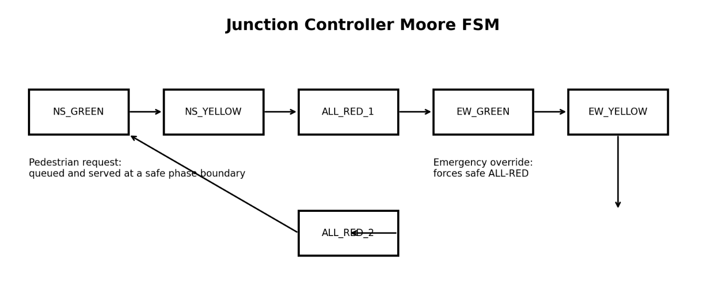
The traffic states are encoded as six normal traffic phases. State 6 is the pedestrian phase. Transitions depend on timer completion, pending pedestrian requests, grants, wave-start conditions and emergency override.
The controller exposes both the encoded light state and status pulses. The one-clock NS-green pulse is especially important because the top-level green-wave scheduler needs an event at phase entry rather than a level that remains high throughout the phase.
Technical review note
A professional review should compare the narrative, RTL and verification artifacts as one chain of evidence. The report deliberately avoids turning a simulation observation into a broader hardware or real-world claim. Where timing is discussed, the reference is the configured simulation clock and the measured event definition used by the testbench.

Review focus | Technical interpretation
Implementation evidence | Use the named RTL module and signal definitions for“Junction Controller FSM”;do not infer behavior from the report alone.
Verification evidence | Use the corresponding testbench, waveform or final transcript to confirm the stated behavior.
Scope control | Results reported here are simulation-level unless the package contains explicit hardware evidence

14. FSM State Definitions and Transitions
State | Code | Role | Normal successor
NS_GREEN | 0 | North–South traffic moves | NS_YELLOW
NS_YELLOW | 1 | Transition warning | ALL_RED_1
ALL_RED_1 | 2 | Safety separation | PED or EW_GREEN
EW_GREEN | 3 | East–West traffic moves | EW_YELLOW
EW_YELLOW | 4 | Transition warning | ALL_RED_2
ALL_RED_2 | 5 | Safety separation | PED or NS_GREEN
PED | 6 | Pedestrian crossing interval | NS/EW phase based on sequence
The state sequence provides a deterministic baseline before optional features are applied. All-red intervals separate opposing green phases.

The testbench records whether each traffic state has been observed. The final Task 5 run additionally exercises emergency behavior from every one of the six traffic states.
A key design property is that state transitions are synchronous. This makes phase changes deterministic relative to the clock and avoids asynchronous state changes inside the controller.
Transition review
The all-red states are not cosmetic states in the model; they are explicit FSM states. This makes the separation between opposing traffic phases visible in the source and in waveforms. Pedestrian service is also inserted at defined transition points rather than being allowed to interrupt an active green phase arbitrarily.
Technical review note
A professional review should compare the narrative, RTL and verification artifacts as one chain of evidence. The report deliberately avoids turning a simulation observation into a broader hardware or real-world claim. Where timing is discussed, the reference is the configured simulation clock and the measured event definition used by the testbench.
Review focus | Technical interpretation
Implementation evidence | Use the named RTL module and signal definitions for”FSM State Definitions and Transitions”;do not infer behavior from the report alone.
Verification evidence | Use the corresponding testbench, waveform or final transcript to confirm the stated behavior.
Scope control | Results reported here are simulation-level unless the package contains explicit hardware evidence

15. Junction Controller — RTL Review
The controller uses a combinational next-state process and sequential state/register updates. Adaptive timing is encapsulated in a small function so the state machine remains readable.
function [COUNTER_WIDTH-1:0] calc_green_time; input [2:0] density; reg [COUNTER_WIDTH+3:0] calc; begin calc = MIN_GREEN_TIME + density * GREEN_STEP; if (calc > MAX_GREEN_TIME) calc_green_time = MAX_GREEN_TIME; else calc_green_time = calc[COUNTER_WIDTH-1:0]; end endfunction
The function implements the policy green_time = min(MAX_GREEN_TIME, MIN_GREEN_TIME + density × GREEN_STEP). The sampled value is used for the green phase target rather than being continuously changed mid-phase.
This distinction is important for deterministic timing. A changing density input during a green phase does not produce a moving target; the phase uses the value captured at entry.
The controller also maintains request_pending and wave_pending flags so that transient external events can be retained until a safe transition point.
RTL structure
The controller keeps policy calculations separate from transition logic. The green-time function calculates a bounded value, while the FSM decides when that value is sampled and used. This organization makes it easier to reason about timing correctness and to change parameter values without rewriting the state machine.
Technical review note
A professional review should compare the narrative, RTL and verification artifacts as one chain of evidence. The report deliberately avoids turning a simulation observation into a broader hardware or real-world claim. Where timing is discussed, the reference is the configured simulation clock and the measured event definition used by the testbench.

Review focus | Technical interpretation
Implementation evidence | Use the named RTL module and signal definitions forr “Junction Controller — RTL Review”; do not infer behavior from the report alone.
Verification evidence | Use the corresponding testbench, waveform or final transcript to confirm the stated behavior.
Scope control | Results reported here are simulation-level unless the package contains explicit hardware evidence

16. State-by-State Operating Sequence
This section describes the normal operating cycle as a timing narrative. It provides a reviewer with an intuitive interpretation of the encoded states and timer interactions.
Step | Controller activity | Safety/coordination purpose
1 | Enter NS_GREEN and sample density | Start bounded adaptive interval
2 | NS_GREEN timer expires | Move to warning phase
3 | NS_YELLOW expires | Insert all-red separation
4 | ALL_RED_1 resolves | Serve pedestrian grant if pending; otherwise EW_GREEN
5 | EW_GREEN timer expires | Move to EW warning
6 | EW_YELLOW expires | Insert second all-red separation
7 | ALL_RED_2 resolves | Serve pedestrian grant if pending; otherwise return to NS_GREEN
8 | Repeat | Continuous synchronous operation
Pedestrian service is therefore not treated as an unrelated asynchronous event. The arbiter provides a grant, and the junction controller consumes it at a defined transition point.
Emergency override is handled as a higher-priority control path. The final regression confirms the emergency behavior from all six traffic phases.
Sequence review
A reviewer should read the sequence as a closed loop. Each phase has a clear successor, all normal transitions are clocked, and exceptional behavior is handled through explicit inputs. This is preferable to relying on implicit combinational timing because the intended behavior can be followed directly in a waveform.
Technical review note
A professional review should compare the narrative, RTL and verification artifacts as one chain of evidence. The report deliberately avoids turning a simulation observation into a broader hardware or real-world claim. Where timing is discussed, the reference is the configured simulation clock and the measured event definition used by the testbench.
Review focus | Technical interpretation
Implementation evidence | Use the named RTL module and signal definitions for”State-by-State Operating Sequence”do not infer behavior from the report alone.
Verification evidence | Use the corresponding testbench, waveform or final transcript to confirm the stated behavior.
Scope control | Results reported here are simulation-level unless the package contains explicit hardware evidence

17. Parameterization and Reuse
Parameterization allows the same RTL to be used with different timing policies without changing the structural source code.
Parameter | Purpose | Final integration value
COUNTER_WIDTH | Timer/state timing width | 8
MIN_GREEN_TIME | Minimum green duration | 3
MAX_GREEN_TIME | Maximum green duration | 6
GREEN_STEP | Increment per density level | 1
YELLOW_TIME | Yellow duration | 1
RED_TIME | All red duration | 1
PED_TIME | Pedestrian duration | 2
WAVE_DELAY | Inter-junction delay | 2 cycles
EMERGENCY_RESPONSE | Emergency response parameter | 2

The adaptive timing testbench uses a different configuration (minimum 2, maximum 5) to validate the policy independently. This demonstrates that the logic is parameterized rather than hard-coded to the final integration values.
junction_controller #( .COUNTER_WIDTH(8), .MIN_GREEN_TIME(3), .MAX_GREEN_TIME(6), .GREEN_STEP(1), .YELLOW_TIME(1), .RED_TIME(1), .PED_TIME(2), .WAVE_DELAY(2), .EMERGENCY_RESPONSE(2) ) dut (...);
Parameterization also makes the design easier to port to another clock frequency or a different simulation scale, provided the timing semantics are revalidated.
Reuse note
Parameterization provides a practical reuse path. The same controller can be instantiated with different timing values for unit tests and final integration. The Task 4 configuration deliberately uses a different minimum and maximum green value, demonstrating that the adaptive calculation is not tied to one fixed constant set.
Technical review note
A professional review should compare the narrative, RTL and verification artifacts as one chain of evidence. The report deliberately avoids turning a simulation observation into a broader hardware or real-world claim. Where timing is discussed, the reference is the configured simulation clock and the measured event definition used by the testbench.
Review focus | Technical interpretation
Implementation evidence | Use the named RTL module and signal definitions for“Parameterization and Reuse”do not infer behavior from the report alone.
Verification evidence | Use the corresponding testbench, waveform or final transcript to confirm the stated behavior.
Scope control | Results reported here are simulation-level unless the package contains explicit hardware evidence

18. Pedestrian Arbitration
The pedestrian arbiter accepts two independent requests but produces at most one grant when both junctions are free. When both requests are present, it uses the last-grant state to alternate priority.
if (!busy_a && !busy_b) begin if (req_a && req_b) begin if (last_grant == 1'b0) grant_b = 1'b1; else grant_a = 1'b1; end else if (req_a) begin grant_a = 1'b1; end else if (req_b) begin grant_b = 1'b1; end end
The arbiter is combinational for the current grant decision and sequential for remembering which side was most recently served. Reset initializes last_grant so the first simultaneous request is assigned to A.
Condition | Grant
Neither request | None
Only A requests | A
Only B requests | B
Both request, A was last | B
Both request, B was last | A
Either junction busy | None

The fairness property is directly measurable: under repeated simultaneous demand, the final verification checked 120 grants and observed A=60 and B=60.
Fairness rationale
The arbiter uses a simple round-robin tie-break rather than a fixed priority. Fixed priority can repeatedly delay one side under simultaneous demand. Remembering the last served side provides a small amount of state while keeping the arbitration logic transparent and easy to verify.
Technical review note
A professional review should compare the narrative, RTL and verification artifacts as one chain of evidence. The report deliberately avoids turning a simulation observation into a broader hardware or real-world claim. Where timing is discussed, the reference is the configured simulation clock and the measured event definition used by the testbench.
Review focus | Technical interpretation
Implementation evidence | Use the named RTL module and signal definitions for“Pedestrian Arbitration;”do not infer behavior from the report alone.
Verification evidence | Use the corresponding testbench, waveform or final transcript to confirm the stated behavior.
Scope control | Results reported here are simulation-level unless the package contains explicit hardware evidence
19. Pedestrian Fairness Verification
Fairness is evaluated over repeated service opportunities rather than inferred from a single arbitration decision.

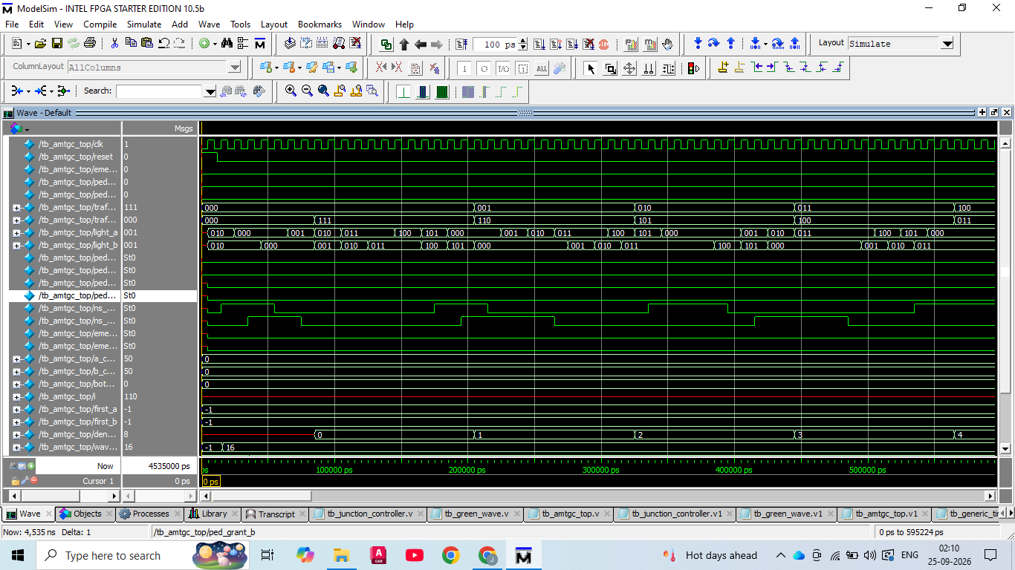
The final Task 5 regression reports 120 pedestrian grants. The observed distribution is A=60 and B=60, which demonstrates balanced service for the tested repeated-request scenario
Metric | Measured value
Total grants checked | 120
A grants | 60
B grants | 60
Difference | 0
Fairness scenario | Repeated requests with arbiter tie-breaking
This is a simulation result for the implemented arbitration policy; it is not a claim that all real-world pedestrian demand patterns have equal waiting times.
Technical review note
A professional review should compare the narrative, RTL and verification artifacts as one chain of evidence. The report deliberately avoids turning a simulation observation into a broader hardware or real-world claim. Where timing is discussed, the reference is the configured simulation clock and the measured event definition used by the testbench.
Review focus | Technical interpretation
Implementation evidence | Use the named RTL module and signal definitions forr “Pedestrian Fairness Verification”do not infer behavior from the report alone.
Verification evidence | Use the corresponding testbench, waveform or final transcript to confirm the stated behavior.
Scope control | Results reported here are simulation-level unless the package contains explicit hardware evidence

20. Emergency Override
Emergency handling is treated as a global priority signal. The final regression explicitly drives the emergency input while the controller is in each of the six traffic phases.
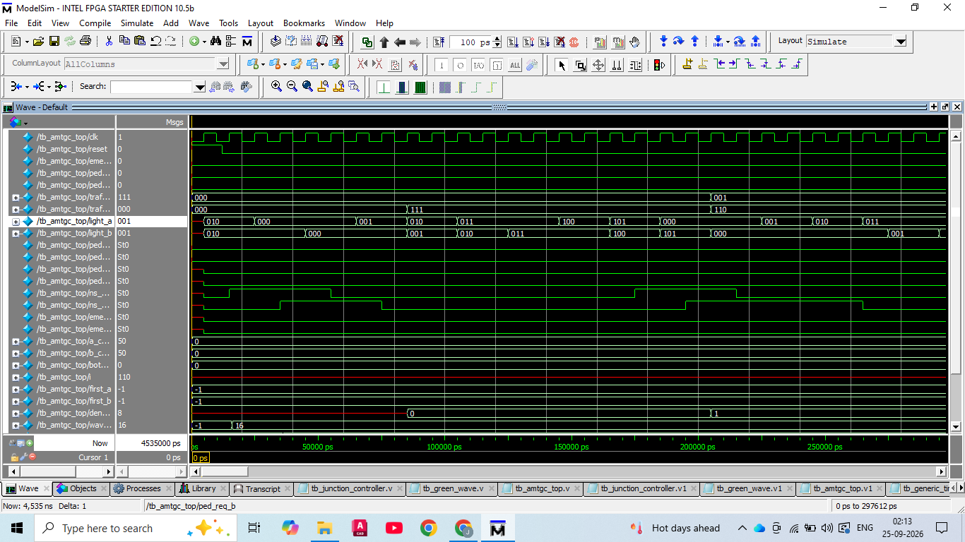
The top-level emergency signal is distributed to both junction controllers. The coordination scheduler is also cleared on reset or emergency so a pending green-wave countdown does not remain active after the override.
Phase code | Phase | Emergency case
0 | NS_GREEN | PASS
1 | NS_YELLOW | PASS
2 | ALL_RED_1 | PASS
3 | EW_GREEN | PASS
4 | EW_YELLOW | PASS
5 | ALL_RED_2 | PASS
The testbench waits until the requested phase is actually observed before asserting emergency, making the scenario phase-specific rather than time-based.
21. Green-Wave Coordination
The green-wave mechanism coordinates the start of the North–South green interval at Junction B relative to Junction A. The reference configuration uses WAVE_DELAY=2 clock cycles.
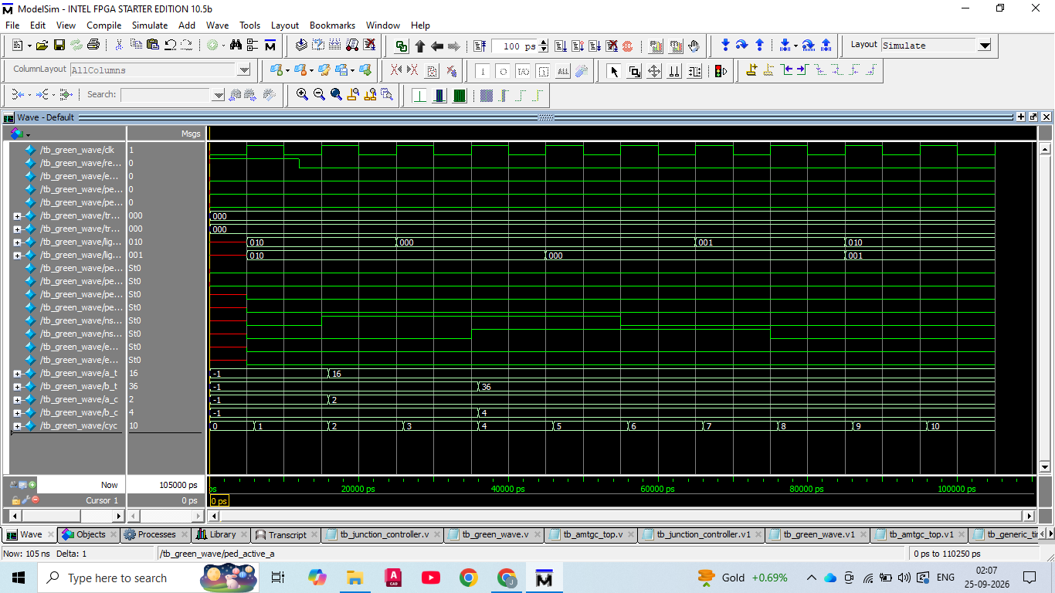
Junction A emits a one-clock ns_green_pulse at green entry. The top-level scheduler records a pending wave and counts down. Junction B receives wave_start when the requested delay is reached.
assign b_wave_start = wave_waiting && (wave_counter == {{(COUNTER_WIDTH-1){1'b0}},1'b1});
The final integration evidence reports a measured offset of 20000 ns, corresponding to two clock cycles in the simulation. Task 5 repeats the check under five different density combinations to ensure that adaptive green duration does not disturb the required entry offset.
Technical review note
A professional review should compare the narrative, RTL and verification artifacts as one chain of evidence. The report deliberately avoids turning a simulation observation into a broader hardware or real-world claim. Where timing is discussed, the reference is the configured simulation clock and the measured event definition used by the testbench.
Review focus | Technical interpretation
Implementation evidence | Use the named RTL module and signal definitions for “Green-Wave Coordination”do not infer behavior from the report alone.
Verification evidence | Use the corresponding testbench, waveform or final transcript to confirm the stated behavior.
Scope control | Results reported here are simulation-level unless the package contains explicit hardware evidence

22. Traffic-Density Adaptive Timing
Adaptive timing maps the three-bit density input to a bounded green duration. Density is sampled at green-phase entry so that one phase has a stable timing target.
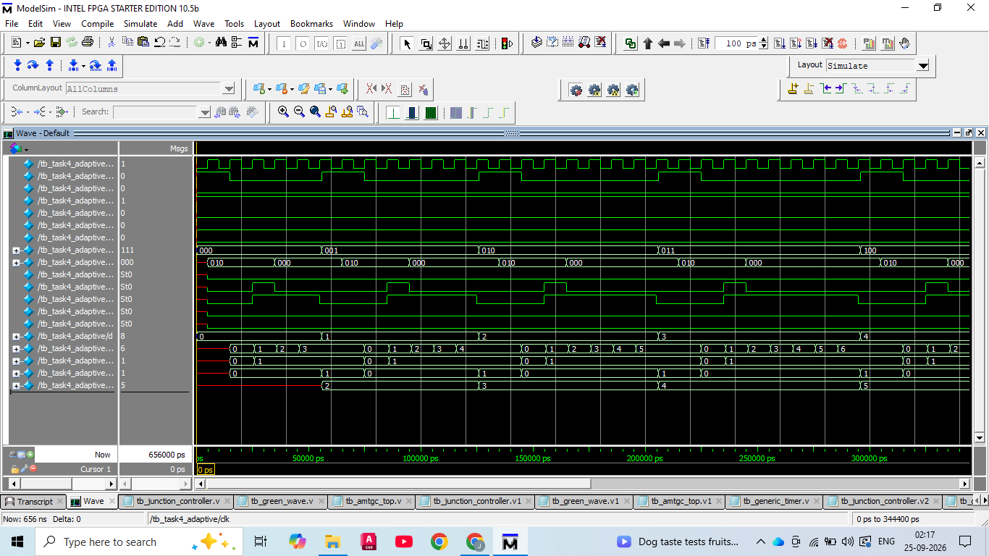
Density | Target green | Observed green cycles*
0 | 2 | 3
1 | 3 | 4
2 | 4 | 5
3 | 5 | 6
4 | 5(clamped) | 6
5 | 5(clamped) | 6
6 | 5(clamped) | 6
7 | 5(clamped) | 6

*The observed count includes the sampled/entry cycle used by the testbench; the target values are the controller timing targets. The important acceptance property is the bounded density mapping and the saturation at the configured maximum.
Task 4 explicitly confirmed minimum green target 2, maximum green target 5 and a complete density sweep from 0 through .
23. Task 4 Verification Evidence
Task 4 isolates adaptive timing from the full system so that density mapping can be evaluated without confounding pedestrian or green-wave activity.
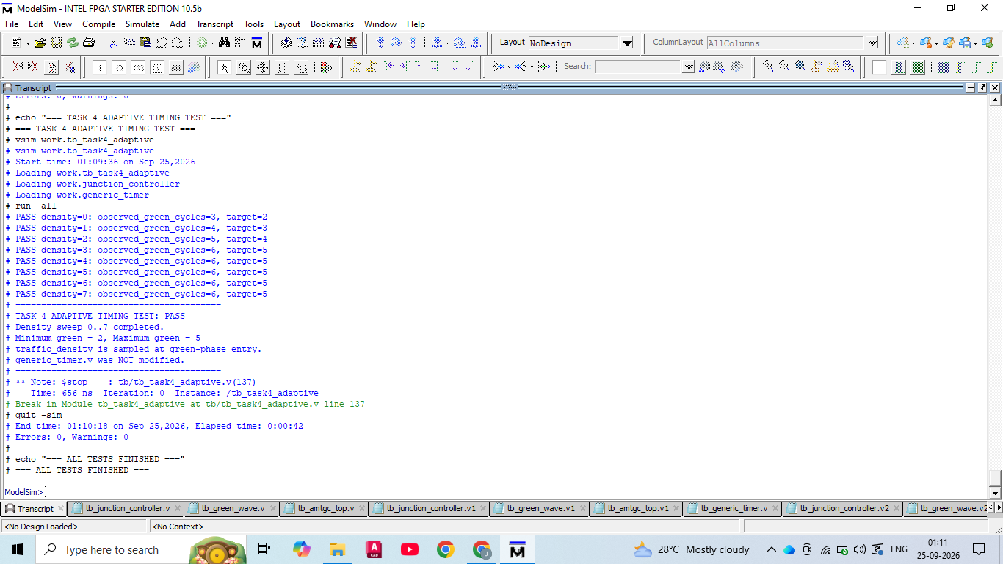
Check | Result
Density sweep | 0 through 7
Minimum green target | 2
Maximum green target | 5
Maximum saturation | Verified for densities 4–7
Timer modification | None
Simulation errors | 0
Simulation warnings | 0

The testbench prints a PASS line for each density value and ends with the explicit statement that the Task 4 adaptive timing test passed. The verification also documents that the generic timer was not modified.
This separation is useful for debugging: if adaptive timing failed, the reviewer could inspect the mapping function and sampled target without first diagnosing the rest of the integration.
24. Task 3 Integration Evidence
Task 3 combines the major coordination features: green-wave timing, pedestrian fairness and emergency override.
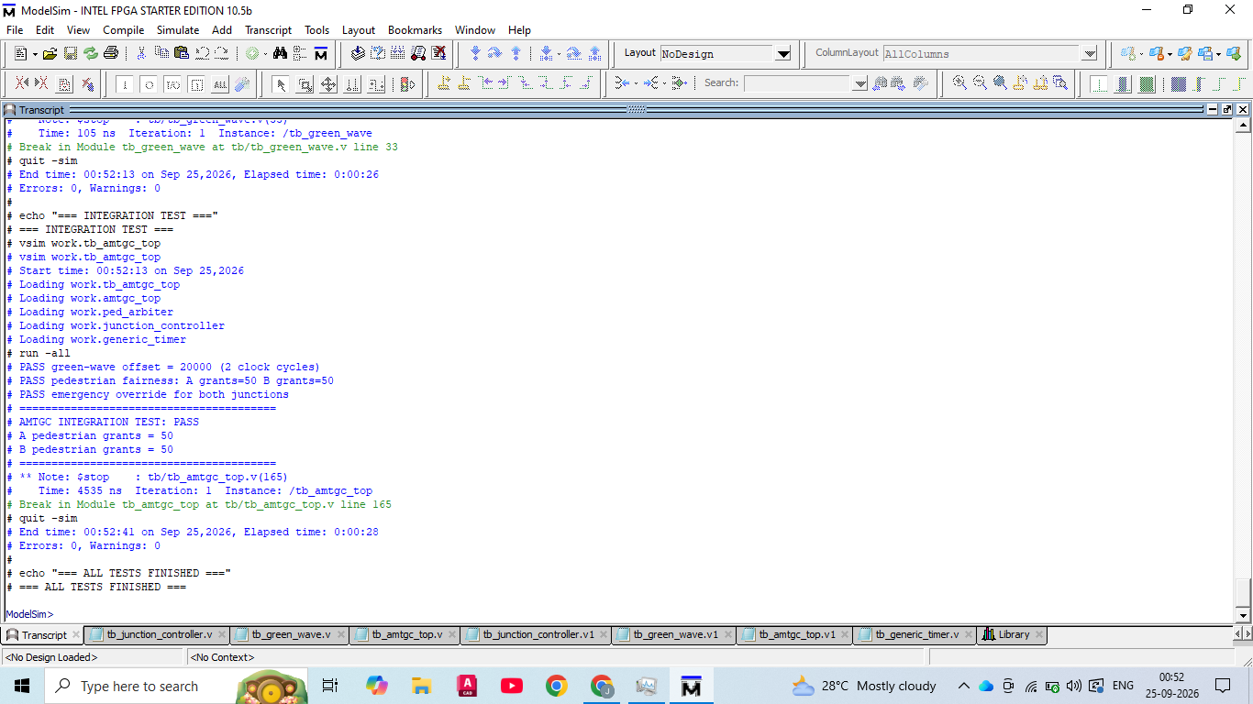
Integration property | Measured result
Green-wave offset | 20000 ns = 2 clock cycles
Pedestrian fairness | A=50, B=50
Emergency override | PASS for both junctions
Overall integration | PASS
Simulation errors/warnings | 0 / 0

The Task 3 result is complementary to Task 5. Task 3 provides focused integration evidence, while Task 5 expands the coverage with randomized density operation, a longer fairness run, all six emergency phases, multiple green-wave density combinations and reset during active operation.
Technical review note
A professional review should compare the narrative, RTL and verification artifacts as one chain of evidence. The report deliberately avoids turning a simulation observation into a broader hardware or real-world claim. Where timing is discussed, the reference is the configured simulation clock and the measured event definition used by the testbench.
Review focus | Technical interpretation
Implementation evidence | Use the named RTL module and signal definitions for “Task 3 Integration Evidence”; do not infer behavior from the report alone.
Verification evidence | Use the corresponding testbench, waveform or final transcript to confirm the stated behavior.
Scope control | Results reported here are simulation-level unless the package contains explicit hardware evidence

25. Verification Methodology
Verification is structured from small unit tests to full-system regression. This minimizes the chance that an integration failure is mistaken for a low-level timing defect.
Layer | Testbench | Purpose
Unit | tb_generic_timer.v | Timer targets, reset and zero target
Unit | tb_junction_controller.v | FSM state coverage and pedestrian path
Feature | tb_green_wave.v | Measured inter-junction offset
Feature | tb_task4_adaptive.v | Density 0–7 adaptive timing
Integration | tb_amtgc_top.v | Top-level combined behavior
Regression | tb_task5_full.v | Reset, randomized density, fairness, emergency and wave combinations

The methodology emphasizes observable assertions and PASS/FAIL output. A failing condition terminates the simulation with a FAIL message, while successful completion records a PASS result.
This approach is especially appropriate for an internship engineering project because it produces both executable source and reviewer-readable evidence.
Verification architecture
The verification hierarchy mirrors the design hierarchy. Low-level timer behavior is tested first, then the single-junction FSM, then green-wave and adaptive features, then top-level integration, and finally the full regression. This ordering makes failures easier to localize and provides evidence for both individual modules and the combined system.
Technical review note
A professional review should compare the narrative, RTL and verification artifacts as one chain of evidence. The report deliberately avoids turning a simulation observation into a broader hardware or real-world claim. Where timing is discussed, the reference is the configured simulation clock and the measured event definition used by the testbench.
Review focus | Technical interpretation
Implementation evidence | Use the named RTL module and signal definitions for “Verification Methodology”do not infer behavior from the report alone.
Verification evidence | Use the corresponding testbench, waveform or final transcript to confirm the stated behavior.
Scope control | Results reported here are simulation-level unless the package contains explicit hardware evidence

26. Directed Verification Scenarios
Directed tests are used where the expected outcome is precise and deterministic. They are particularly effective for state machines, counters and phase-specific emergency behavior.
Scenario | Stimulus | Expected observation
Timer target 3 | start with target=3 | done asserted at target boundary
Timer target 0 | start with target=0 | immediate done
FSM sequence | run 20+ clocks | all six traffic states observed
Pedestrian request | assert request then grant | PED state reached
Green wave | observe A/B NS-green entry | two-cycle difference
Emergency phase 0–5 | wait for each state then assert emergency | emergency path active
Reset during operation | assert reset mid-run | state/timing recovery

Directed tests are deterministic by construction. They establish the baseline before the randomized density regression is executed.
Directed-test rationale
Directed scenarios are valuable where the expected result is exact. They make off-by-one timing errors, missing states and incorrect emergency entry conditions immediately visible. The project combines these deterministic cases with the randomized density run so that both known edge cases and changing operating conditions are exercised.
Technical review note
A professional review should compare the narrative, RTL and verification artifacts as one chain of evidence. The report deliberately avoids turning a simulation observation into a broader hardware or real-world claim. Where timing is discussed, the reference is the configured simulation clock and the measured event definition used by the testbench.
Review focus | Technical interpretation
Implementation evidence | Use the named RTL module and signal definitions for “Directed Verification Scenarios”;do not infer behavior from the report alone.
Verification evidence | Use the corresponding testbench, waveform or final transcript to confirm the stated behavior.
Scope control | Results reported here are simulation-level unless the package contains explicit hardware evidence

27. Randomized Verification
The full regression introduces randomized traffic-density values for 200 cycles. Randomization is used to exercise the adaptive timing interface across changing demand rather than a single fixed traffic pattern.
The final transcript reports: “PASS randomized traffic-density run: 200 cycles.” The testbench also checks the pedestrian arbiter over 120 grants and executes emergency checks from all six traffic phases.
Randomized coverage item | Count / range
Density values | 3-bit, 0–7
Randomized operation | 200 cycles
Pedestrian grants | 120
A/B distribution | 60 / 60
Emergency phase positions | 6
Green-wave combinations | 5

Randomized verification does not replace directed tests. It complements them by increasing the number of state/timing combinations encountered during normal operation.
The final result is considered clean because the simulation completed with zero errors and zero warnings in the recorded transcript.
Randomized-test rationale
Randomization increases the number of density patterns seen during continuous operation, but the final result remains deterministic in its acceptance criteria. The test still checks explicit properties such as successful completion, fairness counts and phase-specific emergency behavior. Randomized stimulus therefore complements rather than replaces directed checks.

Technical review note
A professional review should compare the narrative, RTL and verification artifacts as one chain of evidence. The report deliberately avoids turning a simulation observation into a broader hardware or real-world claim. Where timing is discussed, the reference is the configured simulation clock and the measured event definition used by the testbench.
Review focus | Technical interpretation
Implementation evidence | Use the named RTL module and signal definitions for “Randomized Verification”;do not infer behavior from the report alone.
Verification evidence | Use the corresponding testbench, waveform or final transcript to confirm the stated behavior.
Scope control | Results reported here are simulation-level unless the package contains explicit hardware evidence

28. Final Task 5 Verification Transcript
The following is the final verification record preserved in the submission package. It is reproduced as a compact evidence table so the report remains readable while retaining the exact measured claims.
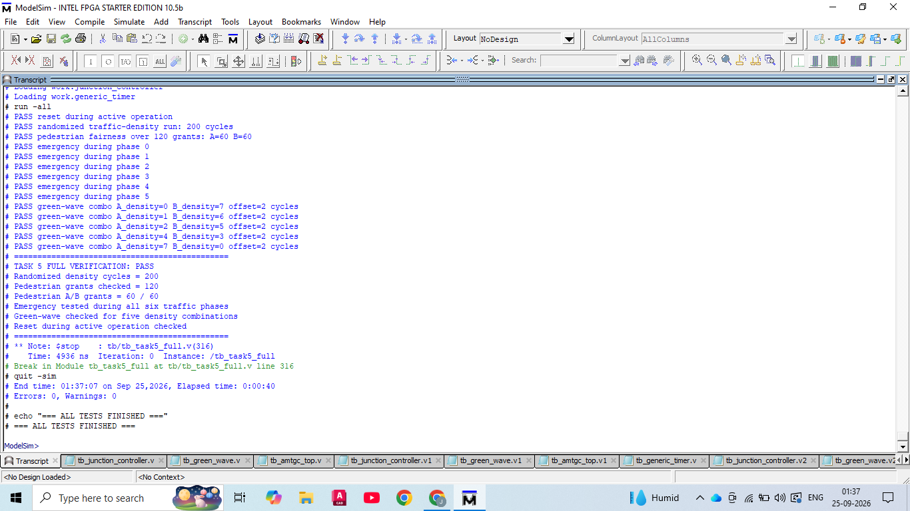
Verification item | Recorded result
Reset during active operation | PASS
Randomized traffic-density runs | 200 cycles — PASS
Pedestrian fairness | 120 grants; A=60, B=60 — PASS
Emergency phase0 | PASS
Emergency phase1 | PASS
Emergency phase2 | PASS
Emergency phase3 | PASS
Emergency phase4 | PASS
Emergency phase5 | PASS
Green-wave combinations | 5 combinations — all PASS
Overall Task 5 | PASS
Errors / warnings | 0/0

29. Quantitative Simulation Results
The verification results can be summarized numerically to make the evidence easier to review.
Metric | Value | Interpretation
Randomized cycles | 200 | Adaptive operation exercised
Pedestrian grants | 120 | Longer fairness observation
A grants | 60 | 50% of observed grants
B grants | 60 | 50% of observed grants
Emergency phases | 6/6 | Every normal traffic phase covered
Wave combinations | 5/5 | Density combinations covered
Wave offset | 2 cycles | Configured delay achieved
Task 4 density sweep | 8/8 values | All 0–7 codes exercise
Simulation errors | 0 | Clean run
Simulation warnings | 0 | Clean run

The numerical results are simulation measurements, not hardware measurements. In particular, the green-wave offset is a clock-cycle relationship in the ModelSim environment.
Metrics interpretation
The quantitative results provide a compact summary of the regression. The 60/60 pedestrian split documents the tested fairness behavior; six emergency phase checks demonstrate phase coverage; five wave combinations demonstrate that adaptive density changes did not break the inter-junction offset; and zero errors or warnings indicate a clean recorded run.
Technical review note
A professional review should compare the narrative, RTL and verification artifacts as one chain of evidence. The report deliberately avoids turning a simulation observation into a broader hardware or real-world claim. Where timing is discussed, the reference is the configured simulation clock and the measured event definition used by the testbench.
Review focus | Technical interpretation
Implementation evidence | Use the named RTL module and signal definitions for“Quantitative Simulation Results”do not infer behavior from the report alone.
Verification evidence | Use the corresponding testbench, waveform or final transcript to confirm the stated behavior.
Scope control | Results reported here are simulation-level unless the package contains explicit hardware evidence

30. Integrated System Waveform
The integrated waveform provides a visual cross-check of the top-level signals while the regression provides the formal PASS/FAIL record.
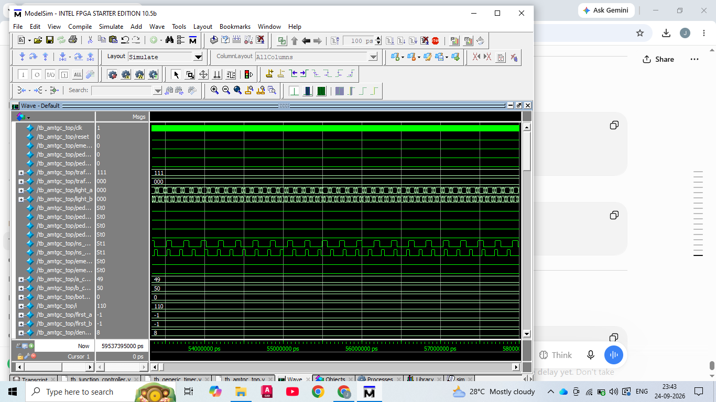
The waveform is useful for correlating the encoded light states with pedestrian and emergency status. A professional review should use the waveform together with the source and testbench rather than treating a screenshot as a substitute for executable verification.
The final package retains the waveform image under waveforms/ so the evidence can be reviewed independently of the report.
Technical review note
A professional review should compare the narrative, RTL and verification artifacts as one chain of evidence. The report deliberately avoids turning a simulation observation into a broader hardware or real-world claim. Where timing is discussed, the reference is the configured simulation clock and the measured event definition used by the testbench.
Review focus | Technical interpretation
Implementation evidence | Use the named RTL module and signal definitions for “Integrated System Waveform”;do not infer behavior from the report alone.
Verification evidence | Use the corresponding testbench, waveform or final transcript to confirm the stated behavior.
Scope control | Results reported here are simulation-level unless the package contains explicit hardware evidence

31. Traffic-State Waveform
A second waveform view focuses on traffic-state activity. This helps reviewers inspect phase sequencing and the relationship between encoded states and status signals.
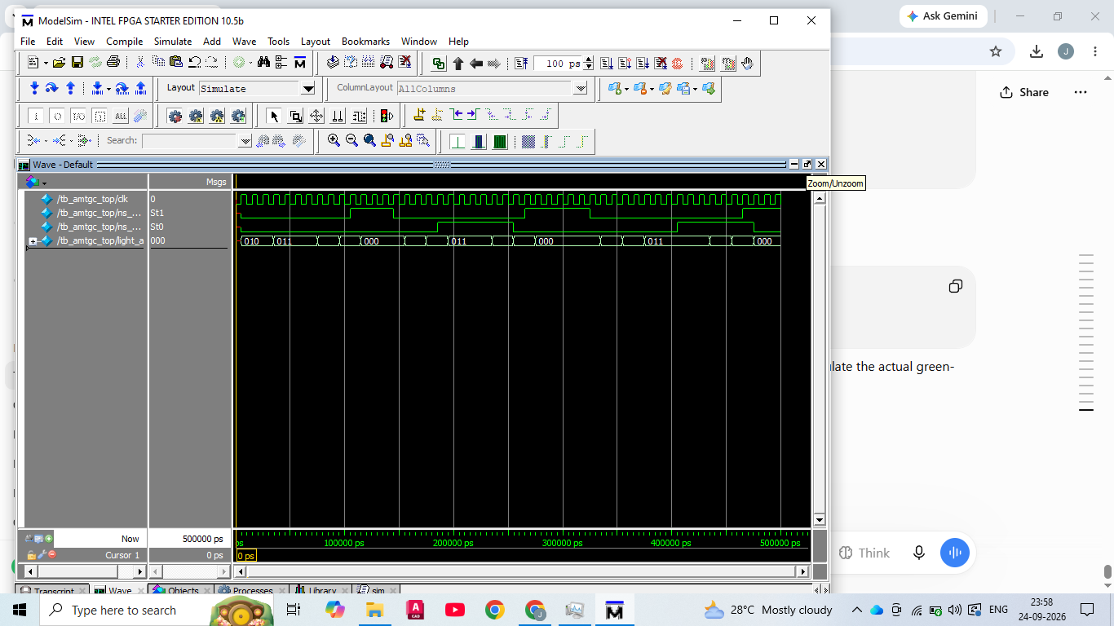
The encoded states are interpreted using the documented state table: 0 NS_GREEN, 1 NS_YELLOW, 2 ALL_RED_1, 3 EW_GREEN, 4 EW_YELLOW, 5 ALL_RED_2 and 6 PED.
Waveform review is especially useful for identifying off-by-one timing errors, missing all-red intervals and unexpected state transitions. The unit and full regression tests provide the stronger machine-readable confirmation.
Technical review note
A professional review should compare the narrative, RTL and verification artifacts as one chain of evidence. The report deliberately avoids turning a simulation observation into a broader hardware or real-world claim. Where timing is discussed, the reference is the configured simulation clock and the measured event definition used by the testbench.
Review focus | Technical interpretation
Implementation evidence | Use the named RTL module and signal definitions for “Traffic-State Waveform”;do not infer behavior from the report alone.
Verification evidence | Use the corresponding testbench, waveform or final transcript to confirm the stated behavior.
Scope control | Results reported here are simulation-level unless the package contains explicit hardware evidence

32. Challenges Faced and Resolutions
The project required iterative verification and repository cleanup. The most important engineering lessons came from issues that were observable in the simulation workflow.

Challenge | Observed symptom | Resolution
Wrong ModelSim directory | Design-unit files not found | Run commands from project root and use relative paths
Insufficient fairness observation | Earlier run ended before the intended grant count
Adaptive timing interpretation | Observed cycle count differed from target by entry cycle | Document target vs observed measurement explicitly
Wave timing interpretation | Need a measurable event relationship | Use ns_green entry pulses and cycle counter
Submission clarity | Evidence scattered across files | Consolidate transcript, coverage matrix and report

These resolutions improved reproducibility and reduced the chance of reporting a passing result from an incomplete test.
Debugging lesson
The most important debugging principle in this project was to verify the execution environment before changing RTL. A wrong working directory can look like a source-code failure when the simulator simply cannot find the files. Later, fairness coverage was increased when the first count was lower than the intended acceptance target. These are reproducibility lessons as much as coding lessons.
Technical review note
A professional review should compare the narrative, RTL and verification artifacts as one chain of evidence. The report deliberately avoids turning a simulation observation into a broader hardware or real-world claim. Where timing is discussed, the reference is the configured simulation clock and the measured event definition used by the testbench.

Review focus | Technical interpretation
Implementation evidence | Use the named RTL module and signal definitions for Challenges Faced and Resolutions”do not infer behavior from the report alone.
Verification evidence | Use the corresponding testbench, waveform or final transcript to confirm the stated behavior.
Scope control | Results reported here are simulation-level unless the package contains explicit hardware evidence

33. Bug Log and Verification Lessons
A concise bug log is useful because it records not only the final state of the project but also how verification quality was improved. Issue / lesson Engineering response.
Issue / lesson | Engineering response | Status
Relative file paths | Run from AMTGC_Final root | Resolved
Task 5 fairness count | Increase to 120 grants | Resolved 60/60
Adaptive cycle interpretation | Separate target duration from observed entry count | Documented
Green-wave event definition | Measure first A/B NS-green edges | Verified
Timer reuse | Avoid modifying generic_timer for adaptive feature | Preserved
The key lesson is to define the measured event before writing the assertion. For example, “green-wave delay” is ambiguous until the project defines it as the difference between the first observed NS-green entry edges.
The final package therefore contains both the verification transcript and the underlying testbench source.

Verification lesson
A verification result is only as strong as its measurement definition. The adaptive test distinguishes the configured target from the number of observed clock samples, and the green-wave test measures the difference between specific entry events. Writing those definitions down prevents an apparently correct waveform from being interpreted incorrectly.
Technical review note
A professional review should compare the narrative, RTL and verification artifacts as one chain of evidence. The report deliberately avoids turning a simulation observation into a broader hardware or real-world claim. Where timing is discussed, the reference is the configured simulation clock and the measured event definition used by the testbench.
Review focus | Technical interpretation
Implementation evidence | Use the named RTL module and signal definitions for “Bug Log and Verification Lessons”do not infer behavior from the report alone.
Verification evidence | Use the corresponding testbench, waveform or final transcript to confirm the stated behavior.
Scope control | Results reported here are simulation-level unless the package contains explicit hardware evidence

34. Conclusion and Final Review Checklist
AMTGC demonstrates a structured Verilog RTL approach to multi-junction traffic control with parameterized timing, pedestrian arbitration, emergency override, green-wave coordination and adaptive timing. The project is supported by reproducible ModelSim verification rather than by screenshots alone.
Review item | Status
RTL source included | YES
Testbenches included | YES
ModelSim script included | YES
Architecture and FSM diagrams included | YES
Task 3 integration evidence included | YES
Task 4 adaptive evidence included | YES
Task 5 final transcript included | YES
Randomized density run — 200 cycles | YES
Pedestrian grants — 120; A/B=60/60 | PASS
Emergency — all six phase | PASS
Green-wave — five combinations | PASS
Reset during active operation | PASS
Final simulation errors/warnings | 0 / 0

Final engineering statement
0 / 0 The submitted RTL and verification artifacts form a coherent, traceable project package. The measured results support the stated simulation-level objectives. Any physical deployment, real traffic optimization or safety certification would require additional hardware, calibration, formal review and field validation.
Reviewer sign-off
Student: Yarrabarla Sadhvi Sri Date: _26-9-2026_______________ Reviewer: _____________________________ Date: ________________

