AMTGC
Adaptive Multi-Junction Traffic Grid Controller
FINAL INTERNSHIP TECHNICAL REPORT
Complete RTL Design • Architecture • FSM • Integration • Verification • Simulation Evidence
Verilog RTL | ModelSim Intel FPGA Edition 10.5b

Student Name: ______Sadhvi Sri Yarrabarla________________________
College / University: ______RGUKT ONGOLE___________________
Internship Organization: ________ELEVANCE SKILLS______________

- Executive Summary

AMTGC is a modular Verilog RTL architecture for two coordinated four-way traffic junctions. It separates reusable timing, junction state control, pedestrian arbitration and system integration.
The implemented system supports normal North-South/East-West sequencing, explicit all-red safety intervals, pedestrian arbitration, emergency override, green-wave coordination and traffic-density adaptive green timing.
The final evidence reports 200 randomized density cycles, 120 pedestrian grants with A=60 and B=60, emergency tests during all six traffic phases, five green-wave combinations, a two-clock-cycle measured green-wave offset, and zero ModelSim errors/warnings
. • Task 4 density sweep 0–7: PASS
• Minimum green: 2 cycles; maximum green: 5 cycles
• generic_timer.v unchanged for adaptive timing
• Task 5 full verification: PASS 2.
2. Project Scope, Problem and Objectives
The project demonstrates how reusable RTL blocks can be combined into a coordinated multi-junction traffic controller. The local controller must remain deterministic while the system adds coordination, pedestrian service, emergency response and adaptive timing.
The scope is RTL and simulation. Physical deployment is outside the verified scope and would require FPGA pin constraints, real sensors, physical signal interfaces, fail-safe mechanisms and hardware-in-the-loop validation.
• Reusable timer
• Parameterized junction FSM
• Fair pedestrian arbitration
• Emergency override
• Green-wave coordination
• Adaptive timing with bounded limits
• Self-checking final verification

3.Requirements and Verification Strategy

The requirements were translated into explicit verification scenarios. Module-level tests isolate timer and FSM behavior; integration tests validate green-wave, arbitration and emergency behavior; the unified Task 5 environment verifies the complete system.
Directed scenarios deliberately exercise critical conditions while randomized traffic-density activity broadens stimulus. The final testbench reports PASS/FAIL automatically instead of depending solely on manual waveform inspection.
• Reset during active operation
• Emergency during phases 0–5
• More than 100 pedestrian grants
• Five green-wave density combinations
• Density sweep 0–7
• Minimum/maximum adaptive limits
• 4. Final Architecture200 randomized density cycles

4. Final Architecture

The top-level architecture instantiates two parameterized junction controllers. Each controller uses the reusable timer and participates in system-level coordination. A shared pedestrian arbiter provides centralized request/grant policy.
The separation keeps application policy in the controller while the timer remains generic. This is particularly important for Task 4, where
adaptive timing is added without changing the timer implementation.
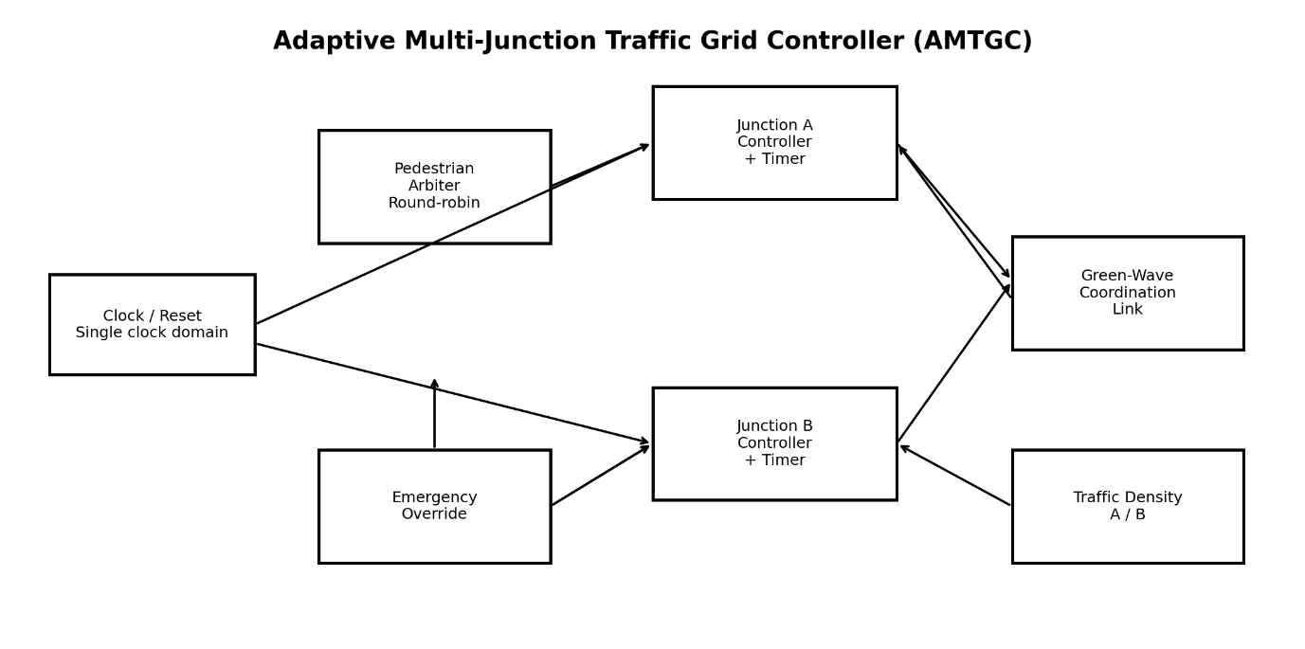

5. RTL Module Design
generic_timer.v — reusable parameterized timing primitive. junction_controller.v — parameterized traffic FSM, timing policy and adaptive green-target calculation.
ped_arbiter.v — shared pedestrian request/grant arbitration. amtgc_top.v — complete system integration.
The same junction-controller source is instantiated for both junctions, reducing duplicated RTL and keeping behavior consistent
6. Junction Controller FSM and State Operation
The controller uses explicit states for green, yellow, all-red and pedestrian service. The sequence is designed to prevent direct conflicting-green transitions.
State encoding used in the documented implementation is: 0=NS_GREEN, 1=NS_YELLOW, 2=ALL_RED_1, 3=EW_GREEN, 4=EW_YELLOW, 5=ALL_RED_2, 6=PED.
Explicit all-red states provide a safety interval between conflicting movements. Timing is handled through the reusable timer rather than embedded counter logic.
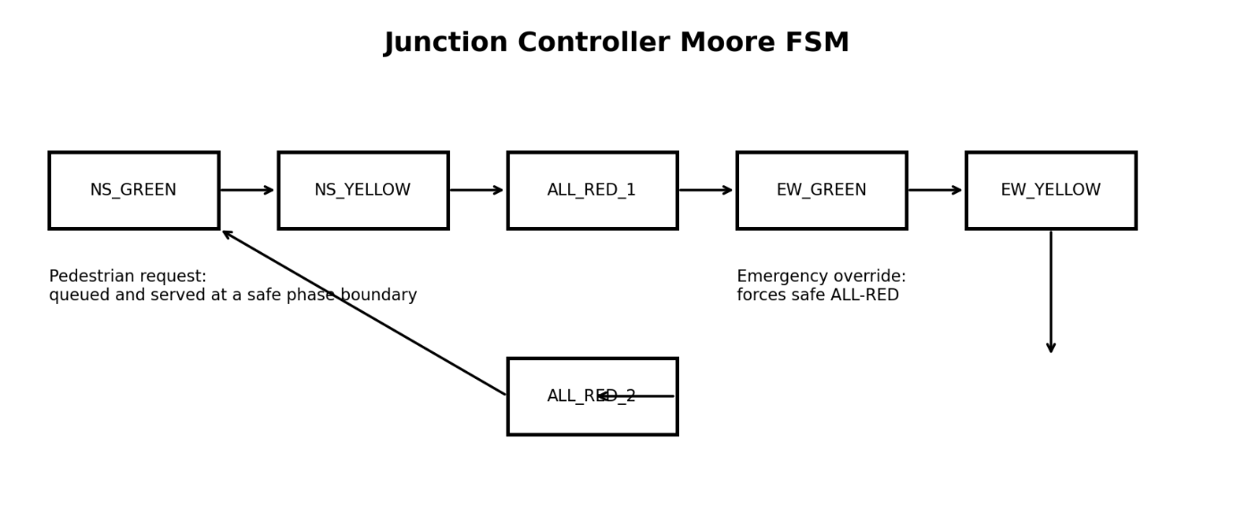

7. Junction Controller Simulation Evidence
The module-level waveform shows clock/reset activity, controller state signals and timing behavior. It is retained as direct ModelSim evidence and should be interpreted together with the final self-checking transcript.
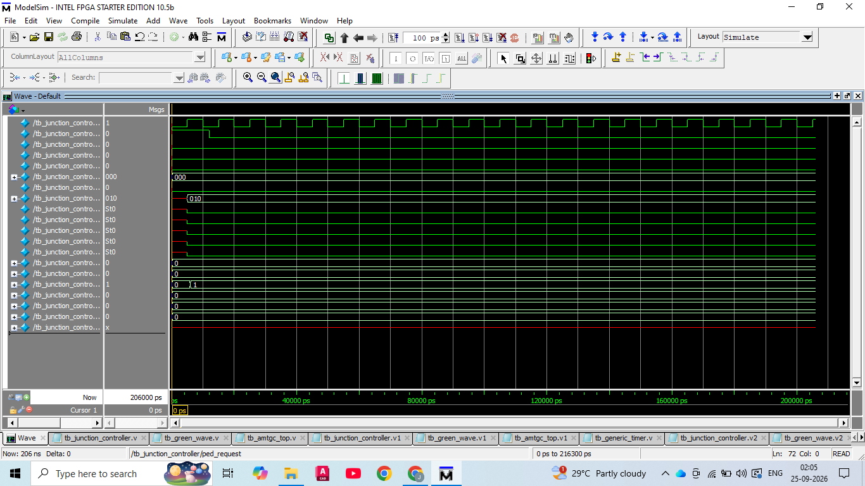

8. System Integration and Green Wave
amtgc_top.v connects both controllers, timing resources and the shared pedestrian arbiter. The green-wave mechanism establishes a bounded timing relationship between Junction A and Junction B.
The measured integration result is a 20,000 ps offset, corresponding to two clock cycles in the configured simulation.

9. Task 3 Integration Verification
The Task 3 integration test reports three important results: green-wave offset verification, pedestrian fairness and emergency override. The evidence is retained as a direct PASS transcript
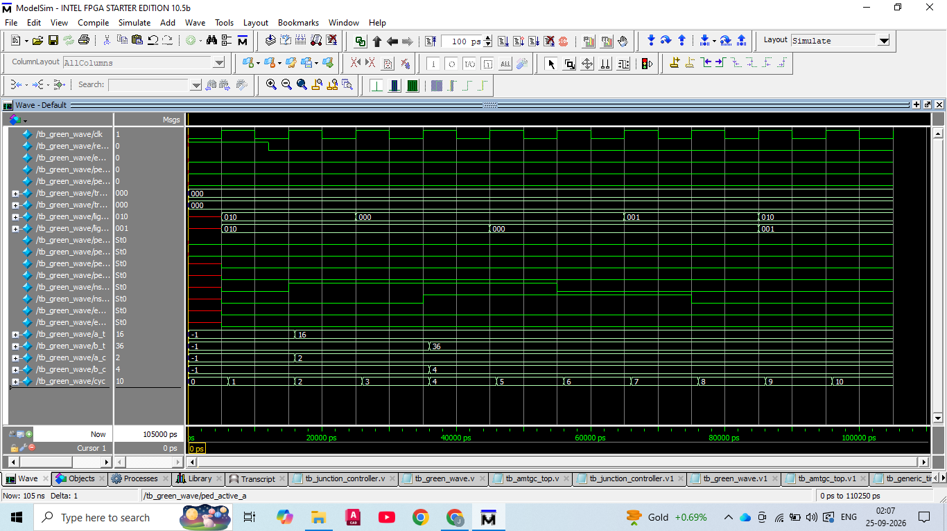

10. Pedestrian Arbitration and Fairness
The shared arbiter receives requests and produces grants without exposing internal junction FSM state. The final Task 5 test deliberately checks 120 grants, exceeding the more-than-100 requirement.
The final result is A=60 and B=60. This is the primary numerical fairness evidence
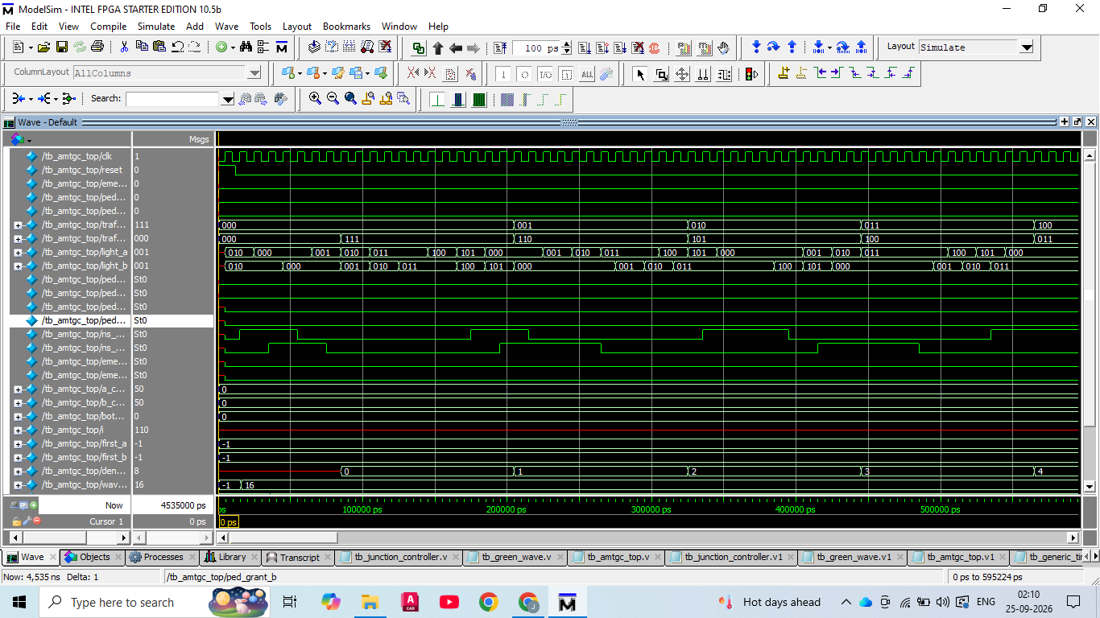

11. Emergency Override
Emergency behavior is verified during all six traffic phases represented by the final controller/testbench. The final transcript reports PASS for phase 0, phase 1, phase 2, phase 3, phase 4 and phase 5.
The emergency waveform is included as visual evidence; the self-checking transcript is the authoritative result for complete phase coverage.
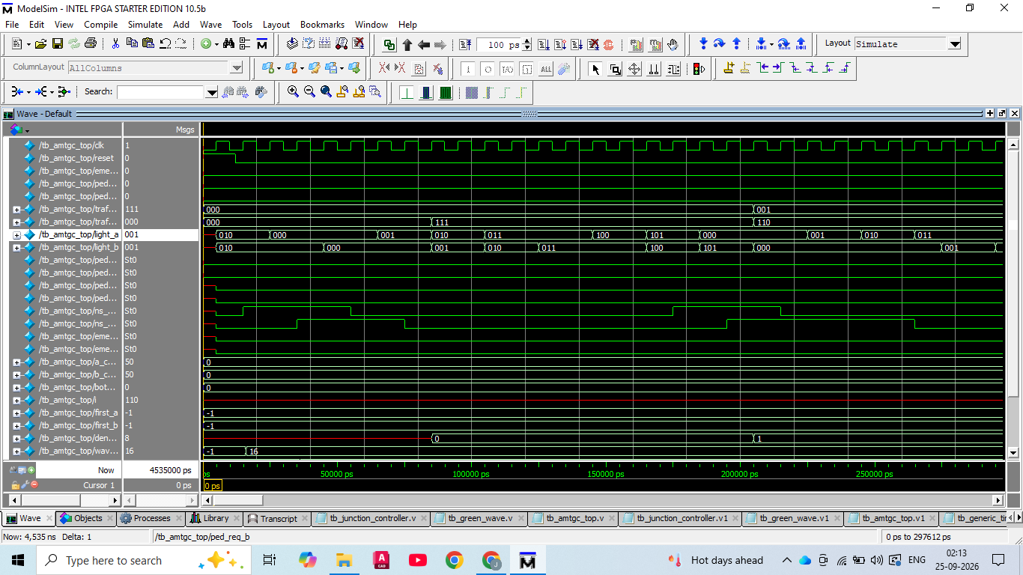

12. Traffic-Density Adaptive Timing
traffic_density is a 3-bit input representing values 0–7. The controller computes a green-time target from density and clamps it to configured safety limits.
The verified configuration has a minimum green duration of 2 cycles and a maximum of 5 cycles. Density is sampled at green-phase entry so the active phase remains deterministic.
Most importantly, generic_timer.v was not modified. The timer remains reusable while the controller supplies an adaptive target.
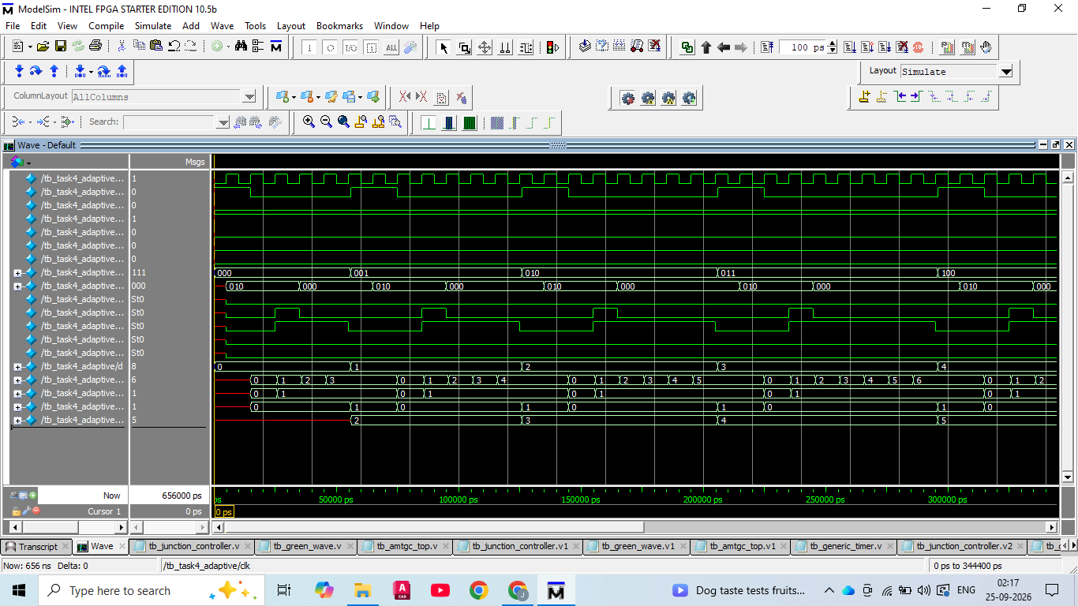

13. Task 4 Adaptive Verification
The density sweep tests every possible 3-bit density value. The supplied transcript reports PASS for density 0 through density 7 and confirms the minimum and maximum green limits.
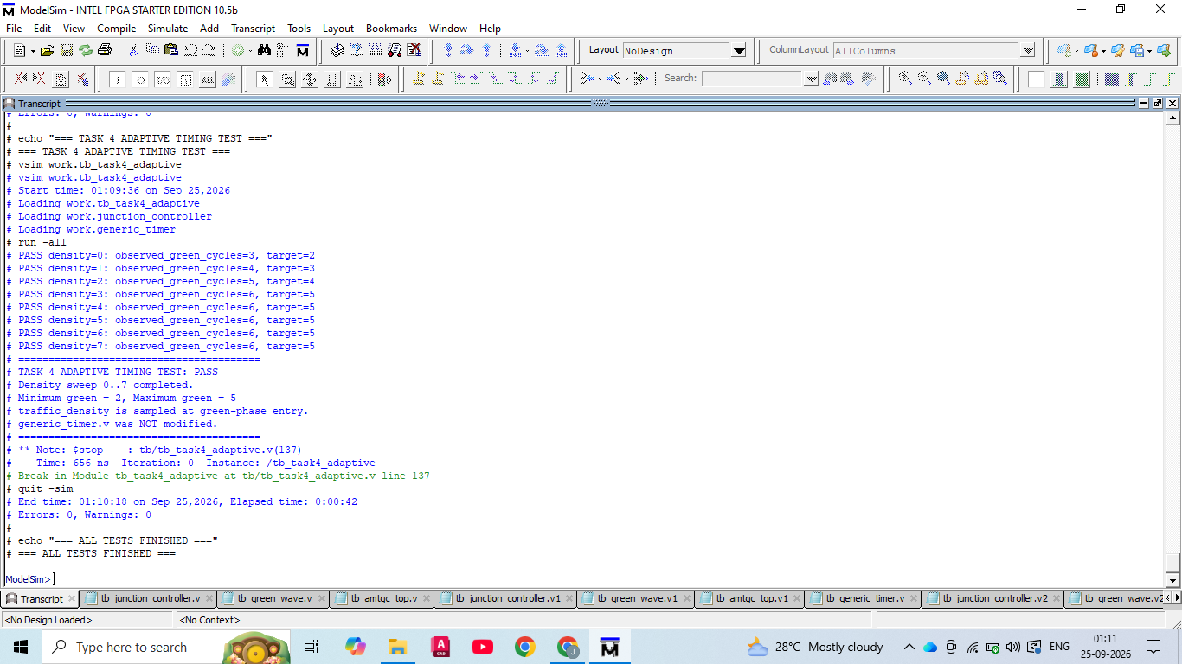

14. Full Verification Methodology
The final verification environment is self-checking. It combines directed tests with randomized activity and reports explicit PASS/FAIL results.
Directed tests include reset during operation, emergency during every traffic phase, pedestrian fairness, density limits and green-wave combinations. Randomized testing runs 200 traffic-density cycles.
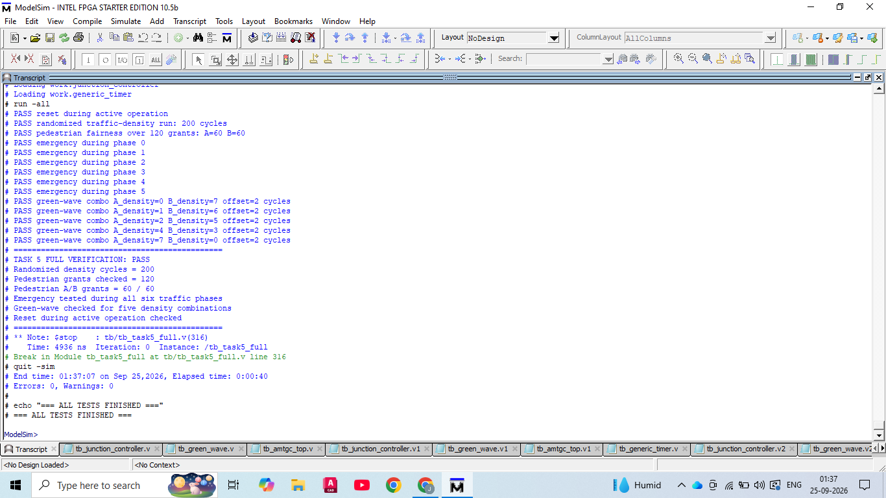

15. Task 5 Full Verification Evidence
The Task 5 transcript is the primary final verification artifact. It combines the major functional requirements and corner cases in one unified environment.

16. Quantitative Verification Results
Verification item | PASS
Reset during active operation | 200 cycles — PASS
Randomized density | 120 grants; A=60, B=60 — PASS
Pedestrian fairness | All six traffic phases — PASS
Emergency coverage | Five density combinations — PASS
Green-wave offset | 2 clock cycles
Density sweep | 0–7 — PASS
Minimum green | 2 cycles
Maximum green | 5 cycles
ModelSim errors / warnings | 0 / 0
Final result | TASK 5 FULL VERIFICATION: PASS
The numerical results above are taken from the supplied ModelSim verification evidence and are preserved in the final verification transcript.
17. Integrated-System Waveform
The integrated waveform demonstrates the relationship among clock, reset, traffic density, light outputs, controller activity and pedestrian signals. It is retained as system-level visual evidence.
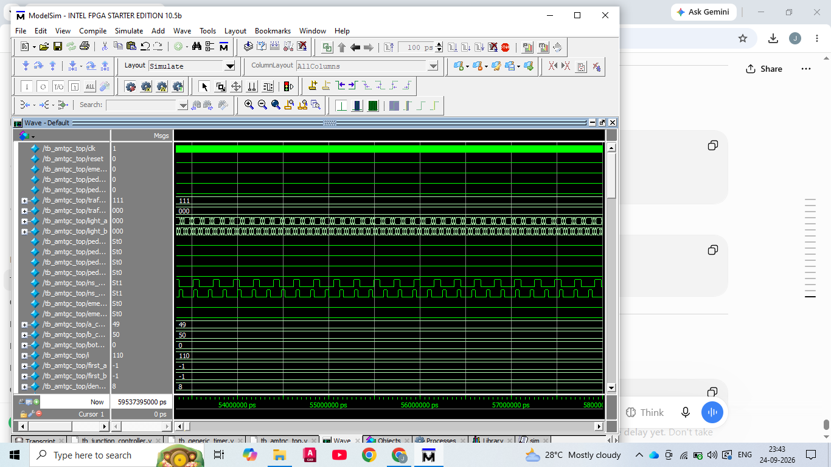

18. Traffic-State Activity
This waveform provides an additional view of traffic-state evolution across a longer simulation interval. It complements the event-based PASS transcript with direct time-domain evidence.
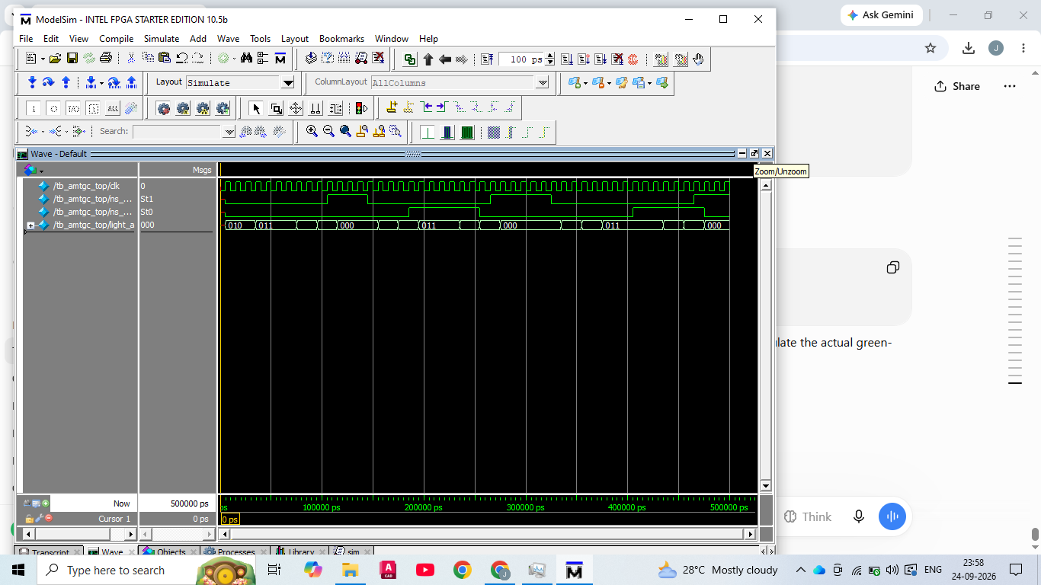

19. Debugging Record and Engineering Lessons
The development process included normal ModelSim workflow problems such as launching from the wrong working directory. The final project uses the project root and `do sim/run_all.do` to make execution reproducible.
A more important issue was found in the fairness verification: an early test stopped after 64 grants, which did not satisfy the more-than-100 requirement. The testbench was corrected to continue to 120 grants. The corrected run produced A=60 AMTGC — Final Internship Technical Documentation Page 11 and B=60.
This issue is documented intentionally. Verification code is itself an engineering artifact and must be checked against the requirement it is supposed to prove.

20. Verification Coverage Matrix
The package includes a separate coverage matrix. The final evidence covers timer behavior, junction FSM operation, green-wave coordination, pedestrian fairness, all six emergency phases, density 0–7, minimum/maximum green, active-operation reset and randomized activity.
• Module-level: timer and junction controller
• Integration: green wave, arbiter and emergency
• System-level: unified self-checking Task 5
• Randomized: 200 density cycles
• Quantitative fairness: 120 grants

21. Repository Structure and Reproducibility
The final package is organized into source, testbench, simulation, documentation, diagrams, waveform and verification folders. This organization follows the professional-delivery requirement that another engineer should be able to understand and reproduce the work without verbal guidance.
The preferred command from the project root is `do sim/run_all.do`. A manual compile sequence is included in README.md.

22. Professional Documentation Set
The package contains an integrated technical report plus separate Task 1–6 records, a Bug Log, Assumptions Document, Verification Coverage Matrix, Self-Attestation Checklist and README. The integrated report contains the architecture, FSM, design decisions, verification methodology, results, debugging lessons, limitations and evidence.

23. Engineering Decisions and Trade-offs
A single clock domain reduces synchronization complexity. Shared arbitration centralizes fairness. Sampling density at green entry keeps active-phase timing deterministic. The standalone timer preserves reuse. Explicit all-red states provide safety separation. Parameterized controllers avoid duplicated RTL.

24. Limitations and Future Work
The current implementation is a simulation-focused RTL demonstration rather than a certified road-traffic controller. Physical deployment would require FPGA constraints, real sensor interfaces, physical signal drivers, fail-safe mechanisms, watchdogs and hardware-in-the-loop testing. Future work can extend formal assertions, functional coverage, sensor filtering, physical green-wave calibration and hardware validation.

25. Final Submission Contents
The submission package contains the final verified RTL, all testbenches, ModelSim script, technical documentation, architecture/FSM diagrams, waveform screenshots, PASS transcripts, bug/assumption/attestation documents and a coverage matrix.
• Public GitHub repository: must be entered and tested in the portal
• Demonstration video: must be entered and tested in the portal
• Student/college/internship identity: must match portal records

