Userful links

Eureka server : <http://localhost:8761/>

<http://localhost:9191/actuator/hystrix.stream>

<http://localhost:9295/hystrix>

Step1>Start Registry service

Step2>config server service

Step3>api gateway service

Step4>hystrix dashbord

Step5> run zip using java -jar zipkin-server-2.23.2-exec.jar on cmd in the same folder were jar is present then enter <http://127.0.0.1:9411/zipkin/> (from cmd ) in browser

Step6>other application services (After Zipkin because otherwise services are not getting shownin zipkin

Sample request

<http://localhost:9191/departments/>

{

    "departmentName":"IT",

     "departmentAddress":"Nagpur",

      "departmentCode":"IT-006"

}

<http://localhost:9191/users/>

{

    "firstName":"IT",

     "lastName":"Nagpur",

      "email":"IT-006",

      "departmentId":"1"

}

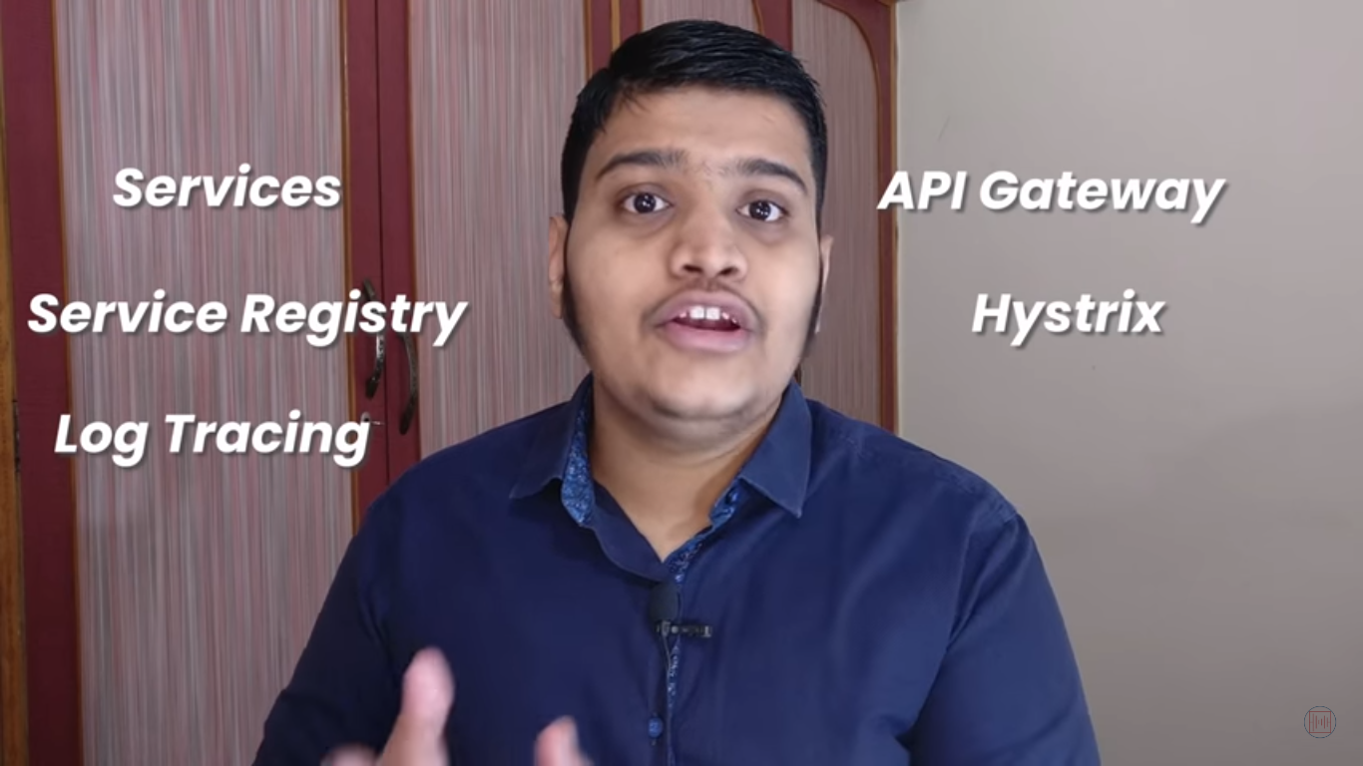

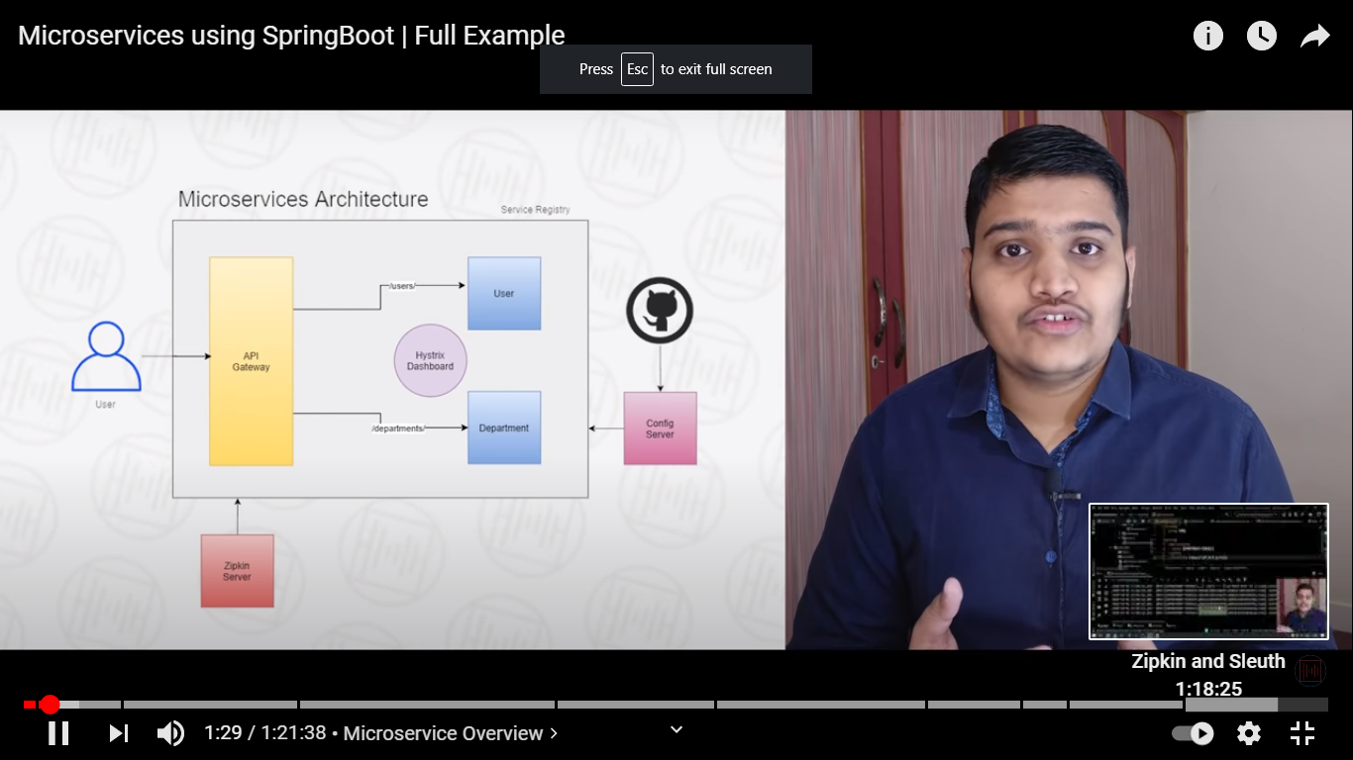

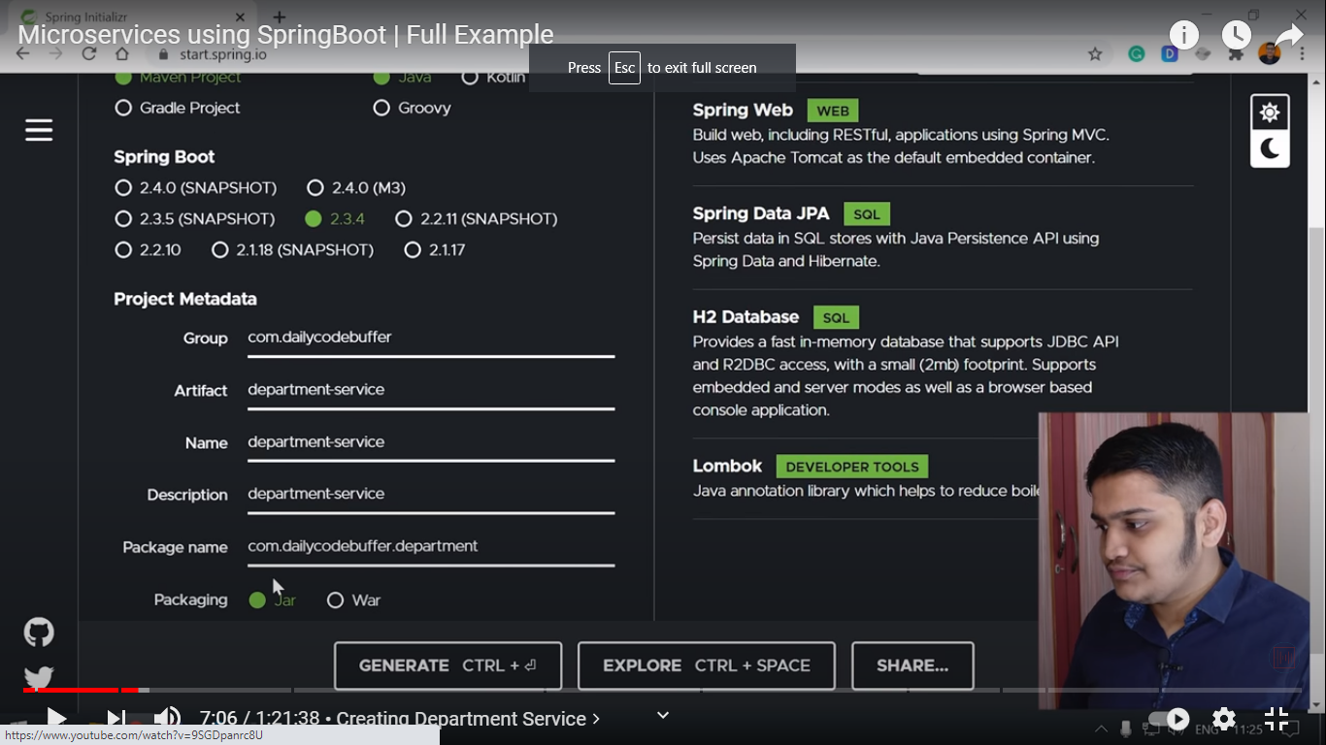

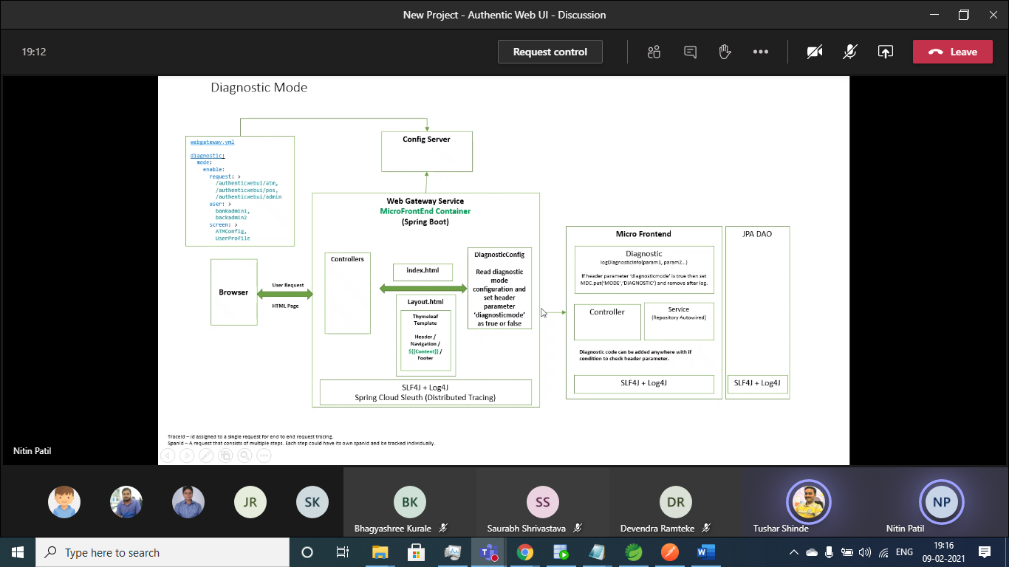

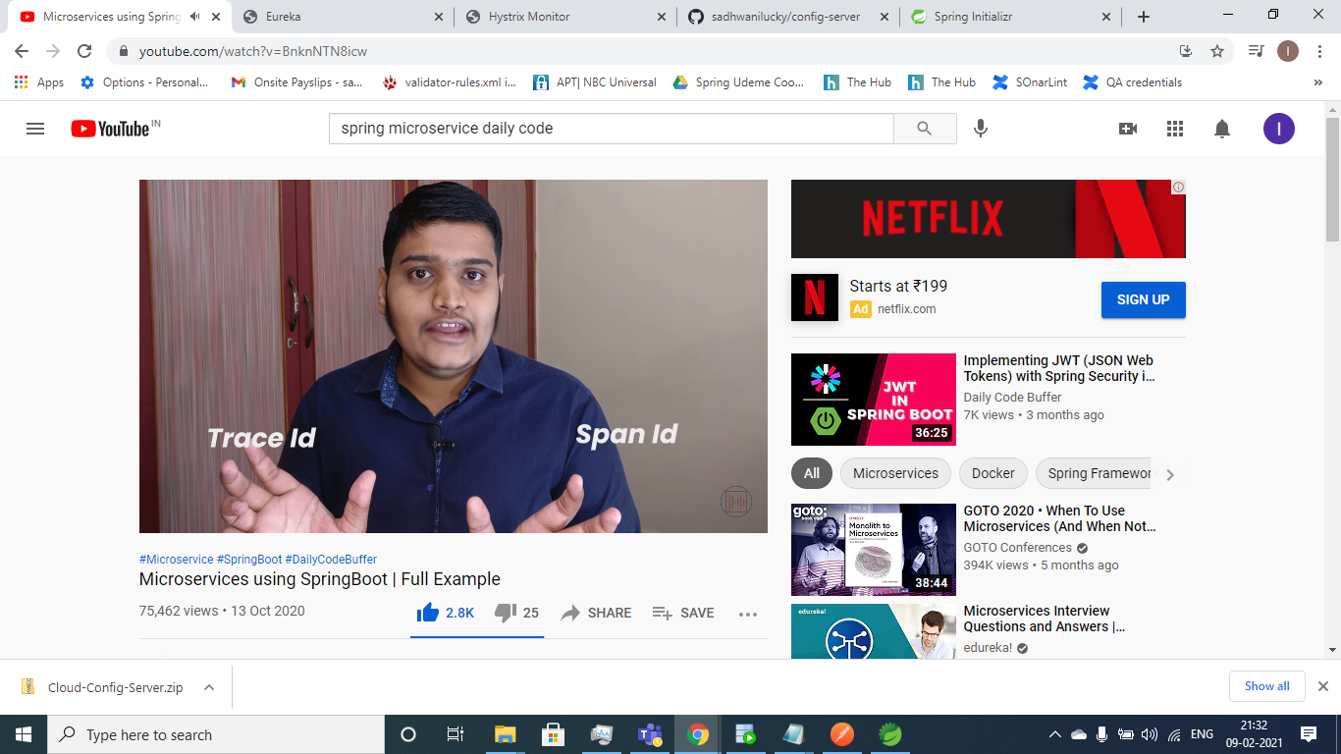

Zipkin (<https://zipkin.io/pages/quickstart.html>) and sleuth is used for distributed log tracing

Trace id will be same throughout the request and span id is changed for each microservice

Service Registry -> To maintain URL and port

Hystrix : for fall back method if any end point is down

spring spring security oauth2