Fine-tuning LLMs on Benchmark Datasets:
A Data Efficiency Study using Gemma 3 1B and Phi-4 Mini
Datasets: MMLU (Knowledge) | HumanEval (Coding) | GPU: Kaggle P100

1. Overview
This investigates how much training data is actually needed to improve a language model's performance on standard benchmarks. Instead of using massive datasets, we fine-tune two modern models with small amounts of data (50 to 1000 samples) to see how efficiently they can learn.
The core question we answer: Does fine-tuning with limited data help or hurt model accuracy?
Models Tested:
- Gemma 3 1B — Google's small 1 billion parameter model
- Phi-4 Mini — Microsoft's efficient 3.8 billion parameter model
Datasets Used:
- MMLU (Massive Multitask Language Understanding) — Tests general knowledge across 57 subjects like history, science, math, and law
- HumanEval — Tests coding ability with 164 Python programming problems
Why This Approach?
Full fine-tuning of large models requires hundreds of thousands of samples and expensive GPUs. We used QLoRA (Quantized Low-Rank Adaptation) — a technique that reduces memory usage by 75% while still updating the model. This allowed us to run all experiments on a single Kaggle P100 GPU (16GB) which is freely available to anyone.

2. Experimental Setup
Setting | Gemma 3 1B | Phi-4 Mini
Dataset | MMLU + HumanEval | MMLU
Sample Sizes | 50, 200, 500 | 200, 500, 1000
Fine-tuning Method | QLoRA (4-bit) | QLoRA (4-bit)
LoRA Rank | r=16 | r=8
Batch Size | 2 | 1
Epochs | 3 | 3
GPU | Kaggle P100 16GB | Kaggle P100 16GB

3. Results

3.1 Gemma 3 1B on MMLU
Experiment | Samples | Accuracy (%)
Baseline (no fine-tuning) | 0 | 30.40%
Fine-tuned | 50 | 29.00%
Fine-tuned | 200 | 29.20%
Fine-tuned | 500 | 28.20%

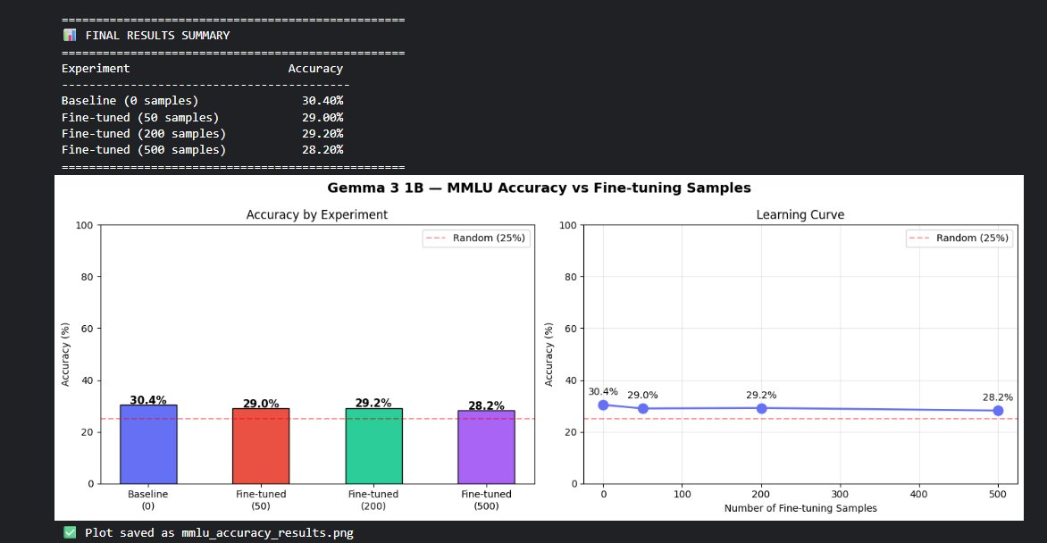
Figure 1: Gemma 3 1B — MMLU Accuracy vs Fine-tuning Samples

3.2 Gemma 3 1B on HumanEval (Coding)
Experiment | Samples | Accuracy (%)
Baseline (no fine-tuning) | 0 | 9.15%
Fine-tuned | 50 | 7.93%
Fine-tuned | 200 | 9.76%
Fine-tuned | 500 | 8.54%

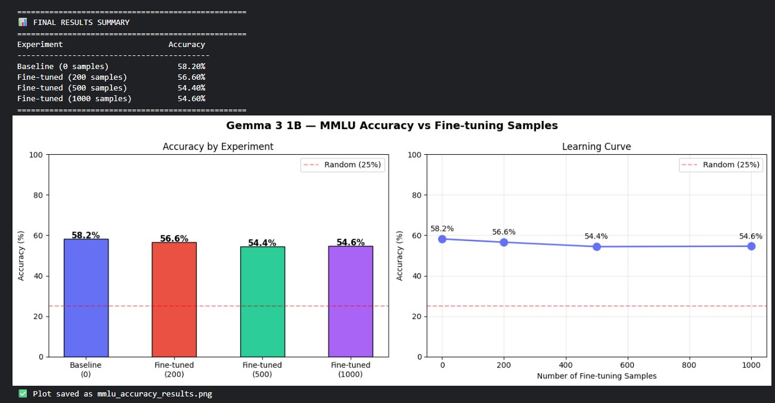
Figure 2: Gemma 3 1B — HumanEval Accuracy vs Fine-tuning Samples

3.3 Phi-4 Mini on MMLU
Experiment | Samples | Accuracy (%)
Baseline (no fine-tuning) | 0 | 58.20%
Fine-tuned | 200 | 56.60%
Fine-tuned | 500 | 54.40%
Fine-tuned | 1000 | 54.60%

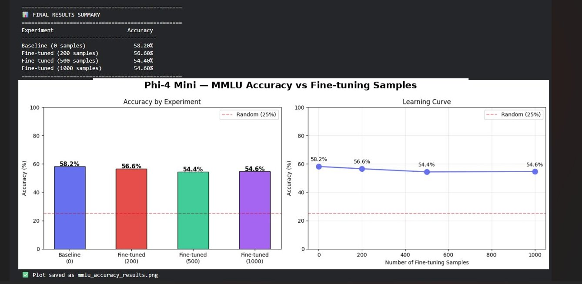
Figure 3: Phi-4 Mini — MMLU Accuracy vs Fine-tuning Samples

4. Analysis & Key Findings
Finding 1: Fine-tuning with small data hurts both models
Across all three experiments, accuracy dropped slightly after fine-tuning compared to the baseline. This is a known phenomenon called catastrophic forgetting — when a model is trained on a narrow subset of data, it partially overwrites the broad general knowledge it learned during pre-training.
Finding 2: Stronger models start higher but fall further
Phi-4 Mini started at 58.2% on MMLU (well above random chance of 25%), while Gemma 3 1B only reached 30.4%. However, Phi-4 Mini also showed a steeper relative drop after fine-tuning, suggesting larger pre-trained models have more general knowledge to lose.
Finding 3: More data does not always help
For Gemma 3 1B on HumanEval, fine-tuning with 200 samples (9.76%) slightly recovered from the 50-sample dip (7.93%), but never surpassed the baseline (9.15%). On coding tasks, the model needs domain-specific training data that closely matches the evaluation format.
Finding 4: QLoRA is effective for memory-constrained GPUs
All experiments ran successfully on a 16GB P100 GPU using 4-bit quantization. Training 500 samples took approximately 20-30 minutes, making this approach practical for anyone with free Kaggle GPU access.

5. Conclusion
This study demonstrates that fine-tuning pre-trained language models with small datasets (50-1000 samples) using QLoRA does not reliably improve benchmark accuracy — and in many cases slightly reduces it. The models already encode strong general knowledge from pre-training that is hard to improve without large, well-curated, task-specific datasets.
The practical takeaway is that for benchmark tasks like MMLU and HumanEval, the base model's pre-training quality matters far more than small-scale fine-tuning. Future work should explore larger fine-tuning datasets (10K+ samples), instruction tuning formats, and task-specific data curation to achieve meaningful accuracy improvements.

