**PART B**

**Time:** 1.00 hour **Marks:** 15

**Consider the following Schema Diagram for understanding the structure and relationship among entities of a library management system database and based on this diagram a database is created that will be shared with you. Now import the database and answer the following Queries.**

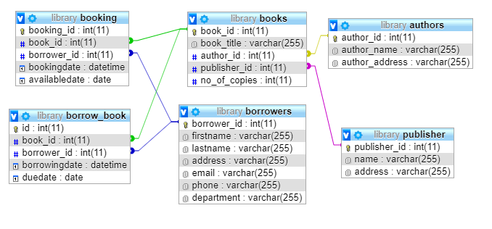

|  |  |
| --- | --- |
|  | [***Instruction*: Create a database named *lirbabry* on MySql Database and execute the following query.]** |
| **1.** | Write a query to find the title, author name, publisher name of all the books available in the library. |
| **A:** | SELECT books.book_title, authors.author_name, publisher.name  FROM books  INNER JOIN authors ON  books.author_id=authors.author_id  INNER JOIN publisher ON  books.publisher_id=publisher.publisher_id; |
| **2.** | SQL query to list the details of borrowers who do not borrow any books yet. |
| **A:** | SELECT * FROM borrowers  WHERE borrower_id NOT IN (SELECT borrower_id FROM borrow_book);  WHERE borrower_id NOT IN (SELECT borrower_id FROM borrow_book);  SELECT * FROM borrowers  WHERE borrower_id NOT IN (SELECT borrower_id FROM borrow_book);  SELECT * FROM borrowers  WHERE borrower_id NOT IN (SELECT borrower_id FROM borrow_book);  WHERE borrower_id NOT IN (SELECT borrower_id FROM borrow_book) ; |
| **3.** | Write a query to display the name of an author who have write a book having 'e' as the second character. |
| **A:** | SELECT authors.author_name FROM authors  INNER JOIN books ON authors.author_id=books.author_id  WHERE books.book_title LIKE '_e%'; |
| **4.** | SQL query to list the details of borrowers who have borrowed more than five books. |
| **A:** |  |
| **5.** | Show the details of the book which have been borrowed most. |
| **A:** |  |
| **6.** | Write a query to show the title and author of each book. |
| **A:** | SELECT books.book_title,authors.author_name FROM books  INNER JOIN authors ON books.author_id=authors.author_id; |
| **7.** | Create a view for the following problem:  Show the list of those borrower who have crossed the due date. |
| **A:** | CREATE VIEW borrowers_view AS  SELECT * FROM borrowers WHERE borrowers.borrower_id IN  (SELECT borrow_book.borrower_id FROM borrow_book  WHERE DATEDIFF(curdate(),borrow_book.duedate)>0); |
| **8.** | Write a query to get the borrower name (firstanme and lastname), book name and borrowing month. |
| **A:** |  |
| **9.** | First execute the following command:  CREATE TABLE writters(  writer_id INT NOT NULL AUTO_INCREMENT,  writer_name varchar(40),  writer_address varchar(40),  PRIMARY KEY(writer_id)  );  Now, Write a SQL statement insert rows to writters table from authirs table. |
| **A:** | INSERT INTO writters  SELECT * from authors; |
| **10.** | Write a query to update the portion of the phone in the borrowers table, within the phone number the substring '337’ will be replaced by ‘999’. |
| **A:** |  |

**Good Luck!!!**