***T***

***able Creation:***

**Table for book**

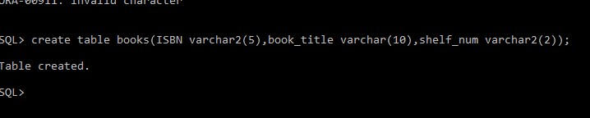

**Table of publisher of book**

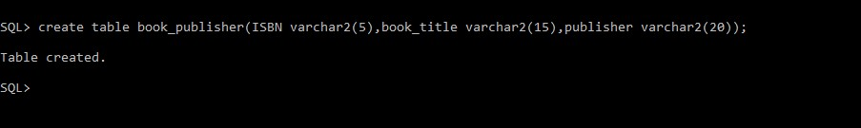

**Table for student who borrowed book**

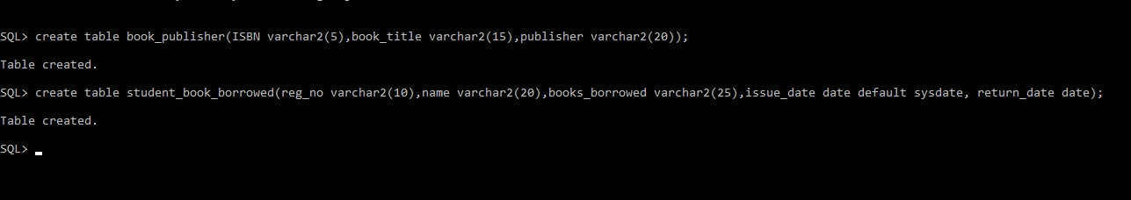

**Student info:**



# Table for book edition

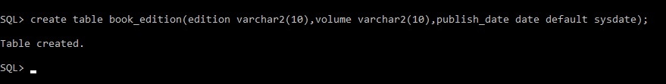

***Modifying tables:***

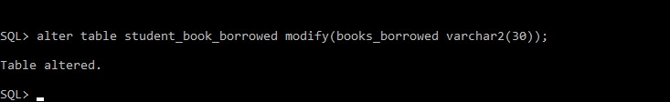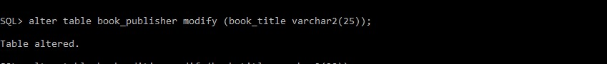

***AFTER INSERTING VALUES IN TABLES***

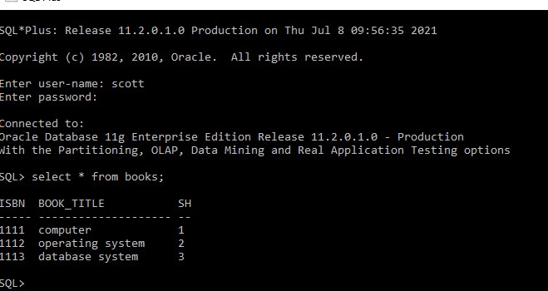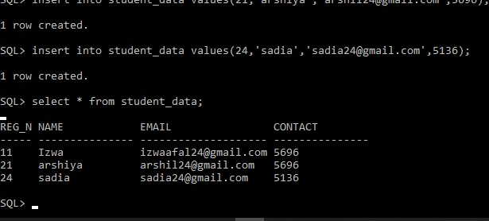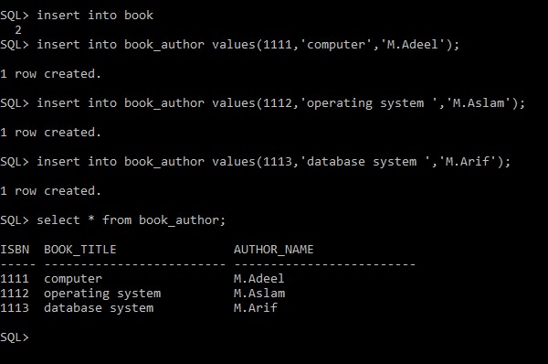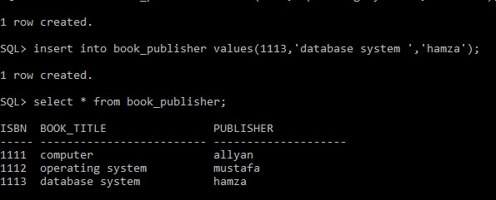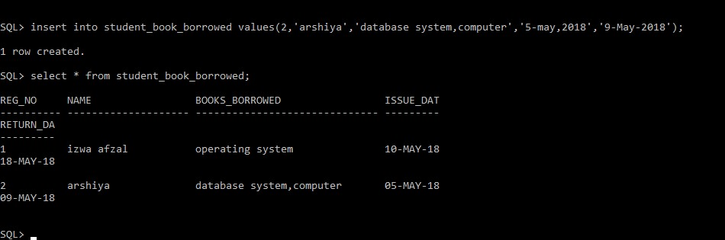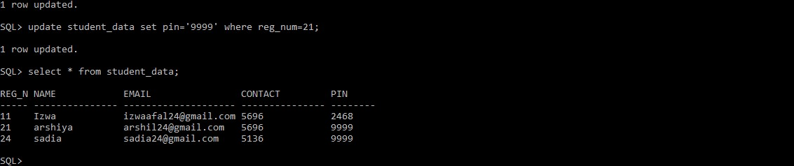

**VIEW TABLE**

**UPDATE TABLE**

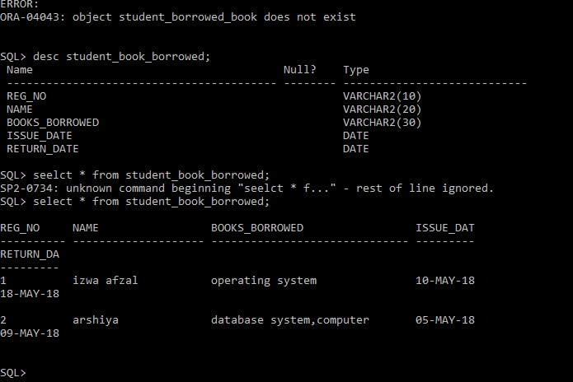

**DELETE**

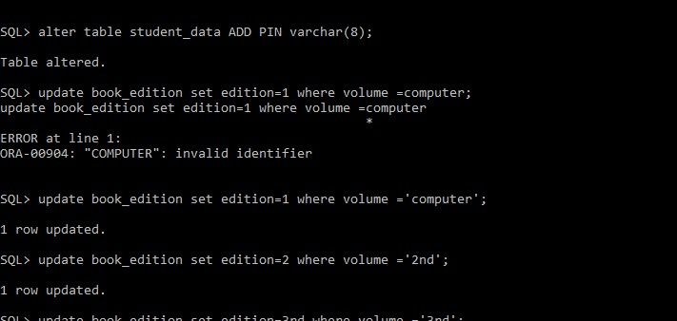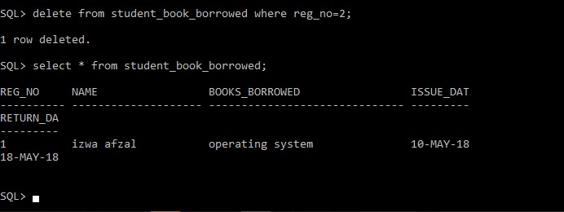

# DATA SHEET VIEW BOOKS

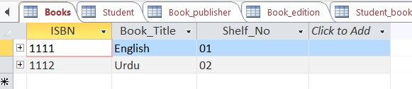

# STUDENT

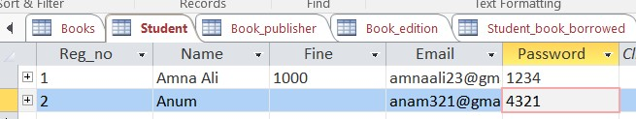

# BOOK AUTHOR

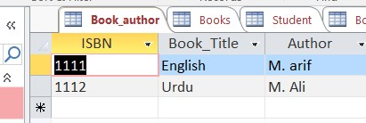

**BOOK EDITION**

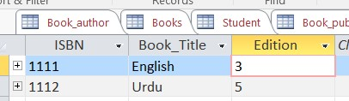

**BOOK PUBLISHER**

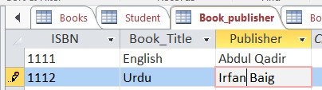

# STUDENT_BORROWED

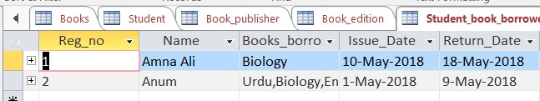

# DESIGN VIEW BOOKS

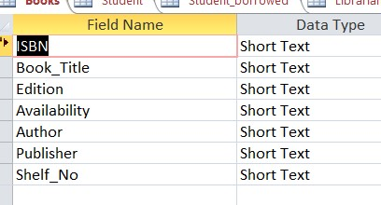

**STUDENT**

**BOOK AUTHOR**

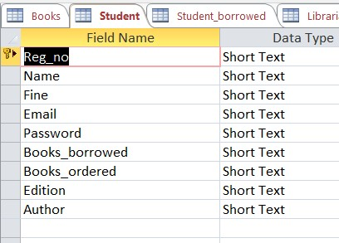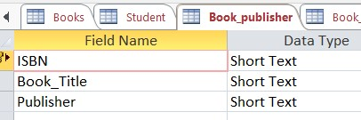

# BOOK EDITION

**BOOK PUBLISHER**

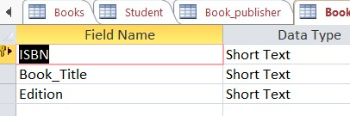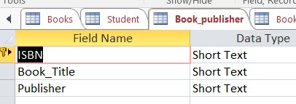

**BOOKS BORROWED**

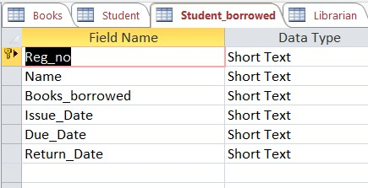

# RELATIONAL SCHEMA BOOKS



# STUDENT



# BOOK AUTHOR

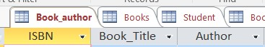

# BOOK EDITION

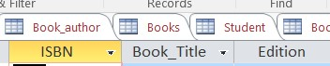

# BOOK PUBLISHER

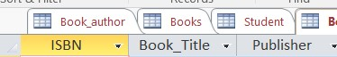

# BOOKS BORROWED



# RELATION BETWEEN STUDENTS AND STUDENT BORROWED

