**Introduction**

***Purpose:***

This document aims to describe the software of the Online Library Management system project with the help of several viewpoints. This document is to primary reference to the implementation phase. This document describes the system so that the system fills the needs described in the SRS document.

***Scope:***

In this document all components of the system and a detailed design of each model are explained. There will be some set of design views which will help the process of developing and understanding the project. This documentation is the guideline for the implementation. ***Identified stakeholders and design concerns:***

**Student:** wants to register into the system.

**Librarian:** issue, view and update book details.

**Administrator:** responsible for the management of the transaction of fine and also login and register details.

* **Context viewpoint:**

Online library management system context viewpoint shows the functions provided by design. There is the flow controlled by user. The online library management system has basically one primary actor and two secondary actors. The actors are dependent of each other. The functional use cases provide the description of the services and their interaction with the actors.

* **Design elements:**

*The features that are available to the Librarian are:*

* A librarian can update a book record
* Add books and their information of the books to the database
* Can take the book returned from students
* Edit the information of the existing books.
* Can access all the accounts of the students.

*The features available to the Students are:*

* Can view The different categories of books available in the Library
* Can view the List of books available in each category
* Can own an account in the library
* Can view the books issued to him
* Can search for a particular book

*The features available to administrator are:*

* Can register the students in management system
* Maintain the record of the registered students and their returned books
* Keep the record of Transection of fine from students

# USE CASE DIAGRAM

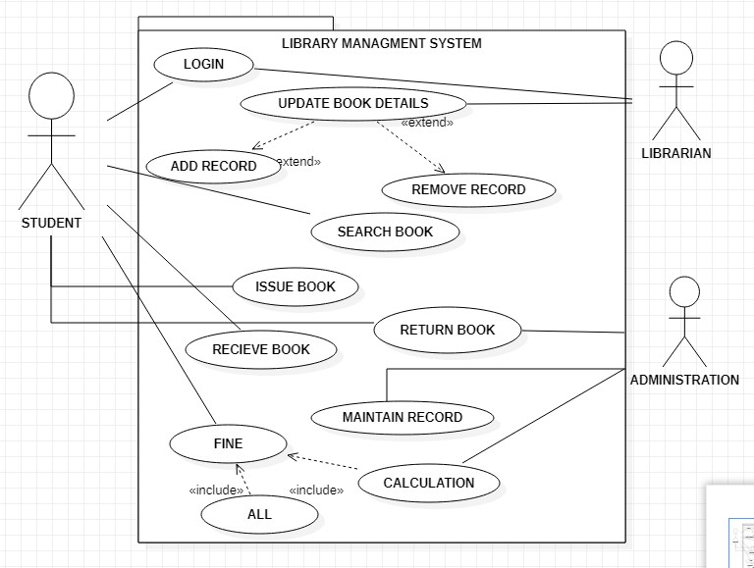

* **Logical viewpoint:**

In this part of the document, the classes that are going to be implemented in the Online Library

Management System will be explained. All classes will be explained clearly below, with tables

and diagrams. After the explanation of all the classes, relationships between them will be explained.

* **Design concerns:**

The design concern of online library management system is to describe the classes and their abstractions for the implementation. It also describes functions and attributes of classes.

* **Design elements:**

**Design entities:** students, librarian, administration, books, transection are the classes of online

LMS.

**Design relationships:** the design entities have dependencies with each other.

**i.** Students and librarian login is handled by administration. **ii.** Students issuing book with the permit of librarian.

**iii.** Students’ record is hold by administration.

# CLASS DIAGRAM

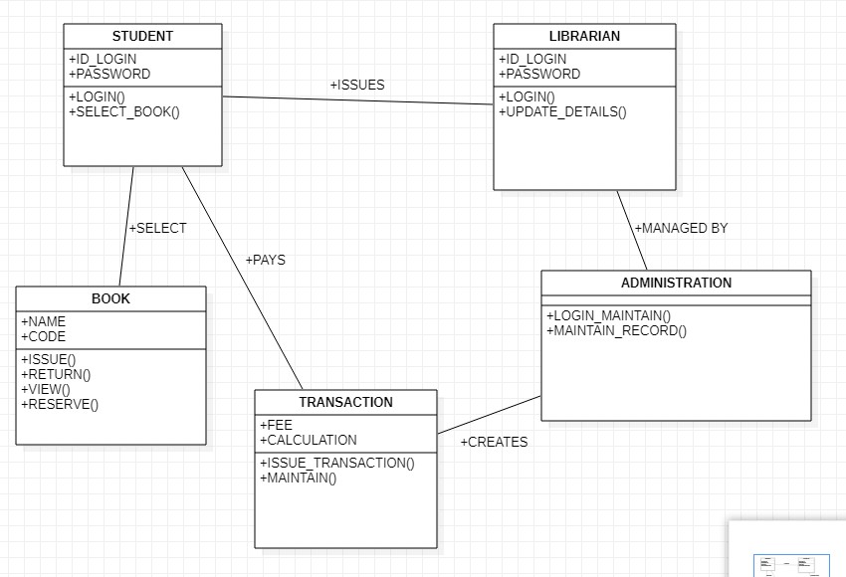

**CONNECTIONS:**

In this section of document, the subsystem of the system and interconnections between those subsystems will be defined in detail.

In this project, our system will have following subsystems:

* Library Database
* Library Server
* Networker side

**i. Library Database System:**

This subsystem shall responsible for storing the whole data in it and permitting library server to access them. **ii. Library Server:**

This subsystem mainly deals with gathering students’ requests for issuing, viewing, reserving or returning books and then this subsystem modify data models and access to database. **iii. Networker Side:**

This subsystem basically creates interface between user (student) and library server so that interaction between server and user can be done.

**Design attributes:**

A. Students:

Login id

Password B. Librarian:

Login id

Password

Authority to issue book C. Administration:

Handle login session

Record returned book data

Maintain records *iv.* Fine calculations D. Transaction:

*i.* Fine fee *ii.* Fine calculation

E. Book:

Issue

Return

View

reserve



**Structure Viewpoint**

The Structure viewpoint is used to document the internal constituents and organization of the design subject in terms of like elements (recursively). Structure of online library system shows that there is a login page for user to sign in. for the users who do not have account will have the sign-up option to register themselves. Admin will maintain the record which is handled by connecting to the network and library database system.

* + - * **Design Concerns**

This design concern includes the coarse-grained activities and reuse of fine-grained components.

Coarse grained components include options such as user will have the login option, sign up option in case of no id. Once user is logged in students will first have to register themselves to the system so that they may search, order or return any book.Moreover, librarian will update the record and will send information to the admin who manages library database system.

* + - * **Design elements**

**Design entities:** students, librarian, books, fine and administration are design entities of online library management system.

**Design relationships:** the design entities have dependencies with each other.

**i.** Students and librarian login is handled by administration. **ii.** Students issuing book with the permit of librarian. **iii.** Students’ record is hold by administration.

**Design attributes:**

A. Students:

Login id

Password B. Librarian:

Login id

Password

Authority to issue book C. Administration:

Handle login session

Record returned book data

Maintain records

Fine calculations

**Design constraints:**

This attribute is used to describe the dependency of each constraint.

* + - * 1. The Library server is fully depending on Library database system.
        2. The network side is responsible for interaction between user and servers.

➢ **Example Languages**



***CLASS DIAGRAM* Interaction:**

This part of the document will explain the interaction between the different modules of the library management system.

Following are the basic modules of the system:

* + - Student
    - Computer/librarian
    - Library database (books database).
    - **Student:**

Request to get the book.

* + - **Computer/librarian:**

Precede the request.

* + - **Database:**

Database for maintaining books and journals.

**10.3 Design attributes:**

A. Student

Login id

Password

B. Computer librarian

Login id

Password

Authority to issue book

C. Library database ***i.*** Books

***ii.*** Journals

1. **4 Example language:**

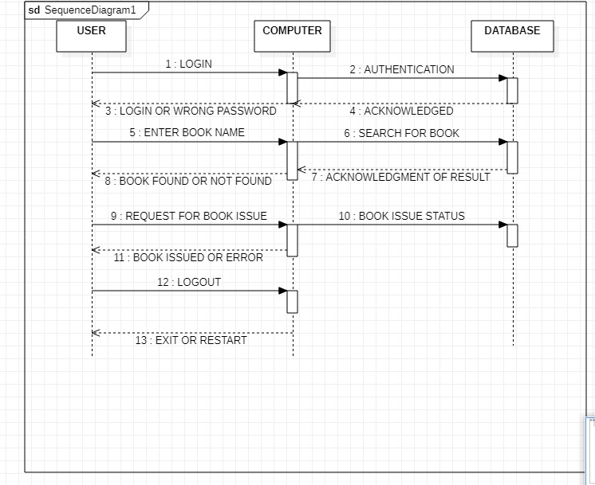

***SEQUENCE DIAGRAM***

**10. Resources:**

Resources provided for the system will be explain and design in this part. Different resources are needed and gather to make a library management system.

* 1. **Design concerns:**

Resources viewpoint will provide an overview of all the resources used in the system. Resources that this system need as well as the resources that this system will provide.

* 1. **Design elements:**

All the resources which helps to make this system e.g. ***students, librarian, administration, books, transaction*** are the resources of online LMS.

**10.3 Design attributes:**

A. Students:

* + 1. Login id
    2. Password B. Librarian:
    3. Login id
    4. Password
    5. Authority to issue book C. Administration:
    6. Handle login session
    7. Record returned book data
    8. Maintain records iv. Fine calculations D. Book:
       1. Issue
       2. Return
       3. View *iv.* reserve

E. Transaction:

*i.* Fine fee *ii.* Fine calculation



***THE END***