**Time Series Analysis using LSTM on Airline Passengers Dataset**

**Abstract:**

This investigates the application of an LSTM network for time series prediction using the Airline Passengers Dataset. Despite achieving a satisfactory fit on the training data, the model shows a significant prediction error on the test data, highlighting a potential overfitting issue and the need for further optimization strategies.

**Data Preprocessing:**

The raw dataset comprises monthly totals of international airline passengers from 1949 to 1960. It was transformed to a stationary time series by removing the increasing trend. Subsequently, it was normalized to a scale of 0-1 for improving the learning efficiency of the LSTM model.

**Model Training and Evaluation:**

The dataset was split into training (67%) and test (33%) sets. The LSTM model was designed with an input layer, one LSTM layer with 4 units, and a dense output layer. The model was trained for 100 epochs using the Adam optimizer and Mean Squared Error (MSE) as the loss function.

After training, the model achieved a Root Mean Squared Error (RMSE) of 22.69 on the training set. This indicates the model's average error in predicting the number of airline passengers during the training phase. For the test set, the model yielded an RMSE score of 50.39, providing an estimate of its predictive performance on unseen data.

**Results:**

The resulting forecasts from the model are visualized in the plot given below. The blue line represents the original dataset, while the orange and green lines denote the model's predictions on the training and test sets respectively.

The model appears to fit the training data reasonably well, capturing the general trend of the data. However, it exhibits larger deviations in the test set, which is reflected in the higher RMSE score. This may suggest a potential overfitting issue where the model has learned the training data too closely and is not generalizing well to new, unseen data.

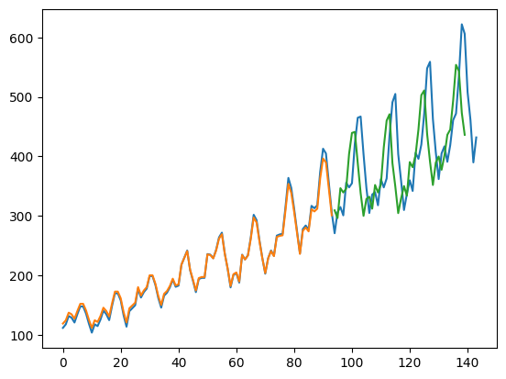

**Conclusion**

The LSTM model has demonstrated its ability to capture and model the temporal dependencies in the airline passengers dataset. However, the discrepancy in performance between the training and test sets indicates room for improvement. Future work could involve tuning the model architecture, employing regularization methods to mitigate overfitting, or exploring other methods of making the time series data stationary.