NED University of Engineering and Technology, Karachi
Computer Science and Information Technology
COMPLEX COMPUTING PROBLEM (CCP)
PROJECT SUBMISSION

Knowledge-Based Systems (CT-359)
Project Title | WellSense: A Hybrid Knowledge-Based System for Fault Diagnosis and Maintenance Decision Support in Offshore Oil Wells
Submission Date | 1 November 2026
Section | B (AI)
Submitted to | Miss Mehar Fatima
Student Details
Sr. No. | Student Name | Roll No. | Signature
1 | Sadia Khan | CT-24161
2 | Zehra Kazmi | CT-24168
3 | Haseeb Yaqoob | CT-24172
4 | Roman Aziz | CT-24192

1. Problem Statement
- Explain how a Knowledge-Based System can represent industrial equipment knowledge, including equipment, components, symptoms, faults, causes, and maintenance actions, using an appropriate knowledge representation formalism. (CLO 1)
- Analyze the given industrial equipment fault-diagnosis problem by identifying incomplete requirements, stakeholder needs, relationships, constraints, and suitable knowledge-based approaches for developing an effective solution. (CLO 2)
- Evaluate suitable knowledge representation methods and inference algorithms for diagnosing equipment faults and recommending maintenance actions, and justify the selected approach based on accuracy, explainability, safety, cost, and system requirements. (CLO 3)

2. Problem Description / Project Context
Offshore oil wells operated by Petrobras, Brazil's largest oil company, produce oil through a long flow path: from the reservoir, through a permanent downhole gauge (PDG) and a downhole safety valve (DHSV), up the production tubing to a subsea Christmas tree on the seabed (with its pressure–temperature transducer, TPT), along a flowline and riser to the platform, and through a production choke (PCK) into the process plant. Many wells are also lifted by gas injected through a gas-lift choke, a service line and the well annulus. Each well is monitored by up to 27 sensors and valve signals, and nine kinds of undesirable events threaten it — from a spurious closure of the safety valve and severe slugging to hydrate plugs that can block a line for weeks and need intervention vessels costing more than US$500,000 per day [3]. Each event shows up as a combination of symptoms (pressure rising in one place and falling in another, cooling, oscillations), and the same symptom can have several causes. The knowledge needed to interpret them is heterogeneous: real sensor time series in Petrobras's public 3W dataset [1], [2], [4]; expert descriptions in the dataset author's doctoral thesis [3]; engineering handbooks and standards on safe remediation [5]–[8]; basic flow physics; and the knowledge of control-room operators, who can check things no sensor measures.
The data are incomplete and conflicting: 65.9 % of the variables are missing across the dataset, sensors freeze or send error codes, the downhole gauge in particular often fails [2], [3], and some sensors are not installed on a given well at all. The people involved also want different things: the HSE officer requires that no unsafe action is ever proposed, the production manager wants the least lost production, the finance manager the lowest intervention cost, and operators need few false alarms and clear reasons. This project builds WellSense, a hybrid knowledge-based system that cleans the real Petrobras data (ETL), represents the domain in an ontology and 153 production rules with certainty factors, diagnoses the event from the sensors with forward chaining, asks the operator targeted questions with backward chaining when the evidence is not enough, explains every conclusion, and recommends maintenance actions that respect hard safety constraints while balancing the conflicting stakeholder priorities.

3. Problem Analysis

3.1 Problem Understanding
The problem has four parts: (1) turn noisy, incomplete multi-sensor time series into trustworthy evidence; (2) infer which of nine events is developing, and where in the flow path; (3) explain the reasoning so an operator can trust and check it; and (4) recommend what to do, safely. Table 1 lists the events in the scope, as defined by Petrobras [2], [3].
Table 1. Undesirable events in scope (Petrobras 3W v2.0.0) and their consequences [2], [3].
Event | Category | What happens | Severity (1–5)*
1. Abrupt increase of BSW | Reservoir / fluid | Sudden rise in the fraction of water and sediment in the produced liquid. | 3
2. Spurious closure of DHSV | Equipment (safety valve) | The downhole safety valve closes by itself, usually without any surface indication; production stops. | 4
3. Severe slugging | Flow assurance | Periodic, intense flow instability detectable along the whole production circuit; can stress or damage equipment. | 4
4. Flow instability | Flow assurance | Non-periodic, tolerable flow disturbances that can evolve into severe slugging. | 2
5. Rapid productivity loss | Reservoir / fluid | System energy no longer overcomes losses; flow declines and natural flow can be lost. | 3
6. Quick restriction in PCK | Equipment (choke) | Fast, unwanted restriction of the production choke caused by operational problems. | 2
7. Scaling in PCK | Flow assurance | Inorganic deposits build up in the production choke and gradually restrict flow. | 3
8. Hydrate in production line | Flow assurance | Ice-like water–gas crystals form at high pressure and low temperature and can block the production line. | 5
9. Hydrate in service line | Flow assurance | Hydrate blockage in the service (gas-lift) line. | 4

Severity is our relative rating used to prioritise alarms (assumption A6)
The data used is the approved Petrobras 3W dataset v2.0.0 (real instances only). From Petrobras's 32.9 million one-second readings of 1,119 real event instances on 40 wells, Notebook 0 builds a reproducible working set of 65,846 one-minute readings (125 instances, all 10 classes) for knowledge acquisition and development, and keeps all 1,119 instances (549,063 minutes) for evaluation (Section 7).

3.2 Stakeholders and Their Requirements
Seven stakeholder groups were identified. Each has a different requirement, and WellSense addresses each one explicitly (Table 2).
Table 2. Stakeholders, their requirements and how WellSense meets them.
Stakeholder | Requirement | How WellSense addresses it
Control-room operator | Early, clear alarms; few false alarms; simple next steps | Alarms only after CF ≥ 0.6 persists 5 min; plain-English explanations; ranked actions
Production engineer | Correct diagnosis; keep the well producing | Flow-path reasoning locates the fault; Production-first profile
Well-integrity / maintenance team | Protect safety barriers (DHSV); safe interventions; know which sensors are faulty | DHSV equalization constraint; sensor alerts for frozen/failed gauges
HSE officer | Never recommend an unsafe action | Hard safety constraints block unsafe actions under every profile
Production manager | Minimise lost production and downtime | Production-loss criterion and Production-first profile
Asset / finance manager | Minimise intervention cost (vessels > US$500k/day) | Cost criterion and Cost-first profile
Reservoir engineer | Understand water breakthrough and productivity changes | BSW and productivity-loss diagnoses with questions about samples and well tests

3.3 Constraints and Conflicting Requirements

Constraints
- Data quality: variables missing for whole wells; sensor gaps; frozen sensors (29,974 readings in the development data); Petrobras error codes and physically impossible values (62,984 readings removed); spikes.
- Sensor availability differs by well: e.g. some wells have no PDG, no choke pressure or no gas-lift measurements, so every rule must still work with partial information.
- Label limitations: 43 hydrate in service line instances contain no abnormal label at all; four event types have fewer than 15 real instances.
- Time scales: events develop from minutes (DHSV closure, 5–20 min) to days (scaling, 72 h) [3]; the system must reason over different time windows.
- Safety: physical safety rules (hydrate-plug projectile risk, safety-valve equalization) must never be violated [5], [8].
- Real-time and cost: must run minute-by-minute on ordinary hardware (Google Colab) with free tools.

Conflicting requirements
Table 3. Conflicting requirements and how they are resolved.
Conflict | Why it is a conflict | Resolution in WellSense
Safety vs. production | The fastest way to restore flow can be the most dangerous (e.g. one-sided hydrate depressurization) | Safety constraints are hard filters; only safe actions are ranked
Production vs. cost | Coiled tubing clears a plug sooner but needs a vessel | Stakeholder profiles (weighted multi-criteria scores) make the trade-off explicit
Sensitivity vs. false alarms | Alarming early on weak evidence floods operators | CF threshold + 5-minute persistence; uncertain cases trigger questions instead of alarms
Accuracy vs. explainability | Black-box ML can fit data but cannot justify a safety decision | Rule-based reasoning with full explanations; ML used only as a comparison (Section 7)
Automation vs. human authority | Operators are accountable for actions | WellSense is advisory: it asks, explains and recommends; people decide
Live sensor vs. frozen sensor | Two sensors give contradictory evidence | Data-quality weighting (trust 0.2 for frozen) and sensor-validation rules

3.4 Root Cause / Requirement Identification

Incomplete or unclear requirements in the brief, and our resolution
Missing / unclear in the brief | Resolution (justified)
Which equipment and faults? | Offshore oil wells and the nine undesirable events labelled by Petrobras experts [2]
Which data? | Real Petrobras 3W data (approved by the course teacher); ETL pipeline built for it
What counts as a symptom? | Thresholds learned from normal-operation instances (not guessed), with physical minimum floors
What is "incomplete" and "conflicting" information? | Missing/not-installed/invalid sensors and frozen sensors contradicting live ones; handled by trust-weighted CFs, an UNDETERMINED verdict and operator questions
Required accuracy / how to evaluate? | Defined metrics: accuracy, balanced accuracy, detection rate, false-alarm rate, detection delay, on 994 held-out instances
Who has final authority? | The operator; WellSense is a decision-support system
Costs and production losses? | Not available in the data; relative 1–5 scores justified by sources (assumption A6)

Root causes of each event
Event | Root cause (knowledge source)
Abrupt increase of BSW | Water breakthrough (aquifer or injected water reaches the well) [VARGAS2019]
Spurious closure of DHSV | DHSV or its hydraulic actuator fails and closes the valve with no surface command [VARGAS2019]
Severe slugging | Liquid accumulates at the riser base, then is pushed out by gas in cycles [SCHMIDT1985]
Flow instability | Gas–liquid flow disturbances without a regular cycle [VARGAS2019]
Rapid productivity loss | Reservoir properties change (pressure, BSW, GOR, viscosity) so energy no longer overcomes losses [VARGAS2019]
Quick restriction in PCK | Operational problem closes the production choke unintentionally [VARGAS2019]
Scaling in PCK | Inorganic deposits (scale) form in the choke [VARGAS2019]
Hydrate in production line | Water and gas at high pressure and low temperature form hydrate crystals in the production line [VARGAS2019]
Hydrate in service line | Water and gas at high pressure and low temperature form hydrate crystals in the service line [VARGAS2025]

Derived requirements
- FR1 Clean and quality-tag the raw sensor data; never invent long missing stretches.
- FR2 Represent equipment, sensors, symptoms, faults, causes and actions explicitly (ontology).
- FR3 Diagnose the nine events with certainty factors, minute by minute.
- FR4 Handle incomplete and conflicting evidence; abstain when evidence is insufficient.
- FR5 Ask the operator for evidence sensors cannot give (backward chaining).
- FR6 Explain HOW, WHY, WHY-NOT and WHAT-IF.
- FR7 Recommend maintenance actions under stakeholder profiles; never recommend an unsafe action.
- NFR Executable in Google Colab; every rule cites its source; evaluated on unseen data.

3.5 Assumptions
All assumptions are stated here and repeated where they are used:
- A1 One reading per minute is sufficient: Petrobras experts confirm events over 5-minute to 72-hour windows [3]; the first reading of each minute is kept (no averaging), which preserves the fault shape (Notebook 0, Fig. 00).
- A2 The first hour of each instance represents that well's normal behaviour (baseline). Thresholds are learned only from normal-operation instances of the development set.
- A3 Petrobras's observation labels are the ground truth; instances with no abnormal label are reported separately.
- A4 A reading that stays exactly identical for ≥ 60 minutes is frozen. (A very steady real signal could be mis-flagged; frozen readings are therefore down-weighted, not deleted.)
- A5 Physical validity ranges (e.g. absolute pressure > 0; downhole pressure > 10 bar; downhole temperature > 20 °C) identify invalid readings.
- A6 Action safety risk, production loss, cost and effectiveness are relative 1–5 engineering judgements justified by the cited sources; exact costs are not available.
- A7 WellSense is advisory; the operator remains responsible for actions.
- A8 For evaluating backward chaining, a simulated operator answers questions correctly (an upper bound on its benefit).
- A9 The well's operating state (shut-in, restart, depressurization) is known to the control room in real time.
- A10 One dominant event per instance.
- A11 The DHSV status signal is not used for diagnosis because the data show it does not reflect spurious closures (Section 7.3).

4. Knowledge Representation and KBS Design

4.1 Selected Knowledge Representation Formalism
Seven candidate approaches were evaluated against the brief's criteria — accuracy, explainability, safety, cost and fit to the requirements (CLO 3). Table 4 summarises the comparison.
Table 4. Comparison of knowledge representation and inference approaches (H = high, M = medium, L = low).
Approach | Accuracy potential | Explainability | Uncertainty & missing data | Safety assurance | Data / effort needed | Verdict
Production rules (crisp) | M | H | L | H | Low data, medium effort | Good, but no uncertainty
Frames / ontology | n/a (structure) | H | L | M | Low | Needed for structure
Semantic network | n/a (structure) | H | L | M | Low | Subsumed by ontology
Bayesian network | H | M | H | M | Needs probabilities for rare faults | Probabilities cannot be estimated for 4–14 cases
Case-based reasoning | M | M | M | L | Needs many solved cases | Too few cases
Fuzzy logic | M | M | M | M | Membership functions to tune | Partly covered by learned thresholds
ML classifier (e.g. Random Forest) | H on common classes | L | L (imputation) | L | Needs labelled data per fault | Used only as baseline
Hybrid: ontology + rules + MYCIN CF + temporal facts (selected) | M–H | H | H | H | Low data; literature-based | Selected

Selected formalism — a hybrid of four parts:
- Ontology (frame-like classes with relations) for the domain structure: equipment ordered along the flow path, sensors located on equipment, symptoms, faults, causes, actions, constraints and stakeholders [11]. The flow-path order is what lets the rules reason about where a blockage is.
- Production rules (IF–THEN) for heuristic expert knowledge and first-principles knowledge, organised in reasoning levels from sensor facts to diagnoses.
- MYCIN certainty factors [9] for uncertainty: every fact and rule carries a CF in [−1, 1]; negative CFs express evidence against a fault. Sensor facts enter with CF equal to the reading's trust, so data quality propagates through the whole reasoning chain.
- Temporal abstraction in the ETL: raw time series become symbolic facts (level, 15-min trend, oscillation, cycle, sudden jump, 3-hour drift), so rules can describe patterns over time.
Why: it is the only option that is simultaneously explainable (every conclusion traces to rules and sources), safe (hard constraints), robust to missing data (rules use whatever facts exist; CFs fall when evidence is weak), and buildable without large labelled data — essential because four event types have fewer than 15 real cases.

4.2 Knowledge Base / Ontology / Rule Base
The knowledge base is stored as plain JSON files (knowledge_base/), separate from the inference engine, and exported to OWL/Turtle for Protégé [17]. It contains an ontology, 153 rules, 11 operator questions, 31 maintenance actions, 5 safety constraints, 3 stakeholder profiles and 10 cited knowledge sources. Notebook 2 checks it automatically: every condition refers to a known fact, every source exists, every fault has a diagnosis rule, a safe action and a question, and the rules are stratified (no rule depends on a conclusion drawn at the same or a later level).
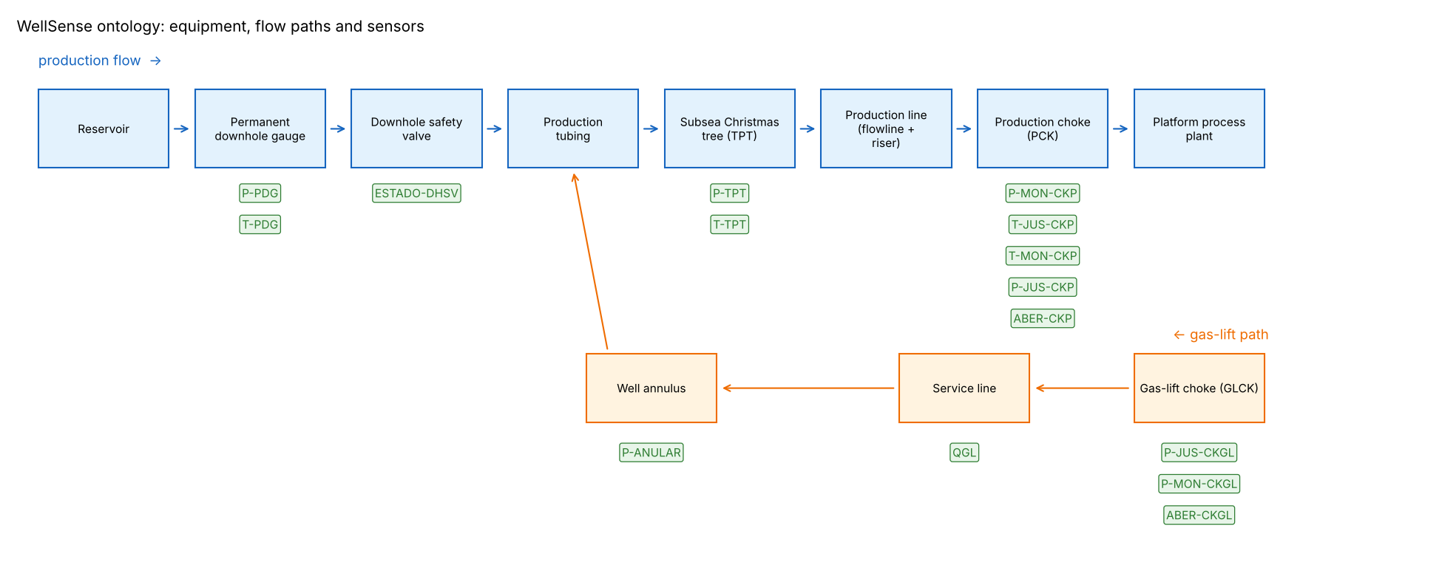
Figure 1. Ontology: equipment along the production and gas-lift paths, with the sensor at each point.

Knowledge acquisition
Knowledge came from three kinds of source: literature and experts (Petrobras thesis and dataset paper, PetroWiki, slugging literature, API RP 14B), first principles (a restriction raises pressure upstream and lowers it downstream; stopped flow cools toward sea temperature), and data — each literature description was checked against the 125 development instances (Figure 2). The data confirmed, for example, that during a spurious DHSV closure the PDG pressure is above normal in 76 % of minutes and the TPT pressure below normal in 96 %, against 1 % and 3 % in normal operation.
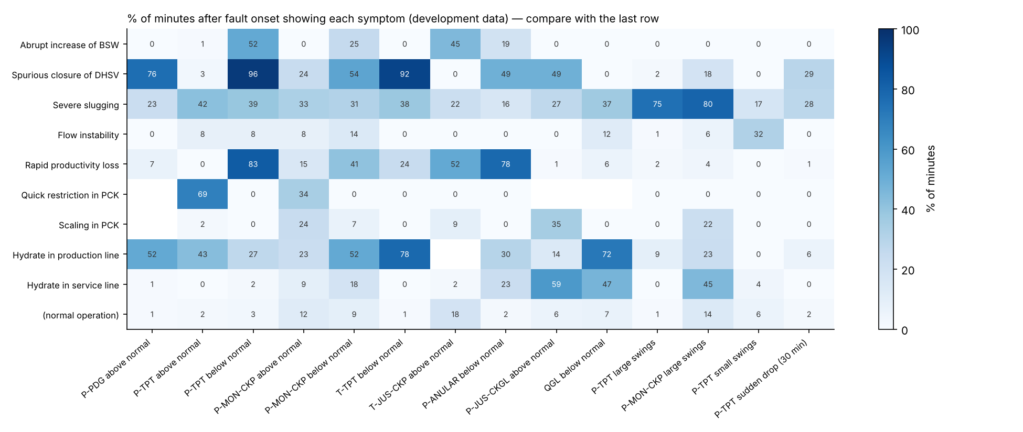
Figure 2. Knowledge acquired from data: % of minutes after fault onset showing each symptom, compared with normal operation (last row).

Rule base
Table 5. Rule base organised in reasoning levels (salience is used for conflict resolution, Section 4.4).
Level | Salience | Rules | Example
Sensor fact → symptom | 90 | 71 | IF p_tpt.level = LOW THEN TPT_P = DOWN (CF 0.9)
Context | 85 | 4 | IF well_state = Shut-In THEN OPERATION = SHUT_IN
Sensor validation | 80 | 3 | IF p_pdg.quality = FROZEN AND TPT_P changing THEN SENSOR_ALERT = PDG_FROZEN
Restriction location | 60 | 9 | IF PDG_P = UP AND TPT_P = DOWN AND NOT OSC_FLOW THEN RESTRICTION = DHSV_ZONE (0.9)
Diagnosis | 40 | 35 | IF RESTRICTION = DHSV_ZONE AND FLOW = STOPPING THEN FAULT = DHSV closure (0.85)
Operator answer | 35 | 21 | IF FAULT = DHSV closure AND Q_DHSV_COMMANDED = NO THEN DHSV closure (+0.5)
Meta (context) | 30 | 10 | IF OPERATION = SHUT_IN AND FAULT = DHSV closure THEN DHSV closure (−0.7)

Symptom-combination rules (salience 70) such as flow stopping (subsea temperature falling) and oscillating flow sit between the symptom and location levels. The central idea of the rule base is flow-path reasoning: the KBS first decides where along the flow path a restriction is (between the PDG and the TPT → DHSV zone; between the TPT and the choke → production line; at the choke; in the gas-lift line), and only then what it is, using speed (sudden vs. slow), temperatures and context. Figure 3 shows how intermediate conclusions connect to the nine faults.
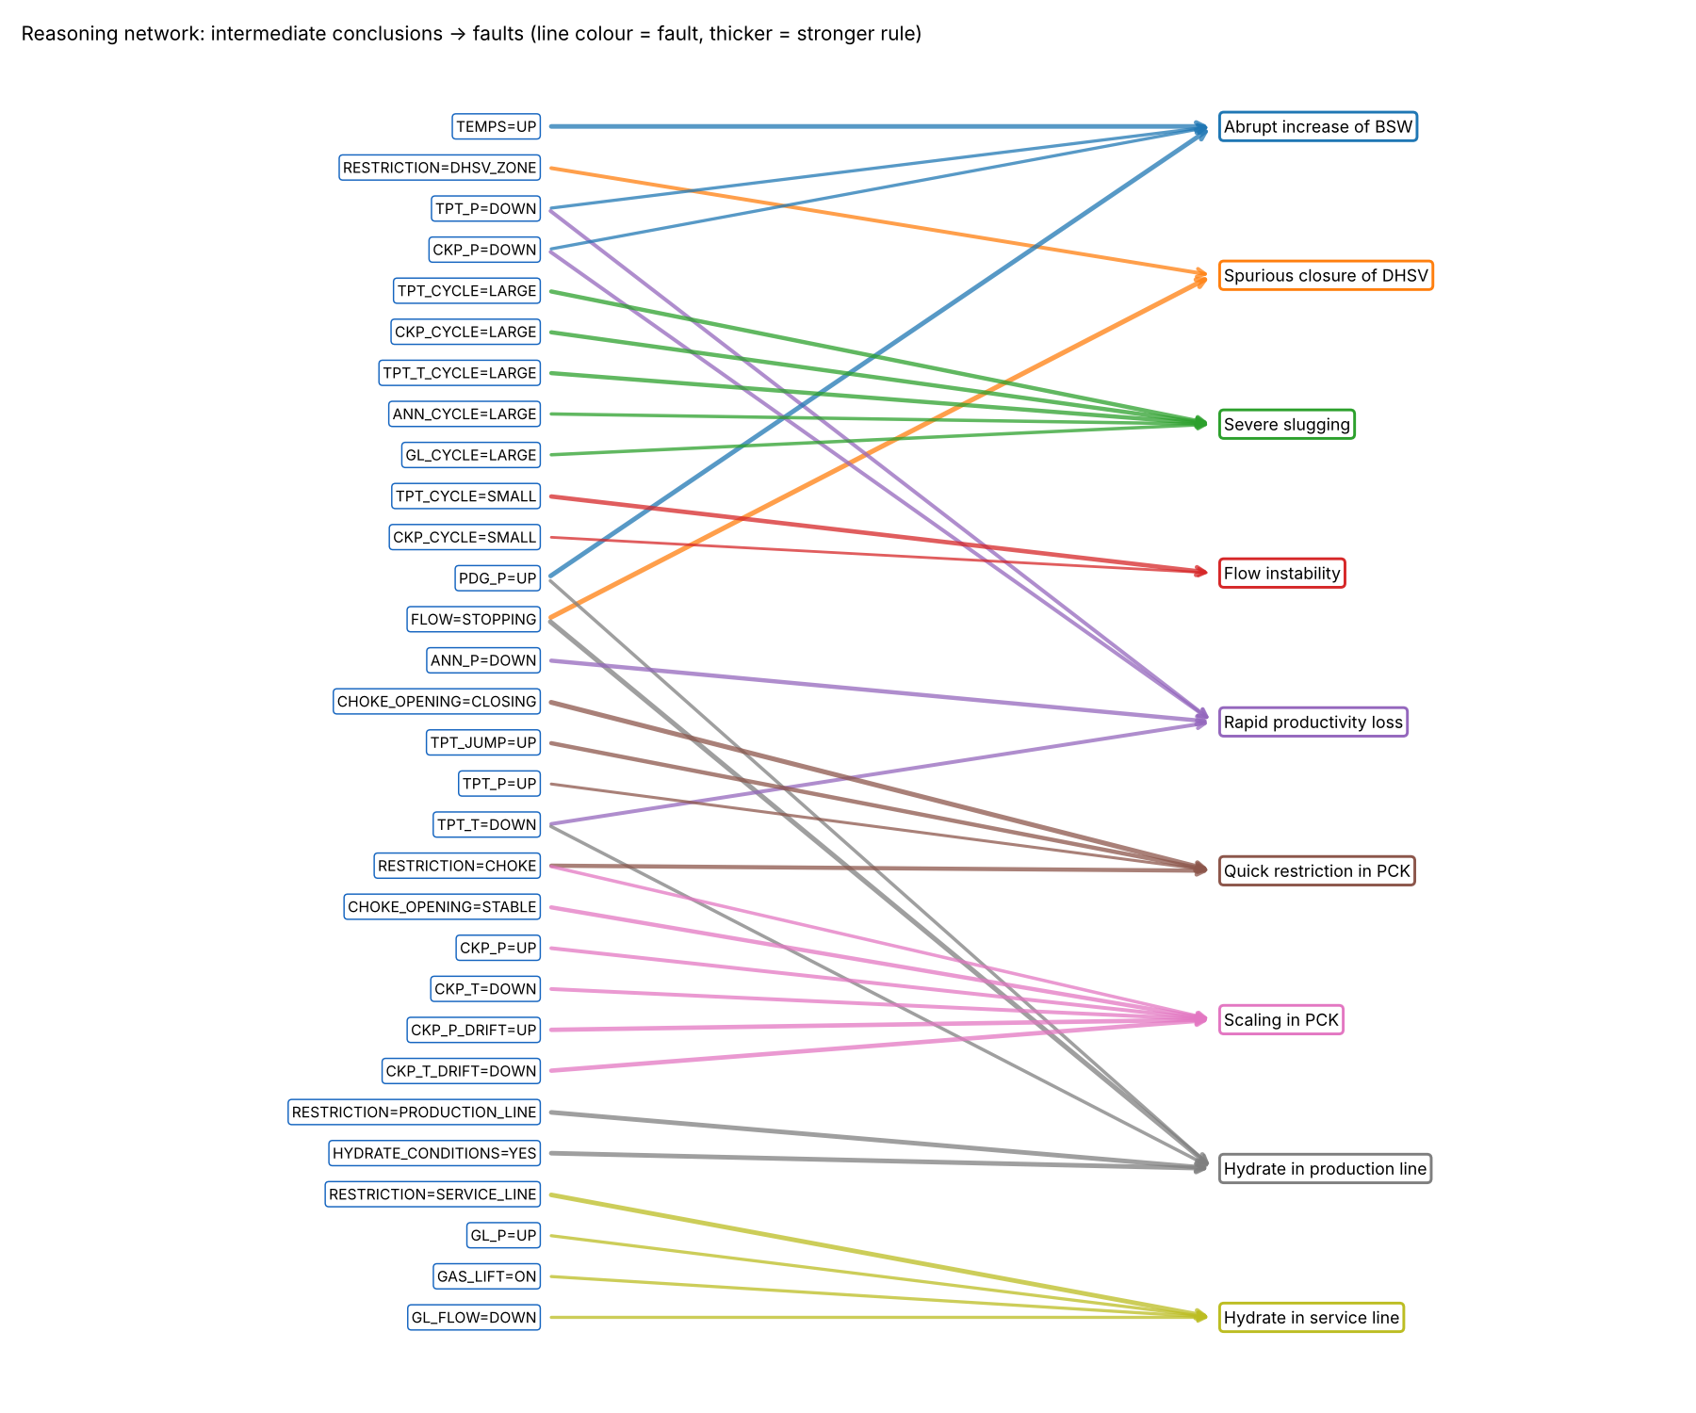
Figure 3. Reasoning network: intermediate conclusions (left) supporting each fault (right); thicker lines are stronger rules.

Questions, actions and safety constraints
11 questions cover evidence only a person can provide (e.g. "Was the DHSV closed on purpose in the last hour?", "Does the latest fluid sample show a higher water cut?"). Each of the 31 actions is scored on safety risk, production loss, cost and effectiveness, and five deliberately unsafe actions are kept so the system can show why they are blocked. The five safety constraints are:
- SC-HYD-ONESIDE — Never depressurize a hydrate plug from one side only — a pressure difference across a released plug turns it into a projectile that can rupture the line.
- SC-HYD-HEAT — Never heat the middle of a hydrate plug — released gas can be trapped and rupture the pipe.
- SC-DHSV-EQUALIZE — Never force a closed DHSV open against a pressure difference — equalize pressure across the valve first, then reopen through its control system.
- SC-SLUG-IGNORE — Do not keep producing through sustained severe slugging without mitigation — it stresses and can damage well and plant equipment.
- SC-SENSOR — Do not base a well-integrity decision on a sensor flagged as frozen or failed.

4.3 Inference Mechanism
The engine (wellsense/engine.py, about 300 lines, written for this project) is a production system with a working memory of (fact, value) → CF pairs.

Forward chaining (data-driven)
- Initialise working memory from the ETL facts of the current minute; each fact's CF = the reading's trust (1.0 good, 0.8 interpolated, 0.2 frozen); missing readings are simply absent.
- Match: a condition holds if its fact has CF ≥ 0.2; a NOT condition holds if the fact is not believed (negation as failure, made safe by stratification).
- Select one rule from the agenda by conflict resolution (Section 4.4).
- Act: conclusion CF = rule CF × min(premise CFs); combine with any existing CF using the MYCIN formula [9].
- Repeat until no rule can fire; each rule fires at most once (refractoriness).
MYCIN combination: CF = CF₁ + CF₂(1 − CF₁) if both are positive; CF₁ + CF₂(1 + CF₁) if both are negative; (CF₁ + CF₂) / (1 − min(|CF₁|, |CF₂|)) otherwise. For example, two rules supporting a DHSV closure with 0.58 and 0.36 combine to 0.73.

Backward chaining (goal-driven)
When the best hypothesis has 0.3 ≤ CF < 0.8, it becomes a goal. The engine searches the rules that conclude that goal for a condition that is a question not yet asked, asks it (showing WHY), adds the answer to working memory and forward-chains again, until the goal is confirmed (CF ≥ 0.8), rejected, or no useful question is left.

Monitoring and alarms
The engine is run on every minute of a well's history (≈1 ms per minute). Following alarm-management practice [15], an alarm is raised only when a fault's CF stays ≥ 0.6 for 5 consecutive minutes; the instance diagnosis is the fault with the longest alarm, Normal if there is none, and Undetermined when fewer than 2 of the 8 key sensors were trustworthy for most of the time.

4.4 Conflict Resolution Strategy
Conflicts are resolved at three levels:

1. Rule conflicts (which rule fires first)
- Salience — lower reasoning levels fire before higher ones (Table 5), so a diagnosis is never reached before the evidence it depends on is settled.
- Specificity — among rules of equal salience, the one with more conditions fires first.
- Strength — then the rule with larger |CF|.
- Refractoriness — each rule fires once per minute of data.

2. Evidence conflicts (contradictory information)
- Data-quality weighting: frozen readings get trust 0.2, so they can never outweigh live sensors.
- Sensor-validation rules detect the contradiction explicitly (e.g. PDG frozen while TPT changes), raise a sensor alert and explain which sensor is believed and why (TPT is rated reliable, PDGs often fail [3]).
- Positive vs. negative evidence for the same fault is combined by the MYCIN formula (e.g. rising temperatures argue against a DHSV closure, CF −0.4).
- Oscillation gate: while the flow oscillates, location rules are blocked, because momentary pressure differences then say nothing about where a restriction is.
- Operation context: during shut-ins, restarts or interventions, faults that the operation itself explains are discounted.

3. Stakeholder conflicts (which action to recommend)
Actions that violate a safety constraint are blocked under every profile. Actions whose preconditions do not hold in the current situation are marked not applicable (e.g. inhibitor dosing once a hydrate plug has stopped the flow [5]). The remaining actions are ranked by a weighted multi-criteria score under the chosen profile — Safety-first (safety weight 0.6), Production-first (production weight 0.6) or Cost-first (cost weight 0.6). For a hydrate plug, Safety-first and Cost-first choose slow two-sided depressurization, while Production-first accepts the cost of coiled tubing to restore flow sooner; one-sided depressurization and mid-plug heating stay blocked for all three.

4.5 Explanation Facility
Four kinds of explanation are generated from the working memory and the rules that fired (wellsense/explain.py):
Type | Question it answers | How it is produced
HOW | How was this concluded? | Recursive trace of the rules that supported the conclusion, with each rule's CF, premise CF, plain-English reason and the sensor readings (and their quality) at the bottom
WHY | Why are you asking me this? | Shown with every question: the suspected fault, its CF, and what each possible answer would do
WHY NOT | Why not another fault? | For each rule that could conclude the alternative, the conditions that failed
WHAT IF | What if a sensor were missing or different? | Re-runs the diagnosis with changed inputs and compares CFs

Example — HOW, for the real DHSV closure on WELL-00003 (Notebook 3, Case A), abbreviated:
Spurious closure of DHSV: CF +0.80
<- rule D-DHSV-1 (0.85 x premise 0.68 = +0.58): blockage at the DHSV with production stopping
RESTRICTION = DHSV_ZONE: CF +0.87
<- rule L-DHSV-1 (0.90 x 0.97): pressure rises below and falls above the DHSV
PDG_P = UP <- p_pdg.level = HIGH (trust 1.00), p_pdg.trend = RISING
TPT_P = DOWN <- p_tpt.level = LOW (trust 1.00), p_tpt.trend = FALLING
FLOW = STOPPING: CF +0.68 <- t_tpt falling: fluid cooling toward sea temperature

Example — WHY, when the PDG is frozen (Case B): "I suspect 'Spurious closure of DHSV' (CF 0.47) but cannot confirm it from the sensors. Answer NO raises it (nobody commanded the closure, so it was spurious); answer YES lowers it (the closure was commanded on purpose — expected, not a fault)."
Example — WHY NOT a hydrate in the production line (Case A): "D-HPL-1 did not fire: needs RESTRICTION = PRODUCTION_LINE; have DHSV_ZONE (0.87)".

4.6 System Architecture
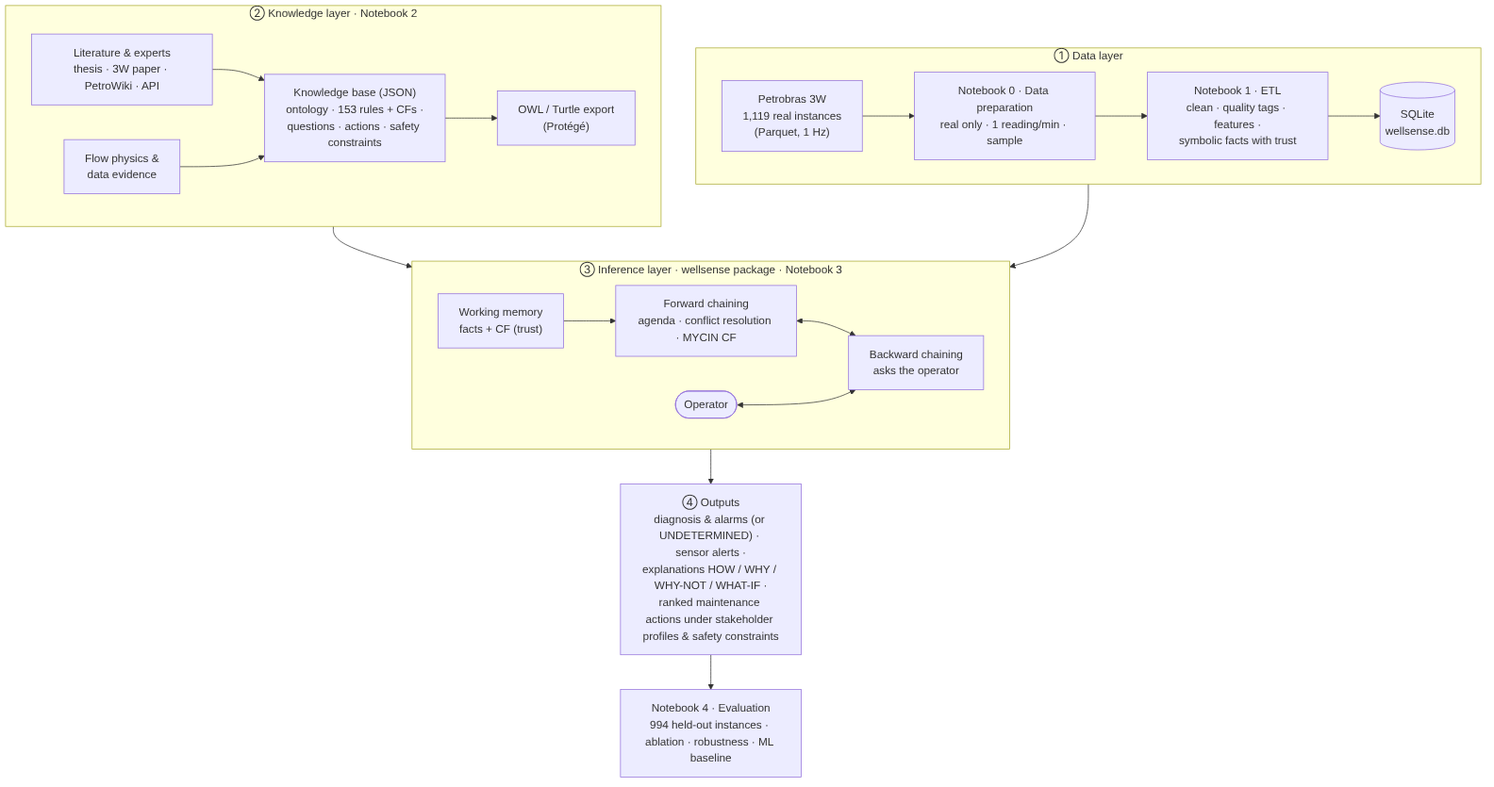
Figure 4. WellSense architecture: data, knowledge, inference and output layers.
The data layer prepares and cleans Petrobras's data into a SQLite database of symbolic facts with trust values. The knowledge layer holds the ontology and rule base as JSON (and OWL). The inference layer combines them in working memory, with forward and backward chaining. The outputs are diagnoses and alarms, sensor alerts, explanations and ranked, safety-filtered maintenance actions. Knowledge and engine are independent: new rules or faults can be added without changing code.

5. Dataset / Knowledge Sources
Source / Dataset | Type | Size / No. of Records | Purpose | Citation / URL
Petrobras 3W Dataset v2.0.0 (real instances) | Real industrial multivariate time series (27 variables, 1 Hz), expert-labelled | 1,119 instances, 40 wells, 32.9 M readings | Primary data source | [1], [2], [4] github.com/petrobras/3W
WellSense working dataset (3W_real_small.csv) | CSV derived by Notebook 0 | 125 instances, 65,846 rows × 34 columns | Development: knowledge acquisition, refinement, demos | Approved by course teacher; reproducible from [4]
WellSense full dataset (3W_real_instances_1min.csv) | CSV derived by Notebook 0 | 1,119 instances, 549,063 rows | Evaluation (994 held-out instances) | Reproducible from [4]
Vargas (2019) doctoral thesis | Expert knowledge | 74 pages; Sections 2.2–2.4 | Event descriptions, sensor reliability, actions, time windows | [3]
3W 2.0.0 paper | Peer-reviewed knowledge / dataset documentation | — | Event signatures, state codes, data issues | [2]
SPE PetroWiki — Hydrate plug removal | Engineering handbook | — | Hydrate remediation and safety constraints | [5]
Schmidt et al. (1985); Godhavn et al. (2005) | Journal papers | — | Slugging causes and mitigation | [6], [7]
API RP 14B | Industry standard | — | Subsurface safety valve operation (equalization) | [8]
Shortliffe & Buchanan (1975) | Journal paper | — | Certainty-factor model | [9]

6. Implementation

6.1 Software / Tools / Libraries
Tool / library | Use
Python 3 in Google Colab | All code; runs in a browser, no installation
pandas, NumPy | ETL, feature engineering, evaluation
SQLite (sqlite3) | Database of clean data, facts, thresholds and the knowledge base
pyarrow (Colab) | Reading Petrobras's Parquet files (Notebook 0)
git | Pinned download of the official dataset (commit 82cebb46)
Matplotlib, NetworkX | Figures, ontology and reasoning-network diagrams
scikit-learn [13] | Random Forest baseline only
JSON, OWL/Turtle (Protégé [17]) | Knowledge base storage and ontology export
Own Python package wellsense | Inference engine, explanation, decision support, monitoring, evaluation — no expert-system library

6.2 Modules and Components
Notebook / module | Responsibility
00_Data_Preparation.ipynb | Downloads Petrobras files; keeps real instances; 1 reading/min; samples 125 development instances; proves identical to the approved file
01_ETL.ipynb | Extract, Transform (13 steps), Load into SQLite; data-quality report
02_Knowledge_Base.ipynb | Knowledge sources, ontology (+ OWL export), data evidence, rule base, consistency checks, load KB to DB
03_Inference_and_Diagnosis.ipynb | Engine demonstration on five real cases, explanations, consultation, decision support, knowledge refinement
04_Evaluation.ipynb | Held-out evaluation, error analysis, ablation, robustness, backward-chaining and ML comparison
wellsense/kb.py | Loads and validates the knowledge base
wellsense/engine.py | Working memory, forward chaining, conflict resolution, MYCIN CFs, backward chaining
wellsense/explain.py | HOW, WHY-NOT, WHAT-IF explanations
wellsense/decision.py | Multi-criteria ranking, safety constraints, applicability, stakeholder profiles
wellsense/monitor.py | Minute-by-minute replay, alarm persistence, instance verdict
wellsense/refine.py, evaluate.py | Rule precision analysis; evaluation runs and scores
src/kb_source.py | Authoring script that writes the knowledge base JSON

6.3 Code Structure
WellSense/
├── 00_Data_Preparation.ipynb 01_ETL.ipynb 02_Knowledge_Base.ipynb
├── 03_Inference_and_Diagnosis.ipynb 04_Evaluation.ipynb
├── data/ 3W_real_small.csv, data dictionary, README
├── knowledge_base/ ontology.json, rules.json, questions.json, actions.json,
│ constraints.json, profiles.json, settings.json, sources.json,
│ wellsense_ontology.ttl
├── wellsense/ kb.py, engine.py, explain.py, decision.py, monitor.py,
│ refine.py, evaluate.py
├── src/kb_source.py
├── db/ wellsense.db (+ wellsense_full.db for evaluation)
└── outputs/ figures/, tables/

Core of the forward-chaining loop (from engine.py):
while True:
agenda = [(r, m) for r in rules if r.id not in wm.fired and (m := match(r, wm))]
if not agenda: break
# conflict resolution: salience, then specificity, then |CF|
r, (cf_in, used) = max(agenda, key=lambda a: (a[0].salience, len(a[0].conditions), abs(a[0].cf)))
wm.fired.add(r.id) # refractoriness
contribution = r.cf * cf_in # MYCIN: rule CF x premise CF
wm.facts[(r.fact, r.value)] = combine_cf(old, contribution) if old else contribution

6.4 User Inputs and Outputs
Inputs | Outputs
Sensor facts for each minute (from the ETL), with quality and trust | Fault certainty factors and alarms (or UNDETERMINED)
Operator answers to questions (clicked in the live consultation, or typed in Case B when INTERACTIVE = True) | Sensor alerts (frozen / failed gauges)
An engineer's own observations, chosen from menus in the live consultation (Notebook 3, Section 9) | Verdict with its priority (severity 1–5)
Stakeholder profile (Safety / Production / Cost) | Explanations: HOW, WHY, WHY-NOT, WHAT-IF
Well operating state | Ranked maintenance actions with blocked / not-applicable actions and reasons

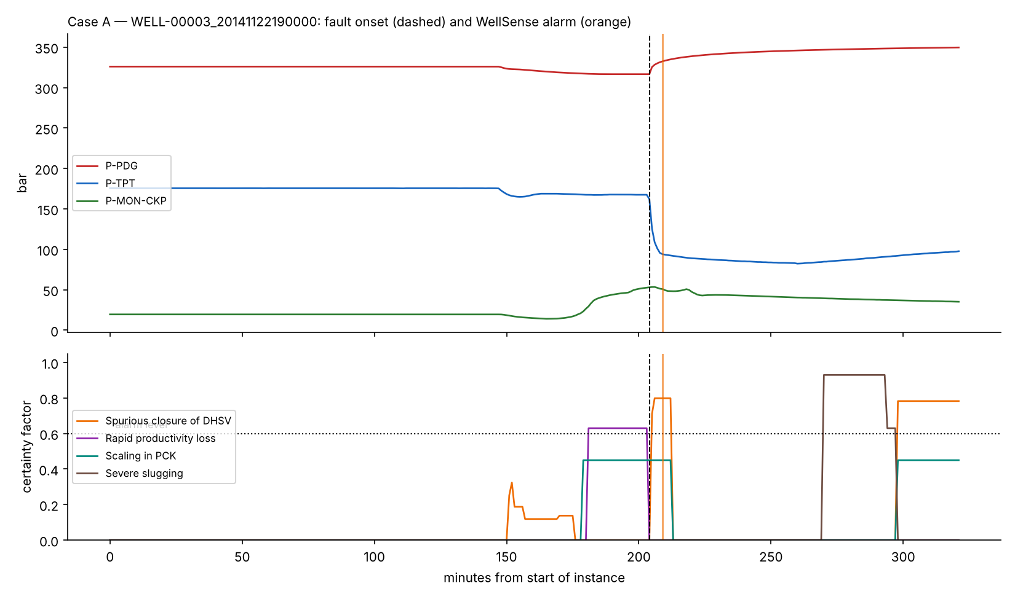
Figure 5. Output on a real spurious DHSV closure (WELL-00003): pressures (top) and fault certainty factors (bottom); the alarm comes 5 minutes after the labelled onset.
Maintenance recommendation produced for this case (Safety-first): 1. equalize pressure across the DHSV, then reopen it through its control line (score 0.85); 2. keep the well closed and schedule an inspection (0.79); forcing the valve open without equalizing — BLOCKED by SC-DHSV-EQUALIZE.

Live consultation prototype
Besides diagnosing recorded sensor data, WellSense includes a live consultation prototype (Notebook 3, Section 9) in which an engineer describes a situation in their own words and receives a diagnosis, an explanation and safe maintenance advice. It runs inside Google Colab with simple menus and buttons, so no separate user interface is needed. The user selects what each key sensor is doing (for example "subsea tree pressure: dropped suddenly", "downhole pressure: went up", "stuck at one value" or "don't know"), how sure they are (Sure = 1.0, Fairly sure = 0.8, Not sure = 0.5), what the well is doing (producing, shut in, restarting, intervention), the gas-lift and choke state, and which stakeholder profile decides; ready-made examples can also be loaded.
Clicking Diagnose converts these observations into exactly the symbolic facts the ETL produces, with the user's confidence as their certainty factor; sensors left as don't know stay unknown, so incomplete information is handled as with real data. The same knowledge base and inference engine then run unchanged: forward chaining through all the rules (symptoms → blockage location → fault); backward chaining when the leading fault is uncertain (0.3 ≤ CF < 0.8), with each question shown together with why it is asked and clickable Yes / No / Don't know answers; and finally the report — the verdict with its certainty and priority (severity 1–5), any sensor alerts, the HOW explanation traced back to what the user reported, WHY NOT the most similar alternative fault (or one the user picks), and maintenance actions ranked for the chosen profile on safety risk, production loss (downtime), cost and effectiveness, with unsafe actions BLOCKED and ineffective ones NOT APPLICABLE. With fewer than two key sensors known it answers Undetermined. Because nothing in the engine or knowledge base was changed, the prototype also demonstrates that the knowledge works for any situation an engineer describes, not only for the recorded cases (test results in Section 7.7).

7. Testing and Results

7.1 ETL results
The ETL removed 62,984 invalid readings (error codes such as −9,999,000 Pa and 30,000 °C, values of −10³⁷, zero or negative absolute pressures), flagged 29,974 frozen readings, removed 251 spikes, filled 707 short gaps (≤ 5 min) and dropped 4 variables empty for every instance. Long gaps and sensors not installed were never filled.
Table 6. Data-quality report for the main sensors (development data).
Variable | Raw missing % | Invalid removed | Frozen flagged | Gaps filled | Usable after ETL % | Not installed %
P-PDG | 18.1 | 21,011 | 8,000 | 29 | 37.9 | 15.4
P-TPT | 14.3 | 5,659 | 4,770 | 31 | 69.9 | 14.2
T-TPT | 14.1 | 5,403 | 3,706 | 35 | 72.1 | 14.0
P-MON-CKP | 6.8 | 28 | 619 | 55 | 92.2 | 6.8
T-JUS-CKP | 45.9 | 124 | 0 | 18 | 54.0 | 45.8
P-ANULAR | 28.1 | 1,580 | 2,985 | 108 | 65.1 | 28.0
QGL | 24.3 | 0 | 606 | 125 | 74.8 | 24.2

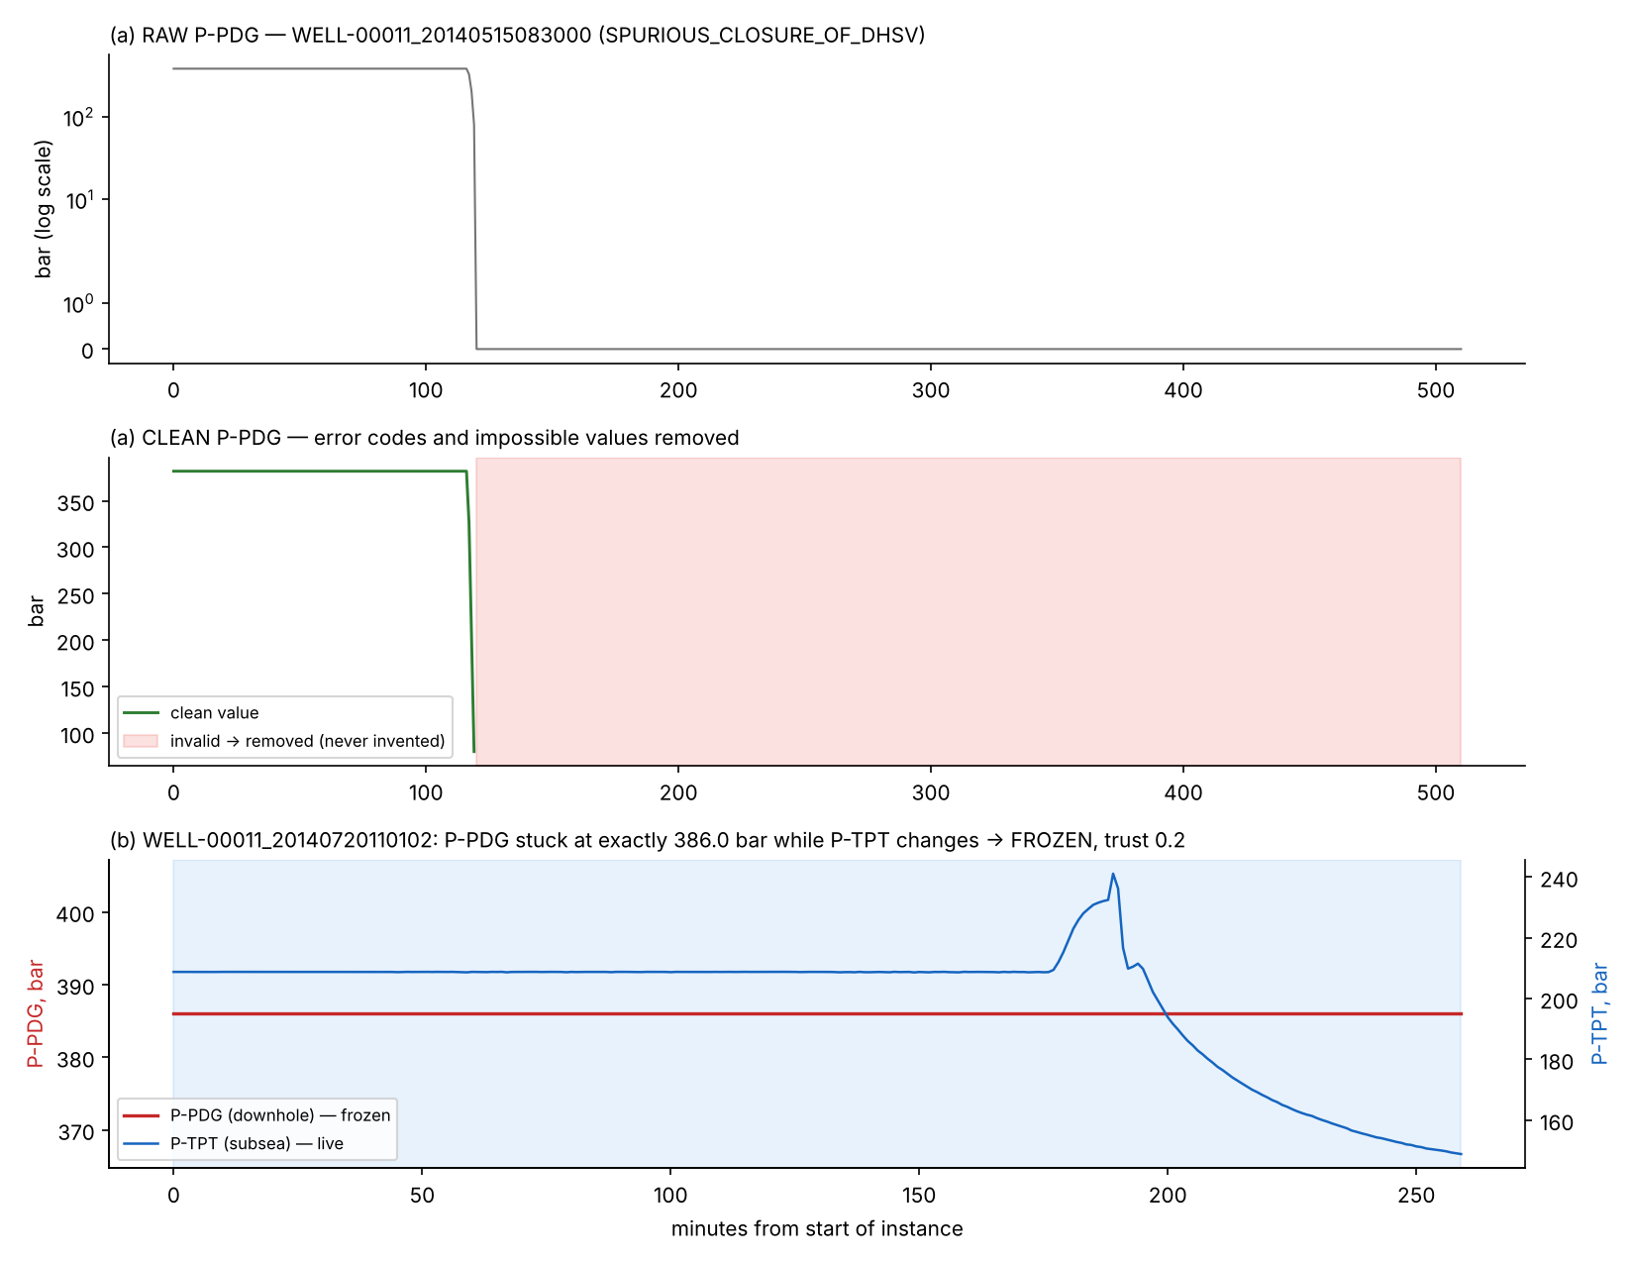
Figure 6. ETL examples: (a) a downhole gauge that starts sending error codes; (b) a frozen gauge (386.0 bar for hours) while the live subsea pressure changes.

7.2 Evaluation protocol
Two disjoint sets were used. The development set (125 instances, all 10 classes) was used to acquire and refine knowledge and to choose the alarm settings. The held-out set (994 instances; 959 with consistent labels) was used once, at the end, with the knowledge base frozen and the ETL thresholds taken from the development set. Because the development set took every instance of the four rarest events, the held-out set contains six classes.
Event | Development | Held-out | Held-out (scored)
Abrupt increase of BSW | 4 | 0 | 0
Flow instability | 15 | 328 | 328
Hydrate in production line | 14 | 0 | 0
Hydrate in service line | 15 | 42 | 7
Normal | 15 | 579 | 579
Quick restriction in PCK | 6 | 0 | 0
Rapid productivity loss | 11 | 0 | 0
Scaling in PCK | 15 | 21 | 21
Severe slugging | 15 | 17 | 17
Spurious closure of DHSV | 15 | 7 | 7

7.3 Knowledge refinement on the development set
The first version of the knowledge base reached 41.6 % accuracy on the development set. Twelve refinements, each justified by physics or the literature, raised this to 49.6% (balanced 45.9%). The most important: (1) a single drop-and-recovery was being read as an oscillation — cycling now requires two direction reversals; (2) the DHSV status signal reported "closed" in only 14 of ~1,500 minutes of real spurious closures but often during normal operation, confirming the thesis statement that closures happen "without any surface indication" [3] — rules using it were removed; (3) location rules are blocked while flow oscillates; (4) an UNDETERMINED verdict replaced silent "normal" when sensors are missing; (5) slow 3-hour drift facts were added for scaling; (6) a data-driven CF adjustment (CF = ½ expert + ½ measured precision) was tested and rejected because it lowered accuracy to 42.7 %. The full log is in Notebook 3, Section 8.

7.4 Held-out results
Table 7. Held-out results of WellSense (959 scored instances never used during development).
Metric | Value
Accuracy (10-class decision incl. Normal/Undetermined) | 52.1%
Balanced accuracy (mean recall over classes) | 57.4%
Event detection rate (any fault alarm on event instances) | 22.6%
False-alarm rate on normal wells | 15.7%
Alarms during labelled-normal minutes (share of instances) | 9.6%
Undetermined (abstained) verdicts | 6.2%
Median detection delay of correct diagnoses | 18 min

Table 8. Correct diagnoses per class (recall). Development-set figures are optimistic because the rules were refined on them.
Event | Held-out | Development
Spurious closure of DHSV | 7/7 (100%) | 8/15 (53%)
Severe slugging | 14/17 (82%) | 13/15 (87%)
Hydrate in service line | 3/7 (43%) | 5/7 (71%)
Scaling in PCK | 7/21 (33%) | 2/15 (13%)
Flow instability | 38/328 (12%) | 7/15 (47%)
Normal | 431/579 (74%) | 13/15 (87%)
Rapid productivity loss | — (none held out) | 6/11 (55%)
Hydrate in production line | — (none held out) | 3/14 (21%)
Abrupt increase of BSW | — (none held out) | 1/4 (25%)
Quick restriction in PCK | — (none held out) | 0/6 (0%)

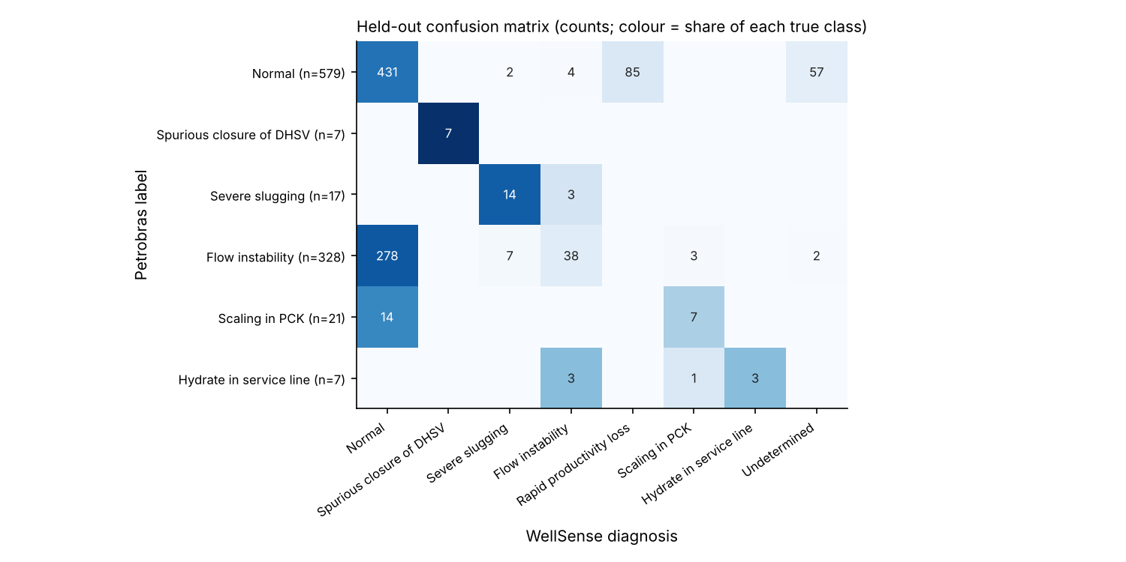
Figure 7. Held-out confusion matrix.
Error analysis. Almost all false rapid productivity loss alarms on normal wells come from a single well (WELL-00002), whose normal operation contains slow pressure declines; excluding it, false alarms on normal wells are rare. All Undetermined verdicts on normal wells come from WELL-00008, which has none of the key sensors — the correct behaviour. Flow instability is detected well on some wells (e.g. WELL-00007, WELL-00014) and not at all on others, because its tolerable, non-periodic swings [3] often stay within normal variation.
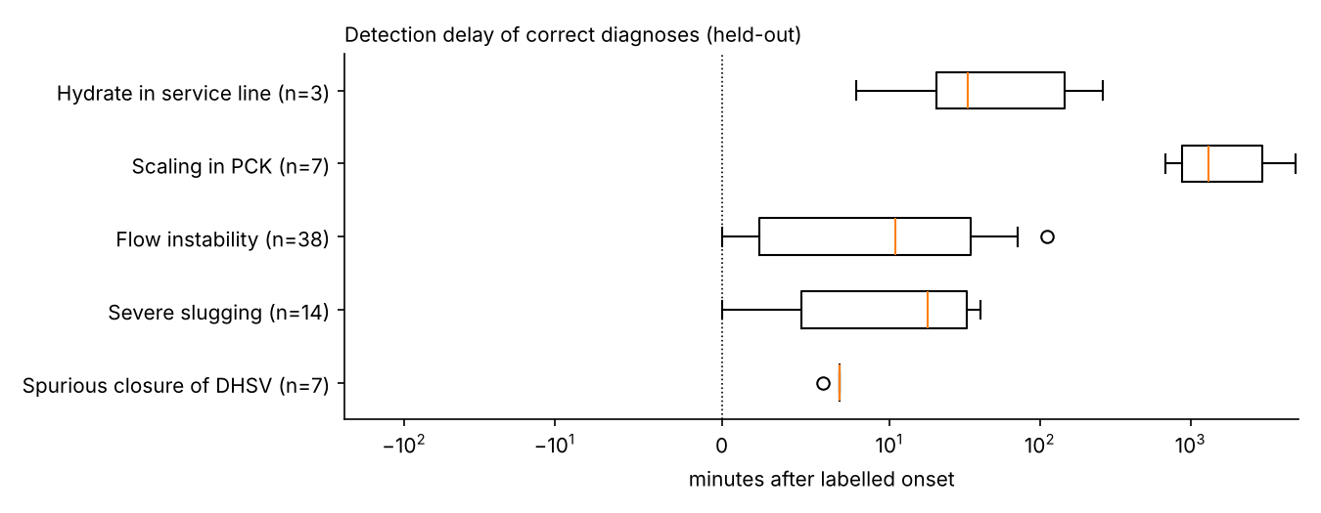
Figure 8. Detection delay of correct held-out diagnoses (minutes after Petrobras's labelled onset).

7.5 Ablation, robustness and backward chaining
Table 9. Ablation study on the held-out set (each row removes one feature).
Variant | Accuracy | Balanced acc. | Detection rate | False alarms (normal wells)
Full WellSense | 52.1% | 57.4% | 22.6% | 15.7%
No data-quality weighting | 52.1% | 57.4% | 22.6% | 15.7%
No oscillation gate | 53.1% | 64.6% | 25.0% | 15.7%
No operation context | 52.1% | 57.4% | 22.6% | 15.7%
No sensor validation | 52.1% | 57.4% | 22.6% | 15.7%

Reading the ablation honestly: removing the oscillation gate improves held-out balanced accuracy (64.6 % vs 57.4 %). The gate helped on the development set but does not generalise — over-fitting to a small development set, and the reason a separate held-out test is essential. It is reported rather than "fixed", because changing the system after seeing test results would contaminate the test. Data-quality weighting, operation context and sensor validation do not change held-out accuracy: the situations they handle are rare in the held-out wells, and they mainly serve explanation and safety (frozen sensors flagged and discounted with a reason; operator-caused changes not misreported as faults).
Table 10. Robustness: key sensors deliberately removed (held-out event instances + 150 normal instances).
Sensors removed | Accuracy | Detection rate | False alarms | Undetermined
0% | 35.8% | 22.6% | 12.7% | 2.3%
25% | 32.8% | 14.2% | 5.3% | 5.5%
50% | 18.9% | 7.1% | 0.7% | 48.1%
75% | 14.0% | 2.4% | 0.0% | 61.7%

As sensors disappear, false alarms fall to zero and Undetermined verdicts rise (to 62 % at 75 % removal): WellSense abstains instead of guessing. Correct detections fall too — with most key sensors gone, most faults cannot be seen.
Table 11. Backward chaining with a simulated operator: verdict at the first suspicious moment, before and after the questions (upper bound, assumption A8).
Set | Suspicious instances | Questions asked (mean) | Correct before | Correct after
development | 79 | 1.5 | 27.8% | 43.0%
held-out | 286 | 1.5 | 47.9% | 48.3%

On the development set, where all ten classes occur, operator answers raise the share of correct verdicts at the first suspicious moment from 28% to 43% — for example spurious DHSV closures from 47 % to 73 % and hydrate in the service line from 17 % to 83 %. On the held-out set the gain is small because most suspicious moments there are flow instability or normal wells, for which the questions add little.

7.6 Comparison with a machine-learning baseline
Table 12. WellSense vs. a Random Forest trained on the same development data, and a trivial "always normal" rule (held-out).
System | Accuracy | Balanced acc. | Detection rate | False alarms (normal wells)
WellSense KBS | 52.1% | 57.4% | 22.6% | 15.7%
Random Forest (ML) | 75.4% | 77.0% | 68.9% | 18.1%
Always "normal" | 60.4% | 16.7% | 0.0% | 0.0%

Table 13. Recall per class on the held-out set: WellSense vs. Random Forest.
Event | WellSense | Random Forest
Spurious closure of DHSV | 100% | 100%
Severe slugging | 82% | 94%
Hydrate in service line | 43% | 29%
Scaling in PCK | 33% | 95%
Flow instability | 12% | 62%
Normal | 74% | 82%

The Random Forest is more accurate (75.4% vs 52.1% accuracy), mainly because it recognises flow instability and scaling far better — subtle patterns that are easier to learn from labelled examples than to describe as rules. Both recognise every DHSV closure; WellSense is better on hydrate in the service line. However, the Random Forest cannot explain an individual diagnosis (it only reports which inputs matter on average), does not detect frozen or failed sensors, needs every input filled with an arbitrary value when sensors are missing, has no safety constraints, makes no recommendation, and could not be built at all for faults without labelled examples. Section 8.1 discusses this trade-off.

7.7 Live consultation prototype tests
The live consultation (Section 6.4) was tested on seven situations described from the menus, covering each main failure type, a frozen gauge and missing information. In every case it produced the expected diagnosis; the frozen-gauge case reproduces the reasoning of Case B on real data.
Table 14. Live consultation tests: situation described by the user, questions asked and final verdict.
Situation described | Questions asked (answer) | Verdict (CF)
Downhole pressure up, subsea pressure dropped suddenly, subsea temperature down (fairly sure) | Closed on purpose? (No) | Spurious DHSV closure (0.84)
Large swings at the subsea tree and before the choke | — | Severe slugging (0.93)
Downhole and subsea pressure up, subsea cooling, choke pressure down, well restarting | — | Hydrate in production line (0.95); unsafe remediation blocked
Choke pressure creeping up and temperature after it creeping down over hours | Scale history? (Yes) | Scaling in PCK (0.83)
Gas-lift line pressure up, gas-lift flow down | — | Hydrate in service line (0.85)
Downhole gauge stuck, subsea pressure dropped suddenly, cooling | Closed on purpose? (No); control-line pressure normal? (Yes) | Sensor alert PDG frozen; DHSV closure 0.47 → 0.67
Only subsea pressure known | — | Undetermined (fewer than 2 key sensors)

8. Evaluation, Limitations and Conclusion

8.1 Evaluation of the Proposed Approach
Against the CLO 3 criteria:
- Accuracy: on 959 unseen instances WellSense reached 52.1% accuracy and 57.4% balanced accuracy. It recognised every held-out spurious DHSV closure (7/7) a median of 7 minutes after onset and most severe slugging events, with fewer false alarms on normal wells than the ML baseline; scaling, hydrate in the service line and especially flow instability remain hard. A Random Forest trained on the same development data was more accurate (75.4%). These results are honest: the test set was never used to build or tune either system.
- Explainability: every conclusion is traceable from the diagnosis down to individual sensor readings, rules and literature sources (HOW / WHY / WHY-NOT / WHAT-IF). The Random Forest can only report global feature importances.
- Safety: no unsafe action is ever recommended — the five constraints block five unsafe actions under all stakeholder profiles, and situation-dependent actions are withheld when they would not work.
- Incomplete and conflicting information: the system reasons with whatever sensors exist, degrades gracefully when sensors are removed (Table 10), says Undetermined instead of guessing, detects frozen sensors, and asks the operator when evidence is not enough (Table 11).
- Cost: free tools in Google Colab; ≈1 ms per minute of data; no labelled training data needed — 125 development instances were used only to check and refine expert knowledge.
The comparison with machine learning (Tables 12–13) illustrates the central trade-off of the brief. On raw accuracy for the common classes, a model fitted to labelled data wins. But the brief asks for a system that represents equipment knowledge, handles incomplete and conflicting information, explains its reasoning, respects safety and recommends maintenance — and on every one of those the knowledge-based approach is the only one of the two that delivers. For a decision-support system whose users are accountable for interventions costing hundreds of thousands of dollars, an explainable, safe diagnosis that is sometimes uncertain (and says so) is more useful than a more accurate black box. The evaluation also shows where knowledge alone falls short — subtle, slow patterns — which motivates the clearest next step: a hybrid in which learned detectors become additional evidence (facts with CFs) inside the rule base, so accuracy improves while every conclusion stays explainable and safety-filtered.

8.2 Limitations
- Rare events: only 4–14 real instances exist for four event types; all are in the development set, so their performance is not measured on unseen data.
- Slow events: scaling develops over ~72 hours [3]; the 15-hour window after onset often does not show it.
- Well-specific normal behaviour: one well (WELL-00002) produced most false alarms; thresholds are shared across wells.
- Flow instability is hard to separate from normal variation with the available sensors.
- Frozen-sensor rule (≥ 60 identical minutes) can flag a very steady real signal; such readings are down-weighted, not deleted.
- Certainty factors are expert judgements, not probabilities; action scores are relative judgements (A6).
- Backward chaining was evaluated with a simulated, always-correct operator — an upper bound.
- Label inconsistencies in the source data (43 instances) limit evaluation of hydrate in the service line.
- No maintenance records: the brief lists historical maintenance records as a knowledge source, but the Petrobras data contain none; knowledge came instead from expert literature, flow physics, operator answers and sensor data, and action scores are engineering judgements rather than measured outcomes.
- Accuracy: a Random Forest baseline was more accurate on the common classes (Section 7.6).

8.3 Future Improvements
- Learn a separate normal baseline per well (and per operating mode) to cut false alarms.
- Longer temporal windows and trend tests for slow events (scaling over days).
- Use Petrobras's simulated and hand-drawn instances to test rules for rare events.
- Add learned anomaly detectors as extra evidence inside the rule base (hybrid KBS + ML), keeping explanations.
- Interactive dashboard for the control room, and a real operator study of the questions and explanations.
- Bayesian-network version once more labelled cases exist, to compare CFs with probabilities.

8.4 Conclusion
WellSense shows how a knowledge-based system can represent industrial equipment knowledge — equipment along the flow path, sensors, symptoms, faults, causes and maintenance actions — in an ontology and 153 production rules with certainty factors (CLO 1); how the fault-diagnosis problem can be analysed in terms of incomplete requirements, stakeholder needs, constraints and conflicts (CLO 2); and why a hybrid rule-based approach is the right choice when explainability, safety and scarce labelled data matter (CLO 3). Built on real Petrobras data with a full ETL pipeline, it diagnoses events minute by minute, handles missing and conflicting sensor evidence, asks the operator when needed, explains every conclusion and recommends safe, stakeholder-aware maintenance actions. A live consultation prototype lets an engineer describe any situation and receive the same diagnosis, questions, explanations and safety-checked advice. Evaluated honestly on 959 unseen instances, it detects safety-valve closures and severe slugging reliably, and its weaknesses — slow and subtle events, well-specific behaviour — are understood and point to clear next steps.

9. References
[1] R. E. V. Vargas, C. J. Munaro, P. M. Ciarelli, A. G. Medeiros, B. G. do Amaral, D. C. Barrionuevo, J. C. D. de Araújo, J. L. Ribeiro, L. P. Magalhães, "A realistic and public dataset with rare undesirable real events in oil wells," Journal of Petroleum Science and Engineering, vol. 181, 106223, 2019.
[2] R. E. V. Vargas et al., "3W Dataset 2.0.0: a realistic and public dataset with rare undesirable real events in oil wells," arXiv:2507.01048, 2025.
[3] R. E. V. Vargas, "Base de dados e benchmarks para prognóstico de anomalias em sistemas de elevação de petróleo," Doctoral thesis, Universidade Federal do Espírito Santo, 2019. https://github.com/ricardovvargas/3w_dataset
[4] Petrobras, "3W Project — dataset v2.0.0," GitHub, CC BY 4.0. https://github.com/petrobras/3W (commit 82cebb46).
[5] Society of Petroleum Engineers, "Hydrate plug removal," PetroWiki. https://petrowiki.spe.org/Hydrate_plug_removal
[6] Z. Schmidt, D. R. Doty, K. Dutta-Roy, "Severe slugging in offshore pipeline riser-pipe systems," SPE Journal, vol. 25, no. 1, pp. 27–38, 1985.
[7] J.-M. Godhavn, M. P. Fard, P. H. Fuchs, "New slug control strategies, tuning rules and experimental results," Journal of Process Control, vol. 15, no. 5, pp. 547–557, 2005.
[8] American Petroleum Institute, API RP 14B, "Design, Installation, Operation, Test, and Redress of Subsurface Safety Valve Systems."
[9] E. H. Shortliffe, B. G. Buchanan, "A model of inexact reasoning in medicine," Mathematical Biosciences, vol. 23, pp. 351–379, 1975.
[10] J. C. Giarratano, G. D. Riley, Expert Systems: Principles and Programming, 4th ed., Thomson Course Technology, 2005.
[11] T. R. Gruber, "A translation approach to portable ontology specifications," Knowledge Acquisition, vol. 5, no. 2, pp. 199–220, 1993.
[12] L. Breiman, "Random forests," Machine Learning, vol. 45, pp. 5–32, 2001.
[13] F. Pedregosa et al., "Scikit-learn: Machine learning in Python," Journal of Machine Learning Research, vol. 12, pp. 2825–2830, 2011.
[14] S. Russell, P. Norvig, Artificial Intelligence: A Modern Approach, 4th ed., Pearson, 2020.
[15] ANSI/ISA-18.2-2016, Management of Alarm Systems for the Process Industries, International Society of Automation, 2016.
[16] W. McKinney, "Data structures for statistical computing in Python," Proc. 9th Python in Science Conference, pp. 56–61, 2010.
[17] M. A. Musen, "The Protégé project: a look back and a look forward," AI Matters, vol. 1, no. 4, pp. 4–12, 2015.

