Advanced Penetration Testing Engineer- Hands On
CYBERSECURITY PROJECT
ON
Vulnerability Assessment & Penetration Testing
Batch 14 | Instructor: Rashadul Islam

Student Name | Sadia Jahan
Student ID | 2023100000336
Date | 16.05.2026
Instructor | Rashadul Islam
Lab Setup | Kali Linux + Metasploitable 2 on Host-Only Network
VA Tool | Nessus Essentials (free) – running on Kali Linux
Date of Submission | 17.05.2023
Time Allowed | 3 Days

GENERAL INSTRUCTIONS
- Read all tasks before starting. Do NOT skip ahead — tasks build on each other.
- Both VMs (Kali and Metasploitable 2) must be on the same Host-Only network/NAT Network.
- Take a screenshot of every key result. Screenshots are required for marks.
- Label screenshots clearly: e.g., va1_nessus_scan_complete.png
- Answers must be your own work. Do not share results with other students.

LAB SETUP (Complete Before Starting)
1. Metasploitable 2
- Download from: https://sourceforge.net/projects/metasploitable/
- Import into VirtualBox or VMware. Set network adapter to Host-Only.
- Default login — username: msfadmin | password: msfadmin
2. Kali Linux
- Also set to Host-Only adapter on the same virtual network.
- Find the target IP: run sudo netdiscover -r 192.168.x.0/24 on Kali.
3. Nessus Essentials (install on Kali)
- Register free at: https://www.tenable.com/products/nessus/nessus-essentials (you will receive a free activation code by email)
- Download the Kali .deb package from Tenable, then install: sudo dpkg -i Nessus-*.deb
- Start the service: sudo systemctl start nessusd
- Open browser on Kali and go to: https://localhost:8834 — complete the setup wizard with your activation code.
- Allow 10–15 minutes for Nessus to download plugins on first launch.

TARGET IP (fill in here and use throughout): ___________________________________

SECTION A: VULNERABILITY ASSESSMENT (50 marks)
In this section you will use Nessus Essentials to scan Metasploitable 2, analyse the results, and produce a structured VA report. You are identifying weaknesses — not exploiting them yet.

VA Task 1: Configure and Run a Nessus Scan | [20 marks]
What you need to do:
Log into Nessus Essentials, create a new scan targeting your Metasploitable 2 IP, run it, and record your observations.

- In Nessus, create a new Basic Network Scan. Fill in the details below:
Scan Name you gave it | Metasploitable 2 Scan
Target IP entered | 192.168.18.129
Scan Policy used | Basic Network Scan
Date & time scan started | May 16, 2026, at 3:08 AM
Date & time scan completed | May 16, 2026, at 3:18 AM
Total scan duration (approx.) | 10 minutes
(Screenshot required: va1_scan_config.png — show the scan settings page before running)

- Once the scan finishes, take a screenshot of the Nessus summary dashboard showing the coloured severity bars (Critical / High / Medium / Low / Info). Fill in the counts below:

Critical | High | Medium | Low | Informational
3 | 3 | 5 | 5 | 79
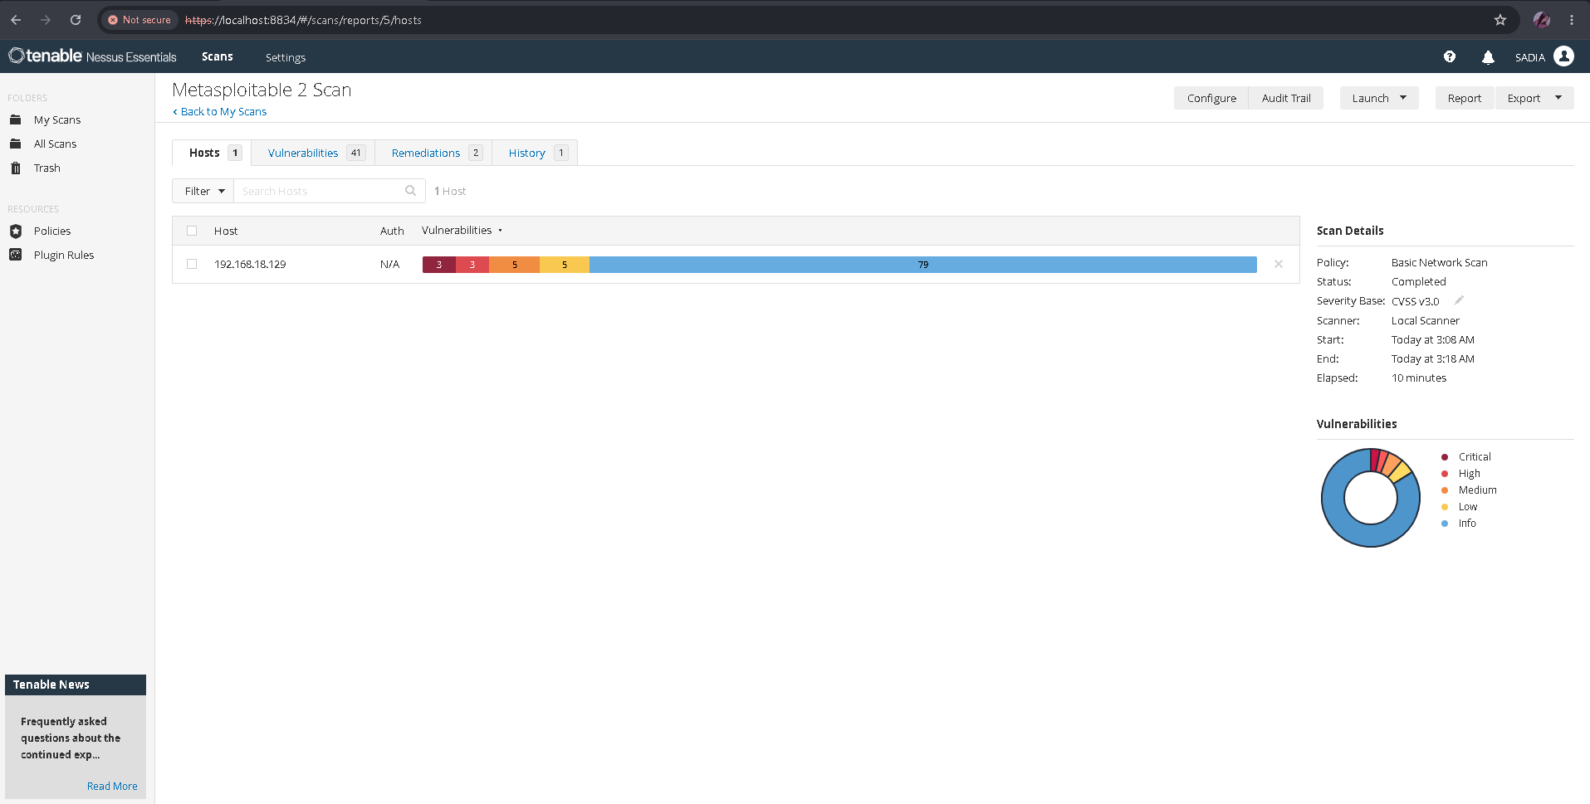

VA Task 2: Analyse Nessus Findings | [30 marks]
What you need to do:
Open the scan results in Nessus. Explore individual findings and record the details for the most important ones.

- From the scan results, identify ONE Critical or High severity vulnerability. Fill in the finding card:

Vulnerability Name | VNC Server 'password' Password
Severity Level | Critical
CVE Number | CVE-1999-0506
Affected Port / Service | 5900 / tcp / vnc
What does this vulnerability mean? | The remote VNC server running on the target operating host is configured with a weak and predictable default password, which is literally the word "password". This allows any automated scanning script or unauthorized user to authenticate successfully without needing explicit administrative permissions.
What could an attacker do with it? | A remote attacker can connect directly to port 5900 using a standard VNC viewer client and log in instantly using the compromised credential. Once inside, they gain complete graphical desktop control to access local databases, modify system properties, or execute malicious binaries.
Fix / Recommendation | Secure the remote VNC service immediately by enforcing a complex, unique, and strong authentication password. Additionally, apply local firewall rules to restrict port 5900 access exclusively to authorized system administrators.
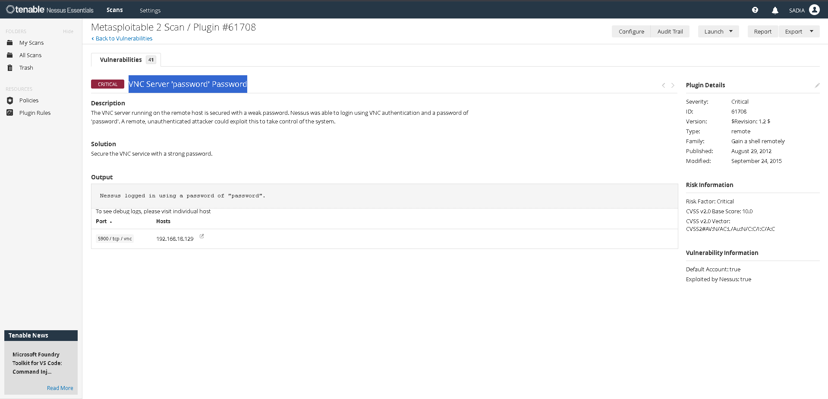
- Find ONE Medium severity vulnerability and fill in a shorter card:

Vulnerability Name | SMTP Service STARTTLS Plaintext Command Injection
CVE Number | CVE-2011-0411
Affected Port / Service | 25 / tcp / smtp
Brief Explanation | The remote SMTP service contains a software flaw in its STARTTLS implementation handling. An unauthenticated attacker could inject plaintext commands during the transitional phase of initiating an encrypted TLS session, potentially allowing them to steal user email credentials or session tracking information.
Fix / Recommendation | Contact the specific software vendor to apply the latest security updates or patches for the Mail Transfer Agent (MTA). Alternatively, disable plaintext command pipelining options within the local SMTP server configuration files
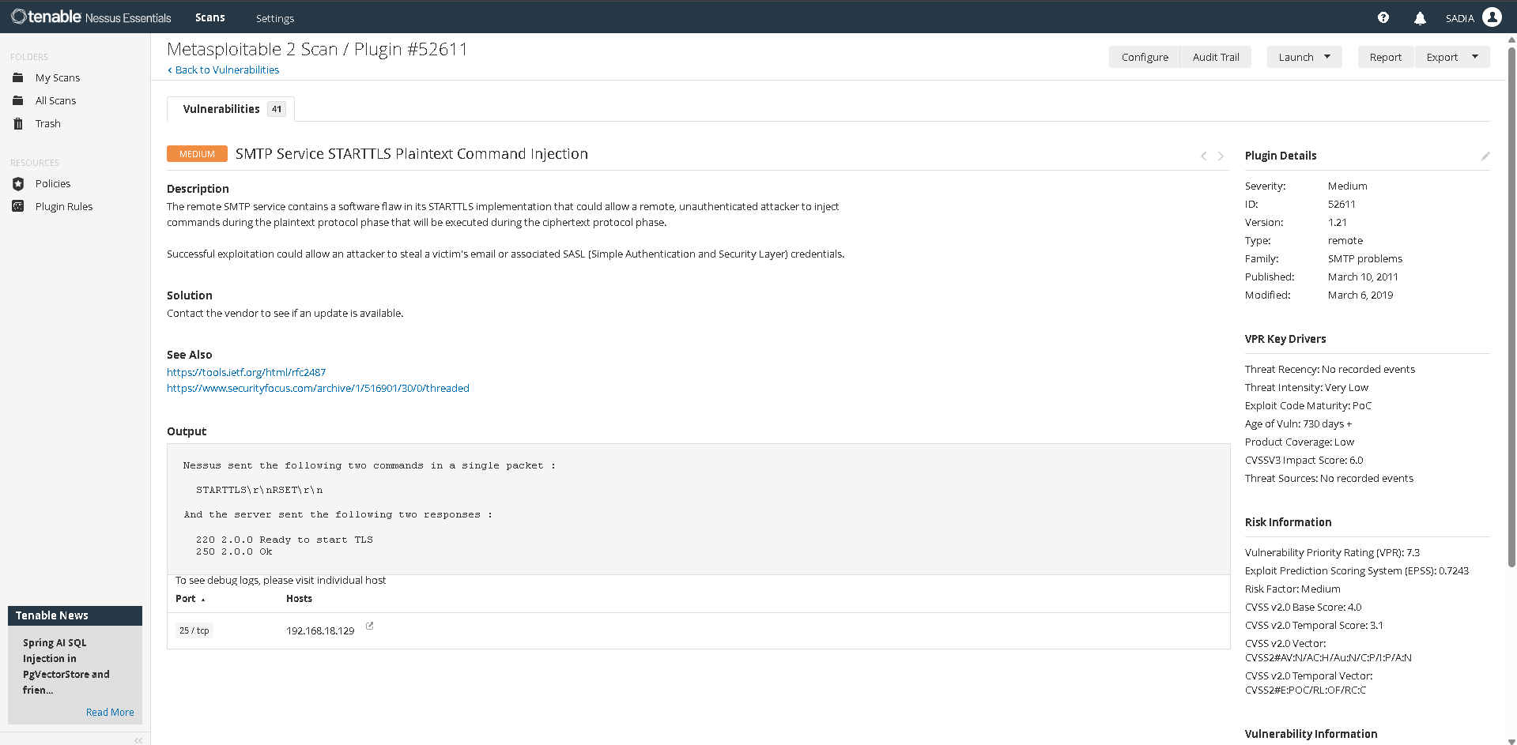
- Look at the full list of open ports and services that Nessus detected. List any SIX below:

Port | Service | Notes / Nessus Comment
21 | ftp | vsftpd 2.3.4 Backdoor vulnerability present.
22 | ssh | OpenSSH 4.7p1 (Multiple SSH vulnerability category).
23 | telnet | Linux telnetd remote unencrypted login active.
25 | smtp | SMTP Service STARTTLS Plaintext Command Injection.
80 | http | Apache httpd 2.2.8 web hosting application running.
445 | microsoft-ds | Samba file sharing platform (Samba Badlock vulnerability risk).

- In your own words, explain the difference between a Vulnerability Assessment and a Penetration Test. (3–4 sentences)

SECTION B: PENETRATION TESTING (50 marks)
Now you will use what you found in Section A and actively exploit a vulnerability on Metasploitable 2 using Metasploit Framework on Kali Linux. You will then document your findings as a short PT report.

PT Task 1: Exploitation with Metasploit | [30 marks]
What you need to do:
Use Metasploit Framework to exploit ONE of the vulnerabilities below. Step-by-step commands are provided as guidance. Follow them, record the outputs, and paste your screenshots.
Choose ONE exploit to attempt:

 | Target Service | Port | Metasploit Module
A | vsftpd 2.3.4 (FTP backdoor) | 21 | exploit/unix/ftp/vsftpd_234_backdoor
B | Samba (SMB) | 445 | exploit/multi/samba/usermap_script

My choice (circle or write A or B): _______

Guided Steps (run these commands in order on Kali):
# | Command to type | What happened / output you saw
1 | msfconsole | Metasploit Framework console successfully initialized and loaded.
2 | search vsftpd (or search samba) | Listed matching modules, confirming exploit/unix/ftp/vsftpd_234_backdoor is present.
3 | use exploit/unix/ftp/vsftpd_234_backdoor (or the Samba module) | Loaded the target FTP backdoor software exploit component workspace.
4 | set RHOSTS <TARGET_IP> | Set the remote target target configurations to Metasploitable 2's specific IP address.
5 | run | Triggered reverse TCP handler on local machine, spawned backdoor, and opened active Meterpreter session 1.
6 | whoami (inside the shell) | Discovered system administrative privileges, returning the output: Server username: root
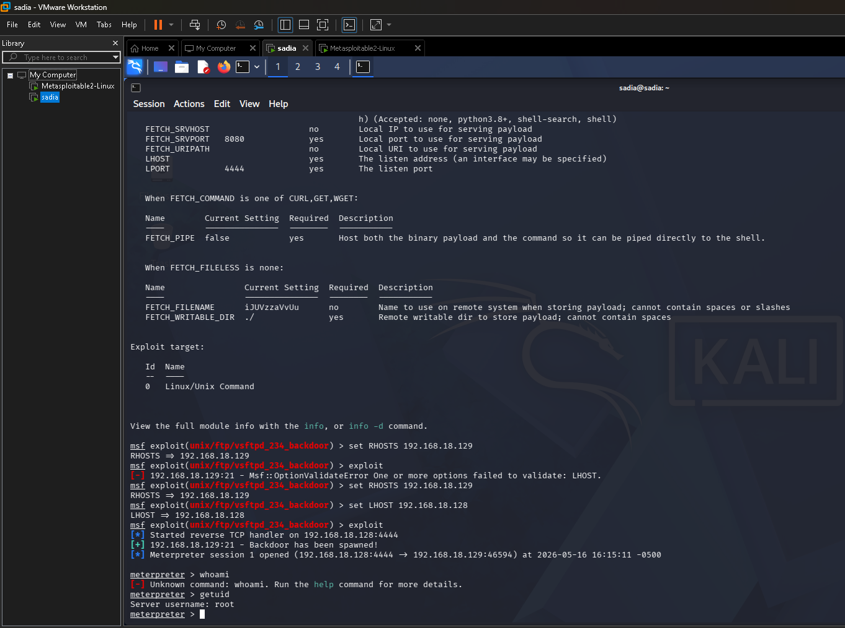
- Did the exploit succeed? Describe what happened in 2–3 sentences:

Yes, the exploit succeeded perfectly. The Metasploit module successfully targeted network port 21 on the vulnerable machine and triggered the legacy code backdoor embedded inside the vsftpd 2.3.4 package. This instantly granted an interactive, persistent execution connection back to the testing console.

- What user account did the shell give you access as (from the whoami output)? Why does this matter?

The shell granted direct terminal access under the root account. This matters critically because root is the maximum administrative privilege account in Linux infrastructures, meaning the system security barrier is completely bypassed, leaving configurations open to absolute modification.

- What TWO simple commands could you run inside the shell to learn more about the target system? Write them below and explain what each one shows:
Command 1: sysinfo ----what it shows: Displays target host machine telemetry details, underlying kernel deployment architecture, and base operating system information.

Command 2: ifconfig — what it shows: Displays active hardware network adapters, localized binding IPv4 addresses, and link-layer MAC references.

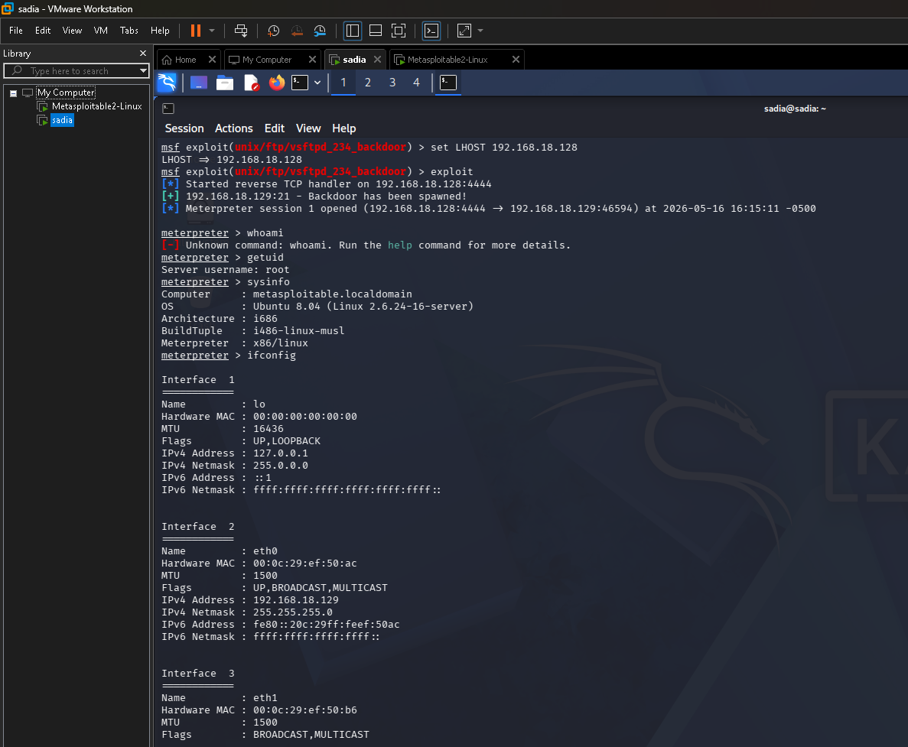
PT Task 2: Write a Short Penetration Test Report | [20 marks]
What you need to do:
Fill in the finding report card below for the exploit you just performed. This is the kind of report a real penetration tester would write for a client.

Finding Title | vsftpd 2.3.4 Backdoor Remote Command Execution
Severity | Critica
Affected Service & Port | FTP / Port 21
CVE Number | CVE-2011-2523
What is the vulnerability? | The application deployment package vsftpd version 2.3.4 contains an unauthenticated malicious backdoor code injection within its historic source architecture. When targeted connections prompt user access parameters including smiley-face indicators, the daemon automatically listens and hooks a shell terminal workspace active over remote network port 6200.
How was it exploited? | Operating from Kali Linux, the standard framework script handler exploit/unix/ftp/vsftpd_234_backdoor was configured. After initializing host settings matching the target IP variable block (192.168.18.129), execution commands were launched, which compromised the listener and caught an administrative root console shell session.
What is the impact? | External malicious network entities can completely bypass system account restriction layers to execute code tasks under supreme root privileges. This facilitates unconditional access to sensitive intellectual properties, allows lateral network pivoting, or causes severe operational system outages
Evidence | pt1_exploit_result.png, pt1_post_commands.png
Recommended Fix | 1. Immediately remove the backdoored vsftpd 2.3.4 package setup from the production environment and install a clean, modern vendor-patched release version. 2. Deploy structural system firewall access rules to explicitly block unauthenticated outside traffic from hitting network port 21. 3. Swap out outdated, plain-text legacy File Transfer Protocol services for modern, secure encrypted tunnels like SFTP (SSH File Transfer Protocol).

- Write a 4–6 sentence Executive Summary of this penetration test — write it for a non-technical manager who needs to understand the risk:

During our recent corporate network infrastructure security check, we detected a critical software vulnerability within the active File Transfer Protocol (FTP) framework. This vulnerability allows an external, unauthenticated party to easily cross normal corporate security log gates without supplying any credentials. Through a safely simulated mock attack, our analyst confirmed that an adversary can exploit this weakness to seize immediate, total administrative mastery over the host operating architecture. This high-risk exposure completely threatens localized database safety, paving the way for data extortion, business operations blockades, or massive malware injections. We strongly emphasize updating the server software stack instantly and tightening network traffic visibility controls to mitigate this extreme organizational risk.

MARKS SUMMARY
Task | Description | Max Marks | Marks Given
VA-1 | Configure and Run Nessus Scan | 20
VA-2 | Analyse Nessus Findings & Report | 30
PT-1 | Exploitation with Metasploit | 30
PT-2 | Short PT Report | 20
 | TOTAL | 100

Instructor Signature: ____________________________

SCREENSHOT SUBMISSION CHECKLIST
Attach all screenshots in a folder named: StudentID_Screenshots

Screenshot File | Required For | Included?
va1_scan_config.png | VA Task 1, Q1 | Yes
va1_scan_summary.png | VA Task 1, Q2 | Yes
va2_critical_finding.png | VA Task 2, Q1 | Yes
va2_medium_finding.png | VA Task 2, Q2 | Yes
pt1_exploit_result.png | PT Task 1 | Yes
pt1_post_commands.png | PT Task 1, Q3 | Yes

— END OF PROJECT QUESTION PAPER —

