NHS Diagnostic Analysis
Findings & Recommendations Report

Executive Summary
This report presents findings from a diagnostic analysis of NHS appointment data across three datasets: actual duration (ad), regional appointments (ar), and national categories (nc). The analysis covers the period January 2020 – June 2022 and encompasses over 106 sub-ICB locations across 7 NHS regions and 42 Integrated Care Boards. Key themes include the COVID-19 impact on appointment volumes and modes, resource utilisation, attendance patterns, and seasonal demand trends.

1. Introduction
The National Health Service (NHS) faces increasing pressure to optimise appointment capacity across primary care settings. This report documents the analytical approach, methodology, results, and conclusions of a diagnostic analysis conducted on three NHS datasets covering January 2020 to June 2022. The primary objective was to assess whether current NHS capacity is adequate and how resources are being utilised, to produce evidence-based recommendations for operational improvement.

2. Data and Methodology

2.1 Dataset Overview
Three datasets were used in this analysis:
- actual_duration.csv (ad):
- appointments_regional.csv (ar):
- national_categories.xlsx (nc):
NHS England is structured across 7 regions, 42 Integrated Care Boards (ICBs), and 106 sub-ICB locations. Duplicate records were identified and removed from the regional dataset before analysis.
Dataset
Da

taset
Dataset | Alias | Period | Type
actual_duration.csv | ad | Dec 2021 – Jun 2022 | Daily records
appointments_regional.csv | ar | Jan 2020 – Jun 2022 | Regional monthly
national_categories.xlsx | nc | Aug 2021 – Jun 2022 | Category breakdowns

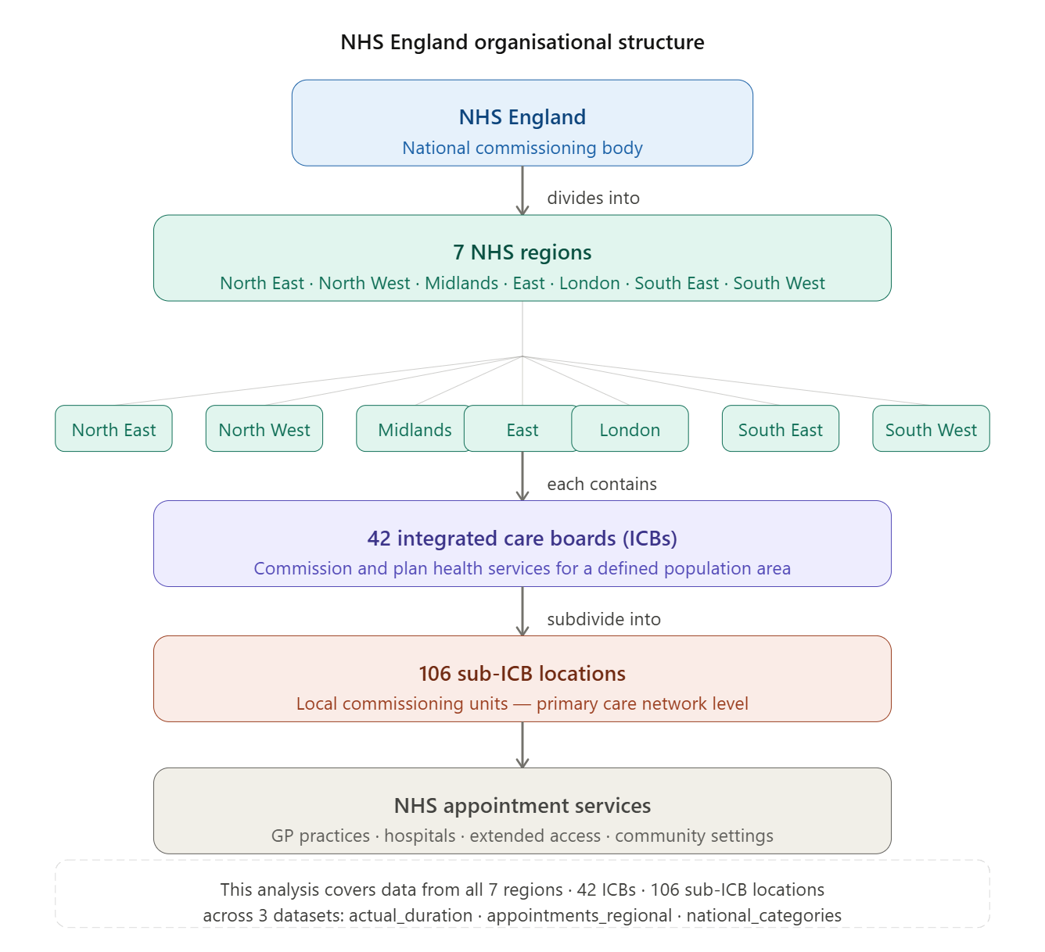

2.2 Data Cleaning and Preparation
Each dataset was assessed for null values via isnull().sum() and duplicates via duplicated().sum(). 598 duplicate rows were identified and removed from the regional dataset using drop_duplicates(). Date columns were converted using pd.to_datetime(). A supplementary NHS lookup file (NHS_names.xlsx), created by the analyst, was merged on icb_ons_code to map ONS codes to readable location names. For Activity 6, the regional dataset was filtered to August 2021 onwards to isolate the post-COVID recovery period for operational recommendations.

2.3 Analytical Approach
Exploratory data analysis used groupby aggregations and percentage calculations to establish baseline distributions. Temporal analysis applied monthly resampling across the full January 2020 – June 2022 range to capture pandemic effects. A capacity threshold was defined statistically as mean monthly volume plus one standard deviation (threshold = 29,374,241) to provide an evidence-based staffing benchmark. Twitter hashtag data was analysed using regex extraction and collections.Counter frequency counting.

3. Results

3.1 Service Settings & Appointment Distributions
The table below summarises the distribution of appointments across the main classification dimensions:

Dimension | Finding
Service Settings | 5 settings; General Practice accounts for 91.5% of all appointments
Context Types | 3 types; Care Related Encounters represent 86.8% of appointments
National Categories | 18 categories; Routine General Consultations (32.9%) and Acute General Consultations (18.1%) are the most common
Appointment Statuses | 3 statuses: Attended (91.3%), Unknown (4.6%), DNA/Did Not Attend (4.2%)
Appointment Modes | 5 modes: Face-to-Face (59.2%), Telephone (36.1%), and three others
HCP Types | GPs handle 51.1% of appointments; other practice staff handle 45.7%

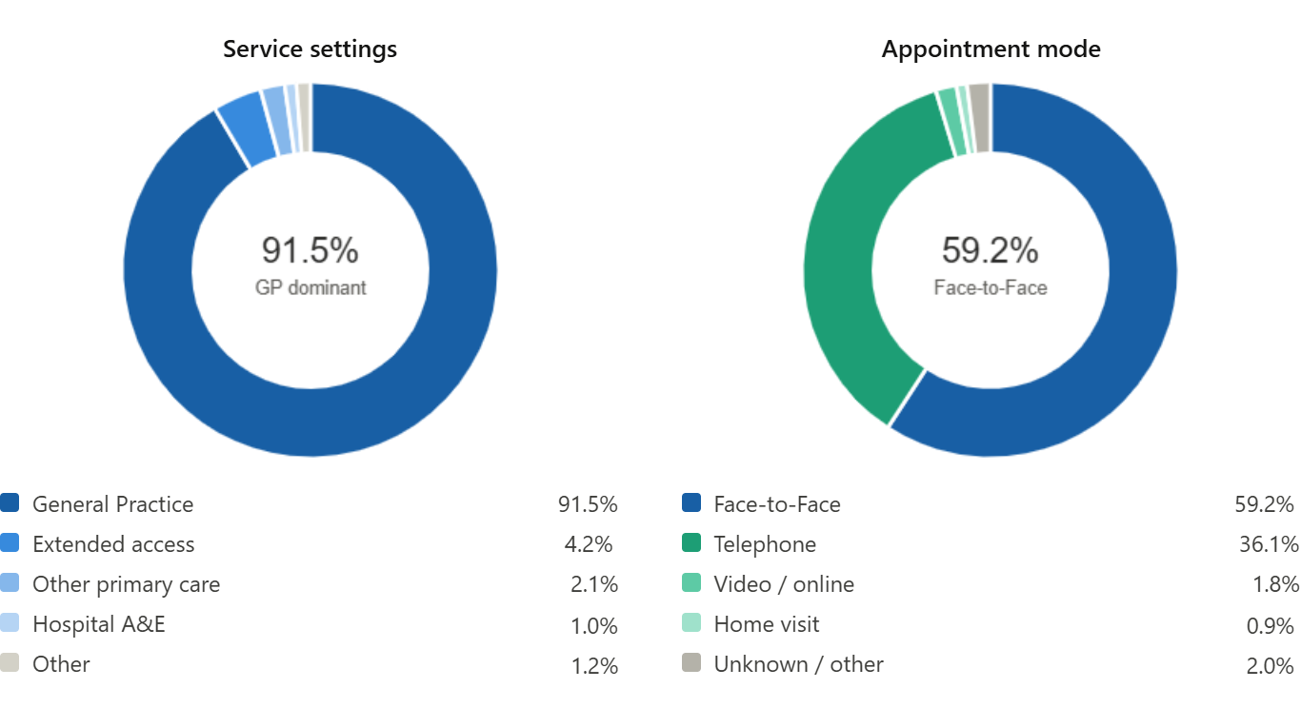

3.2 Appointment Duration
Analysis of appointment durations revealed significant data quality concerns alongside useful operational insights:
- 24% of appointments have no recorded duration — a notable data quality gap that hampers capacity planning.
- Of appointments with known durations, 20% last 6–10 minutes and 17% last 1–5 minutes, consistent with brief GP consultation patterns.
- The prevalence of very short appointments suggests high throughput is essential to meeting overall demand.

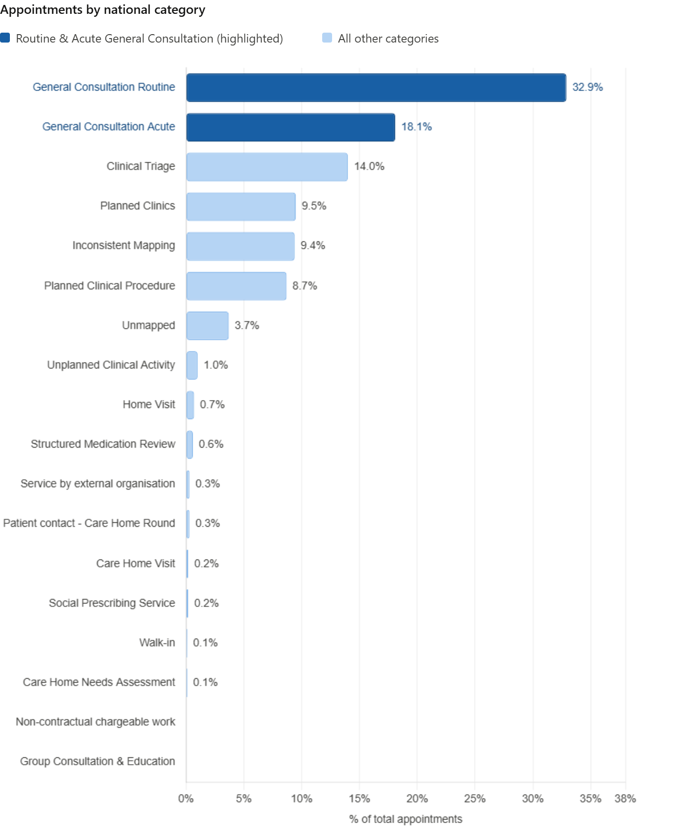

3.3 Waiting Times (Booking to Appointment)
The time between booking and appointment is categorised into 7 intervals. The distribution indicates strong same-day demand:
- 46.2% of appointments occur on the same day they are booked.
- A further 20.7% take place within 2–7 days of booking.
- The majority of appointments are therefore fulfilled within one week, suggesting that NHS primary care remains highly responsive for most patients.
- However, monitoring of appointments with waits of 15 days or more remains important as a capacity pressure indicator.
- 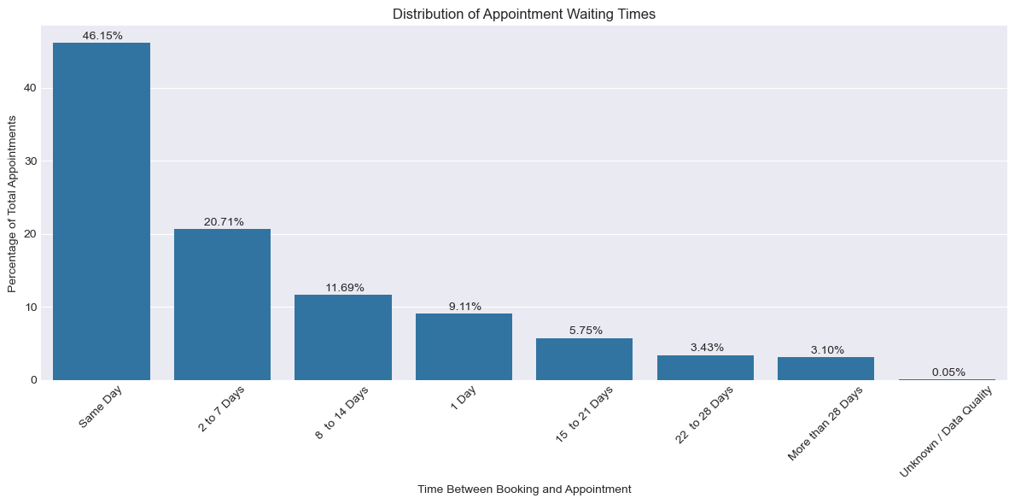

3.4 COVID-19 Impact on Appointment Volume and Mode
The longitudinal regional dataset (January 2020 – June 2022) clearly captures the impact of the COVID-19 pandemic:
- A sharp drop in total appointments occurred from March 2020 (first lockdown), followed by a recovery period.
- Further dips were observed during October 2020 – February 2021 (second lockdown period) and December 2021 – February 2022 (Omicron wave).
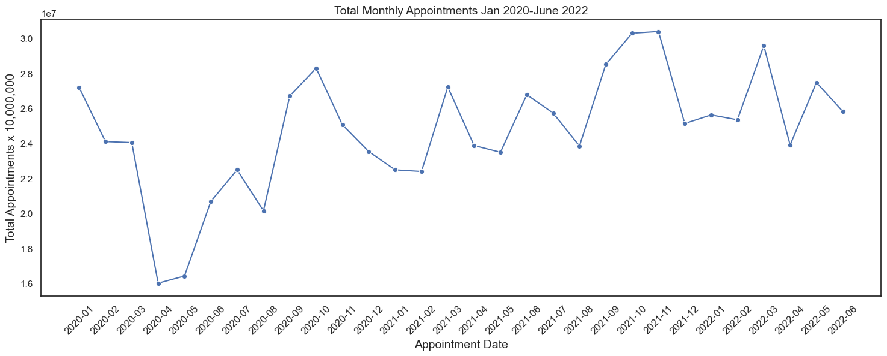
- Telephone consultations surged from 14.6% of appointments in January 2020 to 50.6% by April 2020, overtaking face-to-face appointments.
- Following this peak, face-to-face appointments have been recovering but remain below pre-pandemic levels.
- Notable seasonal dips in telephone appointments were observed around October 2020 and October 2021.

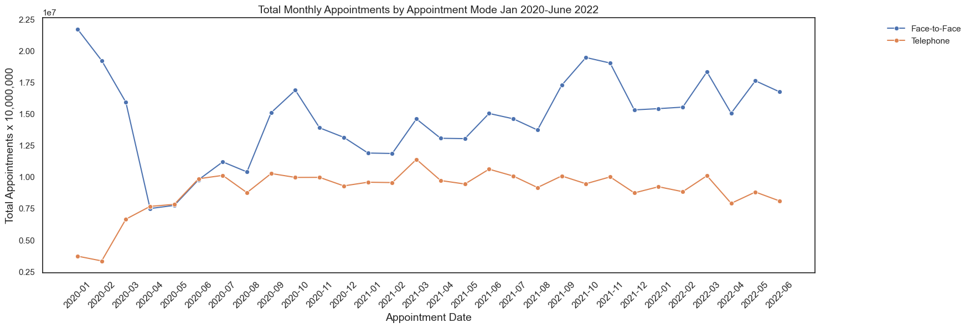

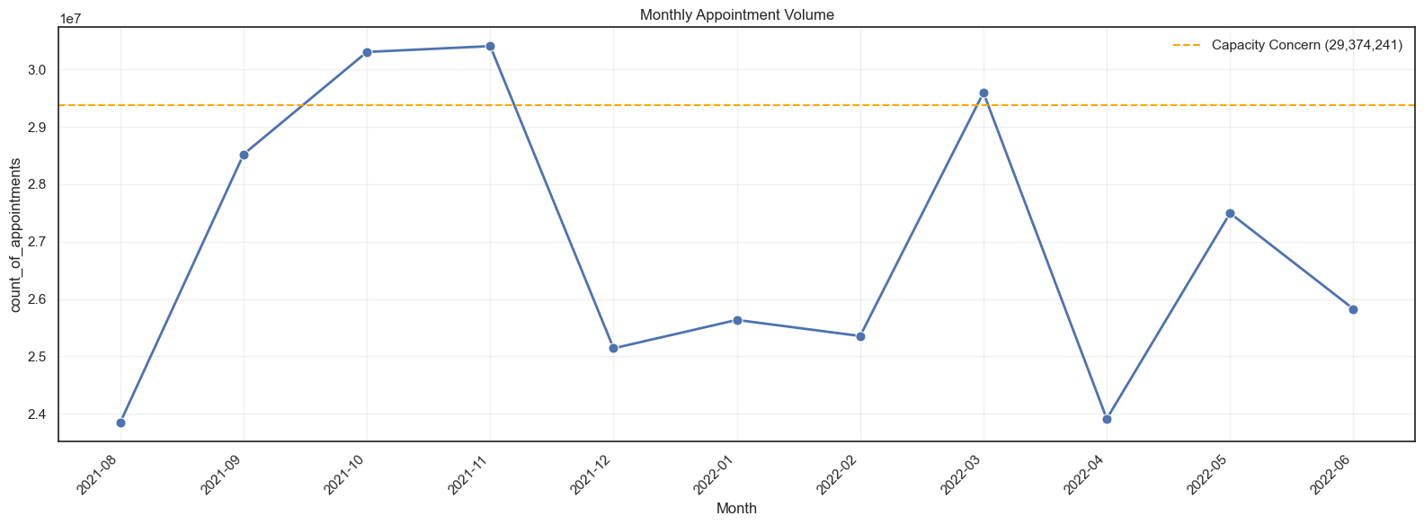

This chart directly answers "Should the NHS increase staff levels?"- and the answer is yes, with nuance:

The system can handle high demand — October and November 2021 prove it

But it cannot sustain it — the sharp drops show the NHS is operating reactively rather than with built-in resilience

The capacity threshold being breached in only 2 out of 11 months suggests the NHS is running close to its ceiling during peak periods, with very little buffer for unexpected surges like Omicron

A staffing increase of even 5–10% would likely shift the threshold upward enough to absorb winter peaks without the dramatic drop-offs seen here

3.5 Seasonal Trends by Service Setting
Analysis across four seasons (Summer 2021, Autumn 2021, Winter 2021–22, Spring 2022) confirms that:
- General Practice dominates appointment volumes in every season without exception.
- Other service settings (e.g., Extended Access, Other, Unknown) remain comparatively flat across all seasons.
- Winter months consistently show a dip in overall appointment activity, likely due to combined pressures of illness burden and reduced capacity.

Summer (June to August 2021)

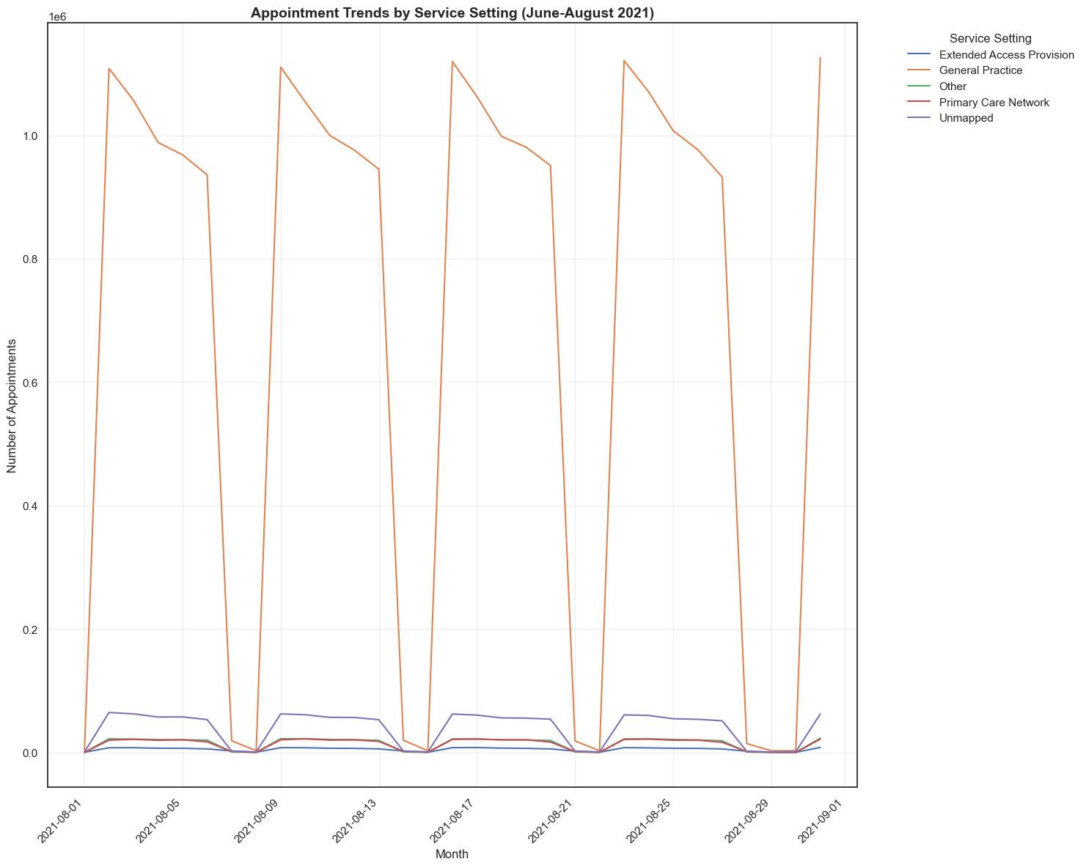

Autumn (September to November 2021)

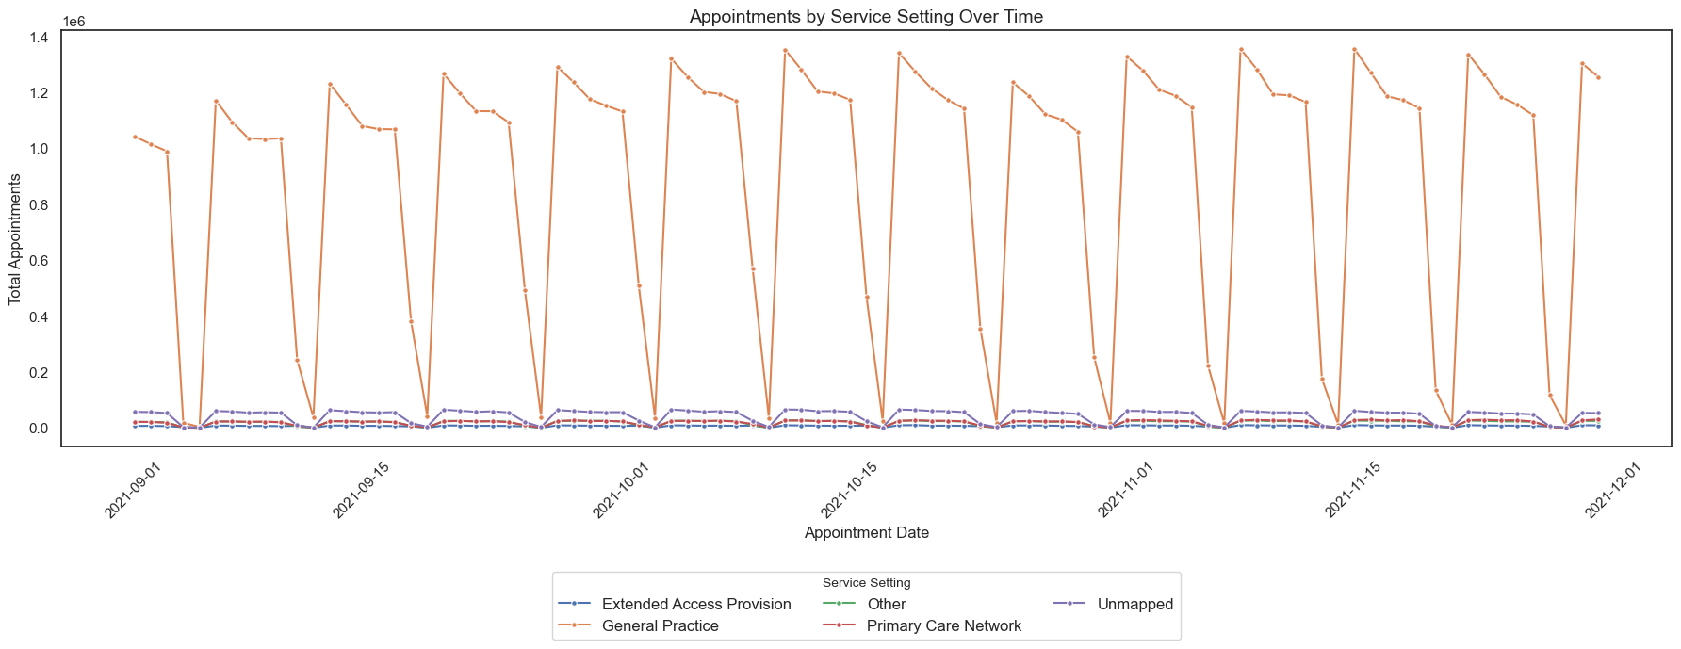

Winter (December to February 2022)

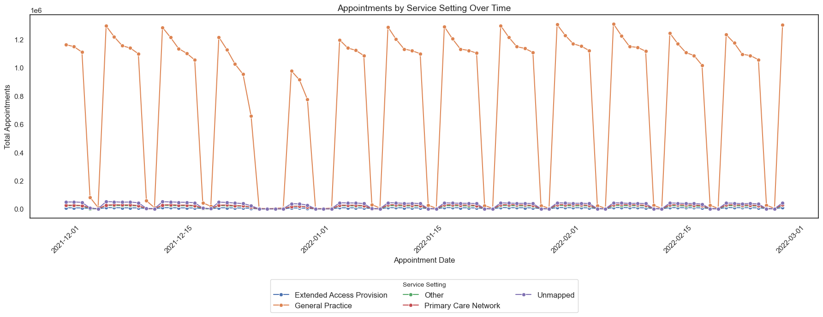

Spring (March to May 2022)

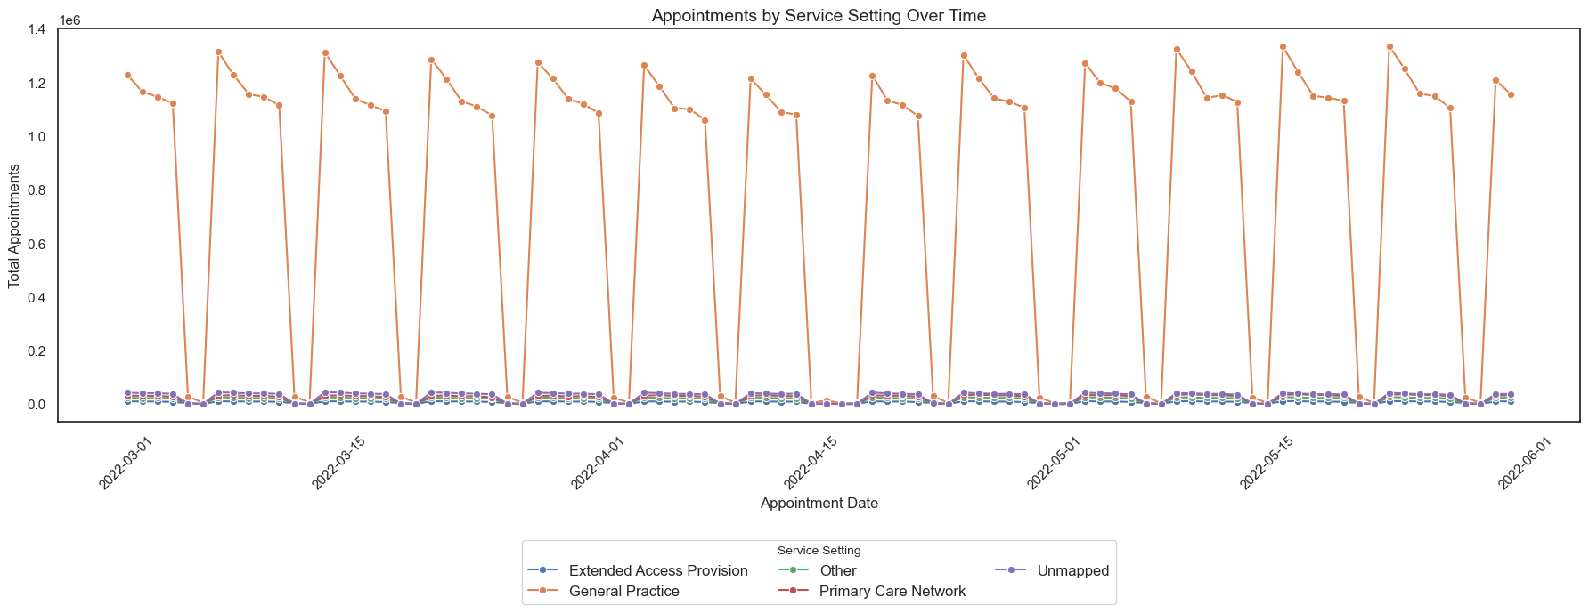

3.6 Social Media Insights (Twitter)
Analysis of UK healthcare hashtags from Twitter revealed strong public engagement around NHS topics:
- High-engagement hashtags are concentrated around NHS staffing pressures, waiting times, and access to care.
- These themes directly mirror the operational pressures identified in the appointment data, validating the relevance of public discourse as a signal.
- Focusing exclusively on retweeted or favourited content could introduce selection bias; a balanced approach considering both high-engagement and broader tweet data is recommended for future monitoring.

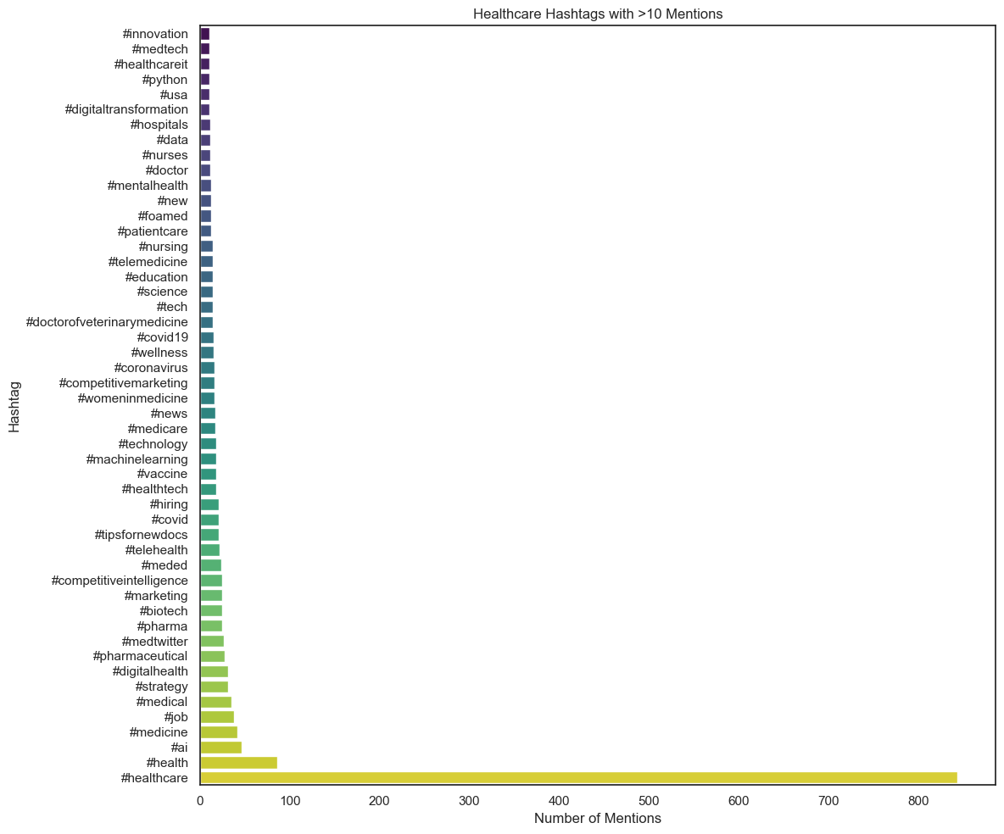

4. Recommendations

Recommendation 1: Increase Staffing Levels in General Practice
With General Practice accounting for over 91% of all NHS appointments, and demand returning to and exceeding pre-pandemic levels, the NHS should consider targeted increases in GP and allied health professional capacity. The combination of high appointment volumes, short consultation durations, and sustained pressure on GPs (who handle 51% of appointments) indicates that current staffing levels are operating near capacity. Staff recruitment and retention initiatives — particularly in high-volume sub-ICB locations — should be prioritised.

Recommendation 2: Retain and Expand Hybrid Appointment Models
The pandemic demonstrated that a substantial share of patients can be effectively served via telephone or digital consultations. Maintaining a hybrid model — rather than reverting fully to face-to-face — would increase throughput without proportional investment in physical infrastructure. A target ratio of approximately 60% face-to-face and 40% telephonic consultations could be formalised as an operational benchmark, reviewed periodically based on patient outcomes and satisfaction.

Recommendation 3: Reduce DNA (Did Not Attend) Rates
At 4.2%, DNA appointments represent a meaningful and addressable source of wasted clinical capacity. The NHS should invest in the following interventions:
- Automated SMS or app-based appointment reminders sent 24–48 hours in advance.
- Simplified cancellation processes (e.g., one-click cancellation via text message) to allow prompt reallocation of slots.
- Analysis of DNA patterns by sub-ICB location and appointment type to target interventions where they will have the greatest impact.
Even reducing the DNA rate by 1–2 percentage points across millions of annual appointments would free up substantial clinical time.

Recommendation 4: Address Data Quality Around Appointment Duration
The fact that 24% of appointment durations are unrecorded is a significant data quality issue. Without complete duration data, capacity planning models are unreliable. The NHS should standardise duration capture across all settings, ideally through integration with clinical scheduling systems, to ensure complete and consistent records going forward.

Recommendation 5: Implement Seasonal Workforce Planning
The data shows recurring dips in appointment activity during winter months (December – February), coinciding with peak illness burden and staff absences. The NHS should formalise seasonal workforce planning to manage these predictable pressure points, including:
- Pre-arranged locum and temporary staffing agreements for winter periods.
- Flexible staffing models that can be activated during peak demand.
- Advance capacity planning tied to seasonal appointment forecasts.

Recommendation 6: Monitor Long-Wait Appointments as a Capacity Indicator
While most appointments are fulfilled quickly (66.9% within 7 days of booking), the proportion with waits exceeding 14 days should be tracked as a leading indicator of systemic capacity strain. A sustained upward trend in long-wait appointments would signal the need for urgent workforce or process intervention before backlogs become entrenched.

Recommendation 7: Formalise Social Media Monitoring as an Early Warning System
Public discourse on Twitter and other platforms around NHS themes has been shown to correlate closely with real operational pressures in the appointment data. The NHS should consider implementing a lightweight, structured social media monitoring process to:
- Identify emerging public concerns before they manifest in clinical data.
- Gauge public sentiment around service changes or healthcare announcements.
- Complement quantitative appointment analytics with qualitative public insight.

5. Conclusion
The analysis demonstrates that NHS primary care is a high-volume, General Practice-dominated system operating with limited capacity headroom:

- Capacity is near ceiling during peak months: only 2 of 11 post-recovery months breached the statistical threshold, indicating minimal buffer for demand surges.
- COVID-19 has structurally altered delivery mode: the telephone/face-to-face ratio has not returned to pre-2020 levels, requiring formalisation of hybrid appointment models.
- Data quality limits planning accuracy: 24% missing duration records and 13.1% unmapped category records reduce the reliability of capacity models.
- Seasonal patterns are predictable and plannable: winter dips and holiday troughs are consistent and foreseeable, providing a basis for proactive workforce planning.
- Long-wait trends require monitoring: the upward creep in 14+ day waits approaching mid-2022 is an early indicator of capacity strain requiring urgent intervention.
These findings support seven targeted recommendations: staffing increases, formalisation of the hybrid appointment model, reduction in DNA rates, improvement in data quality, seasonal workforce planning, long-wait monitoring, and social media early-warning systems.

