

**Stitel Networks, LLC.**

1330 W Auto Dr. #107 Tempe AZ 85284 USA

E-mail: [info@stitelnetworks.com](mailto:info@stitelnetworks.com)

Website: [www.stitelnetworks.com](http://www.stitelnetworks.com/)

GODIRECTVOICE – ANDROID EDITION

***Configuration and Usage Guide***

This guide provides procedures for Account configuration and Usage guideline of **GoDirect Voice** for **Android Edition**. It illustrates the steps in an easy to understand Legal Notice

**Legal Notice**

**WARNING --** This document contains technical data subject to the International Traffic in Arms Regulation (ITAR) or the Export Administration Regulation (EAR) of 1979. This data may not be exported, released, or disclosed to foreign nationals without the requisite Export License and/or a Technical Assistance Agreement. A violation of these export laws is subject to severe criminal penalties. Include this notice with any reproduction portion of this document.

|  |  |  |  |
| --- | --- | --- | --- |
| **Rev** | **Description** | **Changed By** | **Date** |
|  |  |  |  |
|  |  |  |  |
| v1 | Initial preparation of Document Template Guide | Sadia Nawsin | 2/23/2025 |
|  |  |  |  |

|  |  |
| --- | --- |
| Document Information Table | |
| **Prepared By** | Sadia Nawsin |
| **Document No** | DOC.SN.QA.TEM001.001 |
| **Revision No** | REV .1 |
| **Page Count** | 18 |
| **Creation Date** | 2/23/2025 |

**REVISION TABLE**

# **TABLE OF CONTENTS**

**REVISION TABLE** 2

**1.** **Application Launching – Heading 1** 8

**2.** **Account List- When User has more than one Account – Header** **1** 9

**2.1** **Account List – Heading 2** 9

**2.2** **App Navigation Drawer** 10

**3.** **Call** 11

**3.1 Incoming call Screen** 11

3.1.1 Making Outgoing call from History Details-Heading 3 11

***From History Details for Saved Contact – Heading 4*** 11

# **TABLE OF FIGURES**

**Figure 1: Application Launching 8**

**Figure 2: Account List in Different Dial-out selection 9**

**Figure 3: App Navigation Drawer 10**

**Figure 4: Outgoing Call Screen (Number Dialed from History Details of saved contact) 11**

***Disclaimer***

* This document is prepared based on Application’s Current stable version 5.1.9
* All screenshots are taken using Google Pixel 3 XL (Android 11 )

***Introduction***

1. **How to use this manual**
2. This manual provides information about the Account Configuration of GoDirect Voice application.
3. Standard usage procedures of application that users must know are given in this manual.
4. This publication is written in agreement with the ATA Specification.
5. Warnings, cautions, and notes in this manual give the data that follows:
   * + A NOTE gives data, not commands. The NOTE helps personnel when they do the related instructions
6. Notes follow the applicable paragraph or
7. **Observance of Manual Instructions**
   1. All personnel must carefully configure accounts for a specific PBX System

1. **Illustrations**
2. Supplemental illustrations use a suffix number to the basic figure number. For example, if Figure 1 is used, it signifies that it is an illustration of the item identified by Figure
3. **Scope**
   1. This manual provides information for Personal smartphone users about the configuration of every type of a cabin accounts and/or Sign In with Auto provisioned accounts of **GoDirect Voice- Android Edition** mobile application.
4. **Acronyms and Abbreviations**
   * 1. **General**

1) The abbreviations are used in agreement with ASME Y14.38

***List of Acronyms and Abbreviations Term***

|  |  |  |  |
| --- | --- | --- | --- |
| **Term** | **Full Term** | **Term** | **Full Term** |
| *DTMF* | Dual Tone Multi Frequency | *ASME* | American Society of Mechanical Engineers |
| *Extension* | Extension is an internal number used within a PBX system | *IAX2* | Inter-Asterisk eXchange v2 |
| *PBX* | Private Branch Exchange | *GDR* | GoDirect Router |
| *IP* | Internet Protocol | *URL* | Uniform Resource Locator |
| *ATA* | Air Transport Association | *PSTN* | Public Switched Telephone Network |
| *SIP* | Session Initiation Protocol |  |  |
| *GUI* | Graphical User Interface |  |  |

# **Application Launching – Heading 1**

App Icon

Splash Screen

Seeking Contacts related Permissions

Seeking Storage related Permission

Seeking Permission to access Microphone

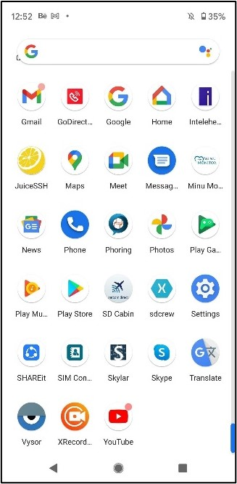 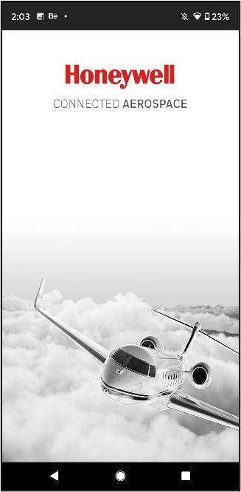 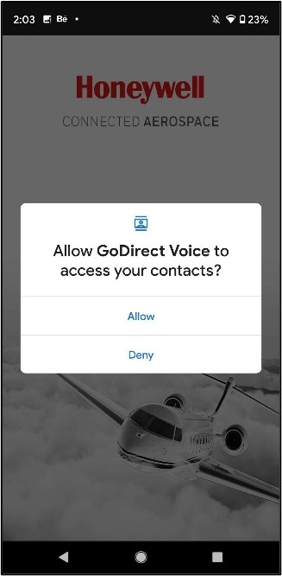

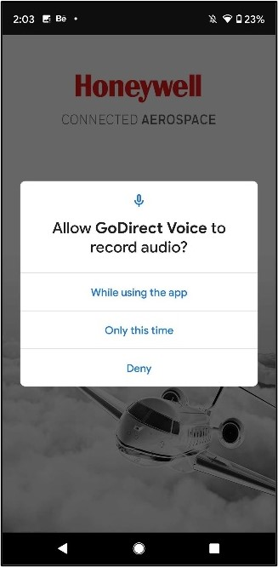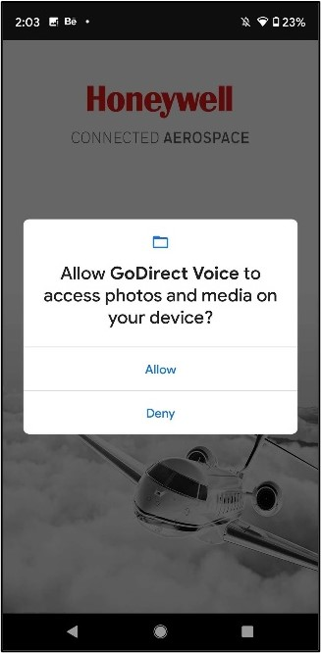

Figure : Application Launching

# **Account List- When User has more than one Account – Header** **1**

## **Account List – Heading 2**

Press “Dialout” button

Navigate to Account List

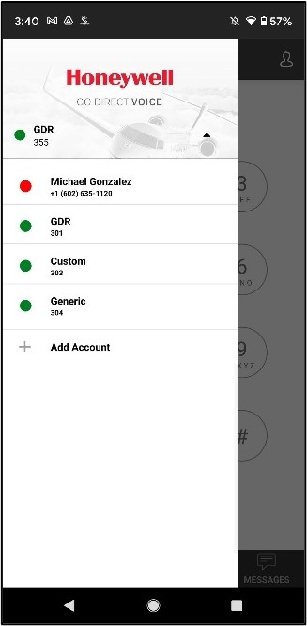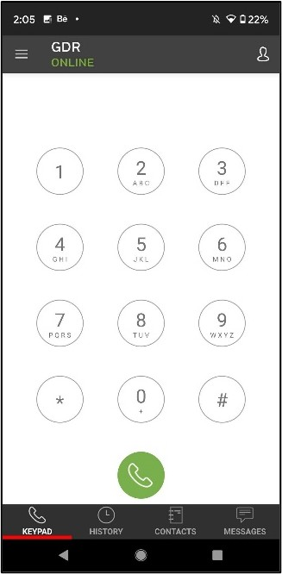

Figure : Account List in Different Dial-out selection

***NOTE: This list is showing into navigation drawer too***

## **App Navigation Drawer**

Press “Select” button

Navigate to Account List

Press “Dialout” button

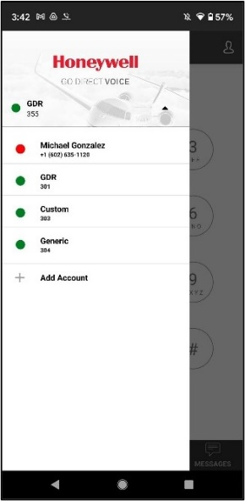

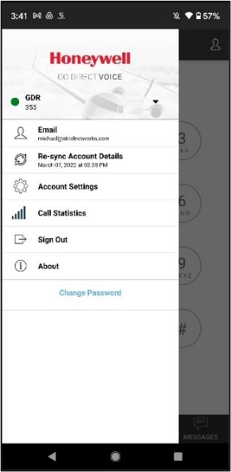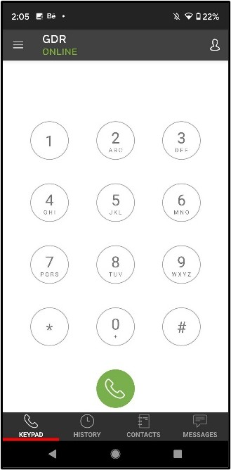

Figure : App Navigation Drawer

# **Call**

## **3.1** **Incoming call Screen**

### 3.1.1 Making Outgoing call from History Details-Heading 3

### ***From History Details for Saved Contact – Heading 4***

Press on “call icon to make outgoing call”

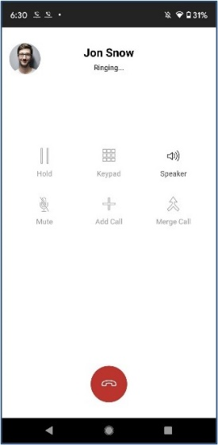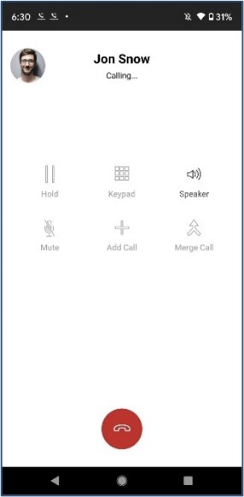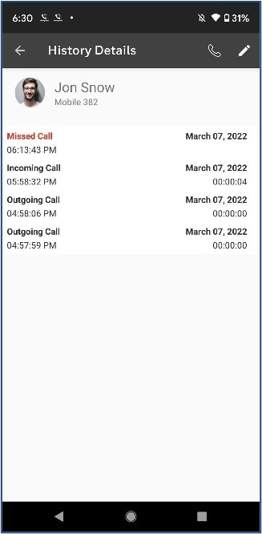

Figure : Outgoing Call Screen (Number Dialed from History Details of saved contact)

============END===========