**LAB REPORT#02**

**Submitted By: Sadia Batool**

**Submitted To: Sir Yasir Ali**

**Class: BS(CS) 30B**

**Roll No: F 59096**

**HTML CODE:**

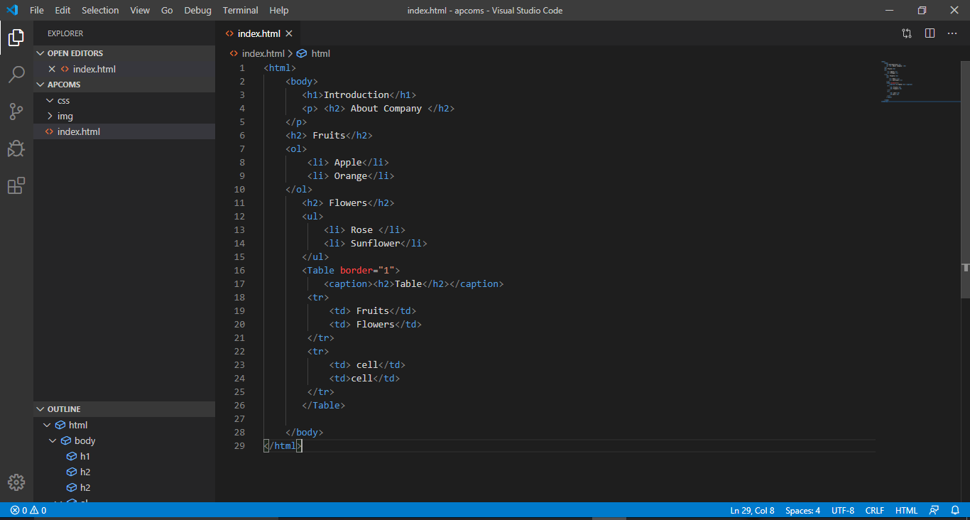

**OUTPUT:**

