**Home Assistant Software System for Timely Managing Household Chors**



A Project submitted to the Department of Computer Science and Engineering,

Hajee Mohammad Danesh Science and Technology University

Course Title: Software Engineering

Course Code: CSE 305

|  |  |
| --- | --- |
| **Submitted To,**  Pankaj Bhowmik  Lecturer  Department of Computer Science and Engineering | **Submitted By,**  Sadia Islam Neela  Student ID: 2002070  Level 3, Semester I |

DEPARTMENT OF COMPUTER SCIENCE AND ENGINEERING

HAJEE MOHAMMAD DANESH SCIENCE AND TECHNOLOGY UNIVERSITY, DINAJPUR-5200, BANGLADESH

**Home Assistant Software System for Timely Managing Household Chors**

The main goal of this project is to develop a software for Home Assistant Software System for Timely Managing Household Chorsusing different steps of Software Development Life Cycle (SDLC). Here, I use Prototype model for developing this software.

First I introduced The Prototype Model of SDLC.

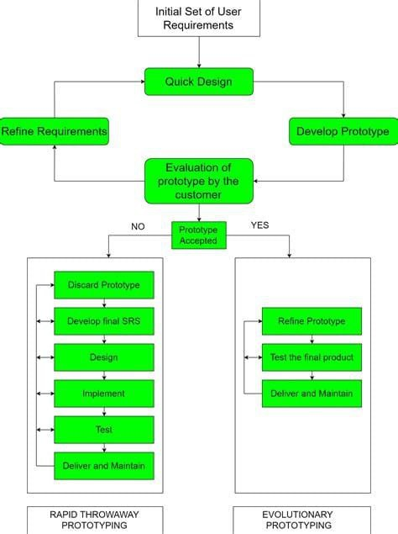

Developing home assistant software using a prototype model in software engineering involves creating an initial version of the software to quickly demonstrate its core features and gather feedback for iterative improvements. Here's a more detailed breakdown of how you can apply the prototype model to home assistant software development:

**Identification of Requirements:**

• Clearly define the requirements for your home assistant software.

• Identify the essential features that the software should support.

**Quick Design and Planning:**

• Develop a preliminary design for the user interface and core functionalities.

• Plan the development process, considering the iterative nature of the prototype model.

**Create a Throwaway Prototype:**

• Develop a basic version of the home assistant software that includes key features.

• This prototype may not have all the functionalities, but it should serve as a tangible

representation of the core concept. .

**User Evaluation:**

• Share the prototype with a small group of users or stakeholders.

• Gather feedback on the user interface, user experience, and the overall concept of your

home assistant software.

**Refinement:**

• Based on user feedback, refine the design and functionality of the prototype.

• Make necessary adjustments to improve user satisfaction and address any identified

issues.

**Iterative Development:**

• Continue to iterate on the prototype, adding new features or refining existing ones.

• Each iteration should build upon the feedback received from users and stakeholders.

**Regular User Testing:**

• Conduct regular user testing sessions to ensure that the evolving prototype meets user

expectations.

• Use testing feedback to guide further development.

**Gradual Enhancement:**

• Gradually enhance the prototype by incorporating additional features and improving

existing ones.

• Prioritize features based on user needs and the overall vision for the home assistant

software.

**Documentation:**

• Keep documentation up-to-date with each iteration.

• Document changes, improvements, and any new features added during the iterative

development process.

. **Integration of Devices and Services:**

• Integrate the home assistant software with a variety of devices and services commonly

used in smart homes.

• Ensure seamless communication and compatibility with a diverse range of devices.

**Security Considerations:**

• Integrate security measures and conduct regular security audits to identify and address

potential vulnerabilities.

• Prioritize user data protection and secure communication with connected devices.

**User Education:**

• Provide documentation or educational materials to help users understand and make the

most of the home assistant software.

• Consider adding tooltips or other guidance within the user interface to assist users.

**Deployment:**

• Once the prototype has evolved into a robust and feature-rich version, consider deploying

it for a wider audience.

• Monitor user feedback and address any issues that may arise in the production

environment.

The prototype model allows for flexibility and responsiveness to user needs throughout the development process, making it well-suited for projects like home assistant software where user interaction and feedback are crucial.