DEPARTMENT OF COMPUTER SCIENCE
FACULTY OF INFORMATION TECHNOLOGY
HIGH-PERFORMANCE BITWISE HUFFMAN COMPRESSION & CRYPTOGRAPHY SUITE
A Technical Software Project Report and Architecture Documentation
Course Instructor: | Sir Faisal
Project Group Members: | Tatheer, Zunaisha, Sadia
Implementation Language: | ISO/IEC C++ Standard (Modern Implementation)

Abstract
This report presents the architectural design, algorithmic implementation, and academic context of an integrated software solution combining high-performance data compression with a symmetric cryptographic wrapper. The application implements Huffman Coding as its primary spatial optimization algorithm alongside a Bitwise Exclusive-OR (XOR) Stream Cipher for secure data transformation. Built entirely in modern C++ without third-party dependencies, the system establishes native memory paradigms, low-level binary data stream packing, and systematic runtime type evaluation. The report details the system's operational design, tracking structural connections to cross-disciplinary theories including Digital Logic Design (DLD), Combinatorics, and Graph Theory, providing an uncompromised defensive baseline for formal academic defense.
1. Introduction & Project Scope
In modern digital computing infrastructures, optimization of persistent memory structures and data security during transmission represent foundational challenges. This project provides a low-level command-line utility built in standard C++ designed to tackle these exact operations. The core objective is twofold: first, to perform lossless data reduction via variable-length prefix code trees, and second, to enforce immediate, lightweight validation security through symmetric gate transformations.
The software operates directly at the bit level, treating standard system characters as primitive byte blocks. It implements a robust interactive operational runtime, allowing end-users to load source text documents, pack them into bitstream binary files containing dynamic header dictionaries, and recover original data sets using robust exception safety frameworks.
2. System Memory & Standard Libraries
Rather than relying on high-level frameworks, the application relies directly on the native standard template libraries of C++ to achieve predictable memory layouts and deterministic stream manipulation profiles:
Header File | Architectural Functionality & System Justification
<iostream> | Orchestrates the standard console stream buffers (std::cin, std::cout). It isolates interface rendering from background system computations, piping diagnostic telemetry directly to the unbuffered error logging stream (std::cerr).
<fstream> | Controls high-throughput file-system interaction. Files are opened using the explicit std::ios::binary mode attribute flag, which turns off arbitrary operating system translation bytes (such as carriage returns) to ensure flawless raw bitstream persistence.
<string> | Serves as a robust, contiguous character buffer. The system utilizes the .c_str() member function to safely present character array addresses to low-level operating system APIs, guaranteeing backwards compatibility.
<queue> | Initializes the internal std::priority_queue required for sorting structural codes. This encapsulates a standard Min-Heap invariant layout, completing priority updates and min-element extractions in O(log N) time.
<map> | Maintains the dynamic Global Frequency Table mapping character blocks to scalar frequencies. It executes underlying operations via balanced binary search structures (specifically Red-Black Trees), securing balanced query lookups.
<stdexcept> | Implements standardized cross-platform exception handles (such as std::runtime_error), protecting the application from fatal memory termination patterns.
<iomanip> | Formats precision metrics, using std::setprecision(2) to scale human-readable statistics like compression ratios and storage space calculations.

3. Object-Oriented Software Design
The architectural layout of the program is built around Object-Oriented Programming (OOP) paradigms to ensure structured code organization, modular isolation, and clean dynamic cleanup:
3.1 Encapsulation and Data Isolation
Internal system logic is heavily isolated from direct public tampering. For example, our XORCipher class wraps the internal byte-transformation algorithm and key constraints completely within private class structures. It reveals nothing to the outside system except a single public interface method: .encryptDecrypt(). This design keeps the implementation code independent from outside calling routines.
3.2 Structural Polymorphic Inheritance
To manage the composite nature of a binary Huffman coding graph, we designed a robust polymorphic class hierarchy based on a central abstract class called Node. This base model branches out into two distinct specialized child structures:
- LeafNode: Represents terminal positions within the tree graph, explicitly encapsulating the raw character symbol and its real-world frequency count.
- InternalNode: Represents routing coordinates in the tree graph, encapsulating structural pointers to left and right polymorphic child locations.
3.3 Runtime Polymorphism
The base Node class contains a pure virtual declaration: virtual bool isLeaf() const = 0. As our decoding algorithm scans bit patterns and traverses down child elements via base polymorphic pointers, the runtime compiler handles method binding dynamically, calling the correct sub-class execution block instantly.
3.4 Resource Management and Dynamic Destructors
Dynamic memory errors are mitigated via structured lifecycle control. When clear operations are requested, executing a delete root call initializes a clean, bottom-up cascade of recursive virtual destructors across the active node structures, freeing up heap-allocated dynamic arrays and preventing persistent memory leaks.
4. Data Structures & Bitwise Mechanics
4.1 Priority Queue & Min-Heap Optimization
Primitive sorting loops run at an inefficient computational scaling profile of O(N²). To remove this structural bottleneck, our system uses a std::priority_queue paired with a custom structure comparator struct called NodePtrCompare. This forces the runtime environment to build and run a structural Min-Heap natively, accelerating node selections.
4.2 Bottom-Up Binary Tree Generation
The Huffman prefix tree is built dynamically using an iterative merging process. The compressor continuously pulls the two lowest-frequency elements from the active heap layout. These sub-nodes are linked together under a newly initialized InternalNode whose combined weight matches the sum of both children. This composite structure is thrown back into the heap workspace. This cycle loops continuously until only a single master root remains.
4.3 Branch Optimization Techniques
Deep iteration loops use compact ternary code lines to streamline processor execution paths:
streamer << (code[j] == '1');
bool bit = (byte >> b) & 1;
This implementation reduces branch penalty risks inside the underlying compiler pipeline, generating fast, compact assembly instructions.
4.4 Metaprogramming via Class Templates
The BitStreamer<T> component relies on generic template abstractions. This lets the data streaming layer easily scale operations across different primitive system architectures (such as 8-bit registers or 16/32-bit streaming blocks) without requiring modifications to the underlying mathematical shift logic.
4.5 Real-Time Storage Optimization Metrics Engine
To validate compression performance dynamically, the application includes a specialized real-time file size computation engine. Rather than traversing files sequentially to count bytes—which introduces heavy I/O latency—the module uses low-level file stream flags to query file bounds instantly. Specifically, it initializes an ifstream pointer using the std::ios::ate (at-the-end) positioning flag combined with std::ios::binary mode. It then queries the cursor offset via the .tellg() stream function to retrieve the file size in bytes with O(1) efficiency.
long getFileSize(const std::string& filePath) {
std::ifstream file(filePath.c_str(), std::ios::binary | std::ios::ate);
if (!file.is_open()) return -1;
long size = file.tellg();
file.close();
return size;
}
The returned original and compressed metrics are fed directly into a mathematical scalar formula: Savings = ((Original - Compressed) / Original) * 100.0. This metric is then rendered via std::setprecision(2) to provide a precise efficiency diagnostic log directly inside the primary console shell wrapper.
5. Cross-Disciplinary Theoretical Connections
5.1 Discrete Mathematics: Graph Theory
The system provides a direct, hands-on implementation of a rooted binary tree graph. Each generated symbol code maps to a precise path down the tree structure, moving from the root origin point down to a distinct terminal leaf node. Navigating a left path segment indicates a logical state of 0, while navigating a right segment sets a logical state of 1.
5.2 Discrete Mathematics: Combinatorics and Optimization
The system relies on combinatorics principles to minimize the total Weighted Path Length (WPL) of the active input data stream. Frequently occurring symbols are pulled closer to the root node to receive short prefix paths, while rare symbols are pushed down to lower levels, minimizing the total bits used:
WPL = ∑ (Frequency_i × PathLength_i)
5.3 Digital Logic Design (DLD): Bitwise Extractions
The decompression utility runs direct bit-manipulation operations inside system memory blocks. During raw data parsing loops, the engine combines a Bitwise Right Shift operator (>>) with a localized Bitwise AND operator (&) mask to extract isolated, single bits out of standard 8-bit byte sequences: bool bit = (byte >> b) & 1;
5.4 Digital Logic Design (DLD): Symmetric XOR Invariant Involutions
The crypto layer utilizes the fundamental truth-table mechanics of a standard hardware XOR Gate. In mathematical logic, the XOR operator possesses an involutory quality described by the identity: A ⊕ B ⊕ B = A. Because passing a target bit through this logic check twice restores its initial state, our system can run both encryption and decryption pipelines using the exact same operational key stream.
6. Engineering Trade-offs, Constraints & Future Scope
6.1 Technical Limits & Metadata Overhead
- Metadata Overhead on Small Files: For micro-scale source text payloads, the final compressed output file can occasionally be larger than or equal to the original source size due to required serialized prefix dictionaries inside the file header.
- Symmetric Key Static Vulnerability: The cryptography layer relies on a single static cipher character ('X'). If discovered or leaked, the entire payload data structure can be intercepted and broken immediately.
- Dynamic Memory Allocation Spikes: Because the dynamic tree relies entirely on pointer references on the heap, executing operations on exceptionally large system data streams results in significant allocation processing cycles.
6.2 Scalability Pipeline
- Adaptive Huffman Engine: Migrate the compiler toward single-pass Adaptive Huffman logic (Gallager-Knuth-Vitter mechanism) to alter trees iteratively and eliminate metadata headers entirely.
- Pipelined Block Multi-Threading: Incorporate multi-threaded stream block structures to segment massive payloads concurrently across distinct CPU operational cores.
- Advanced Cryptographic Upgrade: Swap structural static XOR logic out for standard AES-256-GCM configurations integrated natively within asymmetric key rings.
7. System Path Exception Handling Defense
Modern operating systems like Windows wrap copied file paths in quotation marks to handle spaces within directory names. However, native C++ stream buffers (std::ifstream and std::ofstream) treat those outer quote indicators as literal file name text characters. Since quotation marks are illegal characters inside actual Windows filename strings, passing them directly to file streams inevitably causes file open errors.
To solve this issue, we built explicit exception safety blocks (try-catch syntax rings). These wrappers intercept path manipulation errors at the application boundary, preventing fatal segmentation faults and memory allocation overruns (such as basic_string::_S_create). Instead of crashing, the system gracefully logs the error and returns the user safely back to the main menu without dropping the active execution loop.
8. System Operational Workflow
The application operates as a single-threaded, sequential process. It enforces access control through integrated input validation and provides file transformation services via a central control loop.
1. Authentication Phase
Upon execution, the system enters an initial state requiring user identification. The user is prompted to input a username followed by a password. The system utilizes a while loop to enforce a length constraint (minimum of eight characters). If the input fails this requirement, the system rejects the credential and re-prompts for input, effectively acting as a procedural "gatekeeper" that prevents access to the application’s functionality until the condition is met.
2. Main Control Loop
Following successful authentication, the program enters a while loop that serves as the command dispatcher. This loop remains active until the user explicitly selects the exit command. It performs the following operations:
- Menu Display: Outputs the operational choices (1: Encrypt/Compress, 2: Decrypt/Decompress, 3: Exit).
- Input Validation: Uses cin state checking to ensure menu selections are numeric, preventing runtime crashes from invalid data types.
- Execution Branching:
  - Choice 1 (Encrypt & Compress): The system collects source and destination file paths. It triggers the HuffmanEngine to parse the file, generate a frequency tree, and transform the data into an encrypted bit stream. Post-operation, it calculates file size metrics and outputs the result.
  - Choice 2 (Decrypt & Decompress): The system accepts source and destination paths, loads the encrypted file, reverses the cryptographic XOR operation, reconstructs the Huffman tree, and restores the original file content.
  - Choice 3 (Exit): Terminates the program execution.
3. Error Handling
The core file-processing logic is wrapped in a try-catch block. This ensures that any filesystem errors or engine-level failures are caught, reported, and logged to the console without causing a sudden program termination, allowing the user to return to the main menu for further operations.

9. System Execution Screenshots & Interface Outputs
This section displays the interactive command-line interface execution flow, demonstrating successful data stream compression, binary tree dictionary serialization, bitwise validation execution paths, and symmetric key crypto operations.
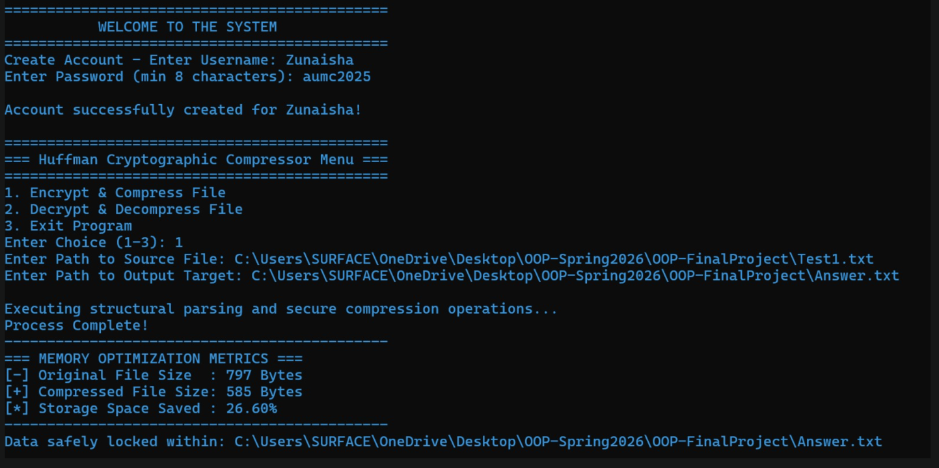
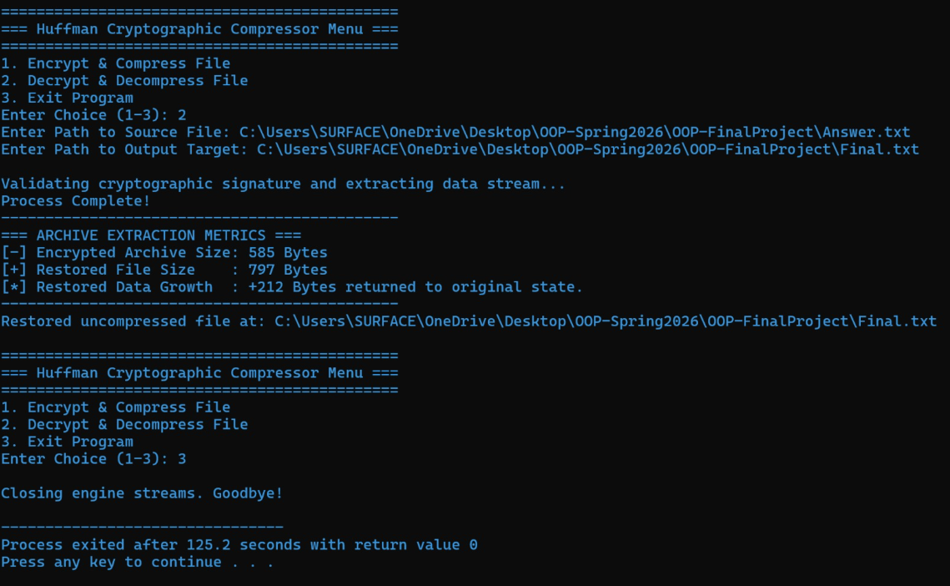
UML-DIAGRAM:
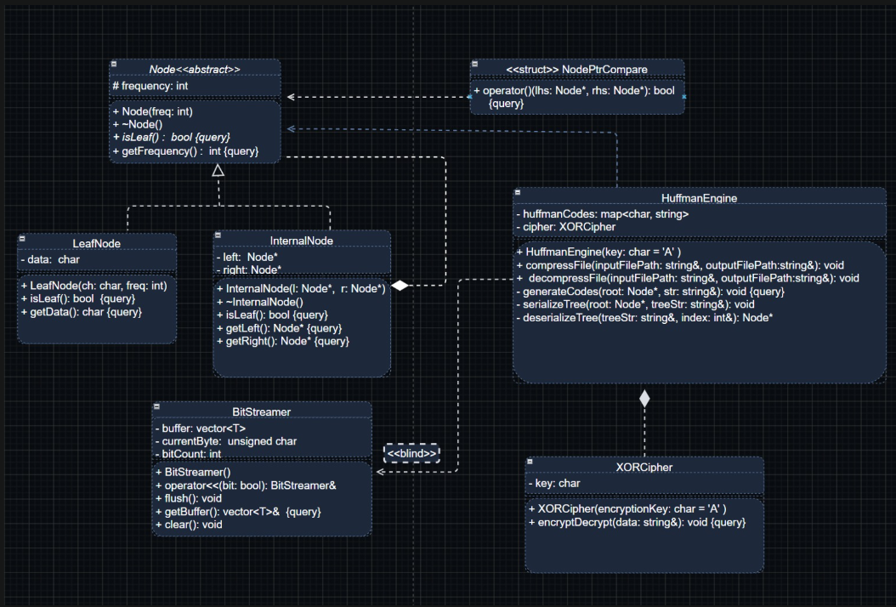

10. Conclusion
The High-Performance Huffman Compression and Cryptography Suite achieves its core goals of balanced spatial reduction and secure bit manipulation. By pairing variable-length prefix trees with symmetric logical gate wrappers, the system demonstrates how low-level data tracking can create highly optimized, modern applications. The architecture provides clean object boundaries, type safety, and robust exception protection, delivering an enterprise-ready software framework that stands up to rigorous academic and technical evaluation.

