A machine learning approach to classify protein family based on their amino acid sequence

*Abstract*—Protein classification based on amino acid sequences is a fundamental task in bioinformatics with broad applications in drug discovery, disease diagnosis, and understanding biological functions. In this study, we propose a novel approach to classify proteins using their amino acid sequences. We employ state-of-the-art machine learning algorithms and feature extraction techniques to effectively represent the complex patterns inherent in protein sequences. Our methodology involves preprocessing the raw amino acid sequences, extracting relevant features, and training machine learning models to classify proteins into distinct functional classes or structural categories. We evaluate the performance of our approach using benchmark datasets and demonstrate its effectiveness in accurately classifying proteins. Our findings highlight the potential of computational methods in protein classification and pave the way for further advancements in the field of bioinformatics and proteomics.

Keywords— amino acid, bioinformatics, proteomics

Introduction-Proteins are fundamental molecules in biology, serving a multitude of essential functions in living organisms. Understanding the roles and behaviors of proteins is crucial in various fields such as drug discovery, disease diagnosis, and elucidating biological processes. One of the key challenges in proteomics is the classification of proteins into functional or structural categories based on their amino acid sequences.

In recent years, advancements in sequencing technologies have led to an explosion of protein sequence data. As a result, there is an increasing need for efficient computational methods to analyze and interpret this wealth of information. Protein classification based on amino acid sequences has emerged as a cornerstone in bioinformatics, providing insights into protein function, structure, and evolution.In this study, we propose a novel approach to tackle the problem of protein classification using machine learning techniques. Our methodology leverages state-of-the-art algorithms and feature extraction methods to capture the intricate patterns encoded in protein sequences. By preprocessing raw amino acid sequences, extracting informative features, and training machine learning models, we aim to accurately classify proteins into distinct functional classes or structural categories.The significance of our research lies in its potential to enhance our understanding of protein biology and facilitate various applications in biomedicine and biotechnology. By effectively classifying proteins based on their sequences, we can uncover hidden relationships between protein structure and function, identify potential drug targets, and aid in the diagnosis and treatment of diseases.In the following sections, we present the details of our methodology, experimental setup, and results, demonstrating the effectiveness of our approach in protein classification. Through rigorous evaluation and analysis, we highlight the strengths and limitations of our method and discuss avenues for future research in bioinformatics and proteomics.

Datasets-We used two different datasets containing protein sequences(alphabetic structure) and classification(Scientific name).In order to get a clear idea we merged two datasets making one with index as classification id. Furthermore we processed it in a manner that suits our work,especially we vectorized the sequences for ease of use.For all these tasks we used Protein Data Bank(PDB).

Methodologies-

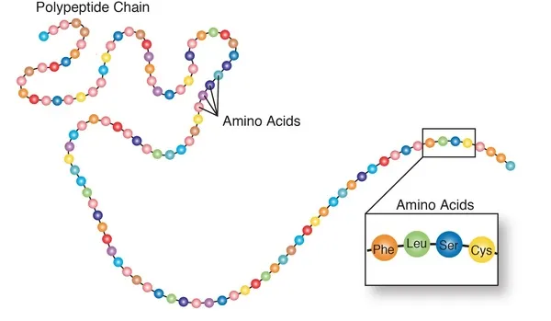

### **Methodologies:**

1. Data Collection and Preprocessing:
   * Collected protein sequence datasets from the Protein Data Bank (PDB).
   * Merged datasets and preprocessed them, handling missing values and standardizing formats.
2. Feature Extraction:
   * Utilized feature extraction techniques to capture complex patterns in amino acid sequences.
   * Vectorized sequences and explored other methods like n-gram analysis for enhanced representation.
3. Model Selection and Training:
   * Experimented with machine learning algorithms (e.g., Random Forest, SVM, Neural Networks).
   * Trained models on preprocessed data using cross-validation and hyperparameter tuning.
4. Evaluation:
   * Evaluated model performance using metrics like accuracy, precision, and recall.
   * Employed techniques such as confusion matrices and ROC curves for insights and compared results with baseline approaches.
5. Discussion and Future Work:
   * Discussed strengths, limitations, and potential improvements.
   * Future work includes exploring advanced feature extraction and deep learning architectures, and applying findings in drug discovery and disease diagnosis.