Objective

Looking for a challenging role in a reputable organization to utilize my technical skills for the growth of the organization as well as to enhance my knowledge about new and emerging trends in the IT sector. Hold BSC in Computer Science and Engineering from Daffodil International University.

Work Experience

**Sr. Executive – Ecommerce**

365Shoppingbd (01.11.2020 – 30.03.2021)

- Build E-Commerce Website.

- Web maintenance, troubleshooting online website issues, tracking website functionality, updating sites.

- Blog Writing, Created and maintained e-Commerce budget, strategy and marketing plans.

**Content Writing Dept. Associate**

Youth School for Social Entrepreneurs (01.07.2020 - 31.10.2020)

- Blog Writing, Checking and follow-up the teams.

- Assign tasks and ensure productivity of the interns.

- Research, Maintain and Update Social Media Platforms.

Technical Skills

|  |
| --- |
| **Languages:** Python, JavaScript, HTML/CSS, WordPress.  **IDE/Tools :** Android Studio, NetBeans, Py-Charm, PhpStorm, Anaconda, Codeblocks, Visual Studio Code, GitHub, Google Colab, MySQL Workbench, phpMyAdmin, Tinkercad.  **Database Systems:** MySQL, SQLite, Access.  **Library/Frameworks :** Keras, TensorFlow, OpenCV, Bootstrap, jQuery, Laravel  **Operating Systems :** Windows 10, Linux  **Others:** MS Office (Word, Excel, PowerPoint etc.) |

Projects

**Portfolio project: Live at:** <https://sadiajamal.github.io/>

**Programmed With: HTML, CSS3, JS.**

**E-Commerce Website: Live at :** <https://www.bancoff.com/>

**Build With: WordPress.**

**Weather Status Prediction of Dhaka city using Machine learning**

A machine learning model that predicts tomorrow’s temperature of Dhaka city.This model is built with Linear Regression, Logistic regression and Naïve Bayes Classifier.

**Programmed With: Python.**

Contact

**Address:**

Mirpur, Dhaka-1216

**Phone:**

+8801715167415

**Email:**

sadia.jamal2015@gmail.com

**GitHub:**

https://github.com/sadiajamal

**LinkedIn:**

https://www.linkedin.com/in/sadia00/

Relevant Courses

* Compiler Design
* Introduction to Bio-Informatics
* Operating Systems
* Computer Graphics
* Embedded Systems
* Robotics
* Introduction to Database Management Systems

**SADIA JAMAL**

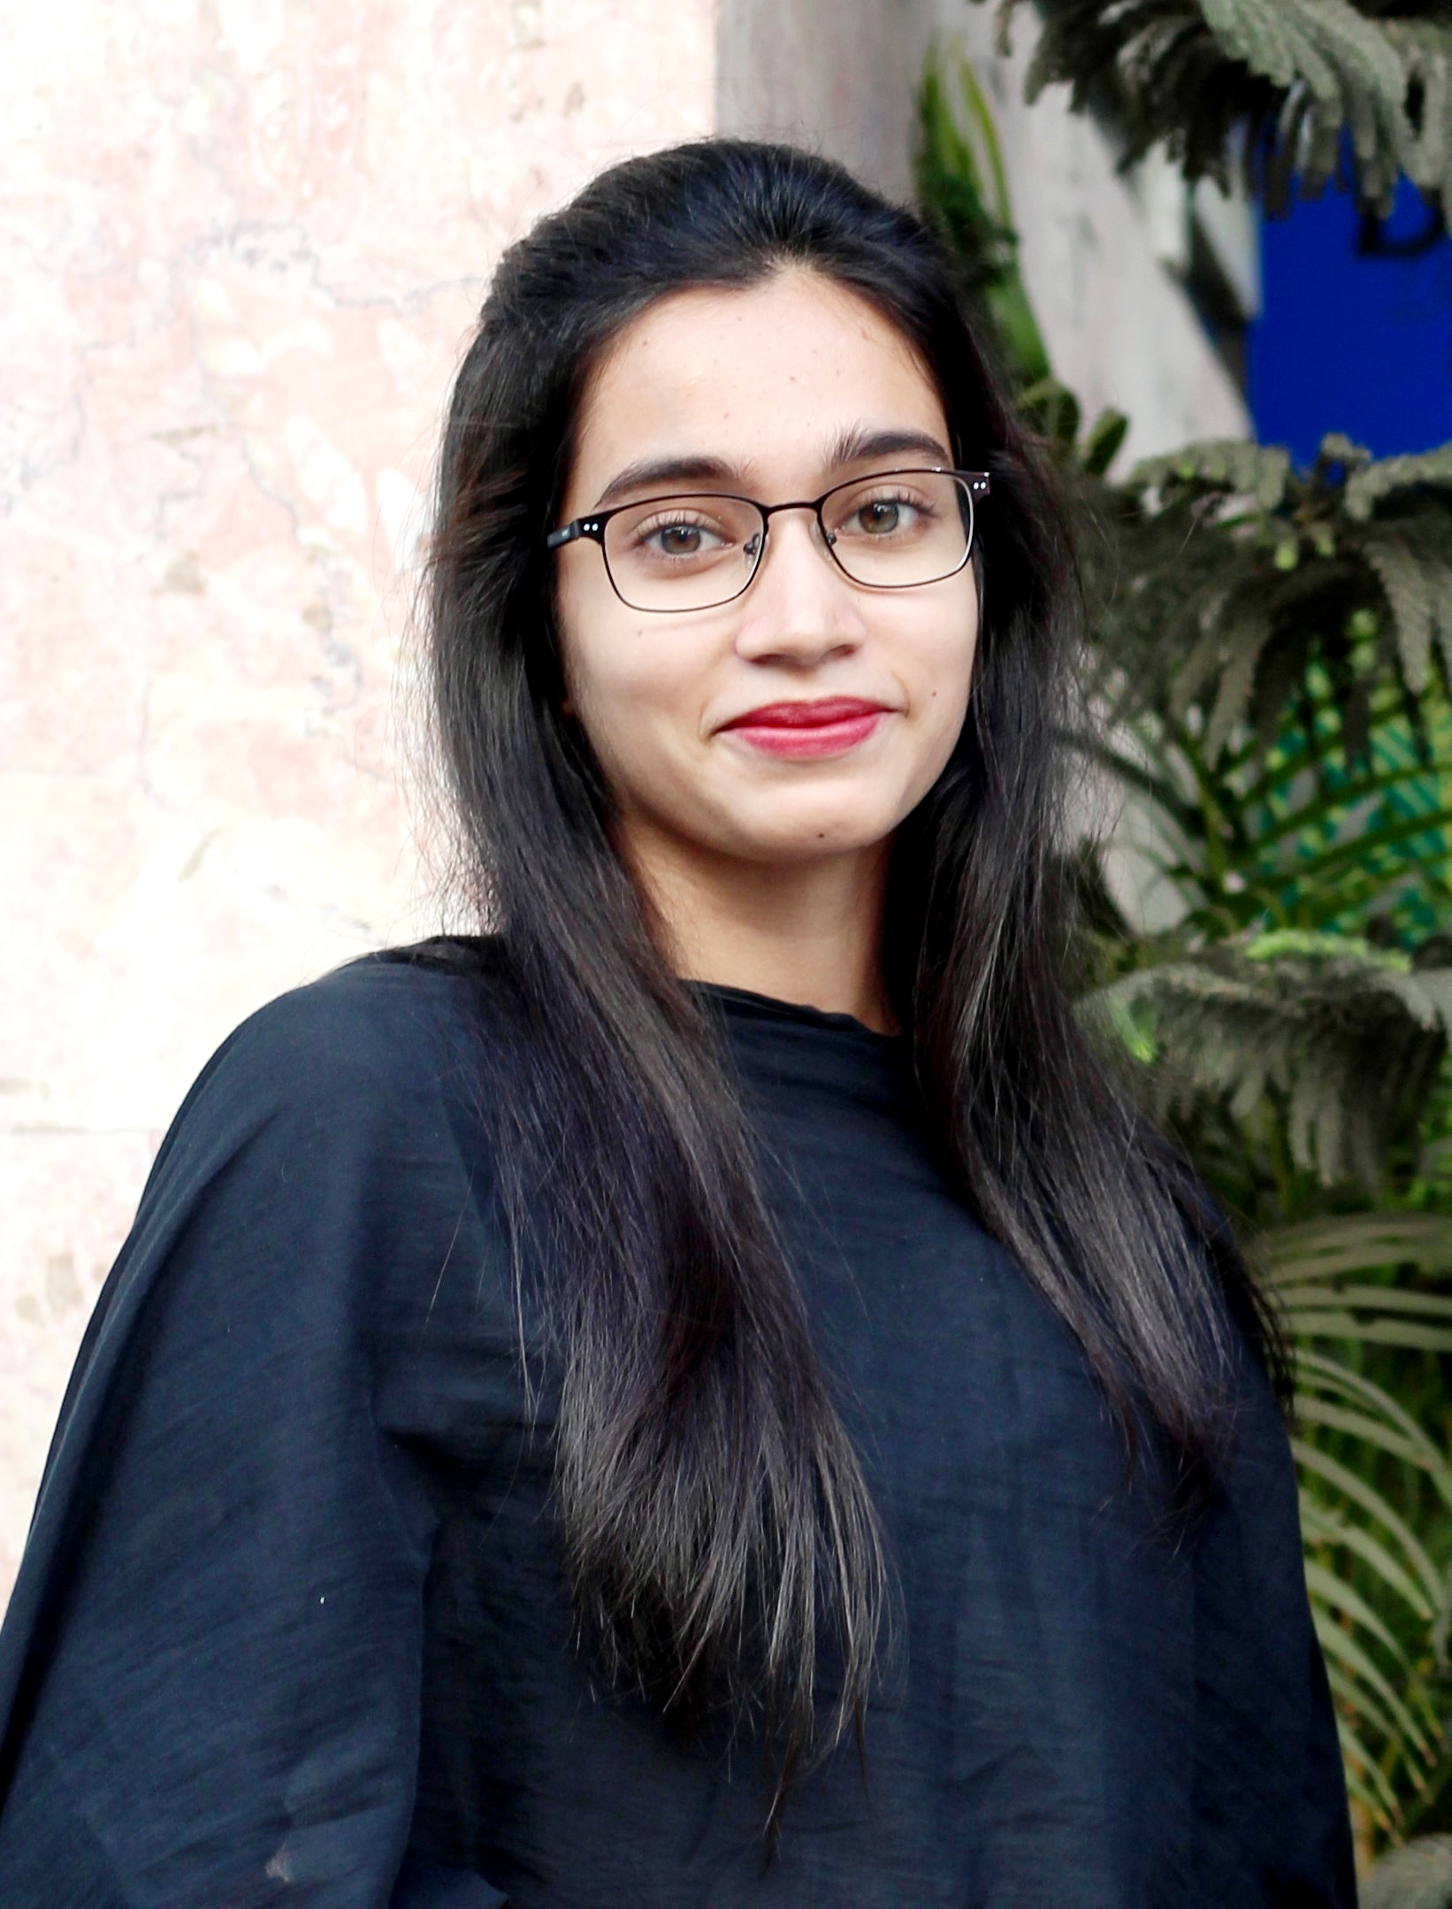

Languages

Bangla, English.

Interests

**Academic:** Problem Solving, Data Structures, Computer Network.

**Research:** Artificial Intelligence, Machine Learning, Deep Learning.

**Personal:** Listening to Music, Reading, Cooking.

**Forest Fire Analysis using ML**

This work is on Brazilian Forest Fire. The model is built with K-means Clustering, Fuzzy C-means and Apriori Algorithm. The model is able to show the states which are in risk of fire, based on previous data.

**Programmed With: Python.**

**DIU Charity Arcade**

A crowd funding website which is for disaster affected people.People can donate money, blood, cloths, medicines etc. for those who are in need.

**Programmed With: PHP, Laravel, HTML, CSS3.**

**Credit Card Fraud Detection**

This model can detect fraudulent credit card transactions so that customers are not charged for items that they did not purchase.

The model is built on Linear Regression, Logistic regression and K-means Clustering.

**Programmed With: Python.**

Education

Bachelor of Science: **Computer Science and Engineering** - 2020

**Daffodil International University**, Dhaka

Higher Secondary School Certificate: **Science Division** - July 2014

**Hizla Degree College**, Barisal

Secondary School Certificate: **Science Division** - April 2012

**DR. Khadem Hossain High School**, Barisal

Research Publications

**Sadia Jamal**, Tanvir Hossen Bappy, Roushanara Pervin, and AKM Shahariar Azad Rabby, “Weather Status Prediction of Dhaka city using Machine learning”, **International Conference on Computational Methods and Data Modeling (2020), India.**

**Sadia Jamal**, Tanvir Hossen Bappy, and AKM Shahariar Azad Rabby, “Brazilian Forest Fire Analysis: An Unsupervised Approach”, **International Conference on Computing and Communication (2020), India.**

Certifications

**Programming Foundations with JavaScript, HTML and CSS: Verify at:** [**https://coursera.org/share/757d9469e7d3853faa24e8e4f8f4cc95**](https://coursera.org/share/757d9469e7d3853faa24e8e4f8f4cc95)

**Interactivity with JavaScript: Verify at:**

[**https://coursera.org/share/d09edd921e1e0278c660f14d3a7515f9**](https://coursera.org/share/d09edd921e1e0278c660f14d3a7515f9)

**Grammar and Punctuation: Verify at:**

[**https://coursera.org/share/6f38be11cb64f87d91f54dc1db34d0e3**](https://coursera.org/share/6f38be11cb64f87d91f54dc1db34d0e3)