Objective

Computer Science and Engineering Graduate from Daffodil International University. Looking for real-life work opportunities where I can apply my skills and contribute to real-world projects.

Projects

**Portfolio project : Live at :** <https://sadiajamal.github.io/>

**Programmed With : HTML, CSS3, JS.**

**E-Commerce Website : Live at :** <https://www.bancoff.com/>

**Build With: WordPress.**

**Weather Status Prediction of Dhaka city using Machine learning**

A machine learning model that predicts tomorrow’s temperature of Dhaka city.This model is built with Linear Regression, Logistic regression and Naïve Bayes Classifier.

**Programmed With : Python.**

**Forest Fire Analysis using ML**

This work is on Brazilian Forest Fire. The model is built with K-means Clustering, Fuzzy C-means and Apriori Algorithm. The model is able to show the states which are in risk of fire, based on previous data.

**Programmed With : Python.**

**DIU Charity Arcade**

A crowd funding website which is for disaster affected people.People can donate money, blood, cloths, medicines etc. for those who are in need.

**Programmed With : PHP, Laravel, HTML, CSS3.**

**Credit Card Fraud Detection**

This model can detect fraudulent credit card transactions so that customers are not charged for items that they did not purchase.

The model is built on Linear Regression, Logistic regression and K-means Clustering.

**Programmed With : Python.**

Technical Skills

|  |
| --- |
| **Languages :** Python, JavaScript, HTML/CSS, C, WordPress.  **IDE/Tools :** Android Studio, NetBeans, Py-Charm, PhpStorm, Anaconda, Codeblocks, Visual Studio Code, GitHub, Google Colab, MySQL Workbench, phpMyAdmin, Tinkercad.  **Database Systems :** MySQL, SQLite, Access.  **Library/Frameworks :** Keras, TensorFlow, OpenCV, Bootstrap, jQuery, Laravel  **Operating Systems :** Windows 10, Linux  **Others :** MS Office (Word, Excel, PowerPoint etc.) |

Contact

**Address:**

380/18/E, Rampura, Dhaka-1209

**Phone:**

+8801715167415

**Email:**

sadia.jamal2015@gmail.com

**GitHub:**

https://github.com/sadiajamal

**LinkedIn:**

https://www.linkedin.com/in/sadia00/

Relevant Courses

* Compiler Design
* Introduction to Bio-Informatics
* Operating Systems
* Computer Graphics
* Embedded Systems
* Robotics
* Introduction to Database Management Systems

**SADIA**

**JAMAL**

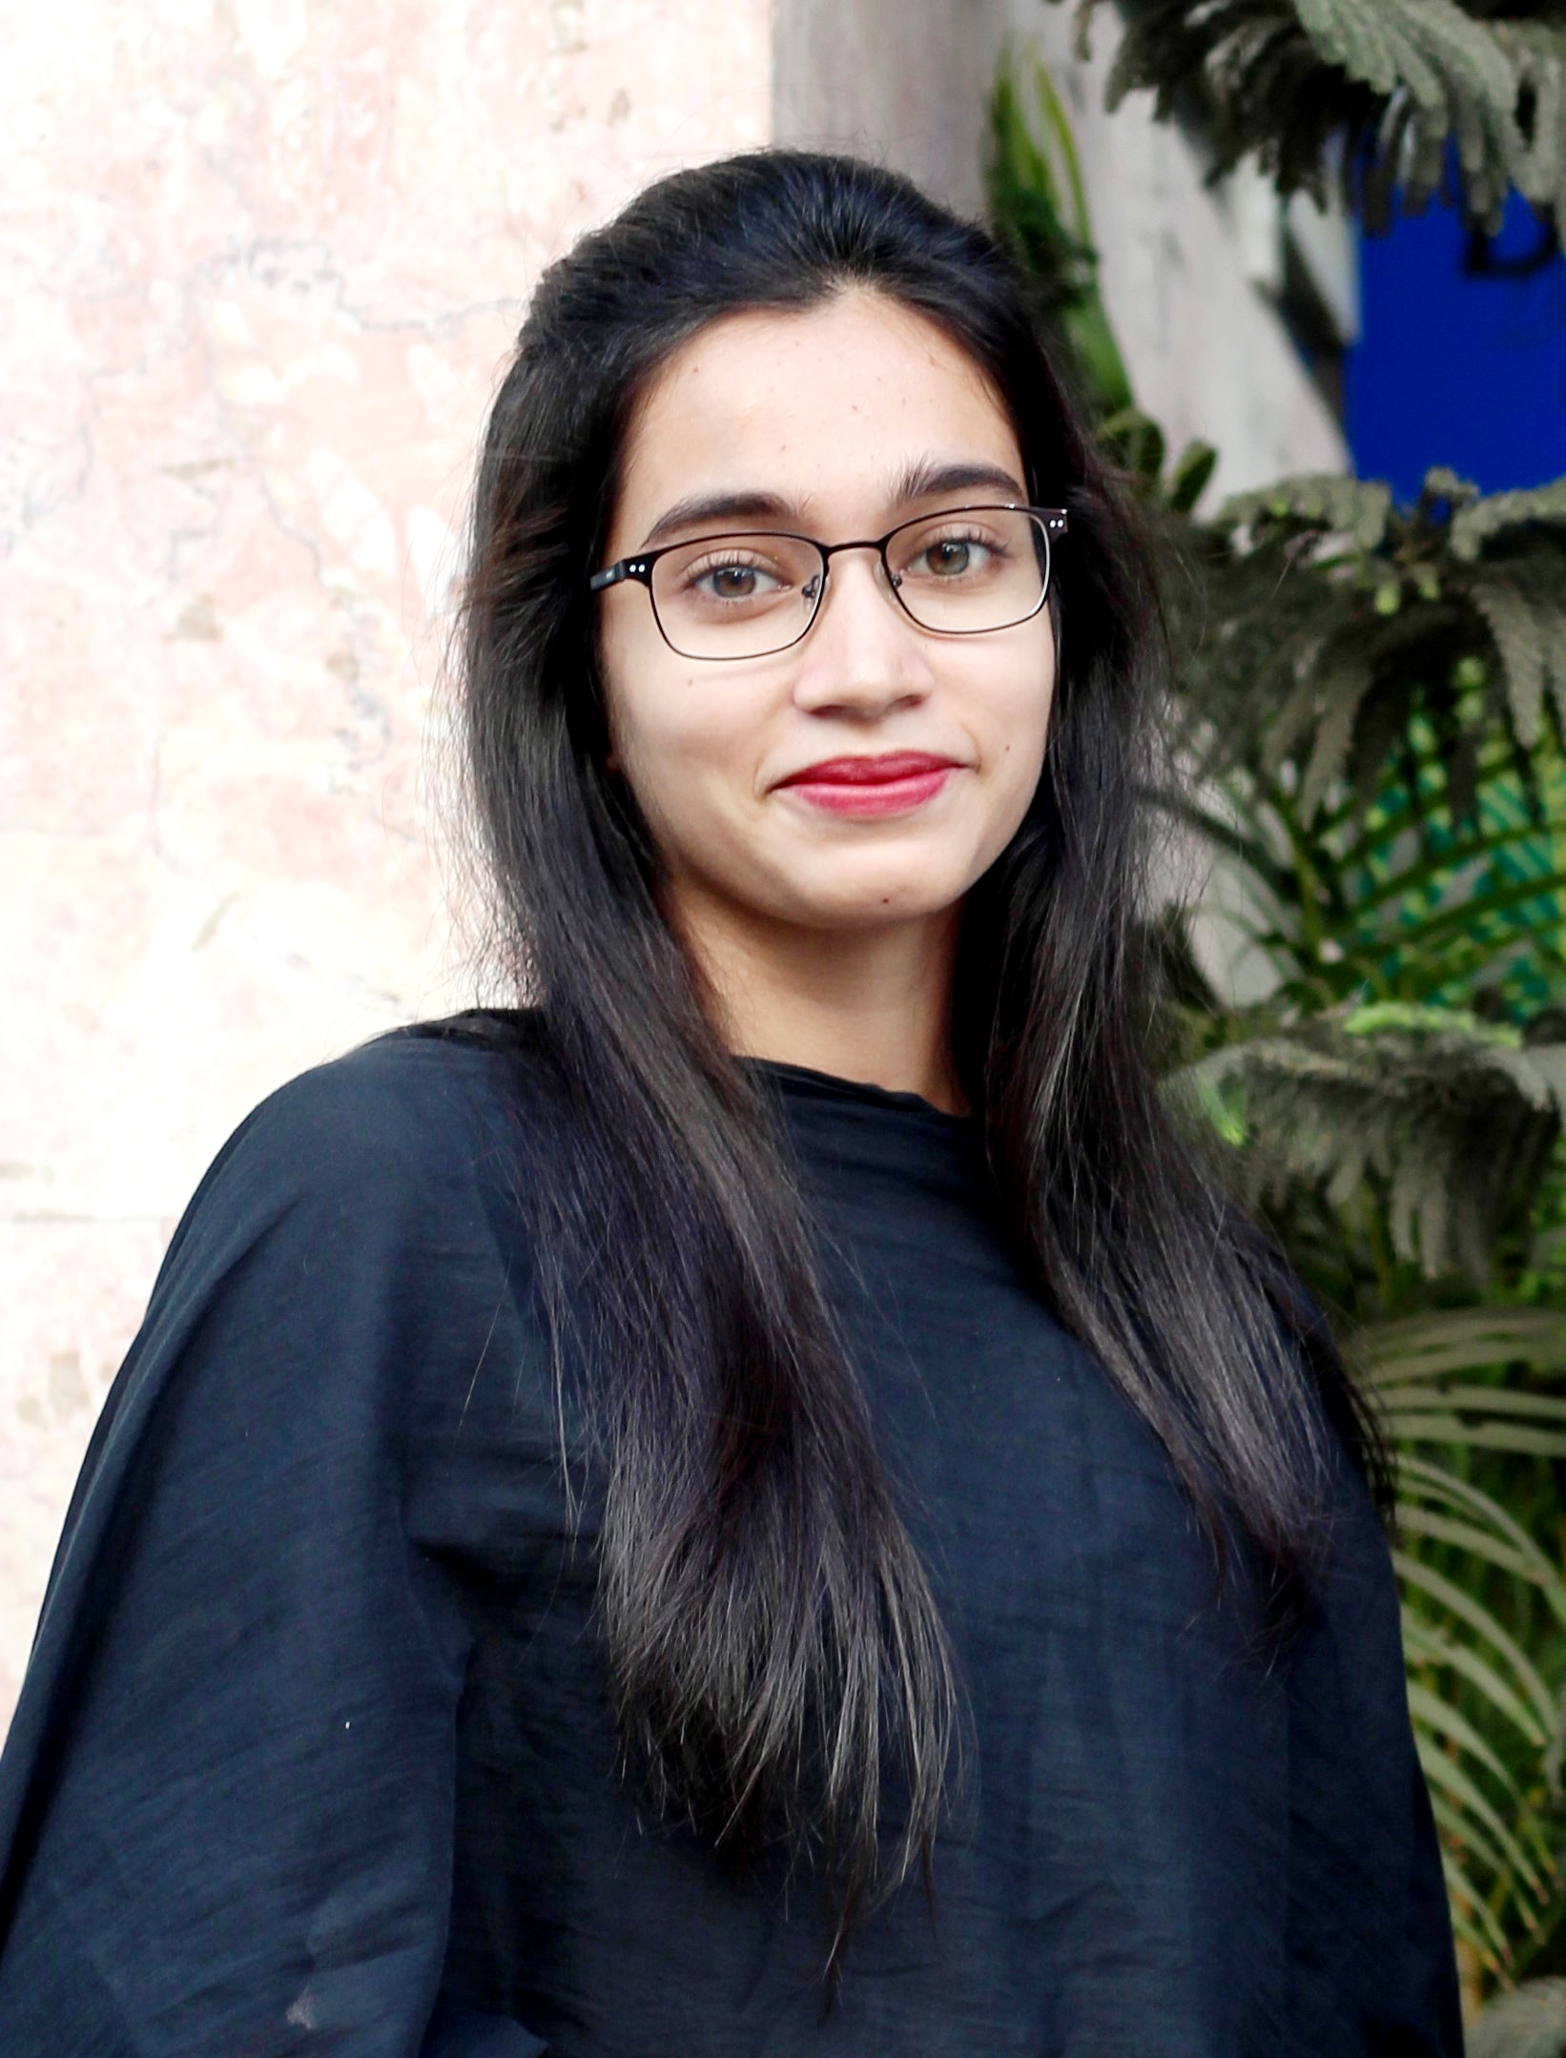

Languages

Bangla, English.

Interests

**Academic :** Problem Solving, Data Structures, Computer Network.

**Research :** Artificial Intelligence, Machine Learning, Deep Learning.

**Personal :** Listening to Music, Reading, Cooking.

Work Experience

**Sr. Executive – Ecommerce**

365Shoppingbd (01.10.2020 - Present)

- Build E-Commerce Website.

- Web maintenance, troubleshooting online website issues, tracking website functionality, updating sites.

- Blog Writing, Created and maintained e-Commerce budget, strategy and marketing plans.

Education

Bachelor of Science : **Computer Science and Engineering** - 2020

**Daffodil International University**, Dhaka

Higher Secondary School Certificate : **Science Division** - July 2014

**Hizla Degree College**, Barisal

Secondary School Certificate: **Science Division** - April 2012

**DR. Khadem Hossain High School**, Barisal

Research Publications

**Sadia Jamal**, Tanvir Hossen Bappy, Roushanara Pervin, and AKM Shahariar Azad Rabby, “Weather Status Prediction of Dhaka city using Machine learning”, **International Conference on Computational Methods and Data Modeling (2020), India.**

**Sadia Jamal**, Tanvir Hossen Bappy, and AKM Shahariar Azad Rabby, “Brazilian Forest Fire Analysis: An Unsupervised Approach”, **International Conference on Computing and Communication (2020), India.**

Certifications

**Programming Foundations with JavaScript, HTML and CSS : Verify at :** [**https://coursera.org/share/757d9469e7d3853faa24e8e4f8f4cc95**](https://coursera.org/share/757d9469e7d3853faa24e8e4f8f4cc95)

**Interactivity with JavaScript : Verify at :**

[**https://coursera.org/share/d09edd921e1e0278c660f14d3a7515f9**](https://coursera.org/share/d09edd921e1e0278c660f14d3a7515f9)

**Grammar and Punctuation : Verify at :**

[**https://coursera.org/share/6f38be11cb64f87d91f54dc1db34d0e3**](https://coursera.org/share/6f38be11cb64f87d91f54dc1db34d0e3)