**WEEK-4**

1# Write a java program to check whether the given number is odd or even.

**CODE**:

import java.util.Scanner;  
public class week_4_1 {  
 public static void main(String[] args) {  
 Scanner sc=new Scanner(System.*in*);  
 System.*out*.println("Enter your number : ");  
 int n= sc.nextInt();  
 if(n%2==0){  
 System.*out*.println("even number");  
 }  
 else {  
 System.*out*.println("odd number");  
 }  
 }  
}

**OUTPUT:** 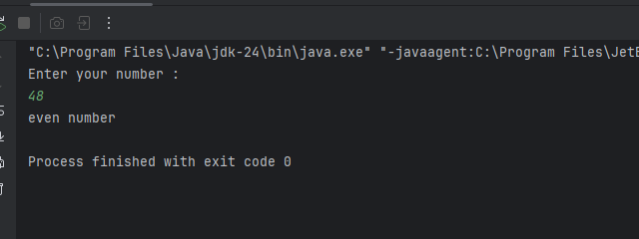

2# Write a java program to find the largest number among the three numbers.

**CODE:**

**import java.util.Scanner;  
public class week_4_2 {  
 public static void main(String[] args) {  
 Scanner sc= new Scanner(System.*in*);  
 System.*out*.println("Enter num 1 : ");  
 int n1=sc.nextInt();  
 System.*out*.println("Enter num 2 : ");  
 int n2=sc.nextInt();  
 System.*out*.println("Enter num 3 : ");  
 int n3=sc.nextInt();  
if(n1>n2 && n1>n3){  
 System.*out*.println(n1 + " is the largest number among "+ n1 +","+ n2 +" and" +n3);  
}  
else if(n2>n1 && n2>n3){  
 System.*out*.println(n2 + " is the largest number among " + n1 +","+ n2 +" and " +n3);  
  
}  
else {  
 System.*out*.println(n3+" is the largest number among "+ n1 + ","+ n2 +" and " +n3);  
}  
 }  
}**

**OUTPUT:** 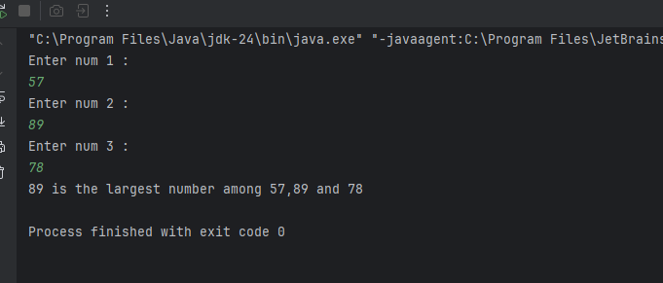

3# Write a Java program that takes a number as input and prints its multiplication table upto 10.

**CODE:**

}

**OUTPUT:**

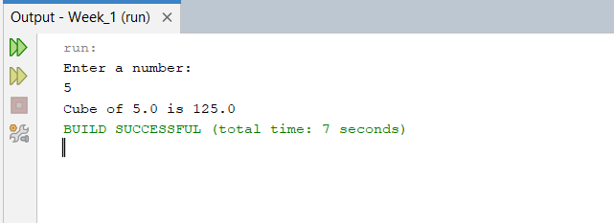

4# Write a Java program that takes three numbers as input to calculate and print the average of the numbers.

**CODE:**

package week_1;

import java.util.Scanner;

public class Avg {

public static void main(String[] args) {

Scanner sc= new Scanner (System.in);

System.out.println("Enter three numbers: ");

int n1=sc.nextInt();

int n2=sc.nextInt();

int n3=sc.nextInt();

double avg = (n1+n2+n3)/3.0;

System.out.println("Average = " + avg);

}

}

**OUTPUT:**

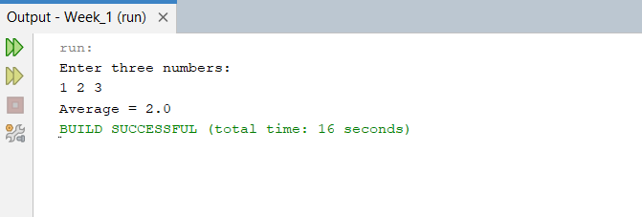

5# Write a Java program to compute the distance between two points.

**CODE:**

package week_1;

import java.util.Scanner;

public class Distance {

public static void main(String[] args) {

Scanner sc = new Scanner (System.in);

System.out.println("Enter first coordinates: ");

double x1 = sc.nextDouble();

double y1 = sc.nextDouble();

System.out.println("Enter second coordinates: ");

double x2 = sc.nextDouble();

double y2 = sc.nextDouble();

double distance= Math.pow((x1-x2),2) + Math.pow((y1-y2),2);

System.out.println("Distance = " + Math.sqrt(distance));

}

}

**OUTPUT:**

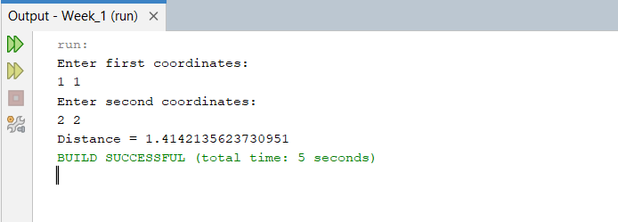

**Optional**

6# Write a Java program to swap two numbers using a temporary variable.

**CODE:**

package week_1_optional;

import java.util.Scanner;

public class Swap {

public static void main(String[] args) {

Scanner sc = new Scanner (System.in);

System.out.println("Enter two integer numbers: ");

int n1=sc.nextInt();

int n2=sc.nextInt();

System.out.println("Before swapping n1 = " + n1 + " and n2 = " + n2);

int temp= n1;

n1=n2;

n2=temp;

System.out.println("After swapping n1 = " + n1 + " and n2 = " + n2);

}

}

**OUTPUT:**

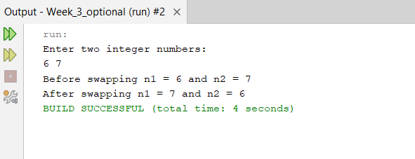

7# Write a Java program to calculate the area of a rectangle given its length and breadth.

**CODE:**

package week_1_optional;

import java.util.Scanner;

public class Rectangle {

public static void main(String[] args) {

Scanner sc = new Scanner (System.in);

System.out.println("Enter length and breadth: ");

double length=sc.nextDouble();

double breadth=sc.nextDouble();

double area=length*breadth;

System.out.println("Area of rectangle = " + area);

}

}

**OUTPUT:**

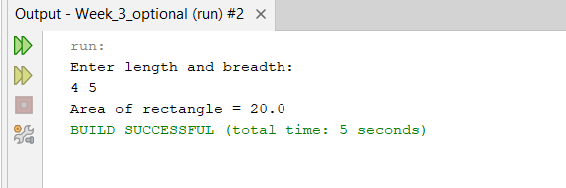

8# Write a Java program to convert temperature from Celsius to Fahrenheit.

**CODE:**

package week_1_optional;

import java.util.Scanner;

public class Celcius_Fahrenheit {

public static void main(String[] args) {

Scanner sc= new Scanner (System.in);

System.out.println("Enter temperature in Celsius: ");

double c=sc.nextDouble();

double f=((9.0/5.0)*c)+32;

System.out.println("Temperature in Fahrenheit is " + f);

}

}

**OUTPUT:**

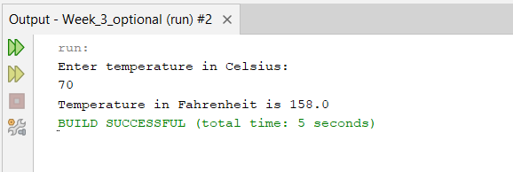

9# Write a Java program that takes two integer inputs and computes their remainder and quotient.

**CODE:**

package week_1_optional;

import java.util.Scanner;

class Remainder_quotient {

public static void main(String[] args) {

Scanner sc= new Scanner (System.in);

System.out.println("Enter two integer values: ");

int n1=sc.nextInt();

int n2=sc.nextInt();

System.out.println("Reaminder = " + (n1%n2) + " and Quotient = " + (n1/n2));}}

**OUTPUT:**

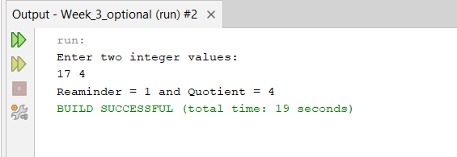

10# Write a Java program to find the circumference of a circle given its radius.

**CODE:**

package week_1_optional;

import java.util.Scanner;

public class Circumfrence {

public static void main(String[] args) {

Scanner sc= new Scanner (System.in);

System.out.println("Enter radius: ");

double r= sc.nextDouble();

double c= 2*Math.PI*r;

System.out.println("Circumference = " + c);

}

}

**OUTPUT:**

