**WEEK - 4**

1# Write a java program to check whether the given number is odd or even.

**CODE**:

**public class week11 {  
 import java.util.Scanner;  
 public class week_4_1 {  
 public static void main(String[] args) {  
 Scanner sc=new Scanner(System.*in*);  
 System.*out*.println("Enter your number : ");  
 int n= sc.nextInt();  
 if(n%2==0){  
 System.*out*.println("even number");  
 }  
 else {  
 System.*out*.println("odd number");  
 }  
 }  
 }  
  
}**

**OUTPUT:** 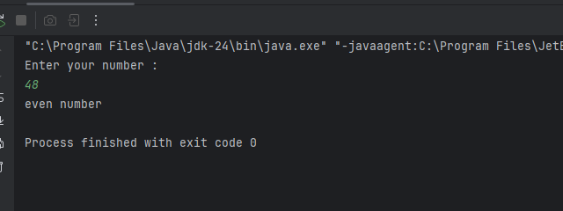

2# Write a java program to find the largest number among the three numbers.

**CODE:**

**import java.util.Scanner;  
public class week_4_2 {  
 public static void main(String[] args) {  
 Scanner sc= new Scanner(System.*in*);  
 System.*out*.println("Enter num 1 : ");  
 int n1=sc.nextInt();  
 System.*out*.println("Enter num 2 : ");  
 int n2=sc.nextInt();  
 System.*out*.println("Enter num 3 : ");  
 int n3=sc.nextInt();  
if(n1>n2 && n1>n3){  
 System.*out*.println(n1 + " is the largest number among "+ n1 +","+ n2 +" and" +n3);  
}  
else if(n2>n1 && n2>n3){  
 System.*out*.println(n2 + " is the largest number among " + n1 +","+ n2 +" and " +n3);  
  
}  
else {  
 System.*out*.println(n3+" is the largest number among "+ n1 + ","+ n2 +" and " +n3);  
}  
 }  
}**

**OUTPUT:** 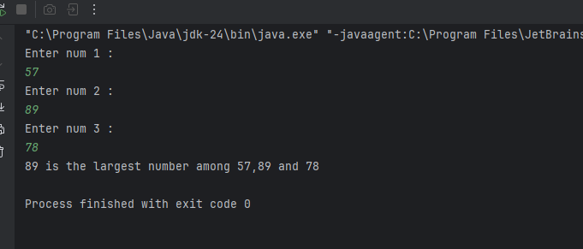

3# Write a Java program that takes a number as input and prints its multiplication table upto 10.

**CODE:**

public class week_4_3 {  
 public static void main(String[] args) {  
 System.*out*.println("The multiplication table of 10 : ");  
 int num=10;  
 for(int i=1;i<=10;i++){  
 System.*out*.println(num+"X"+i+"="+(num*i));  
 }  
 }  
}

**OUTPUT:**

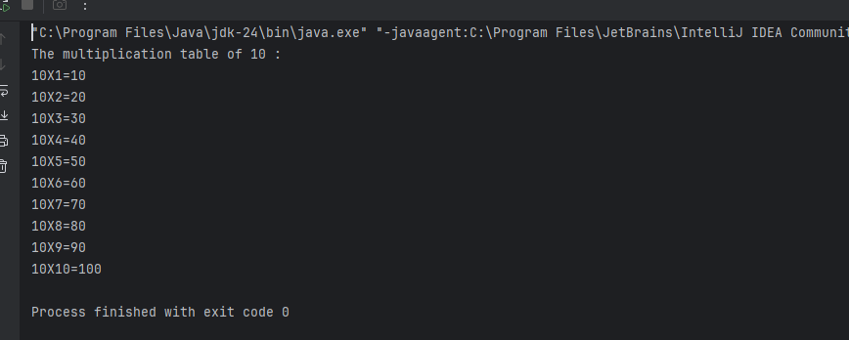

4# Write a Java program to calculate the sum of following series: 1 + 2 + 3 + 4 + .......... + N

**CODE:** **import java.util.Scanner;  
public class week_4_4 {  
 public static void main(String[] args) {  
 Scanner sc= new Scanner(System.*in*);  
 System.*out*.print("Enter the number : ");  
 int N=sc.nextInt();  
 int sum=0;  
for (int i=1;i<=N;i++){  
 sum+=i;  
}  
 System.*out*.println("The sum of the series is : " +sum);  
 }  
}**

**OUTPUT:**

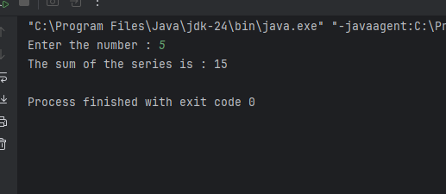

5# Write a Java program to take a number, divide it by 2 and print the result until the number becomes less than 10.

**CODE:** **import java.util.Scanner;  
public class WEEK_4_5 {  
 public static void main(String[] args) {  
 Scanner sc= new Scanner(System.*in*);  
 System.*out*.println("Enter a number : ");  
 int n= sc.nextInt();  
 while (n>=10){  
 n=n/2;  
 }  
 System.*out*.println("Result : "+n);  
 }  
}**

**OUTPUT:** 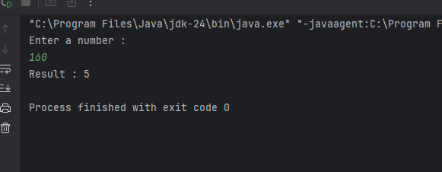

**Optional**

6# Write a Java program to check whether a given character is a vowel or consonant.

**CODE:** **import java.util.Scanner;  
  
public class week_4_6 {  
 public static void main(String[] args) {  
 Scanner sc = new Scanner(System.*in*);  
 System.*out*.println("Enter a letter : ");  
 char ch = sc.next().charAt(0);  
  
 if ((ch >= 'a' && ch <= 'z') || (ch >= 'A' && ch <= 'Z')) {  
 char lowerCh = Character.*toLowerCase*(ch);  
  
 if (lowerCh == 'a' || lowerCh == 'e' || lowerCh == 'i' || lowerCh == 'o' || lowerCh == 'u') {  
 System.*out*.println(ch + " is a vowel");  
 } else {  
 System.*out*.println(ch + " is a consonant");  
 }  
 } else {  
 System.*out*.println(ch + " is not an alphabet");  
 }  
 }  
}**

**OUTPUT:** 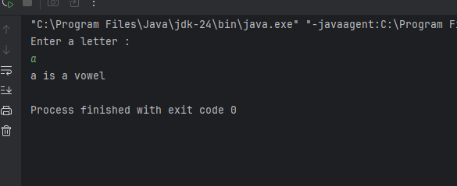

7# Write a Java program to find the smallest number among four given numbers.

**CODE:**

**OUTPUT:** **import java.util.Scanner;  
public class week_4_7 {  
 public static void main(String[] args) {  
 Scanner sc = new Scanner(System.*in*);  
 System.*out*.print("Enter first number: ");  
 int a = sc.nextInt();  
 System.*out*.print("Enter second number: ");  
 int b = sc.nextInt();  
 System.*out*.print("Enter third number: ");  
 int c = sc.nextInt();  
 System.*out*.print("Enter fourth number: ");  
 int d = sc.nextInt();  
   
 int smallest = a;  
 if (b < smallest) {  
 smallest = b;  
 }  
 if (c < smallest) {  
 smallest = c;  
 }  
 if (d < smallest) {  
 smallest = d;  
 }  
 System.*out*.println("The smallest number is: " + smallest);  
 }  
}**

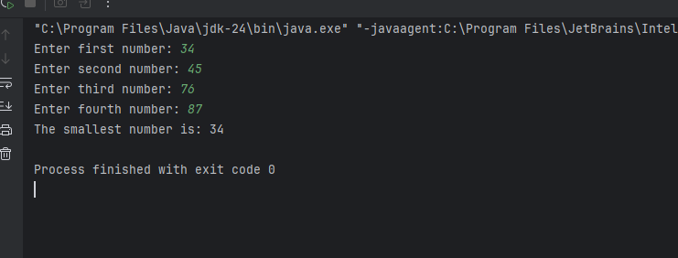

8# Write a Java program to calculate the sum of all even numbers from 1 up to a given number N

**CODE:**

**import java.util.Scanner;**

**public class SumEvenNumbersAny {**

**public static void main(String[] args) {**

**Scanner sc = new Scanner(System.in);**

**System.out.print("Enter how many even numbers to sum: ");**

**int n = sc.nextInt();**

**int sum = 0;**

**int number = 5;**

**for (int i = 1; i <= n; i++) {**

**sum += (number * i);**

**}**

**System.out.println("Sum of first " + n + " even numbers: " + sum)**

**}**

**}**

**OUTPUT:**

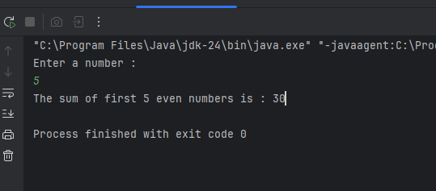

9# Write a Java program to check whether a given year is a leap year or not.

**CODE:**

**import java.util.Scanner;  
  
public class week_4_9 {  
 public static void main(String[] args) {  
 Scanner sc=new Scanner(System.*in*);  
 System.*out*.println("Enter a year :");  
 int year= sc.nextInt();  
 if((year % 4==0 && year % 100!=0)||(year%400==0)){  
 System.*out*.println(year+" is a leap year");  
 }  
 else {  
 System.*out*.println(year+" is not a leap year");  
 }  
 }  
}**

**OUTPUT:**

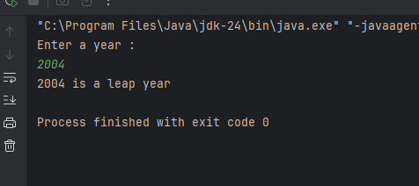

10# Write a Java program that takes a number as input and prints all its factors.

**CODE:**

**import java.util.Scanner;  
public class week_4_10 {  
 public static void main(String[] args) {  
 Scanner sc = new Scanner(System.*in*);  
 System.*out*.print("Enter a number: ");  
 int num = sc.nextInt();  
 System.*out*.println("Factors of " + num + " are:");  
 for (int i = 1; i <= num; i++) {  
 if (num % i == 0) {  
 System.*out*.println(i);  
 }  
 }  
 }  
}**

**OUTPUT:** 