**WEEK - 5**

1# Write a Java program to insert 10, 20, 30 ....in an array and display them.

**CODE**:

**public class week_5_1 {  
 public static void main(String[] args) {  
 int [] num={10,20,30,40,50};  
 System.*out*.println(num[0]);  
 System.*out*.println(num[1]);  
 System.*out*.println(num[2]);  
 System.*out*.println(num[3]);  
 System.*out*.println(num[4]);  
  
 }  
}**

**OUTPUT:**

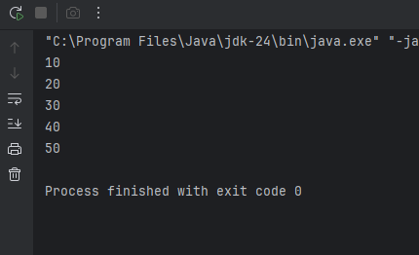

2# Write a Java program to calculate the sum of all the array elements.

**CODE:** **import java.util.Scanner;  
public class WEEK_5_2 {  
 public static void main(String[] args) {  
 Scanner sc = new Scanner(System.*in*);  
 System.*out*.print("Enter the number of elements in the array: ");  
 int n = sc.nextInt();  
 int[] arr = new int[n];  
 int sum = 0;  
  
 System.*out*.println("Enter the elements:");  
 for (int i = 0; i < n; i++) {  
 arr[i] = sc.nextInt();  
 sum += arr[i];  
 }  
 System.*out*.println("Sum of all elements: " + sum);  
 }  
}**

**OUTPUT:** 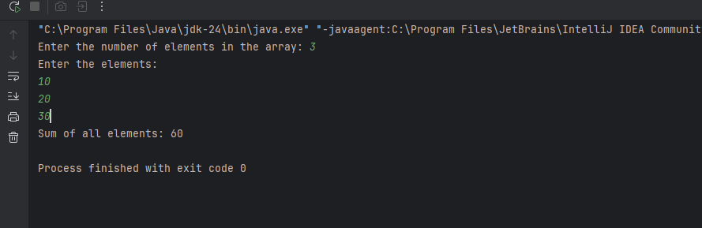

3# Write a java program to print the following pattern.

1

12

123

1234

12345

**CODE:**

**public class WEEK_5_3 {  
 public static void main(String[] args) {  
 int n = 5;  
 for (int i = 1; i <= n; i++) {  
 for (int s = 1; s <= n - i; s++) {  
 System.*out*.print(" ");  
 }  
 for (int j = 1; j <= i; j++) {  
 System.*out*.print(j);  
 }  
 System.*out*.println();  
 }  
 }  
 }**

**OUTPUT:** 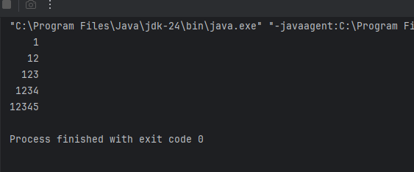

4# Write a java program to find the sum of following series where n is input by the user. 1+1/2+1/3+1/4+...............+1/n.

**CODE:**

**import java.util.Scanner;  
public class week_5_4 {  
 public static void main(String[] args) {  
 Scanner sc=new Scanner(System.*in*);  
 System.*out*.println("Enter the value of n :");  
 int n= sc.nextInt();  
 double sum=0;  
 for(int i=1;i<=n;i++){  
 sum+=1.0/i;  
 }  
 System.*out*.println("The sum of the series is: "+sum);  
 }  
}**

**OUTPUT:**

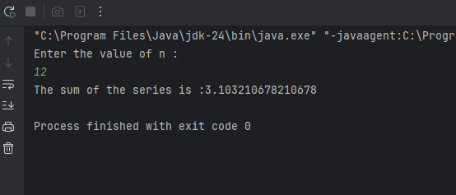

5# Write a Java program and compute the sum of the digits of an integer.

**CODE:**

**import java.util.Scanner;  
public class week_5_5 {  
 public static void main(String[] args) {  
 Scanner sc = new Scanner(System.*in*);  
 System.*out*.print("Enter an integer: ");  
 int number = sc.nextInt();  
 int sum = 0;  
 int temp = Math.*abs*(number);  
 while (temp > 0) {  
 sum += temp % 10;  
 temp /= 10;  
 }  
 System.*out*.println("Sum of digits: " + sum);  
 }  
}**

**OUTPUT:**

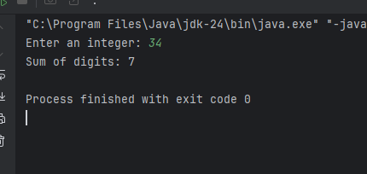

6# Write a Java program to calculate the factorial of a number.

**CODE:**

**import java.util.Scanner;  
public class WEEK_5_6 {  
 public static void main(String[] args) {  
 Scanner sc =new Scanner(System.*in*);  
 System.*out*.println("Enter a number : ");  
 int n=sc.nextInt();  
 long fact=1;  
 for (int i=1;i<=n;i++){  
 fact*=i;  
 }  
 System.*out*.println(n+"!="+fact);  
 }  
}**

**OUTPUT:** 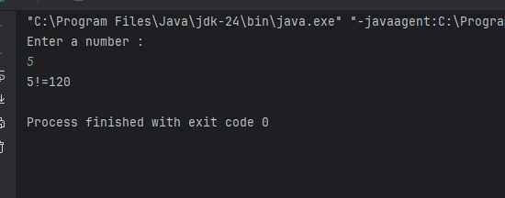

**Optional**

7# Write a Java program to find the largest element in a given integer array.

**CODE:** **import java.util.Scanner;  
public class week_5_7 {  
 public static void main(String[] args) {  
 Scanner sc = new Scanner(System.*in*);  
  
 System.*out*.print("Enter the number of elements in the array: ");  
 int n = sc.nextInt();  
 int[] arr = new int[n];  
 System.*out*.println("Enter " + n + " integers:");  
 for (int i = 0; i < n; i++) {  
 arr[i] = sc.nextInt();  
 }  
 int largest = arr[0];  
  
 for (int i = 1; i < n; i++) {  
 if (arr[i] > largest) {  
 largest = arr[i];  
 }  
 }  
 System.*out*.println("The largest element in the array is: " + largest);  
 }  
}**

**OUTPUT:** 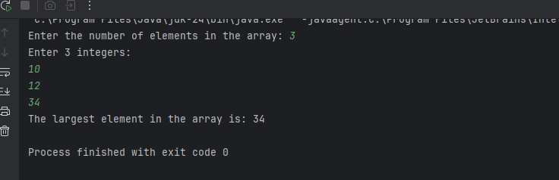

8# Write a Java program to reverse the digits of a given integer.

**CODE:**

**import java.util.Scanner;  
public class week_5_8 {  
 public static void main(String[] args) {  
 Scanner sc = new Scanner(System.*in*);  
 System.*out*.print("Enter an integer: ");  
 int number = sc.nextInt();  
 int reversed = 0;  
 int temp = Math.*abs*(number);  
 while (temp > 0) {  
 int digit = temp % 10;  
 reversed = reversed * 10 + digit;  
 temp /= 10;  
 }  
 if (number < 0) {  
 reversed *= -1;  
 }  
 System.*out*.println("Reversed number: " + reversed);  
 }  
}**

**OUTPUT:**

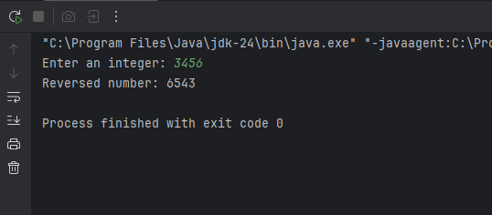

|  |
| --- |
| 9# Write a Java program to check if a given number is a palindrome or not. |

**import java.util.Scanner;  
public class palindrome {  
 public static void main(String[] args) {  
 Scanner sc=new Scanner(System.*in*);  
 System.*out*.println("enter a number : ");  
 int n= sc.nextInt();  
 int temp=n;  
 int rev=0;  
 while (temp>0){  
 int digit=temp%10;  
 rev=rev*10+digit;  
 temp/=10;  
 }  
 if(rev==n){  
 System.*out*.println(n+" is a palindrome");  
 }  
 else {  
 System.*out*.println(n+" is NOT a palindrome");  
 }  
 }  
}**

10# Write a Java program to convert a decimal number into Hexadecimal number and vice-versa.

**CODE:**

**import java.util.Scanner;  
public class week_5_9 {  
 public static void main(String[] args) {  
 Scanner sc = new Scanner(System.*in*);  
 System.*out*.println("Choose conversion:");  
 System.*out*.println("1. Decimal to Hexadecimal");  
 System.*out*.println("2. Hexadecimal to Decimal");  
 System.*out*.print("Enter your choice (1 or 2): ");  
 int choice = sc.nextInt();  
  
 if (choice == 1) {  
 // Decimal to Hexadecimal  
 System.*out*.print("Enter a decimal number: ");  
 int decimal = sc.nextInt();  
 String hex = Integer.*toHexString*(decimal).toUpperCase();  
 System.*out*.println("Hexadecimal: " + hex);  
  
 } else if (choice == 2) {  
 // Hexadecimal to Decimal  
 System.*out*.print("Enter a hexadecimal number: ");  
 String hex = sc.next();  
 int decimal = Integer.*parseInt*(hex, 16);  
 System.*out*.println("Decimal: " + decimal);  
  
 } else {  
 System.*out*.println("Invalid choice.");  
 }  
 }  
}**

**OUTPUT:**

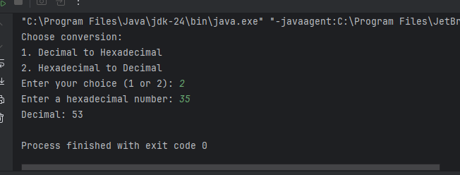

|  |
| --- |
| 11# Write a Java program to print the following pattern:  *  **  ***  **  * |

**CODE:** **public class week_5_11 {  
 public static void main(String[] args) {  
 int n = 3;  
 for (int i = 1; i <= n; i++) {  
 for (int s = 1; s <= n - i; s++) {  
 System.*out*.print(" ");  
 }  
 for (int j = 1; j <= i; j++) {  
 System.*out*.print("*");  
 }  
 System.*out*.println();  
 }  
 for (int i = n - 1; i >= 1; i--) {  
 for (int s = 1; s <= n - i; s++) {  
 System.*out*.print(" ");  
 }  
 for (int j = 1; j <= i; j++) {  
 System.*out*.print("*");  
 }  
 System.*out*.println();  
 }  
 }  
}**

**OUTPUT:**

