**WEEK - 6**

1# Write a Java program to print the odd numbers from 1 to 99.

**CODE**:

public class week_6_1 {  
 public static void main(String[] args) {  
 for (int i=1;i<=100;i+=2){  
 System.*out*.print(i);  
 }  
 }  
}

**OUTPUT:**

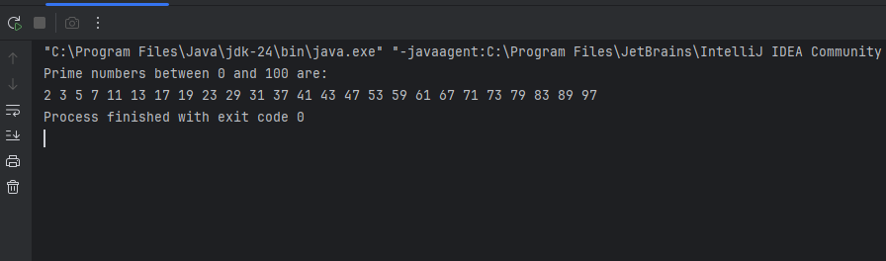

2# Write a Java program to check whether a number is prime or not.

**CODE:**

import java.util.Scanner;  
public class week_6_2 {  
 public static void main(String[] args) {  
 Scanner sc = new Scanner(System.*in*);  
  
 System.*out*.print("Enter a number: ");  
 int num = sc.nextInt();  
  
 boolean isPrime = true;  
  
 if (num <= 1) {  
 isPrime = false;  
 } else {  
 for (int i = 2; i <= num / 2; i++) {  
 if (num % i == 0) {  
 isPrime = false;  
 break;  
 }  
 }  
 }  
 if (isPrime) {  
 System.*out*.println(num + " is a prime number.");  
 } else {  
 System.*out*.println(num + " is not a prime number.");  
 }  
 }  
}

**OUTPUT:** 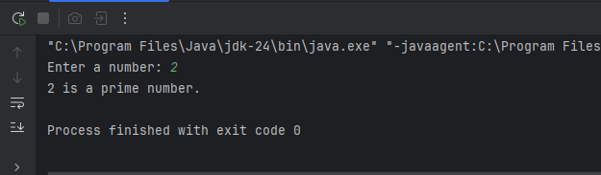

|  |
| --- |
| Write a Java program to swap the first and last elements of an array. |

**CODE:**

**import java.util.Scanner;  
public class week_6_3 {  
 public static void main(String[] args) {  
 Scanner sc = new Scanner(System.*in*);  
 System.*out*.print("Enter the number of elements in the array: ");  
 int n = sc.nextInt();  
 int[] arr = new int[n];  
 System.*out*.println("Enter the elements of the array:");  
 for (int i = 0; i < n; i++) {  
 arr[i] = sc.nextInt();  
 }  
 if (n > 1) {  
 int temp = arr[0];  
 arr[0] = arr[n - 1];  
 arr[n - 1] = temp;  
 }  
 System.*out*.println("Array after swapping first and last elements:");  
 for (int num : arr) {  
 System.*out*.print(num + " ");  
 }  
  
 }  
}**

**OUTPUT:** 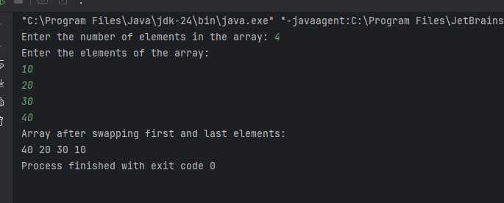

4# Write a Java program to find the maximum and minimum among array elements

**CODE:**

**public class week_6_4 {  
 public static void main(String[] args) {  
 int[] arr = {45, 12, 78, 34, 89, 23};  
  
 int max = arr[0];  
 int min = arr[0];  
  
 for (int i = 1; i < arr.length; i++) {  
 if (arr[i] > max) {  
 max = arr[i];  
 }  
 if (arr[i] < min) {  
 min = arr[i];  
 }  
 }  
  
 System.*out*.println("Maximum element: " + max);  
 System.*out*.println("Minimum element: " + min);  
 }  
}**

**OUTPUT:**

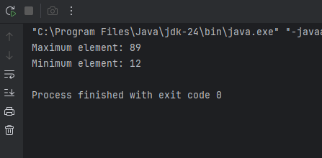

5# Write a Java program to print all prime numbers between 0 to 100.

**CODE:**

public class week_6_5 {  
 public static void main(String[] args) {  
 System.*out*.println("Prime numbers between 0 and 100 are:");  
 for (int num = 2; num <= 100; num++) {  
 boolean isPrime = true;  
 for (int i = 2; i <= Math.*sqrt*(num); i++) {  
 if (num % i == 0) {  
 isPrime = false;  
 break;  
 }  
 }  
 if (isPrime) {  
 System.*out*.print(num + " ");  
 }  
 }  
 }  
}

**OUTPUT:**

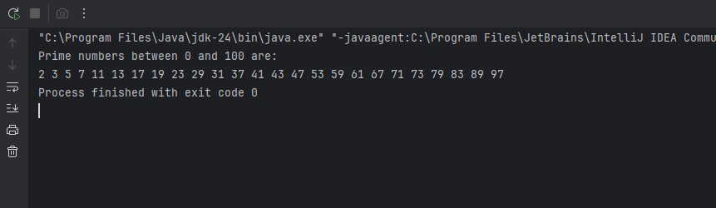

6#Write a Java program to implement linear search.

**CODE:**

**public class week_6_6 {  
 public static void main(String[] args) {  
 int[] arr = {10, 25, 30, 45, 50, 75};  
 int key = 45;  
 boolean found = false;  
  
 for (int i = 0; i < arr.length; i++) {  
 if (arr[i] == key) {  
 System.*out*.println("Element " + key + " found at index " + i);  
 found = true;  
 break;  
 }  
 }  
 if (!found) {  
 System.*out*.println("Element " + key + " not found in the array.");  
 }  
 }  
}**

**OUTPUT:** 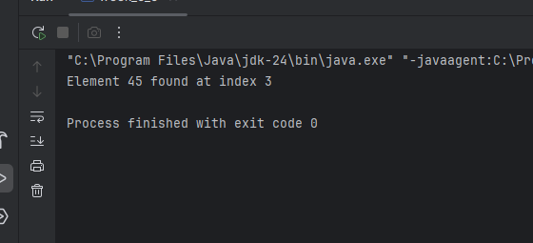

**Optional**

7#Write a Java program to find the second largest element in an array.

**CODE:**

public class week_6_8 {  
 public static void main(String[] args) {  
 int[] arr = {12, 35, 1, 10, 34, 1};  
  
 int largest = Integer.*MIN_VALUE*;  
 int secondLargest = Integer.*MIN_VALUE*;  
  
 for (int num : arr) {  
 if (num > largest) {  
 secondLargest = largest;  
 largest = num;  
 } else if (num > secondLargest && num != largest) {  
 secondLargest = num;  
 }  
 }  
  
 if (secondLargest == Integer.*MIN_VALUE*) {  
 System.*out*.println("No second largest element found.");  
 } else {  
 System.*out*.println("Second largest element is: " + secondLargest);  
 }  
 }  
}

**OUTPUT:** 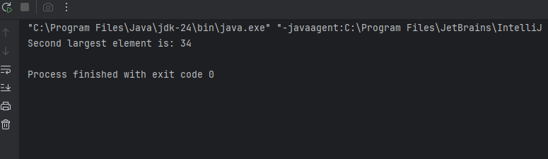

8# Write a program to implement Fibonacci series up to N terms (0,1,1,2,3,5....).

**CODE:**

import java.util.Scanner;  
public class week_6_9 {  
 public static void main(String[] args) {  
 Scanner sc = new Scanner(System.*in*);  
  
 System.*out*.print("Enter the number of terms: ");  
 int n = sc.nextInt();  
  
 int first = 0, second = 1;  
  
 System.*out*.print("Fibonacci Series: ");  
  
 for (int i = 1; i <= n; i++) {  
 System.*out*.print(first + " ");  
 int next = first + second;  
 first = second;  
 second = next;  
 }  
 }  
 }

**OUTPUT:** 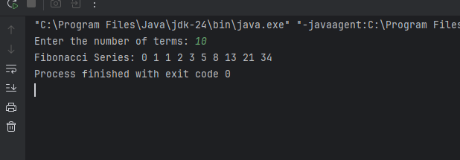

9# Write a Java program to reverse all elements of an array.

**CODE:**

**public class week_6_10 {  
 public static void main(String[] args) {  
 int[] arr = {10, 20, 30, 40, 50};  
  
 System.*out*.print("Original array: ");  
 for (int num : arr) {  
 System.*out*.print(num + " ");  
 }  
  
 int start = 0, end = arr.length - 1;  
 while (start < end) {  
 int temp = arr[start];  
 arr[start] = arr[end];  
 arr[end] = temp;  
 start++;  
 end--;  
 }  
  
 System.*out*.print("\nReversed array: ");  
 for (int num : arr) {  
 System.*out*.print(num + " ");  
 }  
 }  
}**

**OUTPUT:** 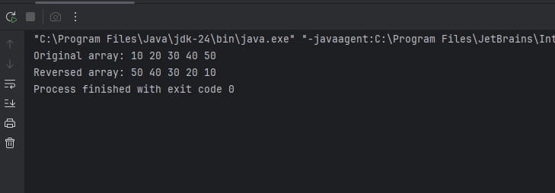

10#Write a Java program to find the frequency of each character in a given string.

**CODE:**

**public class WEEK_6_11 {  
 public static void main(String[] args) {  
 String str = "hello world";  
 str = str.replaceAll("\\s", "");   
  
 int[] freq = new int[256];   
  
 for (int i = 0; i < str.length(); i++) {  
 freq[str.charAt(i)]++;  
 }  
  
 // Print frequency  
 System.*out*.println("Character frequencies:");  
 for (int i = 0; i < freq.length; i++) {  
 if (freq[i] != 0) {  
 System.*out*.println((char) i + " : " + freq[i]);  
 }  
 }  
 }  
}**

**OUTPUT:**

