WEEK-4
1# Write a java program to check whether the given number is odd or even.
CODE:
import java.util.Scanner;
public class week_4_1 {
public static void main(String[] args) {
Scanner sc=new Scanner(System.in);
System.out.println("Enter your number : ");
int n= sc.nextInt();
if(n%2==0){
System.out.println("even number");
}
else {
System.out.println("odd number");
}
}
}

OUTPUT: 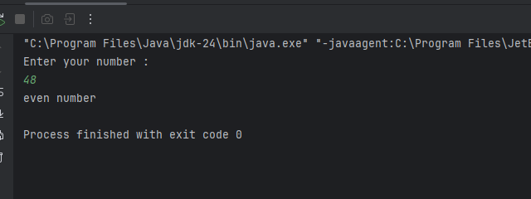

2# Write a java program to find the largest number among the three numbers.
CODE:
import java.util.Scanner;
public class week_4_2 {
public static void main(String[] args) {
Scanner sc= new Scanner(System.in);
System.out.println("Enter num 1 : ");
int n1=sc.nextInt();
System.out.println("Enter num 2 : ");
int n2=sc.nextInt();
System.out.println("Enter num 3 : ");
int n3=sc.nextInt();
if(n1>n2 && n1>n3){
System.out.println(n1 + " is the largest number among "+ n1 +","+ n2 +" and" +n3);
}
else if(n2>n1 && n2>n3){
System.out.println(n2 + " is the largest number among " + n1 +","+ n2 +" and " +n3);
}
else {
System.out.println(n3+" is the largest number among "+ n1 + ","+ n2 +" and " +n3);
}
}
}

OUTPUT: 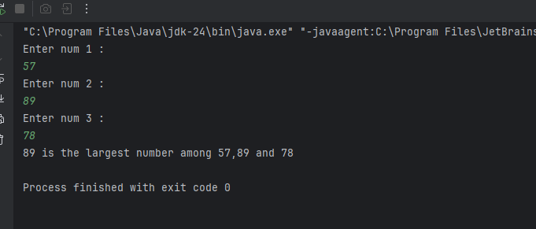

3# Write a Java program that takes a number as input and prints its multiplication table upto 10.
CODE:

}
OUTPUT:
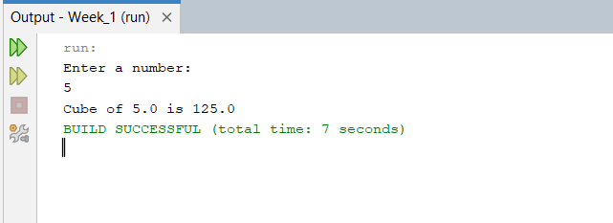

4# Write a Java program that takes three numbers as input to calculate and print the average of the numbers.
CODE:
package week_1;
import java.util.Scanner;
public class Avg {

public static void main(String[] args) {
Scanner sc= new Scanner (System.in);
System.out.println("Enter three numbers: ");
int n1=sc.nextInt();
int n2=sc.nextInt();
int n3=sc.nextInt();
double avg = (n1+n2+n3)/3.0;
System.out.println("Average = " + avg);
}
}
OUTPUT:
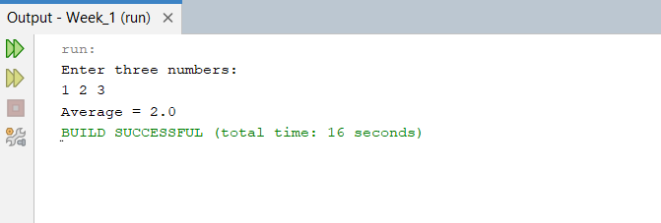

5# Write a Java program to compute the distance between two points.
CODE:
package week_1;
import java.util.Scanner;
public class Distance {

public static void main(String[] args) {
Scanner sc = new Scanner (System.in);
System.out.println("Enter first coordinates: ");
double x1 = sc.nextDouble();
double y1 = sc.nextDouble();
System.out.println("Enter second coordinates: ");
double x2 = sc.nextDouble();
double y2 = sc.nextDouble();
double distance= Math.pow((x1-x2),2) + Math.pow((y1-y2),2);
System.out.println("Distance = " + Math.sqrt(distance));

}
}

OUTPUT:
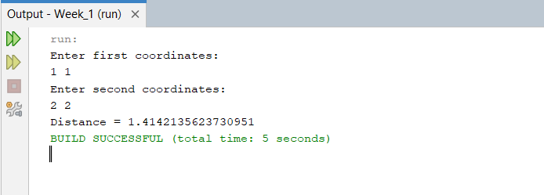

Optional
6# Write a Java program to swap two numbers using a temporary variable.
CODE:
package week_1_optional;
import java.util.Scanner;

public class Swap {
public static void main(String[] args) {
Scanner sc = new Scanner (System.in);
System.out.println("Enter two integer numbers: ");
int n1=sc.nextInt();
int n2=sc.nextInt();
System.out.println("Before swapping n1 = " + n1 + " and n2 = " + n2);
int temp= n1;
n1=n2;
n2=temp;
System.out.println("After swapping n1 = " + n1 + " and n2 = " + n2);
}
}
OUTPUT:
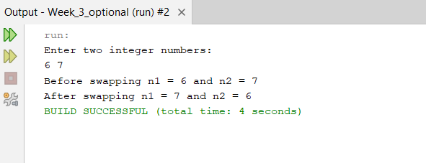
7# Write a Java program to calculate the area of a rectangle given its length and breadth.
CODE:
package week_1_optional;
import java.util.Scanner;

public class Rectangle {

public static void main(String[] args) {
Scanner sc = new Scanner (System.in);
System.out.println("Enter length and breadth: ");
double length=sc.nextDouble();
double breadth=sc.nextDouble();
double area=length*breadth;
System.out.println("Area of rectangle = " + area);
}
}
OUTPUT:
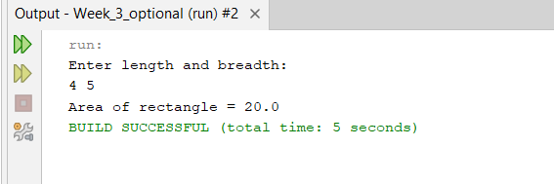

8# Write a Java program to convert temperature from Celsius to Fahrenheit.
CODE:
package week_1_optional;
import java.util.Scanner;

public class Celcius_Fahrenheit {

public static void main(String[] args) {
Scanner sc= new Scanner (System.in);
System.out.println("Enter temperature in Celsius: ");
double c=sc.nextDouble();
double f=((9.0/5.0)*c)+32;
System.out.println("Temperature in Fahrenheit is " + f);
}
}
OUTPUT:
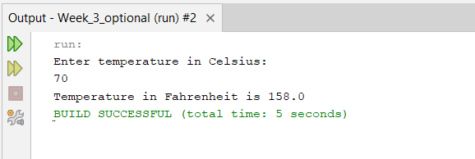

9# Write a Java program that takes two integer inputs and computes their remainder and quotient.
CODE:
package week_1_optional;
import java.util.Scanner;
class Remainder_quotient {
public static void main(String[] args) {
Scanner sc= new Scanner (System.in);
System.out.println("Enter two integer values: ");
int n1=sc.nextInt();
int n2=sc.nextInt();
System.out.println("Reaminder = " + (n1%n2) + " and Quotient = " + (n1/n2));}}
OUTPUT:
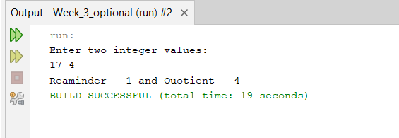
10# Write a Java program to find the circumference of a circle given its radius.
CODE:
package week_1_optional;
import java.util.Scanner;

public class Circumfrence {
public static void main(String[] args) {
Scanner sc= new Scanner (System.in);
System.out.println("Enter radius: ");
double r= sc.nextDouble();
double c= 2*Math.PI*r;
System.out.println("Circumference = " + c);
}
}

OUTPUT:
