WEEK - 4
1# Write a java program to check whether the given number is odd or even.
CODE:
public class week11 {
import java.util.Scanner;
public class week_4_1 {
public static void main(String[] args) {
Scanner sc=new Scanner(System.in);
System.out.println("Enter your number : ");
int n= sc.nextInt();
if(n%2==0){
System.out.println("even number");
}
else {
System.out.println("odd number");
}
}
}
}
OUTPUT: 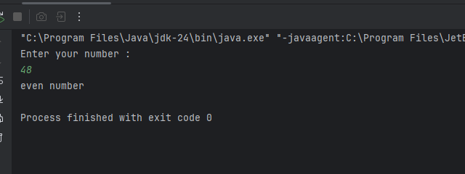

2# Write a java program to find the largest number among the three numbers.
CODE:
import java.util.Scanner;
public class week_4_2 {
public static void main(String[] args) {
Scanner sc= new Scanner(System.in);
System.out.println("Enter num 1 : ");
int n1=sc.nextInt();
System.out.println("Enter num 2 : ");
int n2=sc.nextInt();
System.out.println("Enter num 3 : ");
int n3=sc.nextInt();
if(n1>n2 && n1>n3){
System.out.println(n1 + " is the largest number among "+ n1 +","+ n2 +" and" +n3);
}
else if(n2>n1 && n2>n3){
System.out.println(n2 + " is the largest number among " + n1 +","+ n2 +" and " +n3);
}
else {
System.out.println(n3+" is the largest number among "+ n1 + ","+ n2 +" and " +n3);
}
}
}

OUTPUT: 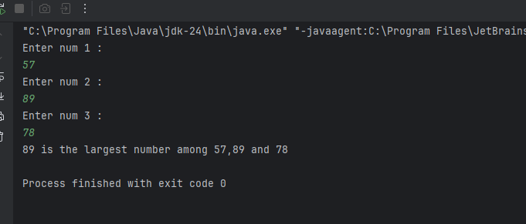

3# Write a Java program that takes a number as input and prints its multiplication table upto 10.
CODE:
public class week_4_3 {
public static void main(String[] args) {
System.out.println("The multiplication table of 10 : ");
int num=10;
for(int i=1;i<=10;i++){
System.out.println(num+"X"+i+"="+(num*i));
}
}
}

OUTPUT:
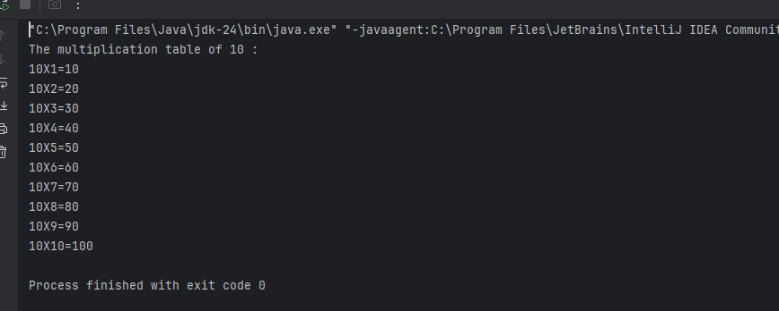

4# Write a Java program to calculate the sum of following series: 1 + 2 + 3 + 4 + .......... + N
CODE: import java.util.Scanner;
public class week_4_4 {
public static void main(String[] args) {
Scanner sc= new Scanner(System.in);
System.out.print("Enter the number : ");
int N=sc.nextInt();
int sum=0;
for (int i=1;i<=N;i++){
sum+=i;
}
System.out.println("The sum of the series is : " +sum);
}
}

OUTPUT:
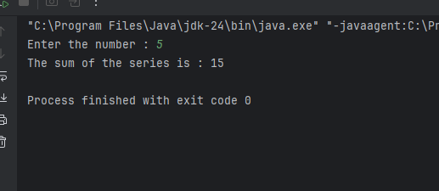

5# Write a Java program to take a number, divide it by 2 and print the result until the number becomes less than 10.
CODE: import java.util.Scanner;
public class WEEK_4_5 {
public static void main(String[] args) {
Scanner sc= new Scanner(System.in);
System.out.println("Enter a number : ");
int n= sc.nextInt();
while (n>=10){
n=n/2;
}
System.out.println("Result : "+n);
}
}
OUTPUT: 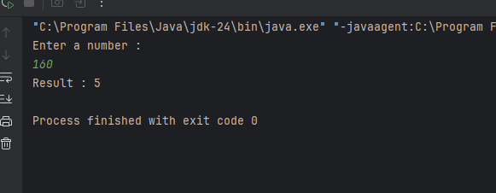

Optional
6# Write a Java program to check whether a given character is a vowel or consonant.
CODE: import java.util.Scanner;
public class week_4_6 {
public static void main(String[] args) {
Scanner sc = new Scanner(System.in);
System.out.println("Enter a letter : ");
char ch = sc.next().charAt(0);
if ((ch >= 'a' && ch <= 'z') || (ch >= 'A' && ch <= 'Z')) {
char lowerCh = Character.toLowerCase(ch);
if (lowerCh == 'a' || lowerCh == 'e' || lowerCh == 'i' || lowerCh == 'o' || lowerCh == 'u') {
System.out.println(ch + " is a vowel");
} else {
System.out.println(ch + " is a consonant");
}
} else {
System.out.println(ch + " is not an alphabet");
}
}
}
OUTPUT: 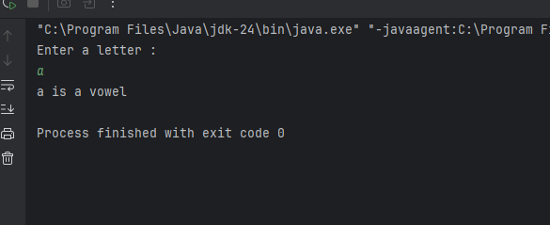

7# Write a Java program to find the smallest number among four given numbers.
CODE:

OUTPUT: import java.util.Scanner;
public class week_4_7 {
public static void main(String[] args) {
Scanner sc = new Scanner(System.in);
System.out.print("Enter first number: ");
int a = sc.nextInt();
System.out.print("Enter second number: ");
int b = sc.nextInt();
System.out.print("Enter third number: ");
int c = sc.nextInt();
System.out.print("Enter fourth number: ");
int d = sc.nextInt();
int smallest = a;
if (b < smallest) {
smallest = b;
}
if (c < smallest) {
smallest = c;
}
if (d < smallest) {
smallest = d;
}
System.out.println("The smallest number is: " + smallest);
}
}

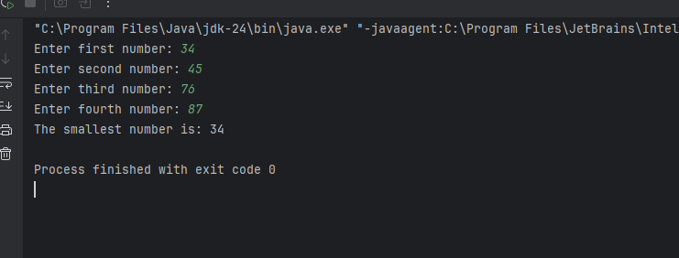

8# Write a Java program to calculate the sum of all even numbers from 1 up to a given number N

CODE:
import java.util.Scanner;
public class SumEvenNumbersAny {
public static void main(String[] args) {
Scanner sc = new Scanner(System.in);
System.out.print("Enter how many even numbers to sum: ");
int n = sc.nextInt();
int sum = 0;
int number = 5;
for (int i = 1; i <= n; i++) {
sum += (number * i);
}
System.out.println("Sum of first " + n + " even numbers: " + sum)
}
}

OUTPUT:
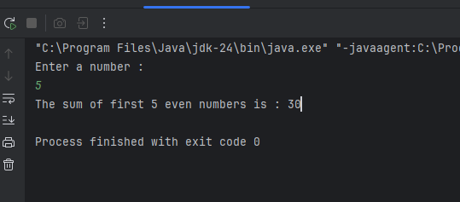

9# Write a Java program to check whether a given year is a leap year or not.
CODE:
import java.util.Scanner;
public class week_4_9 {
public static void main(String[] args) {
Scanner sc=new Scanner(System.in);
System.out.println("Enter a year :");
int year= sc.nextInt();
if((year % 4==0 && year % 100!=0)||(year%400==0)){
System.out.println(year+" is a leap year");
}
else {
System.out.println(year+" is not a leap year");
}
}
}

OUTPUT:
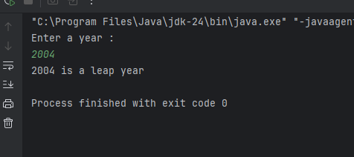
10# Write a Java program that takes a number as input and prints all its factors.
CODE:
import java.util.Scanner;
public class week_4_10 {
public static void main(String[] args) {
Scanner sc = new Scanner(System.in);
System.out.print("Enter a number: ");
int num = sc.nextInt();
System.out.println("Factors of " + num + " are:");
for (int i = 1; i <= num; i++) {
if (num % i == 0) {
System.out.println(i);
}
}
}
}
OUTPUT: 