WEEK - 6
1# Write a Java program to print the odd numbers from 1 to 99.
CODE:
public class week_6_1 {
public static void main(String[] args) {
for (int i=1;i<=100;i+=2){
System.out.print(i);
}
}
}

OUTPUT:
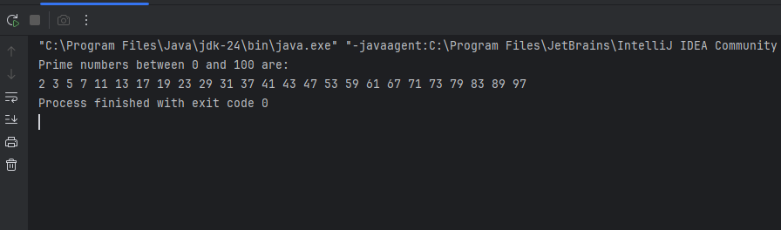

2# Write a Java program to check whether a number is prime or not.
CODE:
import java.util.Scanner;
public class week_6_2 {
public static void main(String[] args) {
Scanner sc = new Scanner(System.in);
System.out.print("Enter a number: ");
int num = sc.nextInt();
boolean isPrime = true;
if (num <= 1) {
isPrime = false;
} else {
for (int i = 2; i <= num / 2; i++) {
if (num % i == 0) {
isPrime = false;
break;
}
}
}
if (isPrime) {
System.out.println(num + " is a prime number.");
} else {
System.out.println(num + " is not a prime number.");
}
}
}

OUTPUT: 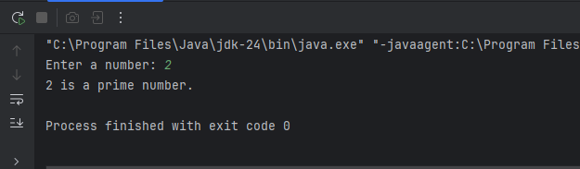
Write a Java program to swap the first and last elements of an array.

CODE:
import java.util.Scanner;
public class week_6_3 {
public static void main(String[] args) {
Scanner sc = new Scanner(System.in);
System.out.print("Enter the number of elements in the array: ");
int n = sc.nextInt();
int[] arr = new int[n];
System.out.println("Enter the elements of the array:");
for (int i = 0; i < n; i++) {
arr[i] = sc.nextInt();
}
if (n > 1) {
int temp = arr[0];
arr[0] = arr[n - 1];
arr[n - 1] = temp;
}
System.out.println("Array after swapping first and last elements:");
for (int num : arr) {
System.out.print(num + " ");
}
}
}
OUTPUT: 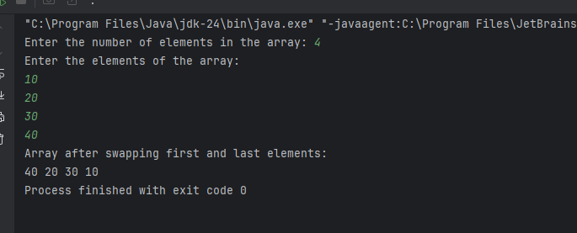

4# Write a Java program to find the maximum and minimum among array elements
CODE:
public class week_6_4 {
public static void main(String[] args) {
int[] arr = {45, 12, 78, 34, 89, 23};
int max = arr[0];
int min = arr[0];
for (int i = 1; i < arr.length; i++) {
if (arr[i] > max) {
max = arr[i];
}
if (arr[i] < min) {
min = arr[i];
}
}
System.out.println("Maximum element: " + max);
System.out.println("Minimum element: " + min);
}
}
OUTPUT:
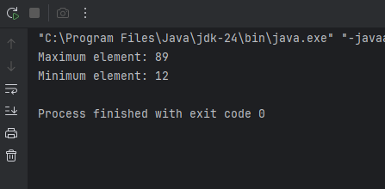

5# Write a Java program to print all prime numbers between 0 to 100.
CODE:
public class week_6_5 {
public static void main(String[] args) {
System.out.println("Prime numbers between 0 and 100 are:");
for (int num = 2; num <= 100; num++) {
boolean isPrime = true;
for (int i = 2; i <= Math.sqrt(num); i++) {
if (num % i == 0) {
isPrime = false;
break;
}
}
if (isPrime) {
System.out.print(num + " ");
}
}
}
}

OUTPUT:
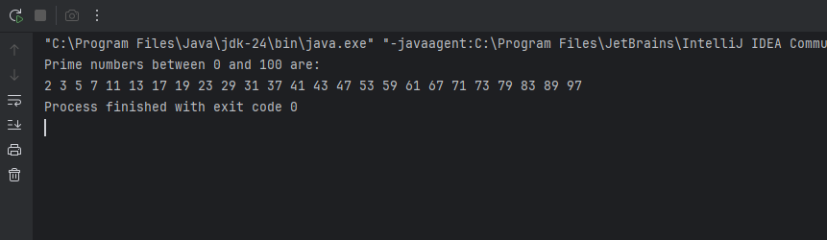

6#Write a Java program to implement linear search.
CODE:
public class week_6_6 {
public static void main(String[] args) {
int[] arr = {10, 25, 30, 45, 50, 75};
int key = 45;
boolean found = false;
for (int i = 0; i < arr.length; i++) {
if (arr[i] == key) {
System.out.println("Element " + key + " found at index " + i);
found = true;
break;
}
}
if (!found) {
System.out.println("Element " + key + " not found in the array.");
}
}
}

OUTPUT: 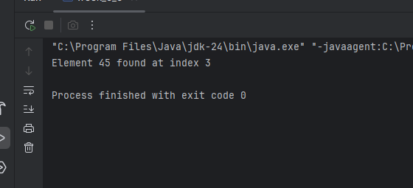
Optional
7#Write a Java program to find the second largest element in an array.
CODE:
public class week_6_8 {
public static void main(String[] args) {
int[] arr = {12, 35, 1, 10, 34, 1};
int largest = Integer.MIN_VALUE;
int secondLargest = Integer.MIN_VALUE;
for (int num : arr) {
if (num > largest) {
secondLargest = largest;
largest = num;
} else if (num > secondLargest && num != largest) {
secondLargest = num;
}
}
if (secondLargest == Integer.MIN_VALUE) {
System.out.println("No second largest element found.");
} else {
System.out.println("Second largest element is: " + secondLargest);
}
}
}
OUTPUT: 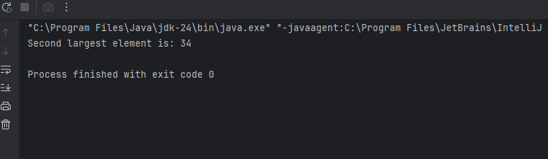

8# Write a program to implement Fibonacci series up to N terms (0,1,1,2,3,5....).

CODE:
import java.util.Scanner;
public class week_6_9 {
public static void main(String[] args) {
Scanner sc = new Scanner(System.in);
System.out.print("Enter the number of terms: ");
int n = sc.nextInt();
int first = 0, second = 1;
System.out.print("Fibonacci Series: ");
for (int i = 1; i <= n; i++) {
System.out.print(first + " ");
int next = first + second;
first = second;
second = next;
}
}
}

OUTPUT: 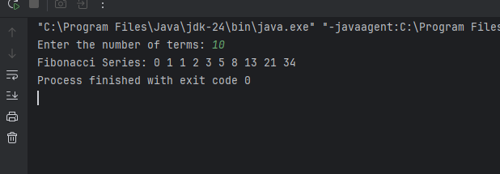

9# Write a Java program to reverse all elements of an array.
CODE:
public class week_6_10 {
public static void main(String[] args) {
int[] arr = {10, 20, 30, 40, 50};
System.out.print("Original array: ");
for (int num : arr) {
System.out.print(num + " ");
}
int start = 0, end = arr.length - 1;
while (start < end) {
int temp = arr[start];
arr[start] = arr[end];
arr[end] = temp;
start++;
end--;
}
System.out.print("\nReversed array: ");
for (int num : arr) {
System.out.print(num + " ");
}
}
}
OUTPUT: 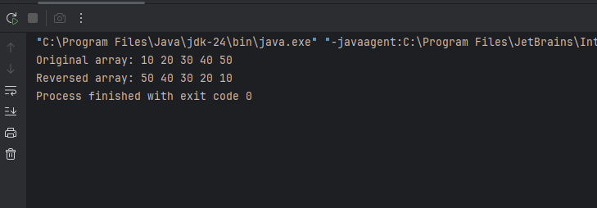

10#Write a Java program to find the frequency of each character in a given string.
CODE:
public class WEEK_6_11 {
public static void main(String[] args) {
String str = "hello world";
str = str.replaceAll("\\s", "");
int[] freq = new int[256];
for (int i = 0; i < str.length(); i++) {
freq[str.charAt(i)]++;
}
// Print frequency
System.out.println("Character frequencies:");
for (int i = 0; i < freq.length; i++) {
if (freq[i] != 0) {
System.out.println((char) i + " : " + freq[i]);
}
}
}
}
OUTPUT:
