WEEK - 5
1# Write a Java program to insert 10, 20, 30 ....in an array and display them.
CODE:
public class week_5_1 {
public static void main(String[] args) {
int [] num={10,20,30,40,50};
System.out.println(num[0]);
System.out.println(num[1]);
System.out.println(num[2]);
System.out.println(num[3]);
System.out.println(num[4]);
}
}
OUTPUT:
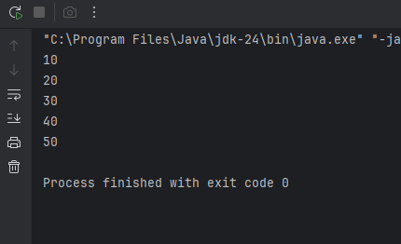

2# Write a Java program to calculate the sum of all the array elements.

CODE: import java.util.Scanner;
public class WEEK_5_2 {
public static void main(String[] args) {
Scanner sc = new Scanner(System.in);
System.out.print("Enter the number of elements in the array: ");
int n = sc.nextInt();
int[] arr = new int[n];
int sum = 0;
System.out.println("Enter the elements:");
for (int i = 0; i < n; i++) {
arr[i] = sc.nextInt();
sum += arr[i];
}
System.out.println("Sum of all elements: " + sum);
}
}
OUTPUT: 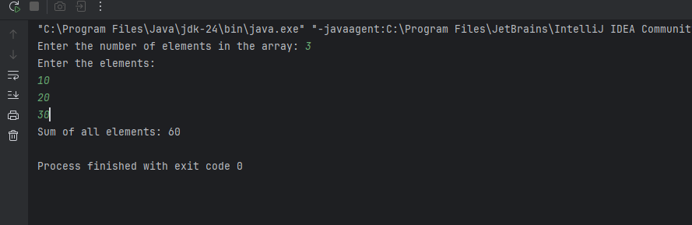

3# Write a java program to print the following pattern.
1
12
123
1234
12345
CODE:
public class WEEK_5_3 {
public static void main(String[] args) {
int n = 5;
for (int i = 1; i <= n; i++) {
for (int s = 1; s <= n - i; s++) {
System.out.print(" ");
}
for (int j = 1; j <= i; j++) {
System.out.print(j);
}
System.out.println();
}
}
}
OUTPUT: 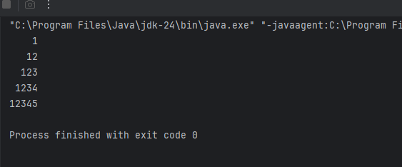

4# Write a java program to find the sum of following series where n is input by the user. 1+1/2+1/3+1/4+...............+1/n.
CODE:
import java.util.Scanner;
public class week_5_4 {
public static void main(String[] args) {
Scanner sc=new Scanner(System.in);
System.out.println("Enter the value of n :");
int n= sc.nextInt();
double sum=0;
for(int i=1;i<=n;i++){
sum+=1.0/i;
}
System.out.println("The sum of the series is: "+sum);
}
}

OUTPUT:
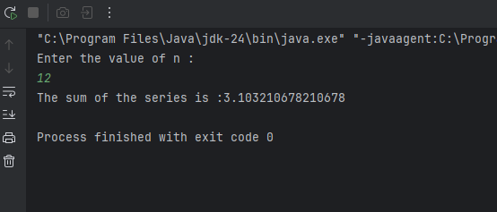

5# Write a Java program and compute the sum of the digits of an integer.
CODE:
import java.util.Scanner;
public class week_5_5 {
public static void main(String[] args) {
Scanner sc = new Scanner(System.in);
System.out.print("Enter an integer: ");
int number = sc.nextInt();
int sum = 0;
int temp = Math.abs(number);
while (temp > 0) {
sum += temp % 10;
temp /= 10;
}
System.out.println("Sum of digits: " + sum);
}
}

OUTPUT:
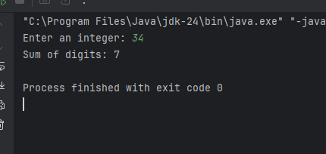

6# Write a Java program to calculate the factorial of a number.
CODE:
import java.util.Scanner;
public class WEEK_5_6 {
public static void main(String[] args) {
Scanner sc =new Scanner(System.in);
System.out.println("Enter a number : ");
int n=sc.nextInt();
long fact=1;
for (int i=1;i<=n;i++){
fact*=i;
}
System.out.println(n+"!="+fact);
}
}
OUTPUT: 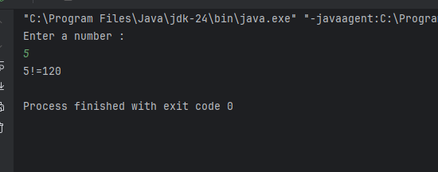
Optional
7# Write a Java program to find the largest element in a given integer array.
CODE: import java.util.Scanner;
public class week_5_7 {
public static void main(String[] args) {
Scanner sc = new Scanner(System.in);
System.out.print("Enter the number of elements in the array: ");
int n = sc.nextInt();
int[] arr = new int[n];
System.out.println("Enter " + n + " integers:");
for (int i = 0; i < n; i++) {
arr[i] = sc.nextInt();
}
int largest = arr[0];
for (int i = 1; i < n; i++) {
if (arr[i] > largest) {
largest = arr[i];
}
}
System.out.println("The largest element in the array is: " + largest);
}
}
OUTPUT: 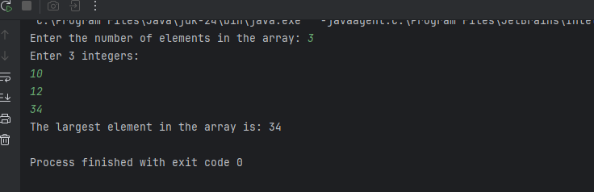

8# Write a Java program to reverse the digits of a given integer.

CODE:
import java.util.Scanner;
public class week_5_8 {
public static void main(String[] args) {
Scanner sc = new Scanner(System.in);
System.out.print("Enter an integer: ");
int number = sc.nextInt();
int reversed = 0;
int temp = Math.abs(number);
while (temp > 0) {
int digit = temp % 10;
reversed = reversed * 10 + digit;
temp /= 10;
}
if (number < 0) {
reversed *= -1;
}
System.out.println("Reversed number: " + reversed);
}
}

OUTPUT:
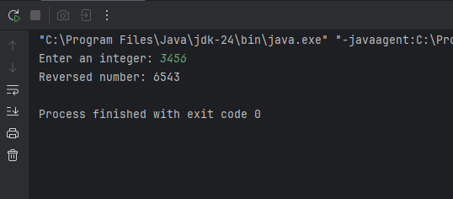

9# Write a Java program to check if a given number is a palindrome or not.

import java.util.Scanner;
public class palindrome {
public static void main(String[] args) {
Scanner sc=new Scanner(System.in);
System.out.println("enter a number : ");
int n= sc.nextInt();
int temp=n;
int rev=0;
while (temp>0){
int digit=temp%10;
rev=rev*10+digit;
temp/=10;
}
if(rev==n){
System.out.println(n+" is a palindrome");
}
else {
System.out.println(n+" is NOT a palindrome");
}
}
}
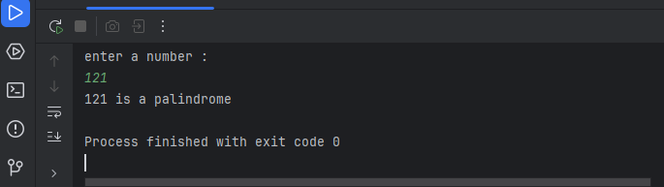

10# Write a Java program to convert a decimal number into Hexadecimal number and vice-versa.
CODE:
import java.util.Scanner;
public class week_5_9 {
public static void main(String[] args) {
Scanner sc = new Scanner(System.in);
System.out.println("Choose conversion:");
System.out.println("1. Decimal to Hexadecimal");
System.out.println("2. Hexadecimal to Decimal");
System.out.print("Enter your choice (1 or 2): ");
int choice = sc.nextInt();
if (choice == 1) {
// Decimal to Hexadecimal
System.out.print("Enter a decimal number: ");
int decimal = sc.nextInt();
String hex = Integer.toHexString(decimal).toUpperCase();
System.out.println("Hexadecimal: " + hex);
} else if (choice == 2) {
// Hexadecimal to Decimal
System.out.print("Enter a hexadecimal number: ");
String hex = sc.next();
int decimal = Integer.parseInt(hex, 16);
System.out.println("Decimal: " + decimal);
} else {
System.out.println("Invalid choice.");
}
}
}

OUTPUT:
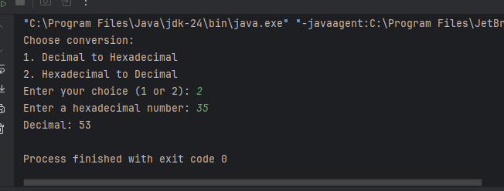
11# Write a Java program to print the following pattern:
*
**
***
**
*

CODE: public class week_5_11 {
public static void main(String[] args) {
int n = 3;
for (int i = 1; i <= n; i++) {
for (int s = 1; s <= n - i; s++) {
System.out.print(" ");
}
for (int j = 1; j <= i; j++) {
System.out.print("*");
}
System.out.println();
}
for (int i = n - 1; i >= 1; i--) {
for (int s = 1; s <= n - i; s++) {
System.out.print(" ");
}
for (int j = 1; j <= i; j++) {
System.out.print("*");
}
System.out.println();
}
}
}
OUTPUT:
