WEEK - 7
1# Write a Java function to implement binary search.
CODE:
import java.util.Scanner;
public class week_7_1{
public static int binarySearch(int[] arr, int target) {
int left = 0, right = arr.length - 1;
while (left <= right) {
int mid = (left + right) / 2;
if (arr[mid] == target) {
return mid; // found
} else if (arr[mid] < target) {
left = mid + 1; // search right half
} else {
right = mid - 1; // search left half
}
}
return -1;
}
public static void main(String[] args) {
Scanner sc = new Scanner(System.in);
System.out.print("Enter the size of array: ");
int n = sc.nextInt();
int[] arr = new int[n];
System.out.println("Enter " + n + " sorted numbers:");
for (int i = 0; i < n; i++) {
arr[i] = sc.nextInt();
}
System.out.print("Enter the number to search: ");
int target = sc.nextInt();
int result = binarySearch(arr, target);
if (result != -1) {
System.out.println("Element found at index: " + result);
} else {
System.out.println("Element not found");
}
}
}
OUTPUT:
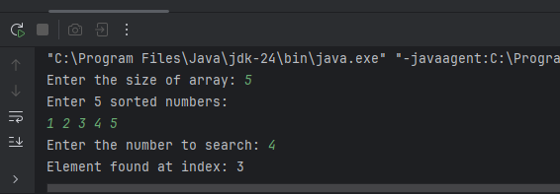
2# Write a Java function to arrange the elements of an array in ascending order (Sorting).
CODE:
public class week_7_2 {
public static void sortAscending(int[] arr) {
int n = arr.length;
for (int i = 0; i < n - 1; i++) {
for (int j = i + 1; j < n; j++) {
if (arr[i] > arr[j]) {
// swap
int temp = arr[i];
arr[i] = arr[j];
arr[j] = temp;
}
}
}
}
public static void main(String[] args) {
int[] arr = {5, 2, 8, 1, 3};
sortAscending(arr);
System.out.print("Sorted array: ");
for (int num : arr) {
System.out.print(num + " ");
}
}
}
OUTPUT:
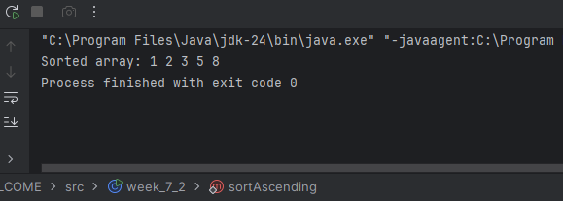
3# Write a program to reverse a given string.
CODE: import java.util.Scanner;
public class week_7_3 {
public static void main(String[] args) {
Scanner sc = new Scanner(System.in);
System.out.print("Enter a string: ");
String str = sc.nextLine();
String reversed = "";
for (int i = str.length() - 1; i >= 0; i--) {
reversed += str.charAt(i);
}
System.out.println("Reversed string: " + reversed);
}
}
OUTPUT:
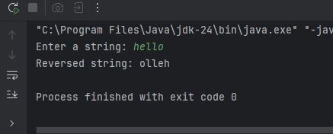
4# Write a program to check whether a given string is palindrome or not.
CODE:
import java.util.Scanner;
public class week_7_4 {
public static void main(String[] args) {
Scanner sc = new Scanner(System.in);
System.out.print("Enter a string: ");
String str = sc.nextLine();
String reversed = "";
for (int i = str.length() - 1; i >= 0; i--) {
reversed += str.charAt(i);
}
if (str.equals(reversed)) {
System.out.println(str + " is a palindrome.");
} else {
System.out.println(str + " is not a palindrome.");
}
}
}
OUTPUT: 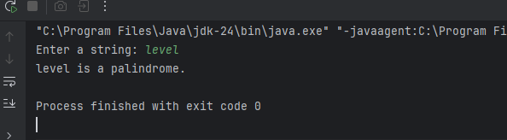

5# Write a program to implement factorial of a number through recursion.
CODE:
import java.util.Scanner;
public class week_7_5 {
public static int factorial(int n) {
if (n == 0 || n == 1) {
return 1; // base case
}
return n * factorial(n - 1); // recursive call
}
public static void main(String[] args) {
Scanner sc = new Scanner(System.in);
System.out.print("Enter a number: ");
int num = sc.nextInt();
System.out.println("Factorial of " + num + " = " + factorial(num));
}
}

OUTPUT:
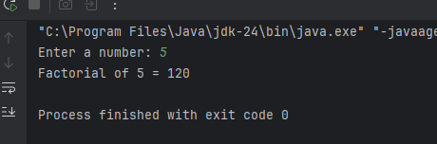
6# Write a program to implement Fibonacci series of a number with and without recursion.
CODE:
(a)Without Recursiom
import java.util.Scanner;
public class week_7_6 {
public static void main(String[] args) {
Scanner sc = new Scanner(System.in);
System.out.print("Enter how many terms: ");
int n = sc.nextInt();
int a = 0, b = 1;
System.out.print("Fibonacci series: ");
for (int i = 1; i <= n; i++) {
System.out.print(a + " ");
int next = a + b;
a = b;
b = next;
}
}
}
(b) With Recursion
import java.util.Scanner;
public class week_7_6 {
public static int fibonacci(int n) {
if (n == 0) return 0; // base case
if (n == 1) return 1; // base case
return fibonacci(n - 1) + fibonacci(n - 2);
}
public static void main(String[] args) {
Scanner sc = new Scanner(System.in);
System.out.print("Enter how many terms: ");
int n = sc.nextInt();
System.out.print("Fibonacci series: ");
for (int i = 0; i < n; i++) {
System.out.print(fibonacci(i) + " ");
}
}
}
OUTPUT:
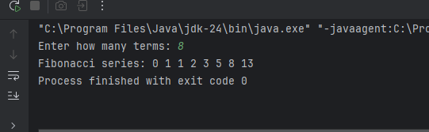
Optional
7# Write a Java function to find the greatest common divisor (GCD) of two numbers with and without using recursion.
CODE:
(a)Without Recursion
import java.util.Scanner;
public class week_7_7 {
public static int gcd(int a, int b) {
while (b != 0) {
int temp = b;
b = a % b;
a = temp;
}
return a;
}
public static void main(String[] args) {
Scanner sc = new Scanner(System.in);
System.out.print("Enter first number: ");
int num1 = sc.nextInt();
System.out.print("Enter second number: ");
int num2 = sc.nextInt();
System.out.println("GCD = " + gcd(num1, num2));
}
(b) With Recursion
import java.util.Scanner;
public class week_7_b {
public static int gcd(int a, int b) {
if (b == 0) {
return a; // base case
}
return gcd(b, a % b); // recursive call
}
public static void main(String[] args) {
Scanner sc = new Scanner(System.in);
System.out.print("Enter first number: ");
int num1 = sc.nextInt();
System.out.print("Enter second number: ");
int num2 = sc.nextInt();
System.out.println("GCD = " + gcd(num1, num2));
}
}
OUTPUT:
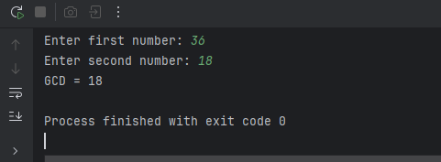

8# Write a program to check whether two strings are anagrams of each other (“listen” and “silent” are anagrams).
CODE:
import java.util.Scanner;
public class week_7_8 {
public static void main(String[] args) {
Scanner sc = new Scanner(System.in);
System.out.print("Enter first word: ");
String s1 = sc.nextLine();
System.out.print("Enter second word: ");
String s2 = sc.nextLine();
// Remove spaces and convert to lowercase
s1 = s1.replaceAll("\\s", "").toLowerCase();
s2 = s2.replaceAll("\\s", "").toLowerCase();
// If lengths are different, not an anagram
if (s1.length() != s2.length()) {
System.out.println("Not an Anagram");
return;
}
// Count characters
int[] count = new int[26]; // only for a–z
for (char c : s1.toCharArray()) {
count[c - 'a']++;
}
for (char c : s2.toCharArray()) {
count[c - 'a']--;
}
// Check if all counts are 0
for (int i : count) {
if (i != 0) {
System.out.println("Not an Anagram");
return;
}
}
System.out.println("It is an Anagram");
}
}
OUTPUT:
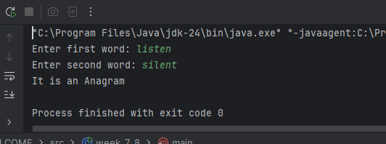

9# Implement quick sort using recursion.

CODE:
import java.util.Scanner;
public class week_7_9 {
public static void quickSort(int[] arr, int low, int high) {
if (low < high) {
int pivotIndex = partition(arr, low, high);
// sort left side
quickSort(arr, low, pivotIndex - 1);
// sort right side
quickSort(arr, pivotIndex + 1, high);
}
}
public static int partition(int[] arr, int low, int high) {
int pivot = arr[high]; // last element as pivot
int i = low - 1; // index of smaller element
for (int j = low; j < high; j++) {
if (arr[j] < pivot) {
i++;
// swap
int temp = arr[i];
arr[i] = arr[j];
arr[j] = temp;
}
}
// place pivot in correct position
int temp = arr[i + 1];
arr[i + 1] = arr[high];
arr[high] = temp;
return i + 1;
}
public static void main(String[] args) {
Scanner sc = new Scanner(System.in);
System.out.print("Enter size of array: ");
int n = sc.nextInt();
int[] arr = new int[n];
System.out.println("Enter " + n + " numbers:");
for (int i = 0; i < n; i++) {
arr[i] = sc.nextInt();
}
quickSort(arr, 0, n - 1);
System.out.print("Sorted array: ");
for (int num : arr) {
System.out.print(num + " ");
}
}
}
OUTPUT:
