WEEK - 8
1# Create a class FRUIT which has data members color, taste and price. Also create a method display() which will print values of FRUIT object. Create three objects of FRUIT class and call their display() methods.
2# Create a class FRUIT which has data members color, taste and price. It has a method setDetails() which will set the values of color, taste and price. Also create a method display() which will print values of FRUIT object.
3# In previous question, set the values of using color, taste and price using Constructor.
4# Add one-argument constructor and two-argument constructor in addition to default constructor in FRUIT class.
5# Use the concept of constructor-chaining in the previous question using this().
CODE:
public class week_8 {
// Part 1: Simple display
static class fruit1 {
String color;
String taste;
int price;
void display() {
System.out.println("Color: " + color + ", Taste: " + taste + ", Price: " + price);
}
}
// Part 2: Using setDetails() method
static class fruit2 {
String color;
String taste;
int price;
void setDetails(String c, String t, int p) {
color = c;
taste = t;
price = p;
}
void display() {
System.out.println("Color: " + color + ", Taste: " + taste + ", Price: " + price);
}
}
// Part 3, 4, 5: Using constructors, overloading, and chaining
static class fruit3 {
String color;
String taste;
int price;
// Default constructor
fruit3() {
this("Unknown", "Unknown", 0); // constructor chaining
}
// One-argument constructor
fruit3(String c) {
this(c, "Unknown", 0); // constructor chaining
}
// Two-argument constructor
fruit3(String c, String t) {
this(c, t, 0); // constructor chaining
}
// Three-argument constructor
fruit3(String c, String t, int p) {
color = c;
taste = t;
price = p;
}
void display() {
System.out.println("Color: " + color + ", Taste: " + taste + ", Price: " + price);
}
}
public static void main(String[] args) {
System.out.println("=== Part 1: Simple display ===");
fruit1 f1 = new fruit1();
f1.color = "Red";
f1.taste = "Sweet";
f1.price = 100;
f1.display();
fruit1 f2 = new fruit1();
f2.color = "Yellow";
f2.taste = "Sour";
f2.price = 50;
f2.display();
fruit1 f3 = new fruit1();
f3.color = "Green";
f3.taste = "Tangy";
f3.price = 70;
f3.display();
System.out.println("\n=== Part 2: Using setDetails() ===");
fruit2 fr2_1 = new fruit2();
fruit2 fr2_2 = new fruit2();
fr2_1.setDetails("Red", "Sweet", 100);
fr2_2.setDetails("Yellow", "Sour", 50);
fr2_1.display();
fr2_2.display();
System.out.println("\n=== Part 3, 4, 5: Constructors + Overloading + Chaining ===");
fruit3 fr3_1 = new fruit3(); // default constructor
fruit3 fr3_2 = new fruit3("Red"); // one-arg constructor
fruit3 fr3_3 = new fruit3("Yellow", "Sweet"); // two-arg constructor
fruit3 fr3_4 = new fruit3("Green", "Tangy", 70); // three-arg constructor
fr3_1.display();
fr3_2.display();
fr3_3.display();
fr3_4.display();
}
}

OUTPUT:
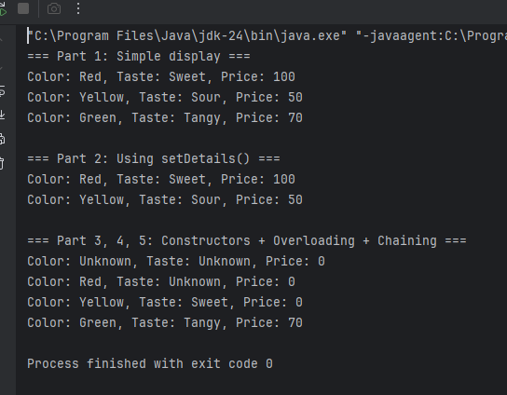

2# Create a class CAR with the following details: Data members: model, color, price. Member methods:
setDetails() – to set values of all data members using setters.
getDetails() – to get values of all data members using getters.
display() – to print all details of the car.
Requirements: 1. Implement default constructor to initialize default values.
2. Implement a parameterized constructor (with one argument) to set only model.
3. Implement another parameterized constructor (with two arguments) to set model and color.
4. Use constructor chaining to reduce code redundancy.
5. Create three objects of CAR class using:
● Default constructor
● One-argument constructor
● Two-argument constructor
6. Set price for each object using the setDetails() method.
7. Call the display() method for each object.
CODE: class Car {
// Data members
private String model;
private String color;
private int price;
// Default constructor
Car() {
this("Unknown", "Unknown", 0); // constructor chaining
}
// One-argument constructor (model only)
Car(String model) {
this(model, "Unknown", 0); // constructor chaining
}
// Two-argument constructor (model + color)
Car(String model, String color) {
this(model, color, 0); // constructor chaining
}
// Three-argument constructor
Car(String model, String color, int price) {
this.model = model;
this.color = color;
this.price = price;
}
// Set details using setters
void setDetails(int price) {
this.price = price;
}
// Get details using getters
String getModel() {
return model;
}
String getColor() {
return color;
}
int getPrice() {
return price;
}
// Display all details
void display() {
System.out.println("Model: " + model + ", Color: " + color + ", Price: " + price);
}
}
public class week_8_opt {
public static void main(String[] args) {
// Create objects using different constructors
Car car1 = new Car(); // default constructor
Car car2 = new Car("Honda"); // one-arg constructor
Car car3 = new Car("Toyota", "Red"); // two-arg constructor
// Set price using setDetails()
car1.setDetails(500000);
car2.setDetails(700000);
car3.setDetails(900000);
// Display details of all cars
System.out.println("=== Car 1 ===");
car1.display();
System.out.println("=== Car 2 ===");
car2.display();
System.out.println("=== Car 3 ===");
car3.display();
}
}

OUTPUT:
