GET DATA
/TYPE=TXT
/FILE="C:\Users\Deeya Rehman\OneDrive\Documents\IBM\Downloads\bp_health_dataset.csv"
/DELCASE=LINE
/DELIMITERS=","
/ARRANGEMENT=DELIMITED
/FIRSTCASE=2
/IMPORTCASE=ALL
/VARIABLES=
Participant_ID F3.0
age F2.0
gender F1.0
bmi F4.1
physical_activity_min F3.0
salt_intake_g F4.1
smoking_status F1.0
stress_level F4.1
systolic_bp F3.0.
CACHE.
EXECUTE.
DATASET NAME DataSet2 WINDOW=FRONT.
FREQUENCIES VARIABLES=Participant_ID age gender bmi physical_activity_min salt_intake_g smoking_status stress_level systolic_bp
/STATISTICS=STDDEV MINIMUM MAXIMUM MEAN
/ORDER=ANALYSIS.

Frequencies

Notes
Output Created |  | 19-AUG-2026 11:51:22
Comments
Input | Data | C:\Users\Deeya Rehman\OneDrive\Documents\IBM\Downloads\bp_health_dataset.csv
Input | Active Dataset | DataSet2
Input | Filter | <none>
Input | Weight | <none>
Input | Split File | <none>
Input | N of Rows in Working Data File | 180
Missing Value Handling | Definition of Missing | User-defined missing values are treated as missing.
Missing Value Handling | Cases Used | Statistics are based on all cases with valid data.
Syntax |  | FREQUENCIES VARIABLES=Participant_ID age gender bmi physical_activity_min salt_intake_g smoking_status stress_level systolic_bp  /STATISTICS=STDDEV MINIMUM MAXIMUM MEAN  /ORDER=ANALYSIS.
Resources | Processor Time | 00:00:00.22
Resources | Elapsed Time | 00:00:00.30

[DataSet2]

Statistics
 |  | Participant_ID | age | gender | bmi | physical_activity_min | salt_intake_g
N | Valid | 180 | 180 | 180 | 174 | 180 | 180
N | Missing | 0 | 0 | 0 | 6 | 0 | 0
Mean |  | 90.50 | 43.60 | .48 | 25.963 | 156.74 | 7.776
Std. Deviation |  | 52.106 | 14.675 | .501 | 4.1020 | 77.355 | 2.9493
Minimum |  | 1 | 20 | 0 | 16.1 | 0 | 2.0
Maximum |  | 180 | 69 | 1 | 37.9 | 458 | 15.7

Statistics
 |  | smoking_status | stress_level | systolic_bp
N | Valid | 180 | 176 | 180
N | Missing | 0 | 4 | 0
Mean |  | .28 | 5.528 | 160.77
Std. Deviation |  | .449 | 2.9354 | 14.318
Minimum |  | 0 | 1.0 | 127
Maximum |  | 1 | 10.0 | 203

FREQUENCIES VARIABLES=gender smoking_status
/ORDER=ANALYSIS.

Frequencies

Notes
Output Created |  | 19-AUG-2026 11:57:10
Comments
Input | Data | C:\Users\Deeya Rehman\OneDrive\Documents\IBM\Downloads\bp_health_dataset.csv
Input | Active Dataset | DataSet2
Input | Filter | <none>
Input | Weight | <none>
Input | Split File | <none>
Input | N of Rows in Working Data File | 180
Missing Value Handling | Definition of Missing | User-defined missing values are treated as missing.
Missing Value Handling | Cases Used | Statistics are based on all cases with valid data.
Syntax |  | FREQUENCIES VARIABLES=gender smoking_status  /ORDER=ANALYSIS.
Resources | Processor Time | 00:00:00.02
Resources | Elapsed Time | 00:00:00.03

[DataSet2]

Statistics
 |  | gender | smoking_status
N | Valid | 180 | 180
N | Missing | 0 | 0

Frequency Table

gender
 |  | Frequency | Percent | Valid Percent | Cumulative Percent
Valid | 0 | 94 | 52.2 | 52.2 | 52.2
Valid | 1 | 86 | 47.8 | 47.8 | 100.0
Valid | Total | 180 | 100.0 | 100.0

smoking_status
 |  | Frequency | Percent | Valid Percent | Cumulative Percent
Valid | 0 | 130 | 72.2 | 72.2 | 72.2
Valid | 1 | 50 | 27.8 | 27.8 | 100.0
Valid | Total | 180 | 100.0 | 100.0

EXAMINE VARIABLES=systolic_bp
/PLOT BOXPLOT HISTOGRAM NPPLOT
/COMPARE GROUPS
/STATISTICS DESCRIPTIVES
/CINTERVAL 95
/MISSING LISTWISE
/NOTOTAL.

Explore

Notes
Output Created |  | 19-AUG-2026 12:08:11
Comments
Input | Data | C:\Users\Deeya Rehman\OneDrive\Documents\IBM\Downloads\bp_health_dataset.csv
Input | Active Dataset | DataSet2
Input | Filter | <none>
Input | Weight | <none>
Input | Split File | <none>
Input | N of Rows in Working Data File | 180
Missing Value Handling | Definition of Missing | User-defined missing values for dependent variables are treated as missing.
Missing Value Handling | Cases Used | Statistics are based on cases with no missing values for any dependent variable or factor used.
Syntax |  | EXAMINE VARIABLES=systolic_bp  /PLOT BOXPLOT HISTOGRAM NPPLOT  /COMPARE GROUPS  /STATISTICS DESCRIPTIVES  /CINTERVAL 95  /MISSING LISTWISE  /NOTOTAL.
Resources | Processor Time | 00:00:06.50
Resources | Elapsed Time | 00:00:11.43

[DataSet2]

Case Processing Summary
 | Cases
 | Valid |  | Missing |  | Total
 | N | Percent | N | Percent | N | Percent
systolic_bp | 180 | 100.0% | 0 | 0.0% | 180 | 100.0%

Descriptives
 |  |  | Statistic | Std. Error
systolic_bp | Mean |  | 160.77 | 1.067
systolic_bp | 95% Confidence Interval for Mean | Lower Bound | 158.67
systolic_bp | 95% Confidence Interval for Mean | Upper Bound | 162.88
systolic_bp | 5% Trimmed Mean |  | 160.43
systolic_bp | Median |  | 159.00
systolic_bp | Variance |  | 205.004
systolic_bp | Std. Deviation |  | 14.318
systolic_bp | Minimum |  | 127
systolic_bp | Maximum |  | 203
systolic_bp | Range |  | 76
systolic_bp | Interquartile Range |  | 19
systolic_bp | Skewness |  | .421 | .181
systolic_bp | Kurtosis |  | .005 | .360

Tests of Normality
 | Kolmogorov-Smirnovª |  |  | Shapiro-Wilk
 | Statistic | df | Sig. | Statistic | df | Sig.
systolic_bp | .071 | 180 | .026 | .985 | 180 | .058

a. Lilliefors Significance Correction

systolic_bp

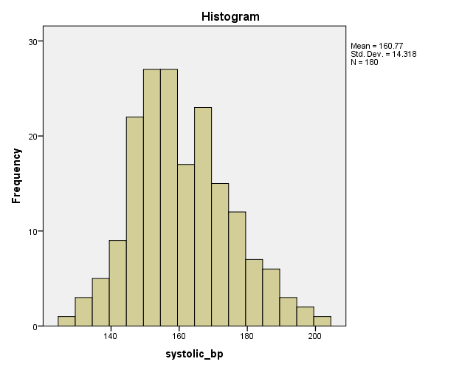

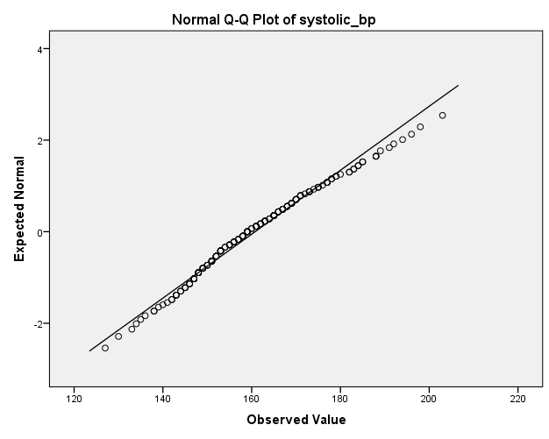

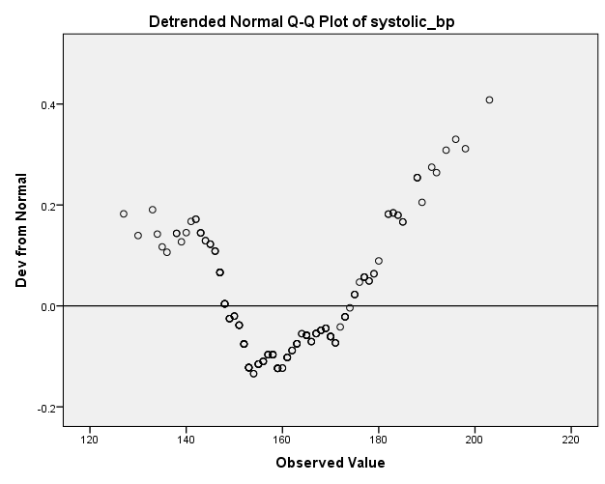

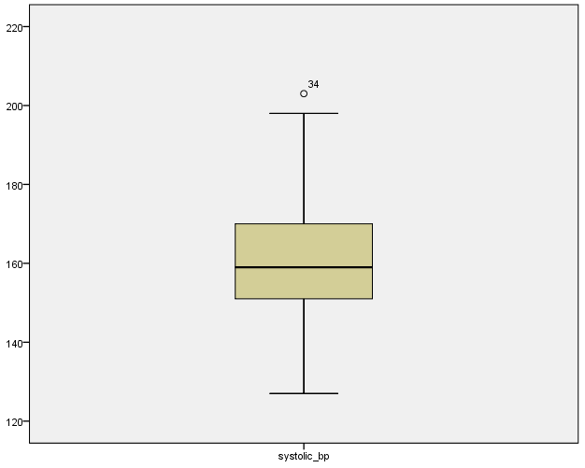

* Chart Builder.
GGRAPH
/GRAPHDATASET NAME="graphdataset" VARIABLES=age systolic_bp MISSING=LISTWISE REPORTMISSING=NO
/GRAPHSPEC SOURCE=INLINE.
BEGIN GPL
SOURCE: s=userSource(id("graphdataset"))
DATA: age=col(source(s), name("age"))
DATA: systolic_bp=col(source(s), name("systolic_bp"))
GUIDE: axis(dim(1), label("age"))
GUIDE: axis(dim(2), label("systolic_bp"))
ELEMENT: point(position(age*systolic_bp))
END GPL.

GGraph

Notes
Output Created |  | 19-AUG-2026 12:31:13
Comments
Input | Data | C:\Users\Deeya Rehman\OneDrive\Documents\IBM\Downloads\bp_health_dataset.csv
Input | Active Dataset | DataSet2
Input | Filter | <none>
Input | Weight | <none>
Input | Split File | <none>
Input | N of Rows in Working Data File | 180
Syntax |  | GGRAPH  /GRAPHDATASET NAME="graphdataset" VARIABLES=age systolic_bp MISSING=LISTWISE REPORTMISSING=NO  /GRAPHSPEC SOURCE=INLINE.  BEGIN GPL  SOURCE: s=userSource(id("graphdataset"))  DATA: age=col(source(s), name("age"))  DATA: systolic_bp=col(source(s), name("systolic_bp"))  GUIDE: axis(dim(1), label("age"))  GUIDE: axis(dim(2), label("systolic_bp"))  ELEMENT: point(position(age*systolic_bp))  END GPL.
Resources | Processor Time | 00:00:01.33
Resources | Elapsed Time | 00:00:01.89

[DataSet2]

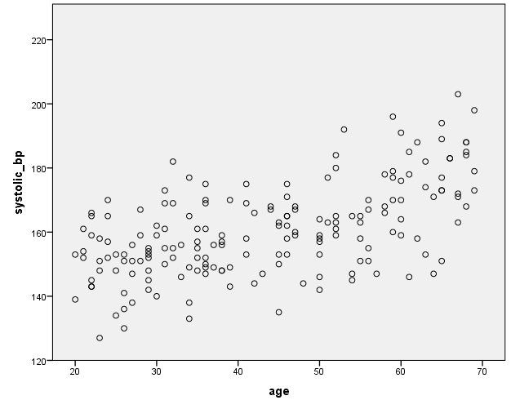

* Chart Builder.
GGRAPH
/GRAPHDATASET NAME="graphdataset" VARIABLES=bmi systolic_bp MISSING=LISTWISE REPORTMISSING=NO
/GRAPHSPEC SOURCE=INLINE.
BEGIN GPL
SOURCE: s=userSource(id("graphdataset"))
DATA: bmi=col(source(s), name("bmi"))
DATA: systolic_bp=col(source(s), name("systolic_bp"))
GUIDE: axis(dim(1), label("bmi"))
GUIDE: axis(dim(2), label("systolic_bp"))
ELEMENT: point(position(bmi*systolic_bp))
END GPL.

GGraph

Notes
Output Created |  | 19-AUG-2026 12:31:37
Comments
Input | Data | C:\Users\Deeya Rehman\OneDrive\Documents\IBM\Downloads\bp_health_dataset.csv
Input | Active Dataset | DataSet2
Input | Filter | <none>
Input | Weight | <none>
Input | Split File | <none>
Input | N of Rows in Working Data File | 180
Syntax |  | GGRAPH  /GRAPHDATASET NAME="graphdataset" VARIABLES=bmi systolic_bp MISSING=LISTWISE REPORTMISSING=NO  /GRAPHSPEC SOURCE=INLINE.  BEGIN GPL  SOURCE: s=userSource(id("graphdataset"))  DATA: bmi=col(source(s), name("bmi"))  DATA: systolic_bp=col(source(s), name("systolic_bp"))  GUIDE: axis(dim(1), label("bmi"))  GUIDE: axis(dim(2), label("systolic_bp"))  ELEMENT: point(position(bmi*systolic_bp))  END GPL.
Resources | Processor Time | 00:00:01.03
Resources | Elapsed Time | 00:00:02.06

[DataSet2]

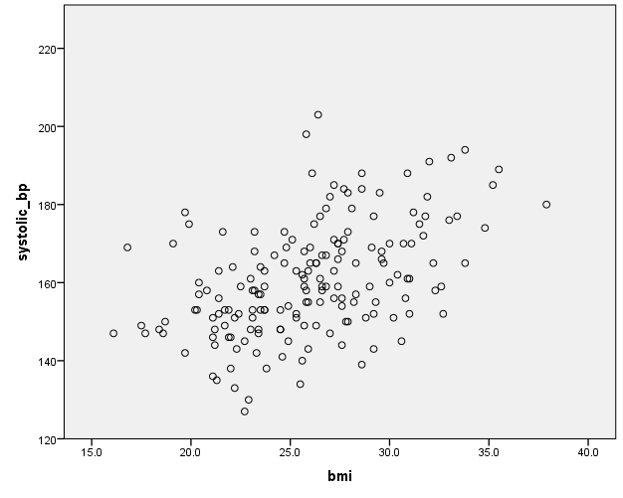

* Chart Builder.
GGRAPH
/GRAPHDATASET NAME="graphdataset" VARIABLES=physical_activity_min systolic_bp MISSING=LISTWISE REPORTMISSING=NO
/GRAPHSPEC SOURCE=INLINE.
BEGIN GPL
SOURCE: s=userSource(id("graphdataset"))
DATA: physical_activity_min=col(source(s), name("physical_activity_min"))
DATA: systolic_bp=col(source(s), name("systolic_bp"))
GUIDE: axis(dim(1), label("physical_activity_min"))
GUIDE: axis(dim(2), label("systolic_bp"))
ELEMENT: point(position(physical_activity_min*systolic_bp))
END GPL.

GGraph

Notes
Output Created |  | 19-AUG-2026 12:32:03
Comments
Input | Data | C:\Users\Deeya Rehman\OneDrive\Documents\IBM\Downloads\bp_health_dataset.csv
Input | Active Dataset | DataSet2
Input | Filter | <none>
Input | Weight | <none>
Input | Split File | <none>
Input | N of Rows in Working Data File | 180
Syntax |  | GGRAPH  /GRAPHDATASET NAME="graphdataset" VARIABLES=physical_activity_min systolic_bp MISSING=LISTWISE REPORTMISSING=NO  /GRAPHSPEC SOURCE=INLINE.  BEGIN GPL  SOURCE: s=userSource(id("graphdataset"))  DATA: physical_activity_min=col(source(s), name("physical_activity_min"))  DATA: systolic_bp=col(source(s), name("systolic_bp"))  GUIDE: axis(dim(1), label("physical_activity_min"))  GUIDE: axis(dim(2), label("systolic_bp"))  ELEMENT: point(position(physical_activity_min*systolic_bp))  END GPL.
Resources | Processor Time | 00:00:00.86
Resources | Elapsed Time | 00:00:01.26

[DataSet2]

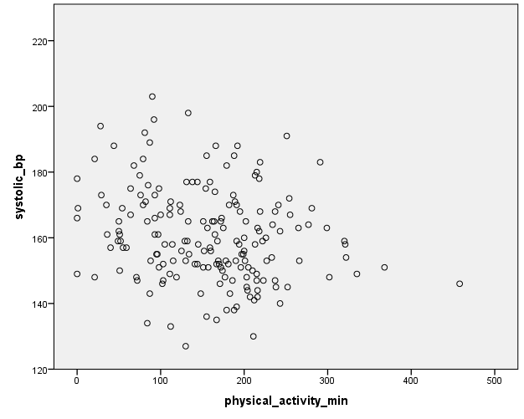

* Chart Builder.
GGRAPH
/GRAPHDATASET NAME="graphdataset" VARIABLES=salt_intake_g systolic_bp MISSING=LISTWISE REPORTMISSING=NO
/GRAPHSPEC SOURCE=INLINE.
BEGIN GPL
SOURCE: s=userSource(id("graphdataset"))
DATA: salt_intake_g=col(source(s), name("salt_intake_g"))
DATA: systolic_bp=col(source(s), name("systolic_bp"))
GUIDE: axis(dim(1), label("salt_intake_g"))
GUIDE: axis(dim(2), label("systolic_bp"))
ELEMENT: point(position(salt_intake_g*systolic_bp))
END GPL.

GGraph

Notes
Output Created |  | 19-AUG-2026 12:32:28
Comments
Input | Data | C:\Users\Deeya Rehman\OneDrive\Documents\IBM\Downloads\bp_health_dataset.csv
Input | Active Dataset | DataSet2
Input | Filter | <none>
Input | Weight | <none>
Input | Split File | <none>
Input | N of Rows in Working Data File | 180
Syntax |  | GGRAPH  /GRAPHDATASET NAME="graphdataset" VARIABLES=salt_intake_g systolic_bp MISSING=LISTWISE REPORTMISSING=NO  /GRAPHSPEC SOURCE=INLINE.  BEGIN GPL  SOURCE: s=userSource(id("graphdataset"))  DATA: salt_intake_g=col(source(s), name("salt_intake_g"))  DATA: systolic_bp=col(source(s), name("systolic_bp"))  GUIDE: axis(dim(1), label("salt_intake_g"))  GUIDE: axis(dim(2), label("systolic_bp"))  ELEMENT: point(position(salt_intake_g*systolic_bp))  END GPL.
Resources | Processor Time | 00:00:00.44
Resources | Elapsed Time | 00:00:00.54

[DataSet2]

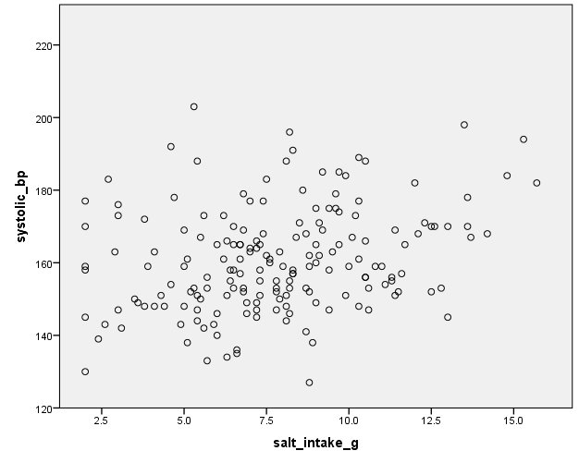

CORRELATIONS
/VARIABLES=salt_intake_g bmi age physical_activity_min stress_level systolic_bp
/PRINT=TWOTAIL NOSIG
/MISSING=PAIRWISE.

Correlations

Notes
Output Created |  | 19-AUG-2026 12:36:54
Comments
Input | Data | C:\Users\Deeya Rehman\OneDrive\Documents\IBM\Downloads\bp_health_dataset.csv
Input | Active Dataset | DataSet2
Input | Filter | <none>
Input | Weight | <none>
Input | Split File | <none>
Input | N of Rows in Working Data File | 180
Missing Value Handling | Definition of Missing | User-defined missing values are treated as missing.
Missing Value Handling | Cases Used | Statistics for each pair of variables are based on all the cases with valid data for that pair.
Syntax |  | CORRELATIONS  /VARIABLES=salt_intake_g bmi age physical_activity_min stress_level systolic_bp  /PRINT=TWOTAIL NOSIG  /MISSING=PAIRWISE.
Resources | Processor Time | 00:00:00.05
Resources | Elapsed Time | 00:00:00.14

[DataSet2]

Correlations
 |  | salt_intake_g | bmi | age | physical_activity_min
salt_intake_g | Pearson Correlation | 1 | -.045 | -.011 | -.087
salt_intake_g | Sig. (2-tailed) |  | .555 | .880 | .248
salt_intake_g | N | 180 | 174 | 180 | 180
bmi | Pearson Correlation | -.045 | 1 | .094 | -.207**
bmi | Sig. (2-tailed) | .555 |  | .215 | .006
bmi | N | 174 | 174 | 174 | 174
age | Pearson Correlation | -.011 | .094 | 1 | .041
age | Sig. (2-tailed) | .880 | .215 |  | .587
age | N | 180 | 174 | 180 | 180
physical_activity_min | Pearson Correlation | -.087 | -.207** | .041 | 1
physical_activity_min | Sig. (2-tailed) | .248 | .006 | .587
physical_activity_min | N | 180 | 174 | 180 | 180
stress_level | Pearson Correlation | -.084 | -.120 | -.052 | .059
stress_level | Sig. (2-tailed) | .270 | .118 | .490 | .440
stress_level | N | 176 | 170 | 176 | 176
systolic_bp | Pearson Correlation | .279** | .476** | .584** | -.214**
systolic_bp | Sig. (2-tailed) | .000 | .000 | .000 | .004
systolic_bp | N | 180 | 174 | 180 | 180

Correlations
 |  | stress_level | systolic_bp
salt_intake_g | Pearson Correlation | -.084 | .279
salt_intake_g | Sig. (2-tailed) | .270 | .000
salt_intake_g | N | 176 | 180
bmi | Pearson Correlation | -.120 | .476
bmi | Sig. (2-tailed) | .118 | .000
bmi | N | 170 | 174
age | Pearson Correlation | -.052 | .584
age | Sig. (2-tailed) | .490 | .000
age | N | 176 | 180
physical_activity_min | Pearson Correlation | .059 | -.214**
physical_activity_min | Sig. (2-tailed) | .440 | .004
physical_activity_min | N | 176 | 180
stress_level | Pearson Correlation | 1 | -.118
stress_level | Sig. (2-tailed) |  | .119
stress_level | N | 176 | 176
systolic_bp | Pearson Correlation | -.118** | 1**
systolic_bp | Sig. (2-tailed) | .119
systolic_bp | N | 176 | 180

**. Correlation is significant at the 0.01 level (2-tailed).

REGRESSION
/DESCRIPTIVES MEAN STDDEV CORR SIG N
/MISSING LISTWISE
/STATISTICS COEFF OUTS CI(95) R ANOVA COLLIN TOL CHANGE
/CRITERIA=PIN(.05) POUT(.10)
/NOORIGIN
/DEPENDENT systolic_bp
/METHOD=ENTER Participant_ID age gender bmi physical_activity_min salt_intake_g smoking_status
/SCATTERPLOT=(*ZRESID ,*ZPRED)
/RESIDUALS DURBIN HISTOGRAM(ZRESID) NORMPROB(ZRESID).

Regression

Notes
Output Created |  | 21-AUG-2026 11:57:02
Comments
Input | Data | C:\Users\Deeya Rehman\OneDrive\Documents\IBM\Downloads\bp_health_dataset.csv
Input | Active Dataset | DataSet2
Input | Filter | <none>
Input | Weight | <none>
Input | Split File | <none>
Input | N of Rows in Working Data File | 180
Missing Value Handling | Definition of Missing | User-defined missing values are treated as missing.
Missing Value Handling | Cases Used | Statistics are based on cases with no missing values for any variable used.
Syntax |  | REGRESSION  /DESCRIPTIVES MEAN STDDEV CORR SIG N  /MISSING LISTWISE  /STATISTICS COEFF OUTS CI(95) R ANOVA COLLIN TOL CHANGE  /CRITERIA=PIN(.05) POUT(.10)  /NOORIGIN  /DEPENDENT systolic_bp  /METHOD=ENTER Participant_ID age gender bmi physical_activity_min salt_intake_g smoking_status  /SCATTERPLOT=(*ZRESID ,*ZPRED)  /RESIDUALS DURBIN HISTOGRAM(ZRESID) NORMPROB(ZRESID).
Resources | Processor Time | 00:00:01.67

Notes
Resources | Elapsed Time | 00:00:02.23
Resources | Memory Required | 3564 bytes
Resources | Additional Memory Required for Residual Plots | 864 bytes

[DataSet2]

Descriptive Statistics
 | Mean | Std. Deviation | N
systolic_bp | 160.63 | 14.244 | 174
Participant_ID | 89.61 | 52.578 | 174
age | 43.47 | 14.736 | 174
gender | .47 | .500 | 174
bmi | 25.963 | 4.1020 | 174
physical_activity_min | 157.81 | 77.063 | 174
salt_intake_g | 7.766 | 2.9944 | 174
smoking_status | .28 | .448 | 174

Correlations
 |  | systolic_bp | Participant_ID | age | gender
Pearson Correlation | systolic_bp | 1.000 | .038 | .600 | .027
Pearson Correlation | Participant_ID | .038 | 1.000 | -.006 | .070
Pearson Correlation | age | .600 | -.006 | 1.000 | -.042
Pearson Correlation | gender | .027 | .070 | -.042 | 1.000
Pearson Correlation | bmi | .476 | -.011 | .094 | .027
Pearson Correlation | physical_activity_min | -.208 | .029 | .030 | -.041
Pearson Correlation | salt_intake_g | .286 | .078 | -.017 | .003
Pearson Correlation | smoking_status | .408 | .134 | .195 | -.060
Sig. (1-tailed) | systolic_bp | . | .311 | .000 | .364
Sig. (1-tailed) | Participant_ID | .311 | . | .469 | .179
Sig. (1-tailed) | age | .000 | .469 | . | .289
Sig. (1-tailed) | gender | .364 | .179 | .289 | .
Sig. (1-tailed) | bmi | .000 | .442 | .107 | .360
Sig. (1-tailed) | physical_activity_min | .003 | .354 | .349 | .297
Sig. (1-tailed) | salt_intake_g | .000 | .153 | .413 | .484
Sig. (1-tailed) | smoking_status | .000 | .039 | .005 | .214
N | systolic_bp | 174 | 174 | 174 | 174
N | Participant_ID | 174 | 174 | 174 | 174
N | age | 174 | 174 | 174 | 174
N | gender | 174 | 174 | 174 | 174
N | bmi | 174 | 174 | 174 | 174
N | physical_activity_min | 174 | 174 | 174 | 174
N | salt_intake_g | 174 | 174 | 174 | 174
N | smoking_status | 174 | 174 | 174 | 174

Correlations
 |  | bmi | physical_activity_min | salt_intake_g | smoking_status
Pearson Correlation | systolic_bp | .476 | -.208 | .286 | .408
Pearson Correlation | Participant_ID | -.011 | .029 | .078 | .134
Pearson Correlation | age | .094 | .030 | -.017 | .195
Pearson Correlation | gender | .027 | -.041 | .003 | -.060
Pearson Correlation | bmi | 1.000 | -.207 | -.045 | .072
Pearson Correlation | physical_activity_min | -.207 | 1.000 | -.092 | -.029
Pearson Correlation | salt_intake_g | -.045 | -.092 | 1.000 | .036
Pearson Correlation | smoking_status | .072 | -.029 | .036 | 1.000
Sig. (1-tailed) | systolic_bp | .000 | .003 | .000 | .000
Sig. (1-tailed) | Participant_ID | .442 | .354 | .153 | .039
Sig. (1-tailed) | age | .107 | .349 | .413 | .005
Sig. (1-tailed) | gender | .360 | .297 | .484 | .214
Sig. (1-tailed) | bmi | . | .003 | .278 | .172
Sig. (1-tailed) | physical_activity_min | .003 | . | .113 | .352
Sig. (1-tailed) | salt_intake_g | .278 | .113 | . | .319
Sig. (1-tailed) | smoking_status | .172 | .352 | .319 | .
N | systolic_bp | 174 | 174 | 174 | 174
N | Participant_ID | 174 | 174 | 174 | 174
N | age | 174 | 174 | 174 | 174
N | gender | 174 | 174 | 174 | 174
N | bmi | 174 | 174 | 174 | 174
N | physical_activity_min | 174 | 174 | 174 | 174
N | salt_intake_g | 174 | 174 | 174 | 174
N | smoking_status | 174 | 174 | 174 | 174

Variables Entered/Removedª
Model | Variables Entered | Variables Removed | Method
1 | smoking_status, physical_activity_min, gender, salt_intake_g, Participant_ID, age, bmi^{b} | . | Enter

a. Dependent Variable: systolic_bp
b. All requested variables entered.

Model Summary^{b}
Model | R | R Square | Adjusted R Square | Std. Error of the Estimate | Change Statistics
 |  |  |  |  | R Square Change | F Change | df1
1 | .847ª | .717 | .705 | 7.732 | .717 | 60.152 | 7

Model Summary^{b}
Model | Change Statistics |  | Durbin-Watson
Model | df2 | Sig. F Change | Durbin-Watson
1 | 166ª | .000 | 2.051

a. Predictors: (Constant), smoking_status, physical_activity_min, gender, salt_intake_g, Participant_ID, age, bmi
b. Dependent Variable: systolic_bp

ANOVAª
Model |  | Sum of Squares | df | Mean Square | F | Sig.
1 | Regression | 25173.908 | 7 | 3596.273 | 60.152 | .000^{b}
1 | Residual | 9924.552 | 166 | 59.786
1 | Total | 35098.460 | 173

a. Dependent Variable: systolic_bp
b. Predictors: (Constant), smoking_status, physical_activity_min, gender, salt_intake_g, Participant_ID, age, bmi

Coefficientsª
Model |  | Unstandardized Coefficients |  | Standardized Coefficients | t | Sig.
 |  | B | Std. Error | Beta | t | Sig.
1 | (Constant) | 92.406 | 4.969 |  | 18.597 | .000
1 | Participant_ID | -.004 | .011 | -.015 | -.347 | .729
1 | age | .502 | .041 | .520 | 12.276 | .000
1 | gender | 1.424 | 1.183 | .050 | 1.203 | .231
1 | bmi | 1.382 | .148 | .398 | 9.346 | .000
1 | physical_activity_min | -.019 | .008 | -.103 | -2.429 | .016
1 | salt_intake_g | 1.399 | .198 | .294 | 7.052 | .000
1 | smoking_status | 8.551 | 1.357 | .269 | 6.303 | .000

Coefficientsª
Model |  | 95.0% Confidence Interval for B |  | Collinearity Statistics
 |  | Lower Bound | Upper Bound | Tolerance | VIF
1 | (Constant) | 82.595 | 102.216
1 | Participant_ID | -.026 | .019 | .968 | 1.033
1 | age | .422 | .583 | .950 | 1.052
1 | gender | -.912 | 3.760 | .987 | 1.014
1 | bmi | 1.090 | 1.674 | .940 | 1.064
1 | physical_activity_min | -.035 | -.004 | .941 | 1.062
1 | salt_intake_g | 1.007 | 1.790 | .980 | 1.021
1 | smoking_status | 5.872 | 11.229 | .935 | 1.070

a. Dependent Variable: systolic_bp

Collinearity Diagnosticsª
Model | Dimension | Eigenvalue | Condition Index | Variance Proportions
 |  |  |  | (Constant) | Participant_ID | age | gender
1 | 1 | 6.230 | 1.000 | .00 | .01 | .00 | .01
1 | 2 | .711 | 2.960 | .00 | .00 | .00 | .11
1 | 3 | .473 | 3.628 | .00 | .00 | .00 | .84
1 | 4 | .226 | 5.254 | .00 | .89 | .02 | .01
1 | 5 | .180 | 5.884 | .00 | .06 | .02 | .01
1 | 6 | .113 | 7.421 | .00 | .01 | .35 | .00
1 | 7 | .058 | 10.384 | .04 | .02 | .58 | .02
1 | 8 | .009 | 25.836 | .96 | .01 | .03 | .00

Collinearity Diagnosticsª
Model | Dimension | Variance Proportions
Model | Dimension | bmi | physical_activity_min | salt_intake_g | smoking_status
1 | 1 | .00 | .00 | .00 | .01
1 | 2 | .00 | .00 | .00 | .79
1 | 3 | .00 | .02 | .01 | .14
1 | 4 | .00 | .09 | .00 | .01
1 | 5 | .00 | .61 | .18 | .01
1 | 6 | .01 | .10 | .53 | .03
1 | 7 | .16 | .03 | .19 | .01
1 | 8 | .83 | .14 | .09 | .00

a. Dependent Variable: systolic_bp

Residuals Statisticsª
 | Minimum | Maximum | Mean | Std. Deviation | N
Predicted Value | 135.56 | 200.71 | 160.63 | 12.063 | 174
Residual | -18.019 | 24.926 | .000 | 7.574 | 174
Std. Predicted Value | -2.079 | 3.322 | .000 | 1.000 | 174
Std. Residual | -2.330 | 3.224 | .000 | .980 | 174

a. Dependent Variable: systolic_bp

Charts

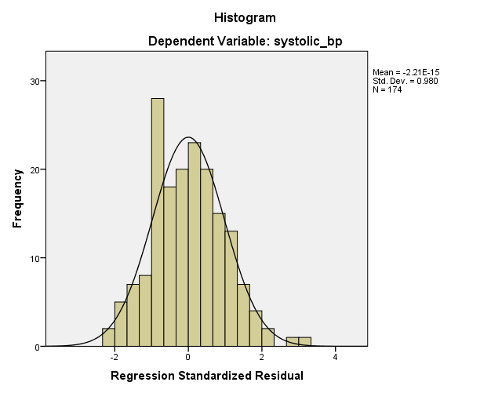

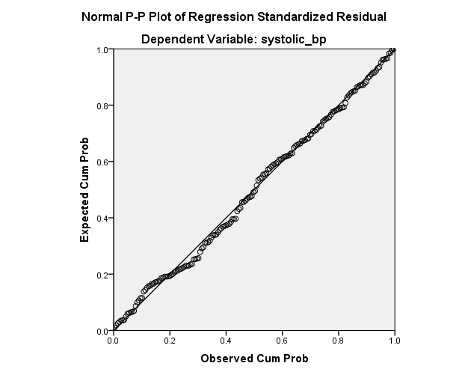

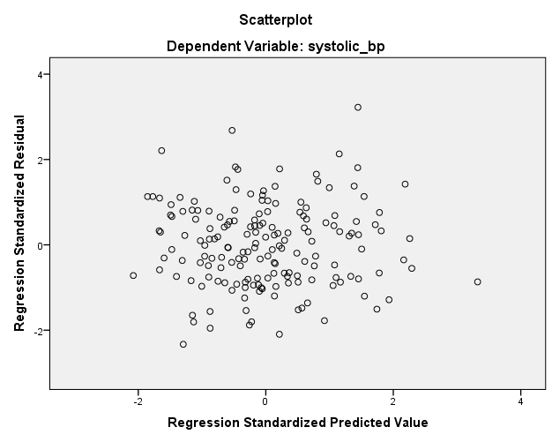

REGRESSION
/DESCRIPTIVES MEAN STDDEV CORR SIG N
/MISSING LISTWISE
/STATISTICS COEFF OUTS CI(95) R ANOVA COLLIN TOL CHANGE
/CRITERIA=PIN(.05) POUT(.10)
/NOORIGIN
/DEPENDENT systolic_bp
/METHOD=ENTER age gender bmi physical_activity_min salt_intake_g smoking_status stress_level
/SCATTERPLOT=(*ZRESID ,*ZPRED)
/RESIDUALS DURBIN HISTOGRAM(ZRESID) NORMPROB(ZRESID).

Regression

Notes
Output Created |  | 21-AUG-2026 12:26:57
Comments
Input | Data | C:\Users\Deeya Rehman\OneDrive\Documents\IBM\Downloads\bp_health_dataset.csv
Input | Active Dataset | DataSet2
Input | Filter | <none>
Input | Weight | <none>
Input | Split File | <none>
Input | N of Rows in Working Data File | 180
Missing Value Handling | Definition of Missing | User-defined missing values are treated as missing.
Missing Value Handling | Cases Used | Statistics are based on cases with no missing values for any variable used.
Syntax |  | REGRESSION  /DESCRIPTIVES MEAN STDDEV CORR SIG N  /MISSING LISTWISE  /STATISTICS COEFF OUTS CI(95) R ANOVA COLLIN TOL CHANGE  /CRITERIA=PIN(.05) POUT(.10)  /NOORIGIN  /DEPENDENT systolic_bp  /METHOD=ENTER age gender bmi physical_activity_min salt_intake_g smoking_status stress_level  /SCATTERPLOT=(*ZRESID ,*ZPRED)  /RESIDUALS DURBIN HISTOGRAM(ZRESID) NORMPROB(ZRESID).

Notes
Resources | Processor Time | 00:00:01.78
Resources | Elapsed Time | 00:00:03.31
Resources | Memory Required | 3564 bytes
Resources | Additional Memory Required for Residual Plots | 864 bytes

[DataSet2]

Descriptive Statistics
 | Mean | Std. Deviation | N
systolic_bp | 160.61 | 14.278 | 170
age | 43.46 | 14.682 | 170
gender | .46 | .500 | 170
bmi | 25.995 | 4.1406 | 170
physical_activity_min | 157.60 | 75.611 | 170
salt_intake_g | 7.748 | 3.0127 | 170
smoking_status | .28 | .449 | 170
stress_level | 5.488 | 2.9518 | 170

Correlations
 |  | systolic_bp | age | gender | bmi
Pearson Correlation | systolic_bp | 1.000 | .611 | .047 | .477
Pearson Correlation | age | .611 | 1.000 | -.033 | .100
Pearson Correlation | gender | .047 | -.033 | 1.000 | .033
Pearson Correlation | bmi | .477 | .100 | .033 | 1.000
Pearson Correlation | physical_activity_min | -.186 | .056 | -.080 | -.208
Pearson Correlation | salt_intake_g | .291 | .000 | -.002 | -.046
Pearson Correlation | smoking_status | .404 | .208 | -.049 | .068
Pearson Correlation | stress_level | -.136 | -.062 | .018 | -.120
Sig. (1-tailed) | systolic_bp | . | .000 | .270 | .000
Sig. (1-tailed) | age | .000 | . | .334 | .097
Sig. (1-tailed) | gender | .270 | .334 | . | .335
Sig. (1-tailed) | bmi | .000 | .097 | .335 | .
Sig. (1-tailed) | physical_activity_min | .008 | .232 | .149 | .003
Sig. (1-tailed) | salt_intake_g | .000 | .500 | .489 | .277
Sig. (1-tailed) | smoking_status | .000 | .003 | .265 | .190
Sig. (1-tailed) | stress_level | .039 | .209 | .409 | .059
N | systolic_bp | 170 | 170 | 170 | 170
N | age | 170 | 170 | 170 | 170
N | gender | 170 | 170 | 170 | 170
N | bmi | 170 | 170 | 170 | 170
N | physical_activity_min | 170 | 170 | 170 | 170
N | salt_intake_g | 170 | 170 | 170 | 170
N | smoking_status | 170 | 170 | 170 | 170
N | stress_level | 170 | 170 | 170 | 170

Correlations
 |  | physical_activity_min | salt_intake_g | smoking_status
Pearson Correlation | systolic_bp | -.186 | .291 | .404
Pearson Correlation | age | .056 | .000 | .208
Pearson Correlation | gender | -.080 | -.002 | -.049
Pearson Correlation | bmi | -.208 | -.046 | .068
Pearson Correlation | physical_activity_min | 1.000 | -.109 | -.012
Pearson Correlation | salt_intake_g | -.109 | 1.000 | .032
Pearson Correlation | smoking_status | -.012 | .032 | 1.000
Pearson Correlation | stress_level | .068 | -.093 | -.067
Sig. (1-tailed) | systolic_bp | .008 | .000 | .000
Sig. (1-tailed) | age | .232 | .500 | .003
Sig. (1-tailed) | gender | .149 | .489 | .265
Sig. (1-tailed) | bmi | .003 | .277 | .190
Sig. (1-tailed) | physical_activity_min | . | .078 | .438
Sig. (1-tailed) | salt_intake_g | .078 | . | .338
Sig. (1-tailed) | smoking_status | .438 | .338 | .
Sig. (1-tailed) | stress_level | .189 | .115 | .193
N | systolic_bp | 170 | 170 | 170
N | age | 170 | 170 | 170
N | gender | 170 | 170 | 170
N | bmi | 170 | 170 | 170
N | physical_activity_min | 170 | 170 | 170
N | salt_intake_g | 170 | 170 | 170
N | smoking_status | 170 | 170 | 170
N | stress_level | 170 | 170 | 170

Correlations
 |  | stress_level
Pearson Correlation | systolic_bp | -.136
Pearson Correlation | age | -.062
Pearson Correlation | gender | .018
Pearson Correlation | bmi | -.120
Pearson Correlation | physical_activity_min | .068
Pearson Correlation | salt_intake_g | -.093
Pearson Correlation | smoking_status | -.067
Pearson Correlation | stress_level | 1.000
Sig. (1-tailed) | systolic_bp | .039
Sig. (1-tailed) | age | .209
Sig. (1-tailed) | gender | .409
Sig. (1-tailed) | bmi | .059
Sig. (1-tailed) | physical_activity_min | .189
Sig. (1-tailed) | salt_intake_g | .115
Sig. (1-tailed) | smoking_status | .193
Sig. (1-tailed) | stress_level | .
N | systolic_bp | 170
N | age | 170
N | gender | 170
N | bmi | 170
N | physical_activity_min | 170
N | salt_intake_g | 170
N | smoking_status | 170
N | stress_level | 170

Variables Entered/Removedª
Model | Variables Entered | Variables Removed | Method
1 | stress_level, gender, age, salt_intake_g, physical_activity_min, smoking_status, bmi^{b} | . | Enter

a. Dependent Variable: systolic_bp
b. All requested variables entered.

Model Summary^{b}
Model | R | R Square | Adjusted R Square | Std. Error of the Estimate | Change Statistics
 |  |  |  |  | R Square Change | F Change | df1
1 | .849ª | .720 | .708 | 7.712 | .720 | 59.606 | 7

Model Summary^{b}
Model | Change Statistics |  | Durbin-Watson
Model | df2 | Sig. F Change | Durbin-Watson
1 | 162ª | .000 | 2.044

a. Predictors: (Constant), stress_level, gender, age, salt_intake_g, physical_activity_min, smoking_status, bmi
b. Dependent Variable: systolic_bp

ANOVAª
Model |  | Sum of Squares | df | Mean Square | F | Sig.
1 | Regression | 24815.597 | 7 | 3545.085 | 59.606 | .000^{b}
1 | Residual | 9634.997 | 162 | 59.475
1 | Total | 34450.594 | 169

a. Dependent Variable: systolic_bp
b. Predictors: (Constant), stress_level, gender, age, salt_intake_g, physical_activity_min, smoking_status, bmi

Coefficientsª
Model |  | Unstandardized Coefficients |  | Standardized Coefficients | t | Sig.
 |  | B | Std. Error | Beta | t | Sig.
1 | (Constant) | 91.969 | 5.208 |  | 17.660 | .000
1 | age | .509 | .042 | .524 | 12.225 | .000
1 | gender | 1.642 | 1.192 | .058 | 1.378 | .170
1 | bmi | 1.374 | .149 | .399 | 9.230 | .000
1 | physical_activity_min | -.018 | .008 | -.093 | -2.160 | .032
1 | salt_intake_g | 1.375 | .200 | .290 | 6.887 | .000
1 | smoking_status | 8.286 | 1.357 | .260 | 6.105 | .000
1 | stress_level | -.027 | .204 | -.006 | -.132 | .895

Coefficientsª
Model |  | 95.0% Confidence Interval for B |  | Collinearity Statistics
 |  | Lower Bound | Upper Bound | Tolerance | VIF
1 | (Constant) | 81.685 | 102.253
1 | age | .427 | .591 | .941 | 1.063
1 | gender | -.712 | 3.996 | .990 | 1.010
1 | bmi | 1.080 | 1.668 | .926 | 1.080
1 | physical_activity_min | -.034 | -.002 | .930 | 1.075
1 | salt_intake_g | .980 | 1.769 | .973 | 1.027
1 | smoking_status | 5.605 | 10.966 | .949 | 1.053
1 | stress_level | -.430 | .376 | .969 | 1.031

a. Dependent Variable: systolic_bp

Collinearity Diagnosticsª
Model | Dimension | Eigenvalue | Condition Index | Variance Proportions
 |  |  |  | (Constant) | age | gender | bmi
1 | 1 | 6.233 | 1.000 | .00 | .00 | .01 | .00
1 | 2 | .714 | 2.955 | .00 | .00 | .08 | .00
1 | 3 | .492 | 3.561 | .00 | .00 | .86 | .00
1 | 4 | .209 | 5.455 | .00 | .02 | .00 | .00
1 | 5 | .178 | 5.916 | .00 | .00 | .02 | .00
1 | 6 | .109 | 7.564 | .00 | .42 | .00 | .01
1 | 7 | .057 | 10.492 | .03 | .53 | .02 | .17
1 | 8 | .009 | 26.493 | .97 | .02 | .01 | .81

Collinearity Diagnosticsª
Model | Dimension | Variance Proportions
Model | Dimension | physical_activity_min | salt_intake_g | smoking_status | stress_level
1 | 1 | .00 | .00 | .01 | .00
1 | 2 | .00 | .00 | .83 | .01
1 | 3 | .02 | .00 | .09 | .01
1 | 4 | .00 | .09 | .03 | .78
1 | 5 | .69 | .15 | .00 | .05
1 | 6 | .12 | .45 | .03 | .01
1 | 7 | .02 | .19 | .00 | .06
1 | 8 | .14 | .11 | .00 | .07

a. Dependent Variable: systolic_bp

Residuals Statisticsª
 | Minimum | Maximum | Mean | Std. Deviation | N
Predicted Value | 135.58 | 200.31 | 160.61 | 12.118 | 170
Residual | -17.525 | 25.193 | .000 | 7.551 | 170
Std. Predicted Value | -2.065 | 3.277 | .000 | 1.000 | 170
Std. Residual | -2.272 | 3.267 | .000 | .979 | 170

a. Dependent Variable: systolic_bp

Charts

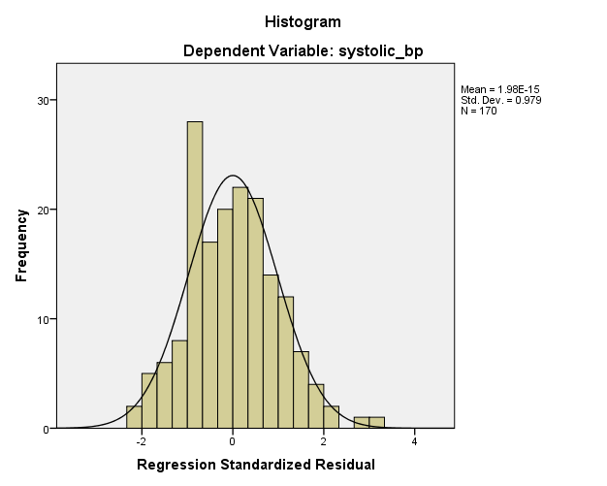

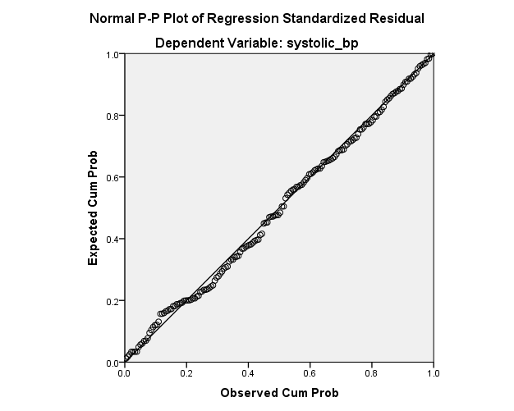

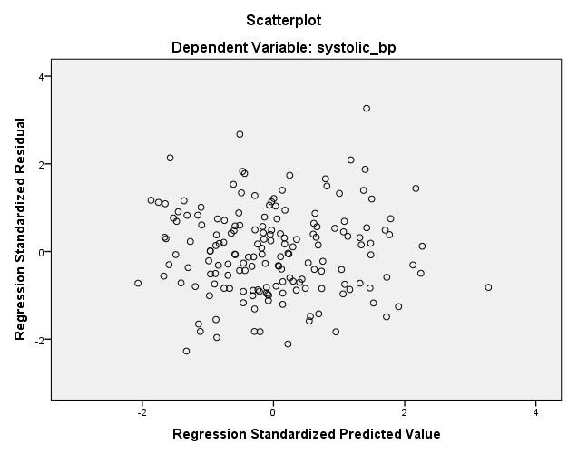

COMPUTE age_x_smoking=age * smoking_status.
EXECUTE.
REGRESSION
/DESCRIPTIVES MEAN STDDEV CORR SIG N
/MISSING LISTWISE
/STATISTICS COEFF OUTS CI(95) R ANOVA COLLIN TOL CHANGE
/CRITERIA=PIN(.05) POUT(.10)
/NOORIGIN
/DEPENDENT systolic_bp
/METHOD=ENTER age gender bmi physical_activity_min salt_intake_g smoking_status stress_level age_x_smoking
/SCATTERPLOT=(*ZRESID ,*ZPRED)
/RESIDUALS DURBIN HISTOGRAM(ZRESID) NORMPROB(ZRESID).

Regression

Notes
Output Created |  | 21-AUG-2026 12:35:35
Comments
Input | Data | C:\Users\Deeya Rehman\OneDrive\Documents\IBM\Downloads\bp_health_dataset.csv
Input | Active Dataset | DataSet2
Input | Filter | <none>
Input | Weight | <none>
Input | Split File | <none>
Input | N of Rows in Working Data File | 180
Missing Value Handling | Definition of Missing | User-defined missing values are treated as missing.
Missing Value Handling | Cases Used | Statistics are based on cases with no missing values for any variable used.
Syntax |  | REGRESSION  /DESCRIPTIVES MEAN STDDEV CORR SIG N  /MISSING LISTWISE  /STATISTICS COEFF OUTS CI(95) R ANOVA COLLIN TOL CHANGE  /CRITERIA=PIN(.05) POUT(.10)  /NOORIGIN  /DEPENDENT systolic_bp  /METHOD=ENTER age gender bmi physical_activity_min salt_intake_g smoking_status stress_level age_x_smoking  /SCATTERPLOT=(*ZRESID ,*ZPRED)  /RESIDUALS DURBIN HISTOGRAM(ZRESID) NORMPROB(ZRESID).

Notes
Resources | Processor Time | 00:00:02.91
Resources | Elapsed Time | 00:00:03.83
Resources | Memory Required | 4036 bytes
Resources | Additional Memory Required for Residual Plots | 856 bytes

[DataSet2]

Descriptive Statistics
 | Mean | Std. Deviation | N
systolic_bp | 160.61 | 14.278 | 170
age | 43.46 | 14.682 | 170
gender | .46 | .500 | 170
bmi | 25.995 | 4.1406 | 170
physical_activity_min | 157.60 | 75.611 | 170
salt_intake_g | 7.748 | 3.0127 | 170
smoking_status | .28 | .449 | 170
stress_level | 5.488 | 2.9518 | 170
age_x_smoking | 13.3765 | 23.01529 | 170

Correlations
 |  | systolic_bp | age | gender | bmi
Pearson Correlation | systolic_bp | 1.000 | .611 | .047 | .477
Pearson Correlation | age | .611 | 1.000 | -.033 | .100
Pearson Correlation | gender | .047 | -.033 | 1.000 | .033
Pearson Correlation | bmi | .477 | .100 | .033 | 1.000
Pearson Correlation | physical_activity_min | -.186 | .056 | -.080 | -.208
Pearson Correlation | salt_intake_g | .291 | .000 | -.002 | -.046
Pearson Correlation | smoking_status | .404 | .208 | -.049 | .068
Pearson Correlation | stress_level | -.136 | -.062 | .018 | -.120
Pearson Correlation | age_x_smoking | .496 | .370 | -.086 | .088
Sig. (1-tailed) | systolic_bp | . | .000 | .270 | .000
Sig. (1-tailed) | age | .000 | . | .334 | .097
Sig. (1-tailed) | gender | .270 | .334 | . | .335
Sig. (1-tailed) | bmi | .000 | .097 | .335 | .
Sig. (1-tailed) | physical_activity_min | .008 | .232 | .149 | .003
Sig. (1-tailed) | salt_intake_g | .000 | .500 | .489 | .277
Sig. (1-tailed) | smoking_status | .000 | .003 | .265 | .190
Sig. (1-tailed) | stress_level | .039 | .209 | .409 | .059
Sig. (1-tailed) | age_x_smoking | .000 | .000 | .132 | .127
N | systolic_bp | 170 | 170 | 170 | 170
N | age | 170 | 170 | 170 | 170
N | gender | 170 | 170 | 170 | 170
N | bmi | 170 | 170 | 170 | 170
N | physical_activity_min | 170 | 170 | 170 | 170
N | salt_intake_g | 170 | 170 | 170 | 170
N | smoking_status | 170 | 170 | 170 | 170
N | stress_level | 170 | 170 | 170 | 170
N | age_x_smoking | 170 | 170 | 170 | 170

Correlations
 |  | physical_activity_min | salt_intake_g | smoking_status
Pearson Correlation | systolic_bp | -.186 | .291 | .404
Pearson Correlation | age | .056 | .000 | .208
Pearson Correlation | gender | -.080 | -.002 | -.049
Pearson Correlation | bmi | -.208 | -.046 | .068
Pearson Correlation | physical_activity_min | 1.000 | -.109 | -.012
Pearson Correlation | salt_intake_g | -.109 | 1.000 | .032
Pearson Correlation | smoking_status | -.012 | .032 | 1.000
Pearson Correlation | stress_level | .068 | -.093 | -.067
Pearson Correlation | age_x_smoking | .002 | .034 | .943
Sig. (1-tailed) | systolic_bp | .008 | .000 | .000
Sig. (1-tailed) | age | .232 | .500 | .003
Sig. (1-tailed) | gender | .149 | .489 | .265
Sig. (1-tailed) | bmi | .003 | .277 | .190
Sig. (1-tailed) | physical_activity_min | . | .078 | .438
Sig. (1-tailed) | salt_intake_g | .078 | . | .338
Sig. (1-tailed) | smoking_status | .438 | .338 | .
Sig. (1-tailed) | stress_level | .189 | .115 | .193
Sig. (1-tailed) | age_x_smoking | .489 | .330 | .000
N | systolic_bp | 170 | 170 | 170
N | age | 170 | 170 | 170
N | gender | 170 | 170 | 170
N | bmi | 170 | 170 | 170
N | physical_activity_min | 170 | 170 | 170
N | salt_intake_g | 170 | 170 | 170
N | smoking_status | 170 | 170 | 170
N | stress_level | 170 | 170 | 170
N | age_x_smoking | 170 | 170 | 170

Correlations
 |  | stress_level | age_x_smoking
Pearson Correlation | systolic_bp | -.136 | .496
Pearson Correlation | age | -.062 | .370
Pearson Correlation | gender | .018 | -.086
Pearson Correlation | bmi | -.120 | .088
Pearson Correlation | physical_activity_min | .068 | .002
Pearson Correlation | salt_intake_g | -.093 | .034
Pearson Correlation | smoking_status | -.067 | .943
Pearson Correlation | stress_level | 1.000 | -.075
Pearson Correlation | age_x_smoking | -.075 | 1.000
Sig. (1-tailed) | systolic_bp | .039 | .000
Sig. (1-tailed) | age | .209 | .000
Sig. (1-tailed) | gender | .409 | .132
Sig. (1-tailed) | bmi | .059 | .127
Sig. (1-tailed) | physical_activity_min | .189 | .489
Sig. (1-tailed) | salt_intake_g | .115 | .330
Sig. (1-tailed) | smoking_status | .193 | .000
Sig. (1-tailed) | stress_level | . | .166
Sig. (1-tailed) | age_x_smoking | .166 | .
N | systolic_bp | 170 | 170
N | age | 170 | 170
N | gender | 170 | 170
N | bmi | 170 | 170
N | physical_activity_min | 170 | 170
N | salt_intake_g | 170 | 170
N | smoking_status | 170 | 170
N | stress_level | 170 | 170
N | age_x_smoking | 170 | 170

Variables Entered/Removedª
Model | Variables Entered | Variables Removed | Method
1 | age_x_smoking, physical_activity_min, stress_level, gender, salt_intake_g, bmi, age, smoking_status^{b} | . | Enter

a. Dependent Variable: systolic_bp
b. All requested variables entered.

Model Summary^{b}
Model | R | R Square | Adjusted R Square | Std. Error of the Estimate | Change Statistics
 |  |  |  |  | R Square Change | F Change | df1
1 | .851ª | .724 | .710 | 7.685 | .724 | 52.789 | 8

Model Summary^{b}
Model | Change Statistics |  | Durbin-Watson
Model | df2 | Sig. F Change | Durbin-Watson
1 | 161ª | .000 | 2.051

a. Predictors: (Constant), age_x_smoking, physical_activity_min, stress_level, gender, salt_intake_g, bmi, age, smoking_status
b. Dependent Variable: systolic_bp

ANOVAª
Model |  | Sum of Squares | df | Mean Square | F | Sig.
1 | Regression | 24941.878 | 8 | 3117.735 | 52.789 | .000^{b}
1 | Residual | 9508.716 | 161 | 59.060
1 | Total | 34450.594 | 169

a. Dependent Variable: systolic_bp
b. Predictors: (Constant), age_x_smoking, physical_activity_min, stress_level, gender, salt_intake_g, bmi, age, smoking_status

age_x_smoking | .135 | .092 | .217 | 1.462 | .146 | -.047 | .317 | .078 | 12.854

Collinearity Diagnosticsª
Model | Dimension | Eigenvalue | Condition Index | Variance Proportions
 |  |  |  | (Constant) | age | gender | bmi
1 | 1 | 6.600 | 1.000 | .00 | .00 | .01 | .00
1 | 2 | 1.304 | 2.250 | .00 | .00 | .02 | .00
1 | 3 | .496 | 3.648 | .00 | .00 | .90 | .00
1 | 4 | .210 | 5.613 | .00 | .02 | .00 | .00
1 | 5 | .178 | 6.087 | .00 | .00 | .02 | .00
1 | 6 | .113 | 7.638 | .00 | .29 | .00 | .01
1 | 7 | .064 | 10.133 | .03 | .14 | .03 | .13
1 | 8 | .026 | 15.828 | .00 | .48 | .01 | .09
1 | 9 | .008 | 27.869 | .97 | .07 | .00 | .76

Collinearity Diagnosticsª
Model | Dimension | Variance Proportions
Model | Dimension | physical_activity_min | salt_intake_g | smoking_status | stress_level | age_x_smoking
1 | 1 | .00 | .00 | .00 | .00 | .00
1 | 2 | .00 | .00 | .02 | .01 | .02
1 | 3 | .02 | .00 | .00 | .01 | .00
1 | 4 | .00 | .10 | .00 | .78 | .00
1 | 5 | .69 | .15 | .00 | .05 | .00
1 | 6 | .11 | .37 | .03 | .00 | .01
1 | 7 | .04 | .27 | .10 | .07 | .08
1 | 8 | .01 | .00 | .79 | .00 | .82
1 | 9 | .13 | .11 | .05 | .07 | .06

a. Dependent Variable: systolic_bp

Residuals Statisticsª
 | Minimum | Maximum | Mean | Std. Deviation | N
Predicted Value | 136.11 | 201.73 | 160.61 | 12.148 | 170
Residual | -18.143 | 23.237 | .000 | 7.501 | 170
Std. Predicted Value | -2.016 | 3.385 | .000 | 1.000 | 170
Std. Residual | -2.361 | 3.024 | .000 | .976 | 170

a. Dependent Variable: systolic_bp

Charts

