Technical & Financial Proposal
AJEX Mobile App Enhancement (Frontend Development Only)
Prepared by: Riseup Labs
Date: January 22, 2026

1. Introduction
This document provides a technical and financial proposal for enhancing the existing AJEX courier/logistics mobile application. The client has requested a brief assessment and a high-level cost estimation for a defined set of proposed functionalities. This proposal is strictly limited to mobile app frontend development for the existing Flutter application (Android and iOS).
Key constraints for this proposal:
• Scope is limited to the Proposed Functionalities listed in the client brief.
• Design/UI/UX and backend development are out of scope.
• All required REST APIs will be provided by the client (no backend work from our side).
• The project is not from scratch; fixing existing/legacy issues and bugs is out of scope unless they are directly caused by the new in-scope changes.

2. Project Scope Overview

2.1 In Scope (Mobile App Frontend Development)
Implementation and integration (frontend-side) for the following proposed functionalities:
• Rate Calculator
• Reschedule Delivery
• On-Demand Delivery (2–3 hours with additional fee)
• Create Pickup Request
• Sign-Up Optimization
• Returns via Parcel Locker

2.2 Out of Scope
• Any functionality not explicitly listed under Proposed Functionalities in the client brief.
• UI/UX design, visual redesign, branding, and new design explorations.
• Backend development, database changes, admin/dashboard development, and API development.
• Bug fixing and refactoring of existing modules unrelated to the above in-scope features.
• Previous issues / known bugs fixing (unless directly introduced by in-scope work).

2.3 Current App Context (Provided by Client)
• Mobile Framework: Flutter
• Platforms: Android and iOS
• State Management: BLoC
• Architecture: MVVM
• Backend Integration: REST APIs
• Live Tracking & Push Notifications: Firebase
• Maps & Location: Google Maps SDK

3. Proposed Approach & Methodology
We will follow an Agile delivery approach with short iterations, enabling early validation of each feature against the provided APIs and existing app flows. Each phase includes: requirement validation, UI implementation (within the existing UI patterns), BLoC integration, API integration, QA, and a demo build.
Engineering principles applied during enhancement:
• Maintain the existing Flutter architecture (MVVM + BLoC) to reduce regression risk.
• Reuse existing UI components and patterns wherever possible for consistency.
• Add well-defined loading, empty, and error states for all new API-driven screens.
• Prioritize regression testing on critical existing flows that intersect with the new features.

4. Development Phases (3 Phases)
The scope is divided into three (3) phases to reduce delivery risk and allow the client to validate each feature set incrementally. Timelines are estimates and depend on timely access to APIs, test environments, and clarification feedback.

Phase 1 – Sign-Up Optimization + Rate Calculator
Goal: Improve onboarding conversion and enable users to estimate delivery cost quickly.
In-scope features:
• Sign-Up Optimization
• Rate Calculator
Engineering scope (frontend):
• Streamline the current sign-up screens and steps within existing UI patterns (no new UI/UX design work).
• Implement validations, error states, and success states for the updated onboarding.
• Implement Rate Calculator screens: input point A → point B and other required shipment parameters as per API, display estimated price/breakdown returned by API.
• Integrate with client-provided APIs; handle API errors and edge cases gracefully.
• Unit/widget tests for critical components; regression pass on login/sign-up related flows.
Human resources & responsibilities (short):
• PM/BA: requirements clarification, backlog/sprint planning, client coordination
• Flutter Developer: UI implementation, BLoC integration, API integration
• QA Engineer: test cases, functional testing, regression testing
Suggested timeline: 1.5 weeks

Phase 2 – Create Pickup Request + Reschedule Delivery
Goal: Enable users to create outbound shipments and manage delivery date changes.
In-scope features:
• Create Pickup Request
• Reschedule Delivery
Engineering scope (frontend):
• Create Pickup Request: build request creation UI (pickup address, package details, preferred schedule if applicable), confirmation, and request history/list.
• Reschedule Delivery: add UI entry points from shipment details; implement reschedule screen, date selection UI, confirmations, and updated status view.
• Integrate with client-provided APIs for create/update/view actions.
• Edge-case handling: unavailable dates/time slots, cutoff rules, and API failures.
• Regression pass on shipment list/details and related navigation.
Human resources & responsibilities (short):
• PM/BA: acceptance criteria, dependency tracking (API readiness), sprint management
• Flutter Developer: feature implementation and integration, code review
• QA Engineer: functional testing, device matrix testing, regression
Suggested timeline: 1.5 weeks

Phase 3 – On-Demand Delivery + Returns via Parcel Locker + Stabilization
Goal: Deliver premium delivery option and enable returns through parcel lockers.
In-scope features:
• On-Demand Delivery (2–3 hours with additional fee)
• Returns via Parcel Locker
Engineering scope (frontend):
• On-Demand Delivery: add option selection, fee display, ETA messaging, and eligibility validation based on API response.
• Returns via Parcel Locker: build return initiation flow, locker selection/authorization screens as per API, and return status tracking UI.
• Stabilization for in-scope changes: performance pass on impacted screens and crash fixes related to the enhancement.
• Final regression cycle and release readiness support (build generation + handover checklist).
Human resources & responsibilities (short):
• PM/BA: coordination, final sign-off, release planning
• Flutter Developer: implementation + stabilization, performance improvements (impacted screens only)
• QA Engineer: full regression, release verification
• Release Engineer (part-time, if required): CI/build support for store-ready builds
Suggested timeline: 1.5 weeks

5. Proposed Technical Stack (Frontend)
The enhancement will follow the current app stack as provided by the client:
Layer | Proposed / Existing Choice
Mobile Framework | Flutter (existing)
State Management | BLoC (existing)
Architecture Pattern | MVVM (existing)
API Integration | REST APIs provided by client
Maps & Location | Google Maps SDK (existing)
Notifications / Tracking | Firebase (existing)

6. Deliverables
• Updated Flutter code for the in-scope functionalities (as per client repository access model).
• Phase-wise build artifacts for testing (Android APK/AAB; iOS IPA/TestFlight build where applicable).
• Test cases and test report (functional + regression).
• Implementation notes: impacted screen list, API mapping list, and release notes per phase.
• Handover session and walkthrough for the client team.

7. Diagram
Diagram 1: User Journey & Feature Flow
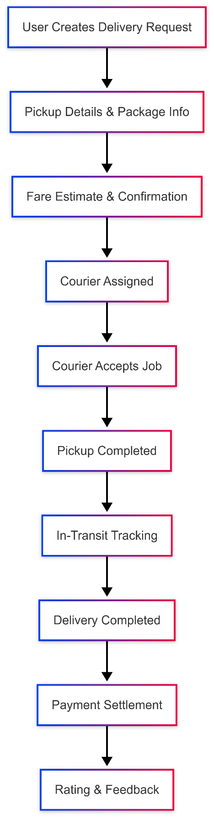

Diagram 2: Frontend Integration Architecture (Flutter UI → BLoC → Repository/Service → Client REST APIs, plus Firebase/Google Maps).
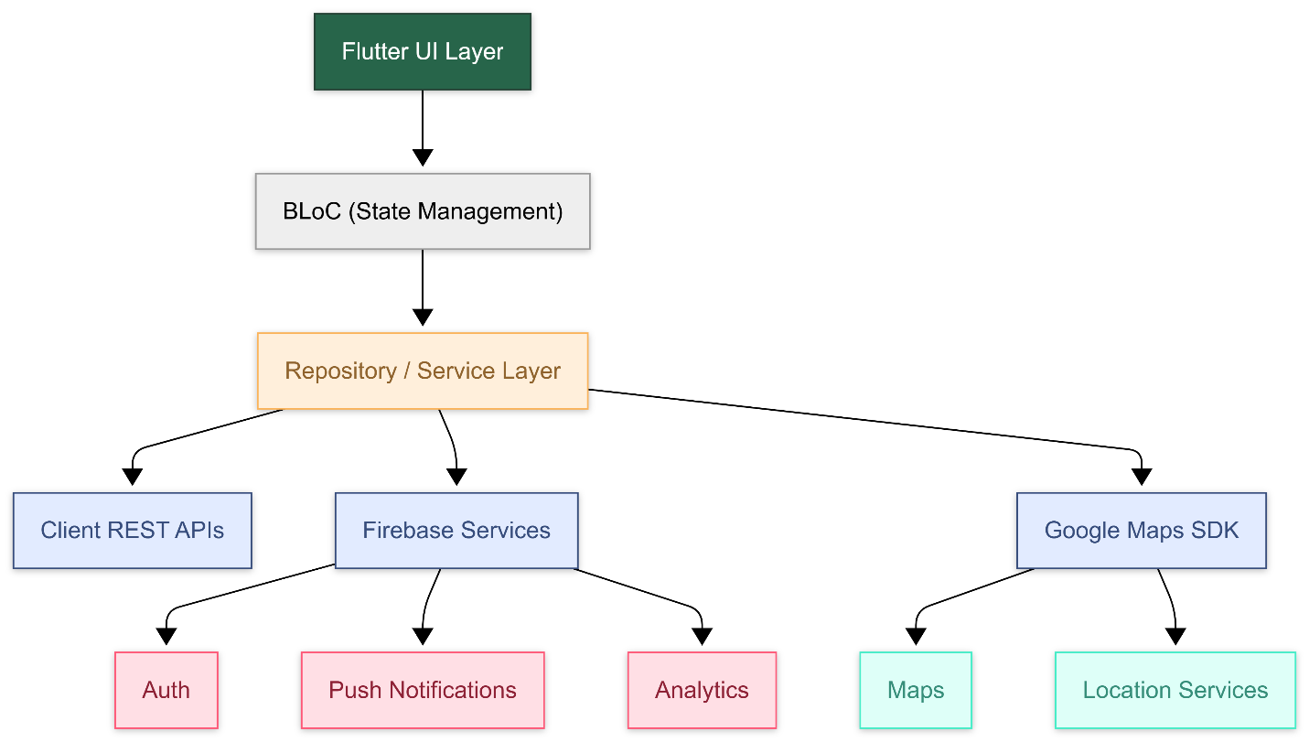

8. Complimentary Support (1 Months)
After completion of Phase 3 and final handover, we will provide one (1) months of complimentary support focused on the delivered frontend scope.
Included in complimentary support:
• Bug fixing for issues introduced by the in-scope frontend changes (reproducible on supported devices).
• Minor UI adjustments within existing patterns (e.g., spacing/alignment fixes, minor copy changes).
• Basic performance improvements for impacted screens (e.g., list rendering, reducing UI jank).
• Support in interpreting crash logs/analytics where access is provided (e.g., Firebase Crashlytics).
Excluded from complimentary support:
• New features, new screens, or any enhancement beyond the Proposed Functionalities.
• Changes required due to API contract changes or backend behavior changes.
• Fixing pre-existing bugs/issues not caused by the in-scope work.

9. Financial Proposal
All costs are estimated in USD and are based on mobile app frontend development only. Third-party licensing/usage costs (if any) are excluded and will be handled by the client.
Phase | Scope of Work | Timeline | Estimated Cost (USD) | Parallel Development
Phase 1 | Sign-Up Optimization + Rate Calculator | 1.5 weeks | $600 | Timeline: 3 Weeks
Phase 2 | Create Pickup Request + Reschedule Delivery | 1.5 weeks | $600 | Timeline: 3 Weeks
Phase 3 | On-Demand Delivery + Returns via Parcel Locker + Stabilization | 1.5 weeks | $600 | Timeline: 3 Weeks

9.1 Payment Terms
Payment will be collected phase-by-phase:
• 30% advance payment at the start of each phase (upon phase kickoff).
• 70% payment upon completion, delivery, and handover of that phase.
• Next phase will start after the previous phase payment is cleared.

9.2 Assumptions & Remarks
• All required REST APIs for the proposed functionalities will be provided by the client, including staging access, documentation, and sample payloads.
• Client will provide access to the existing codebase/repository and required environment configurations.
• Any delays in API readiness, changes in API contracts, or incomplete test data may impact timelines.
• This proposal excludes fixing historical/previous issues, bugs, or performance problems unless directly caused by in-scope work.
• Any request beyond the Proposed Functionalities will be treated as a change request and estimated separately.

10. Acceptance & Sign-off
Each phase will be considered accepted when the delivered build meets the agreed acceptance criteria for the in-scope features and passes the agreed regression checklist.
This proposal is intended for functional assessment and high-level estimation purposes. Final scope, timeline, and cost will be reconfirmed after a short discovery/assessment against the existing app codebase and available APIs.

10. Relevant Project Experience

- eCook – Smart Recipe & Cooking App -
iOS: https://apps.apple.com/us/app/ecook/id6450396013
Android: https://play.google.com/store/apps/details?id=com.riseuplabs.ecook
- BMI Calculator – Health Tracking App- https://riseuplabs.com/bmi-calculator/
- Augmi – AR Furniture Application - https://riseuplabs.com/augmi/
- Sisimpur – Educational App - https://riseuplabs.com/sisimpur/
- Islamic Quotes – Motivation App - https://riseuplabs.com/islamic-quotes/

- Easy Salah Steps: Prayer Guide App - https://riseuplabs.com/easy-salah-steps-prayer-guide/

- Masnoon Dua & Tasbeeh Counter App - https://riseuplabs.com/masnoon-dua-tasbeeh-counter/

- myGov - https://riseuplabs.com/mygov/

- U-Report Bangla Version - https://riseuplabs.com/ureport-bangla-version/

