Technical & Financial Proposal
AMER247 India - B2C Website Development

1. Introduction
This document presents the technical and financial proposal for developing the AMER247 India website from scratch. The recommended solution is intended to support a B2C digital experience is based on assumed features where end users can browse services, review pricing and guidance content, submit service applications online, and reach the AMER247 team through structured enquiry channels.
Based on the supplied page inventory, the target platform includes core informational pages, pricing pages, blog/news content, utility/legal pages, and a large set of service-specific online forms. The implementation approach therefore prioritizes scalable content management, reusable form architecture, and secure application capture.
2. Project Understanding
AMER247 operates as a public-facing immigration and residency support service platform. The current website structure indicates a content-heavy B2C website with multiple user journeys, including service exploration, eligibility and requirement reading, pricing review, form submission, and contact or follow-up requests.
The structure of site pages contains pages across main navigation, blog/news, utility pages, and service-form categories. The form-intensive sections include Amer Services, Emirates ID, Golden Visa, Medical Test, and Insurance related applications, which suggests the need for a modular and maintainable application workflow framework rather than isolated page-by-page implementation.
3. Proposal Objectives
- Develop the AMER247 India website from scratch as a secure, scalable, and manageable B2C web platform.
- Enable public users to browse services, pricing, blog content, and service-specific requirements with ease.
- Provide structured online submission capability for service applications and enquiries.
- Deliver an admin-ready backend for content, service forms, pricing, blog/news, and submission management.
- Reduce long-term maintenance effort by using reusable templates for form pages, content blocks, and submission workflows.
4. Proposed Technical Approach
We propose a monolithic web architecture separating the public-facing frontend from the backend application and admin layer. This allows the B2C website to remain fast and SEO-friendly while supporting a large number of service pages and repeated form patterns through reusable backend configuration.
The solution will be developed using a component-based frontend, an API-driven backend, relational database storage, media/file management, and a secure admin panel for operational updates. Given the large number of structured service forms, a configurable service/form master will be introduced so that related form pages can be managed efficiently without building entirely separate logic for each page.
4.1 Development Methodology
- Requirements-to-build approach using the approved page inventory and form groups.
- Reusable module-first development to reduce duplication across similar service forms.
- Environment-based development lifecycle: Development, Staging, and Production.
- Structured QA cycle covering functional testing, form validation, admin workflows, and pre-launch regression.
- Phase-based delivery with sign-off checkpoints before moving to the next phase.
5. Proposed Technical Stack
Layer | Proposed Choice
Frontend Website | React.Js
Backend / Admin Panel | Laravel 11 (PHP)
API Layer | RESTful API
Database | MySQL / MariaDB
Authentication (Admin) | Role-based admin authentication
Media / File Storage | Server storage or cloud object storage, based on deployment choice
Hosting | Cloud VPS / Managed cloud environment/AWS
Web Server | Nginx
Version Control | Git-based repository
6. Scope of Work - Phase Wise Delivery
To maintain delivery control and cost efficiency, the overall development scope is proposed in two phases. The phase split is designed to first establish the core B2C website and foundational admin architecture, then complete the service application ecosystem and operational enhancements.
6.1 Phase 1 - Core B2C Website and CMS Foundation
- Project setup, environment setup, repository setup, and deployment baseline.
- Frontend implementation of core public pages such as Home, Services, About, Contact, Pricing, UAE Tourist Visa, Online Services entry, and utility/legal pages.
- Responsive page development based on provided UI designs.
- Blog/news listing and blog detail template implementation.
- Backend admin panel setup for content management of pages, service categories, blog/news, utility pages, and banners/sections.
- Pricing module setup for displaying service pricing content in a manageable way.
- Contact / enquiry form development with admin-side submission listing.
- Media/file upload management for page content and blog assets.
- Role-based admin access for content and submission management.
- Functional QA, browser testing, staging deployment, and phase sign-off.
Phase 1 Human Resources and Responsibilities
Role | Responsibility
Project Manager | Planning, scope control, milestone tracking, client coordination, sign-off management
Technical Lead | Solution architecture, code review, technical decision making
Frontend Developer | Public website page development, responsive build, API integration
Backend Developer | Admin CMS, API development, content modules, submission module
QA Engineer | Test cases, functional QA, regression Testing.
DevOps Engineer | Staging setup, deployment pipeline, production readiness
6.2 Phase 2 - Online Service Application Platform and Operational Completion
- Implementation of reusable service application engine for high-volume service form pages.
- Configuration and development of service form groups for Amer Services, Emirates ID, Golden Visa, Medical Test, and Insurance application flows.
- Service-specific dynamic fields, validation rules, and basic document upload support where required.
- Online application submission storage with admin-side listing, filtering, and detail view.
- Status update fields in admin for internal processing visibility.
- FAQ / support content management for online services related guidance.
- Enhanced pricing and service detail linkage between public pages and application forms.
- Final QA across end-user journeys, form validations, and admin operational workflows.
- Production deployment, launch support, handover, and documentation.
Phase 2 Human Resources and Responsibilities
Role | Responsibility
Project Manager | Phase planning, form group prioritization, delivery coordination, acceptance
Technical Lead | Reusable form architecture, backend standards, deployment oversight
Frontend Developer | Form page UI implementation, validation integration, user journey completion
Backend Developer | Dynamic form logic, application storage, admin management, file handling
QA Engineer | Deep validation testing, negative testing, end-to-end regression
DevOps Engineer | Production deployment, server optimization, backup and monitoring setup
7. Key Deliverables
- Production-ready B2C public website developed from scratch
- Responsive frontend implementation based on client-provided designs
- Admin panel for page, blog, pricing, service, and submission management
- Structured online service application workflows
- Content and media management capability
- Submission database and admin-side operational visibility
- Staging and production deployment
- Basic technical handover documentation and admin usage guidance
8. Technical Diagram
The following diagram placeholders are recommended to make the final proposal more presentation-ready. Actual diagrams are intentionally not inserted in this version, as requested.
No. | Suggested Diagram | Purpose
1 | High-Level System Architecture Diagram | Show Public Website -> Admin/API Layer -> Database -> File Storage -> Hosting Environment
2 | Online Service Application Submission Flow | Show User selects service -> fills application form -> uploads documents -> submits -> admin receives and reviews
3 | Admin Content and Submission Management Flow | Show content update, pricing update, blog publish, submission review, and status tracking flow
Diagram 1: High-Level System Architecture Diagram
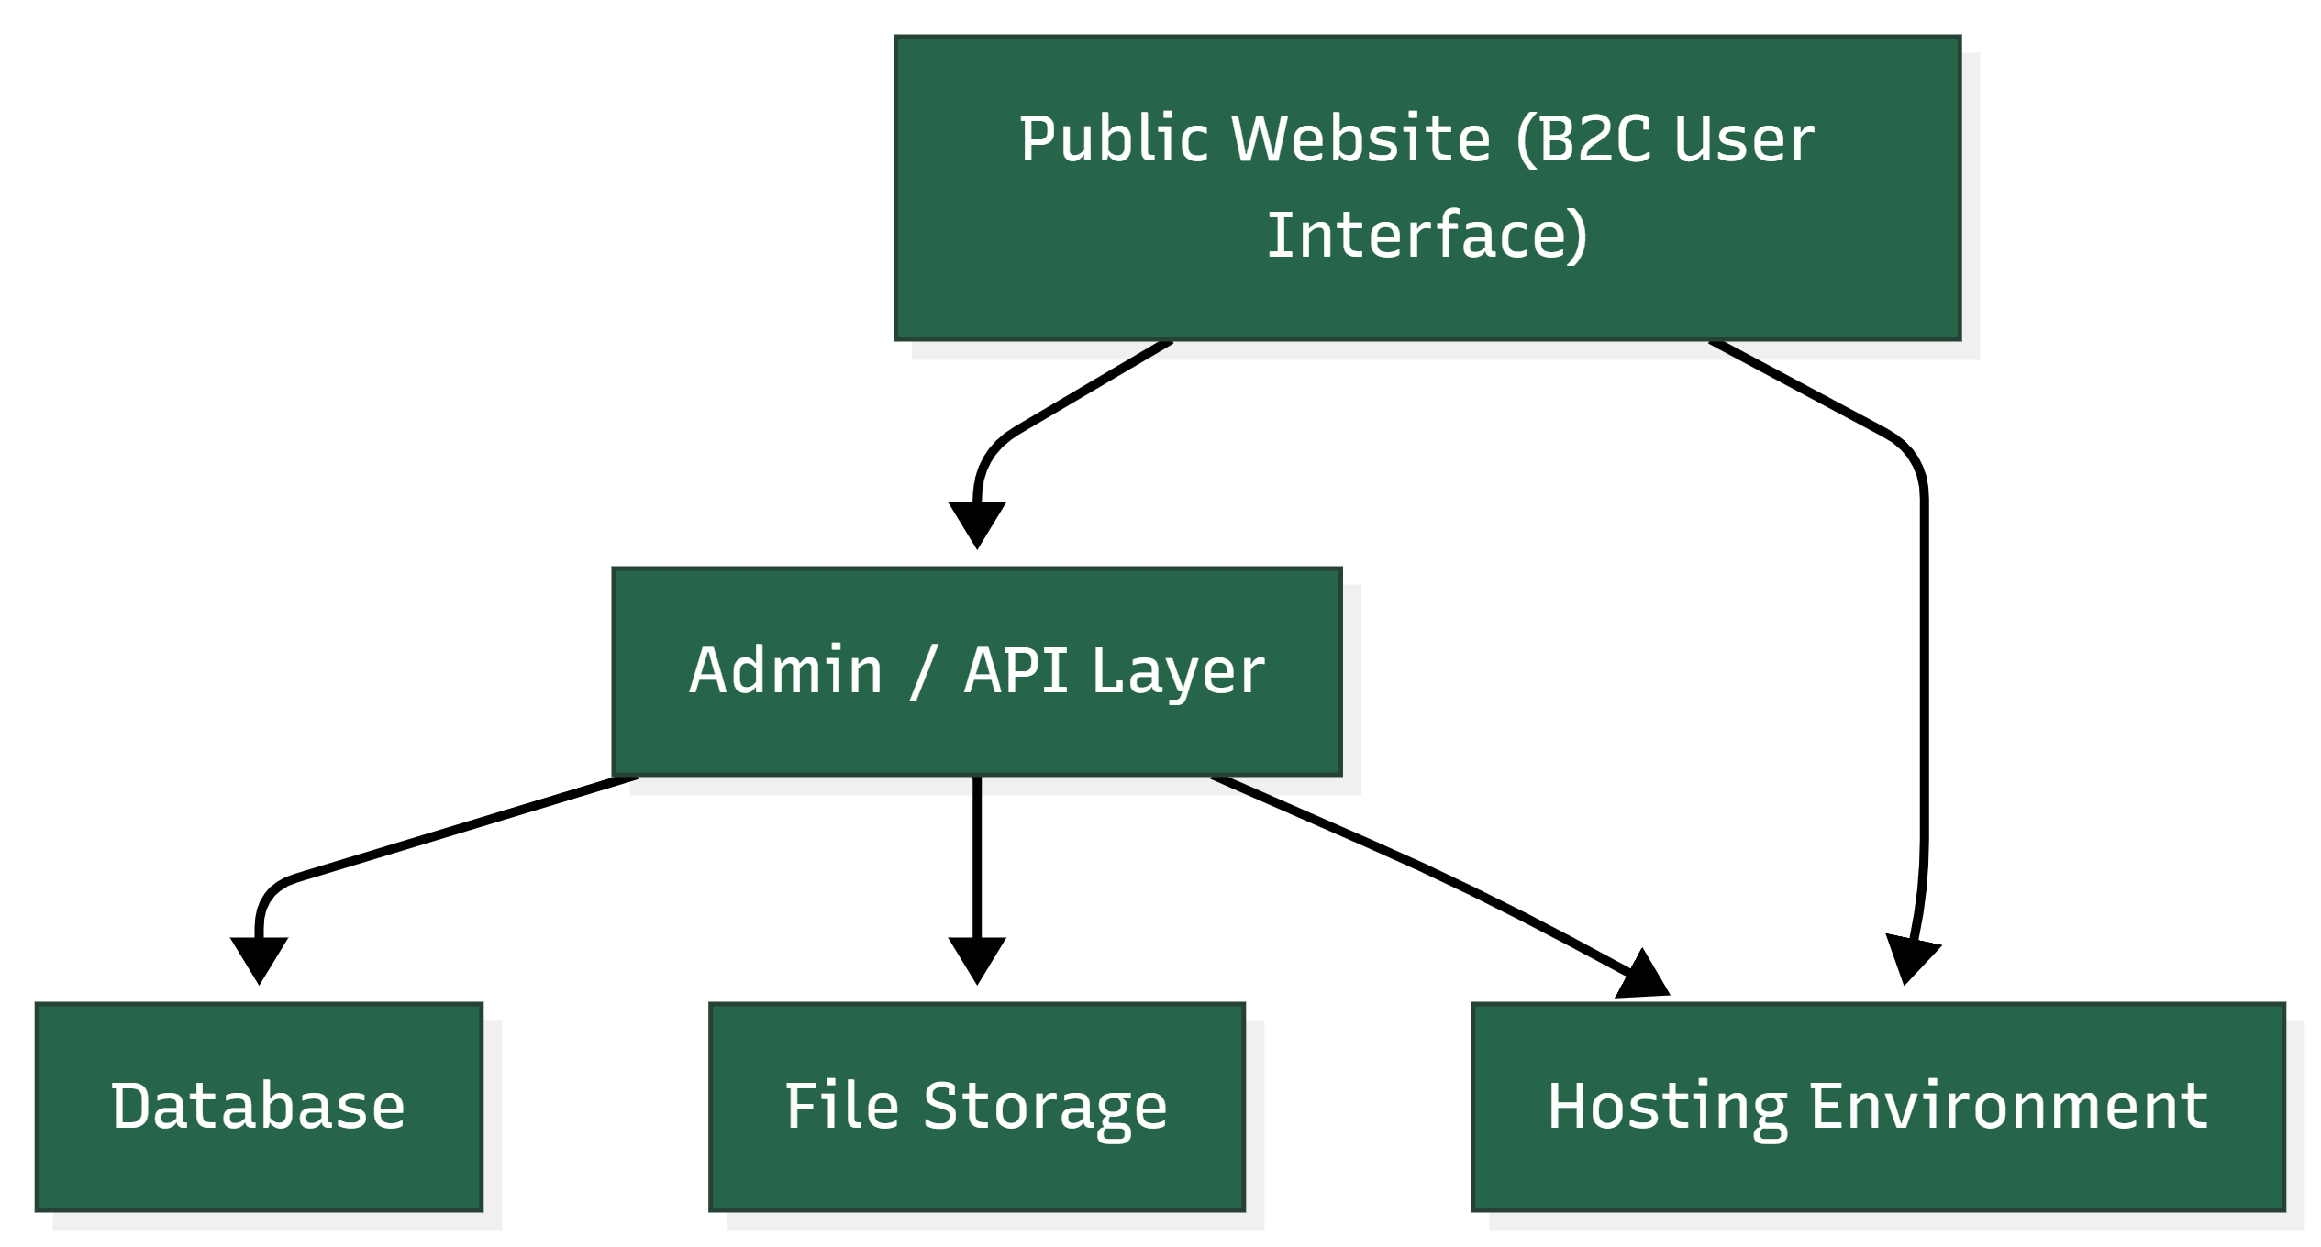

Diagram 2: Online Service Application Submission Flow
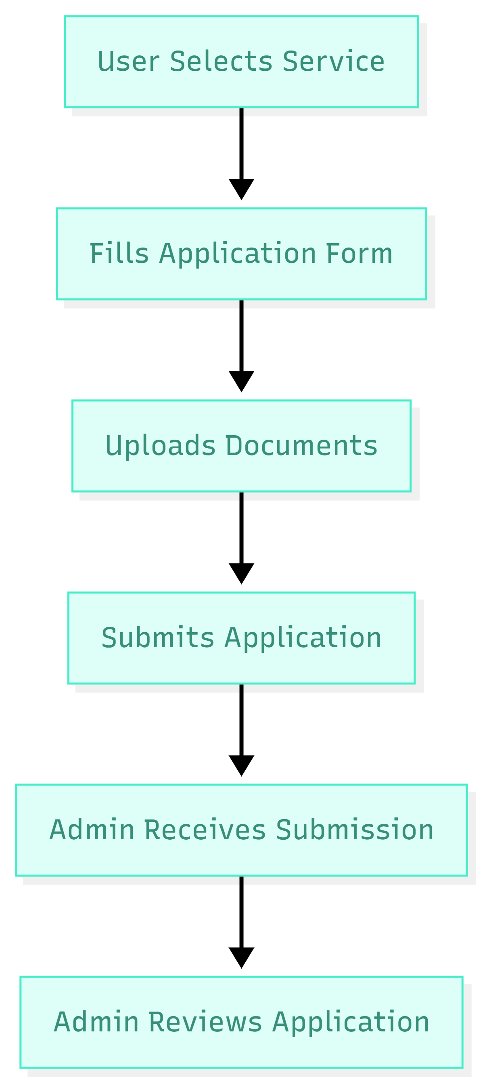

Diagram 3: Admin Content and Submission Management Flow
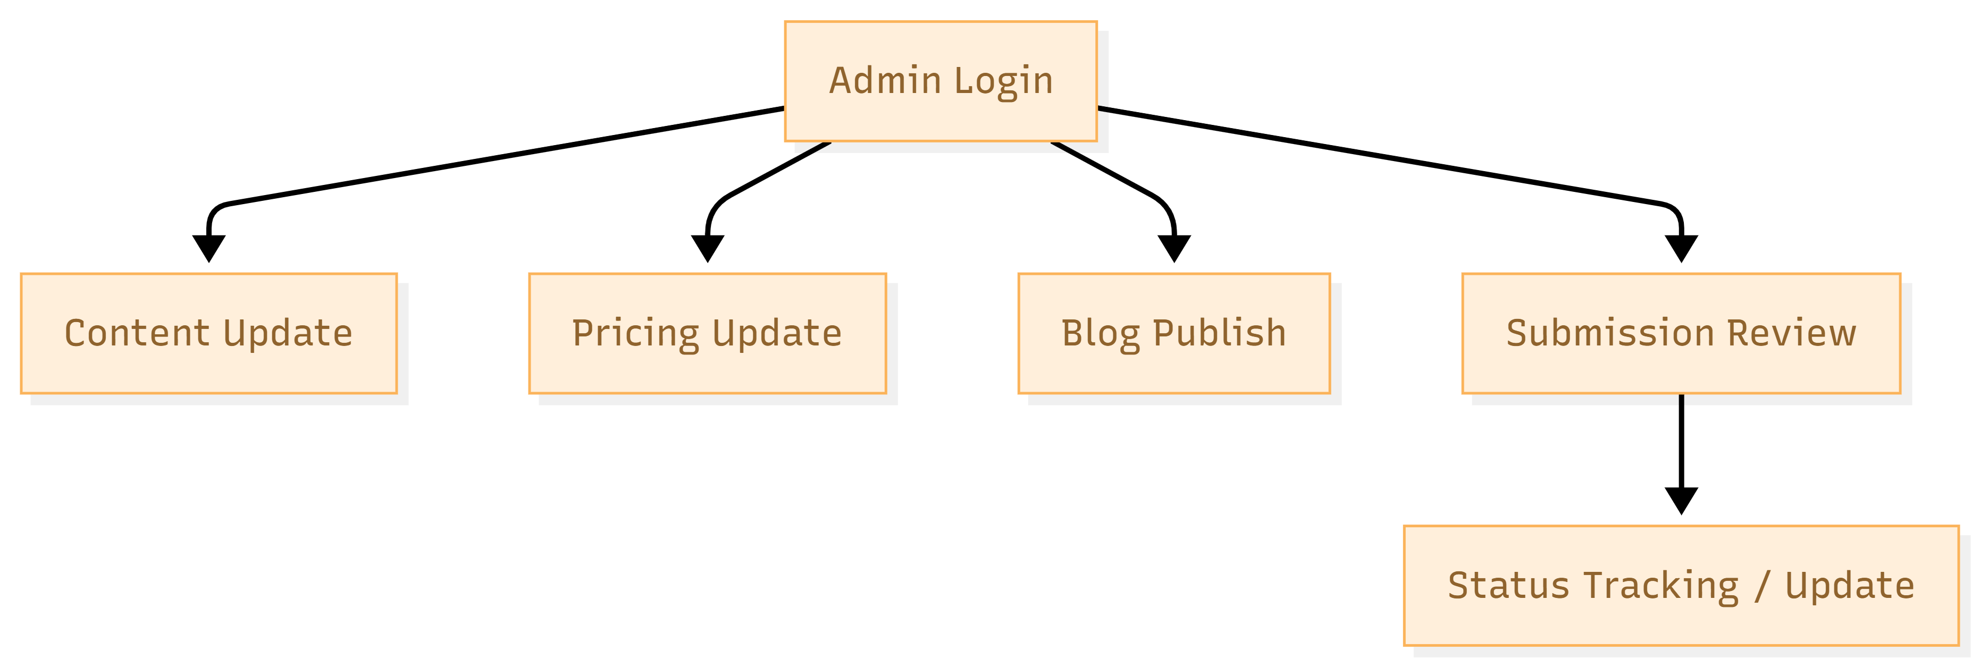
10. Complimentary Support
After final production launch and handover, we will provide 2 months of complimentary support for bug fixing, minor adjustment, and deployment-related stabilization within the delivered scope.
- Fixing reproducible bugs within the delivered modules
- Minor configuration or small adjustment within existing scope
- Basic technical support for deployment stabilization and issue review
Any new feature, major change, or additional workflow beyond the approved scope will be considered under a separate Change Request process.
11. Financial Proposal
The following commercial estimate is prepared for development scope only and excludes UI/UX design, third-party subscriptions, payment gateway charges, hosting charges, domain charges, SMS/email gateway costs, and any external paid service fees.
Phase | Scope of Work | Timeline | Estimated Cost (USD)
Phase 1 | Core B2C website, CMS foundation, blog/news, pricing, enquiry workflow, admin baseline | 1.5 weeks | $2300
Phase 2 | Online service application engine, service form groups, submission management, deployment | 1 weeks | $1000
Total |  | 2.5 weeks | $ 3300
11.1 Payment Terms
- 30% advance payment upon project kickoff
- 30% payment upon completion and sign-off of Phase 1
- 30% payment upon completion and sign-off of Phase 2 on staging / pre-production readiness
- 10% payment upon production launch and final handover

11.2 Change Request
- Any requirement beyond the defined scope will be treated as a Change Request.
- CR Man-day Rate: USD 150 per man-day or USD 25 per man-hour.
12. Assumptions and Remarks
- The website will be developed from scratch.
- The platform is considered a B2C website intended for public/end-user access.
- Design, UI/UX, branding, and design asset preparation are out of scope.
- Client will provide final approved designs, branding assets, content, and required policy text.
- Third-party service charges, hosting, domain, and external license costs are not included in this proposal.
- Payment gateway integration is not included unless explicitly approved in a revised scope.
- Migration of legacy data/content is limited to manageable manual or structured migration support and may require separate effort if volume is high.
- Any additional workflow not evident in the approved requirement baseline may affect timeline and cost.
13. Out of Scope
- UI/UX design and visual redesign work
- Brand strategy, copywriting, and professional content production
- Advanced CRM, ERP, or government system integrations unless separately defined
- Mobile application development
- Call center, chatbot, or automation features not explicitly requested
- Any feature outside the approved website and form submission scope
14. Acceptance and Sign-off
Each phase will be considered completed after implementation of the agreed scope, internal QA completion, staging demonstration, and client sign-off. Production deployment will proceed after final approval and receipt of the applicable payment milestone.

