Technical & Financial Proposal
Brandex – Luxury Ecommerce M&A Advisory Website
(Webflow Platform – Development Only)

Prepared by: Riseup Labs
Date: February 11, 2026

1. Introduction
This document presents a technical and financial proposal to develop the Brandex website from scratch as a premium, white‑glove M&A advisory platform for ecommerce brands. The solution will be built on Webflow with gated buyer access, curated listings, qualification quizzes, and integrated NDA signing and call booking.
Key constraints for this proposal:
• Scope is limited to development (Webflow build, CMS configuration, membership/user accounts, integrations, automation, QA, deployment).
• Designing and UI/UX are out of scope. Implementation will follow client‑provided design assets and brand guidelines.
• Third‑party subscription and usage fees (Webflow plan, PandaDoc, Calendly, Make/Zapier, email platform, analytics tools, etc.) are excluded and will be billed directly to the client.
• Any requirements beyond the agreed scope will be handled through a Change Request (CR) process.

2. Project Context & Objectives
Brandex positions itself as an exclusive, luxury M&A advisory firm for ecommerce deals (not a marketplace). A core requirement is confidentiality-first, gated access: only approved buyers can view listings and detailed financials. The site must support three primary user journeys (Seller, Buyer, Investor) and streamline lead qualification through quizzes and manual approval workflows.

2.1 Target Audiences
• Sellers: ecommerce brand owners seeking exits (Amazon FBA, Shopify, multi-channel)
• Buyers: individuals/firms acquiring ecommerce brands (typically $100K–$10M+ budgets)
• Investors (Phase 2): high-net-worth individuals seeking passive ecommerce ownership

2.2 Key Product Requirements (Development Scope)
• Public marketing pages: Homepage, For Sellers, For Buyers, For Investors (coming soon), About/Team, Resources/Blog, Contact, Legal pages.
• Gated buyer portal: account creation, qualification quiz, NDA signing, manual approval, approved-only navigation entry for “Browse Listings”.
• Listing management via Webflow CMS: add/edit/publish/unpublish listings, mark sold/pending, structured listing fields (financials, operations, growth opportunities).
• Integrations: PandaDoc for NDA e-signature, Calendly for call booking, Airtable as backend database source-of-truth (sync with Webflow), Make.com/Zapier automations, email platform for nurture sequences, analytics pixels.
• Tracking: GA4 and conversion events (account creation, quiz completion, NDA signing, listing views, call bookings, valuation requests).

3. Proposed Technical Approach & Methodology
We propose a Webflow-first, component-driven implementation using Webflow Designer and CMS for structured content, Webflow User Accounts/Memberships for gated experiences, and a lightweight integration layer for approval workflows and NDA signing. Where Webflow’s native capabilities need extension (e.g., approval state gating, automation, and secure workflow orchestration), we will use Make.com/Zapier and vendor APIs (PandaDoc, Calendly, email platform) to implement reliable, auditable process flows.

3.1 Delivery Methodology
• Iterative delivery with weekly demos and acceptance checkpoints.
• Definition of Done per feature: requirements confirmed, built, tested, documented, deployed to staging.
• Integration-first planning: event map, data model, and API/webhook contracts documented before build.
• Security-by-design: least-privilege access, protected pages, secure handling of NDA status, and audit logs for administrative actions.
• Performance-first: optimized assets, CMS best practices, and fast page delivery for SEO and conversions.

3.2 Environments & Governance
• Environments: Staging (for review) → Production (live).
• Versioning & backups: Webflow project backups + asset/version control for custom code and automation scenarios.
• Release governance: staging sign-off prior to production publish; release checklist and rollback plan.
• Change management: scope changes handled through CR with effort estimation and approval.

4. Proposed Technical Stack
Layer | Proposed Choice
Website Platform | Webflow (Designer + Hosting)
CMS | Webflow CMS Collections (Listings, Blog/Resources, Team, Case Studies, FAQs, Legal)
Authentication / Gating | Webflow User Accounts / Memberships (access groups and protected pages)
Listings Filtering/Search | Webflow CMS filters (basic) + Finsweet Attributes for advanced filtering/search (if required)
eSignature / NDA | PandaDoc (embedded signing / signing session)
Scheduling | Calendly (embed + event tracking)
Backend Database (Operational) | Airtable (as source-of-truth for listings/approval operations; synced to Webflow)
Automation / Orchestration | Make.com or Zapier (Webflow ↔ Airtable ↔ PandaDoc ↔ Email platform; retries & logs)
Email / Nurture Sequences | Loops or Mailchimp (client-selected)
Analytics | GA4, Meta Pixel, Google Ads conversion tracking
Security | HTTPS/TLS, Webflow access controls, bot protection/rate limits via Webflow/Cloudflare (as applicable)
Note: Third‑party subscriptions and usage fees are excluded from this proposal and will be paid directly by the client.

5. Scope of Work (Development Only)
The scope is structured into three (3) phases to support staged validation and controlled rollout. UI/UX design is excluded.

5.1 Phase 1 – Foundation & Public Website Build
Objective: Establish Webflow project foundation, core public pages, CMS structure, and baseline tracking.

5.1.1 Development Activities
• Webflow project setup: style guide implementation (per provided design), global components (nav, footer, CTA blocks).
• Build public pages: Homepage (3 paths), For Sellers, For Buyers, For Investors (coming soon), About/Team, Resources/Blog (listing + template), Contact, Legal pages.
• CMS modeling: Listings (structure only), Blog/Resources, Team, Case Studies/Testimonials (if provided), FAQs, Downloads/Media.
• Content editor enablement: CMS collections, reference fields, slug rules, preview conventions.
• Tracking baseline: GA4 setup, key event schema, basic conversion events (CTA clicks, form submits).

5.1.2 Human Resources & Responsibilities
Role | Key Responsibilities (Short)
Project Manager | Backlog, acceptance criteria, coordination, weekly demos
Webflow Developer (Lead) | Webflow build, components, CMS architecture, performance
Automation/Integration Engineer | Tracking setup support, future automation planning
QA Engineer | Cross-browser/device checks, regression checklist for public pages

5.1.3 Suggested Timeline
Estimated duration: 4 weeks

5.2 Phase 2 – Gated Buyer Portal & Approval Workflow
Objective: Implement buyer onboarding (account + quiz + NDA), manual approval states, and approved-only listings access.

5.2.1 Development Activities
• Webflow User Accounts/Memberships: signup/login/logout, account pages, access groups, protected pages.
• Buyer qualification quiz (6 questions) with routing logic and data capture to Airtable.
• PandaDoc NDA integration: generate/send NDA, embedded signing session, webhook to capture signed status.
• Account states: Logged out, Pending approval, Approved (navigation rules and page gating).
• Listings module: Browse Listings (approved-only), Listing Detail template, gated financial sections, image blur/unblur logic by state.
• Filtering UI: price range, revenue range, industry, net margin, business model (basic Webflow filters; upgrade to advanced filtering if needed).
• Admin operations: approval workflow dashboard in Airtable (manual approval), status sync back to Webflow user record/access group.

5.2.2 Human Resources & Responsibilities
Role | Key Responsibilities (Short)
Solution Architect / Tech Lead | Workflow design, security controls, integration architecture
Webflow Developer | Gated pages, CMS templates, membership UI integration
Automation/Integration Engineer | Airtable sync, PandaDoc + webhook flows, retries/logs
QA Engineer | Portal flow testing, permissions tests, NDA and approval regression

5.2.3 Suggested Timeline
Estimated duration: 4 weeks

5.3 Phase 3 – Integrations, QA Hardening, Launch & Handover
Objective: Production readiness through full integration, analytics, security hardening, performance tuning, and handover.

5.3.1 Development Activities
• Calendly integration: embed booking flows, listing-level “Request Introduction Call” tracking.
• Email automation: nurture sequences for buyers/sellers (status-based triggers) via Make/Zapier + email platform.
• Data sync stabilization: Airtable ↔ Webflow CMS and user status reconciliation; retry queue and failure alerts.
• Security hardening: protected content validation, access control checks, spam protection on public forms, least-privilege for tools.
• Performance & SEO: CMS optimization, image optimization, structured metadata, sitemap/robots (as applicable), Lighthouse baseline.
• QA & UAT: test plan, test cases, defect triage; staging sign-off; production release.
• Documentation & training: CMS/admin guide, integration runbook, handover session.

5.3.2 Human Resources & Responsibilities
Role | Key Responsibilities (Short)
Project Manager | UAT coordination, sign-off tracking, release planning
Webflow Developer | Final builds, performance/SEO adjustments, production publish
Automation/Integration Engineer | End-to-end automation, monitoring hooks, analytics events
QA Engineer | Regression + release readiness checklist
DevOps | DNS/domain support guidance, rollout & rollback checklist

5.3.3 Suggested Timeline
Estimated duration: 2 weeks

5.4 Overall Suggested Timeline (Summary)
Total estimated duration: 10 weeks

6. Deliverables
• Production-ready Webflow website with all public pages and premium content structure.
• Gated buyer portal (accounts, approval states, protected listings and financial details).
• Three quiz funnels (Buyer, Seller, Investor waitlist) with data capture and routing.
• PandaDoc NDA signing integrated with onboarding workflow.
• Listings management via Webflow CMS with structured fields and publishing controls.
• Airtable operational database and synchronization workflows (if Airtable is confirmed).
• Automation scenarios in Make/Zapier with logs and retry handling.
• Analytics instrumentation (GA4 + pixels) and event tracking map.
• QA artifacts: test plan, test cases, bug report log, regression checklist.
• Handover package: CMS/admin guide, integration runbook, and walkthrough session.

7. Technical Diagrams
Insert images in the spaces below in the final version:

Diagram 1: High-Level Solution Architecture
Webflow (Public Site + Gated Portal) → Webflow CMS → Airtable (Ops DB) → Make/Zapier → PandaDoc/Calendly/Email Platform → Analytics (GA4/Pixels) → Logs/Alerts

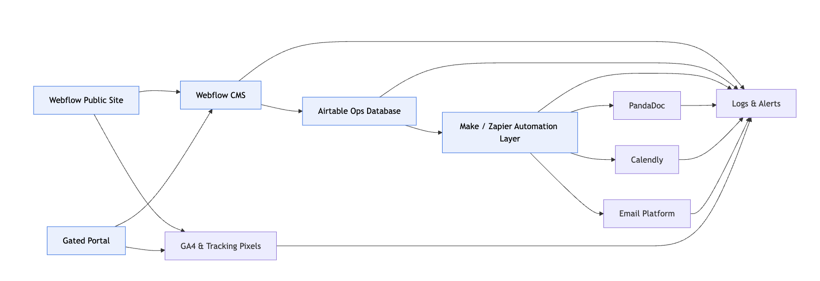

Diagram 2: Buyer Onboarding & Approval Flow
Signup → Buyer Quiz → NDA Signing (PandaDoc) → Under Review → Manual Approval → Access Granted → Browse Listings
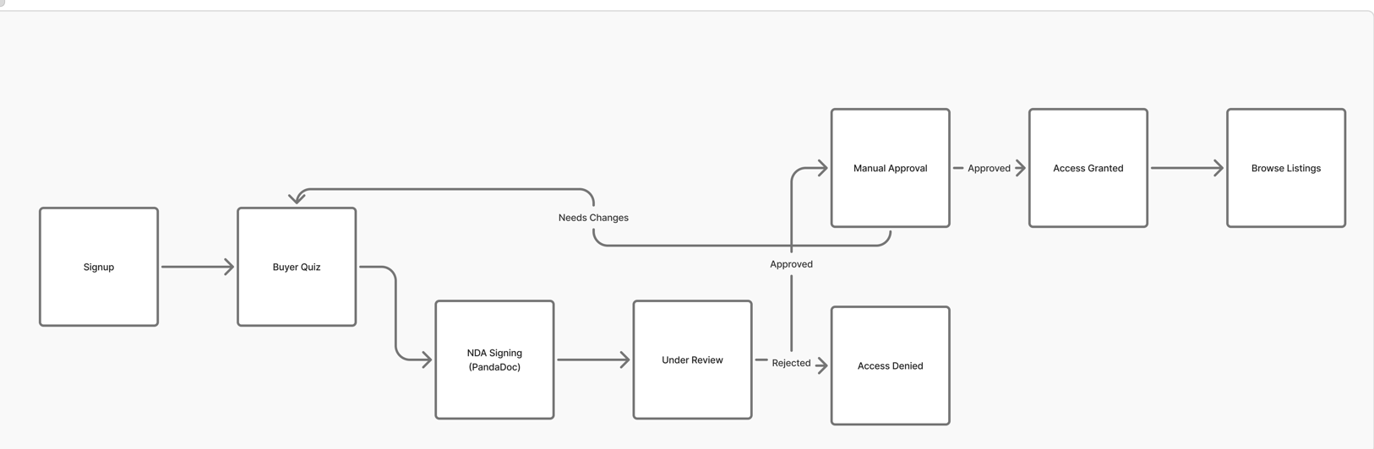

Diagram 3: Listings Data Model (High Level)
Listing (Financials, Ops, Growth) → Media → Status (Active/Sold/Pending) → Visibility Rules (Public blur vs Approved view)
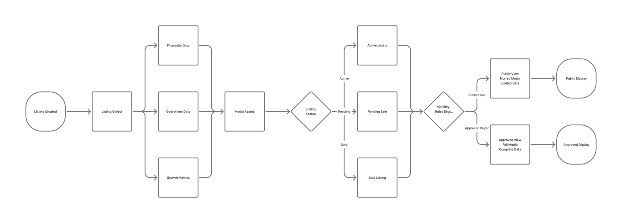

Diagram 4: Automation & Webhooks (Integration Flow)
Webflow Form/User Event → Make/Zapier → Airtable Update → PandaDoc Create/Send → Webhook Signed → Update Access Group → Email Notifications
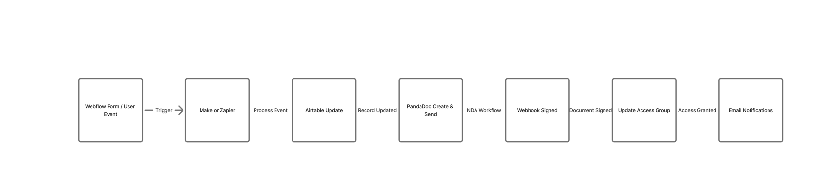

8. Complimentary Support (1 Month)
After production launch and final handover, we will provide one (1) month of complimentary support focused on the delivered scope.
Included:
• Bug fixing for reproducible issues introduced by the delivered work.
• Minor adjustments within existing UI patterns (small layout/copy/config changes).
• Support for analyzing automation logs and integration errors where access is provided.
Excluded:
• New features or major enhancements beyond the agreed scope.
• Changes required due to third-party policy/pricing changes.
• Content writing, translation, or new design work.

9. Financial Proposal
Costing will be finalized after kickoff workshops and confirmation of third‑party tools (Webflow plan, PandaDoc tier, automation platform, email platform) and data synchronization requirements. Third‑party licensing/usage costs are excluded and will be paid directly by the client.
Phase | Scope of Work | Timeline | Estimated Cost (USD)
Phase 1 | Foundation & Public Website Build | 4 Weeks | $3,000
Phase 2 | Gated Buyer Portal & Approval Workflow | 4 Weeks | $2,000
Phase 3 | Integrations, QA Hardening, Launch & Handover | 2 Weeks | $1,500

9.1 Payment Terms
• 30% advance payment upon project kickoff.
• 30% payment upon completion of Phase 1 (public site + CMS baseline) on staging.
• 30% payment upon completion of Phase 2 (gated portal + NDA + listings access) on staging.
• 10% payment upon production release and final handover.

9.2 Change Request (CR)
CR Man-day Rate: USD 150 per man-day or 25 USD per hour.

9.3 Assumptions & Remarks
• Client will provide final UI designs/brand guidelines and content inputs (team bios, case studies, legal text) before implementation.
• Webflow plan and required tool subscriptions will be provisioned by the client before integration starts.
• Manual approval will be performed by Brandex internal users; our scope includes building the operational workflow and status sync.
• Advanced filtering/search may require third-party libraries or scripts; any substantial expansion will be treated as a CR.
• Timelines may shift if third‑party credentials, DNS/domain approvals, or compliance reviews are delayed.

10. Proposed Out of Scope
• UI/UX design, branding exploration, and design asset creation.
• Ongoing content production (blog writing), translation services, or long-term SEO strategy.
• Custom marketplace functionality (bidding, automated deal matching) beyond the gated advisory positioning.
• Third-party subscription fees (Webflow, PandaDoc, Calendly, automation tools, analytics tools).
• Phase 2 Investor Partnership Program product build beyond the “coming soon / waitlist” flow (unless later approved via CR).

11. Acceptance & Sign-off
Delivery will be considered accepted when the agreed scope is implemented on staging, passes the QA and regression checklist, and is formally signed off by the client. Production deployment will proceed after sign-off and completion of the release checklist.

