Technical And Financial Proposal
BuildConnect
Scope: Software Development Only

1. Introduction
This document presents the technical and financial proposal for the phased development of the BuildConnect digital platform, focusing exclusively on software development. The solution will be developed from scratch and delivered in three phases to reduce risk, accelerate time-to-value, and keep the platform extensible for future modules and integrations.
BuildConnect is envisioned as a multi-sided construction technology marketplace and project management experience connecting home builders (Clients) with a professional network (e.g., Architects, Interior Designers, Contractors, Supervisors, Suppliers, Labor, and related service providers). This proposal covers the web frontend (responsive for mobile/tablet).

2. Project Understanding
Based on the shared materials, BuildConnect will provide a unified user experience that enables:
- Multi-role onboarding and dashboards for up to ~15 user types (Clients and Professionals).
- Client journey: project creation, AI-assisted professional discovery, proposal requests, proposal comparison, selection and contracting steps.
- Project execution experience: timeline/Gantt visualization, progress tracking, tasks, file library, and project communications.
- Marketplace and services discovery: materials/furniture browsing, service booking flows, and supplier quote/order tracking screens.
- Localization for Saudi market: bilingual (Arabic & English), RTL support for Arabic, and SAR currency display where applicable.
- A mobile-first experience for on-site usage patterns (contractors, supervisors, labor).
Important note: Backend development, admin/merchant portals, and server-side business logic are out of scope for this engagement. Therefore, the deliverables emphasize frontend development, API-ready integration hooks, and optionally mocked/stubbed endpoints to enable end-to-end UI testing.

3. Phase 1 – Foundation, Localization & Core Client Journey (Web Frontend)

3.1 Objectives
- Establish a scalable web frontend foundation with clean architecture and reusable UI component system.
- Implement bilingual (English/Arabic) localization, including RTL layout rules and content direction handling.
- Deliver the core Client journey screens for project creation and professional discovery, plus base shared modules (notifications, messaging shell).
- Deliver API-ready integration contracts and mock data layer for UI validation.

3.2 Scope of Work

Frontend Engineering Setup
- Web app setup (React/Next.js) with environment configuration (Dev/Staging/Prod).
- Code quality baseline: linting, formatting, branching strategy, and CI build pipeline.
- Reusable design-system implementation (components, layout grid, typography tokens) based on approved UI references.

Localization (Arabic & English)
- i18n framework setup, translation keys, and language switcher.
- RTL support for Arabic (layout mirroring, icons/direction-safe components, numeric formatting).
- Locale-aware formatting (dates, numbers, currency display in SAR where relevant).

Authentication & Role Onboarding (Frontend)
- Login and sign-up screens (role selection: Client vs Professional).
- Client onboarding screens (basic profile, preferences).
- Professional onboarding base screens (basic info + verification placeholder flow).

Client Journey – Core Screens (Frontend)
- Client dashboard (active projects, pending actions, recent activity).
- Create New Project wizard (multi-step, conditional inputs, budget/timeline fields, reference uploads UI).
- AI Quick Match discovery screens (card-based professional list, match score presentation, CTA to profile/proposal request).
- Request Proposal & Proposal Inbox (list view + status UI).
- Compare Proposals (side-by-side comparison UI).

Common Modules – Baseline
- Global navigation patterns per role (frontend routing and access guards).
- Notification center UI and in-app alert components.
- Messaging/chat UI shell (project-based conversation list + message thread UI).
- File uploader components and basic project library UI (folders/tags/search placeholders).

3.3 Human Resources – Phase 1 (Short Responsibilities)
Role | Responsibilities (Short)
Technical Project Manager | Plan sprints, coordinate stakeholders, manage scope/risks, track deliverables.
Solution Architect | Define frontend architecture, integration contracts, localization approach, security baseline.
Frontend Developers (2) | Build UI components, implement flows, routing, state management, i18n/RTL.
QA Engineer | Test UI flows, regression, cross-browser responsiveness, localization checks.
DevOps Engineer | CI pipeline, build/deploy setup for staging, environment configuration.

3.4 Suggested Timeline – Phase 1
Duration: 4 weeks

4. Phase 2 – Multi-Role Workflows, Marketplace & Project Execution (Web Frontend)

4.1 Objectives
- Complete the major professional and supplier journeys with role-based dashboards and key workflows.
- Deliver project execution experience: timeline/Gantt, progress tracker, tasks, payments/milestones screens (UI only), and richer file library.
- Deliver marketplace modules (materials/services/marketing) as frontend-ready product flows.
- Harden cross-device responsiveness and performance for complex components (tables, kanban, Gantt).

4.2 Scope of Work

Professional Journeys (Frontend)
- Architect base dashboard screens: briefs inbox, brief details, proposal submission UI, active projects, milestone submission/upload UI, earnings/financials screens (UI only).
- Interior Designer variations (mood boards sections, materials selection UI placeholders).
- Contractor variations: bid management with cost breakdown UI, resource planning & team assignment screens, progress reporting screens.
- Supervisor variation: site visit scheduling UI, inspection checklist forms, report/issues submission UI.

Labor & Supplier Journeys (Frontend)
- Labor dashboard: job opportunities list, job requests inbox, active job detail (check-in/out UI), earnings report (UI only).
- Supplier dashboard: catalog manager (list/grid, search/filter), add/edit material forms, project opportunities list, quote submission UI, order tracking screens.
- Furniture supplier variations (style/material tagging UI).

Client Post-Contract Project Execution (Frontend)
- Project overview dashboard (timeline progress widget, activity feed, team list).
- Project timeline / Gantt chart view (interactive for professionals; view-only for clients).
- Project progress tracker (milestones and % complete visualization).
- Payments & milestones screens (escrow/release payment UI – integration hooks only).
- BoQ & supplier comparison tables + AI cost optimizer results presentation (UI + mock data).
- Live CCTV monitoring dashboard (camera grid UI, embed placeholder integrations).
- Project library enhancements (foldering, tagging, preview UI).

Marketplace, Services & Marketing Modules (Frontend)
- Materials marketplace: category overview, product list with filters, product detail, watchlist, price alert UI.
- Checkout/order placement UI flow (frontend only; payment integration hooks).
- Services module: service category list, booking interface, booking calendar UI.
- Marketing module: campaign creation wizard, campaign management list, leads interface (frontend only).
- Real estate agent journey UIs (where applicable): client requests, listings creation/management (frontend only).

Quality & Performance
- Component optimization for large tables and dashboards (virtualized lists where needed).
- Cross-browser testing and responsive refinement for mobile/tablet breakpoints.
- Accessibility checks and localization QA for Arabic RTL layouts.

4.3 Human Resources – Phase 2 (Short Responsibilities)
Role | Responsibilities (Short)
Technical Project Manager | Sprint delivery, dependency management, UAT coordination.
Backend Developer | Role-based routing strategy, performance patterns, integration contract refinement.
Frontend Developers (3) | Implement complex dashboards, marketplace flows, Gantt/tables, role variations.
QA Engineers (2) | Functional/regression testing, localization/RTL testing, responsiveness and performance checks.
DevOps Engineer | Staging releases, monitoring setup for frontend, build optimization.

4.4 Suggested Timeline – Phase 2
Duration: 4 Weeks
5. Phase 3 – QA, Optimization & Go-Live
5.1 Objectives
- Deliver a fully regression-tested, production-ready release.
- Optimize performance and strengthen security.
- Establish multilingual SEO baseline.
- Complete deployment, training, and formal handover.
5.2 Scope of Work
QA & Regression
- End-to-end regression across all roles and modules.
- Cross-browser, responsive, and Arabic RTL validation.
- Final production sign-off.
Performance Optimization
- Image optimization, lazy loading, and bundle size reduction.
- Caching strategy implementation and performance benchmarking.
Security Hardening
- Frontend security checks (XSS/CSRF exposure review).
- Secure headers configuration and role-permission validation.
- Backup configuration and restore testing.
Deployment & Handover
- Production deployment and smoke testing.
- Monitoring and backup verification.
- Admin training session.
- Final documentation and source code handover.
5.3 Human Resources – Phase 3
Role | Responsibilities (Short)
Technical Project Manager | Go-live coordination and stakeholder alignment.
Solution Architect | Security, performance, and SEO oversight.
Frontend Developers (2) | Bug fixing and optimization.
QA Engineers (2) | Full regression and UAT validation.
DevOps Engineer | Production deployment, backups, monitoring.
SEO Specialist (PT) | Multilingual SEO validation.
5.4 Suggested Timeline
Duration: 1.5 weeks (3 sprints × 2 weeks)

6. Technical Architecture Overview (Frontend-Only Scope)
The solution will follow a modular, scalable frontend architecture. Since backend development is out of scope, the architecture below focuses on frontend layers and API integration boundaries.

6.1 Proposed Technical Stack
- Web Frontend: React.js with Next.js
- State Management: Redux Toolkit
- Internationalization: i18next (Web)
- UI Components: TailwindCSS / MUI (Web)
- Testing: Jest + React Testing Library (Web)
- CI/CD: GitHub Actions / GitLab CI for web build pipelines.
6.2 Diagrams
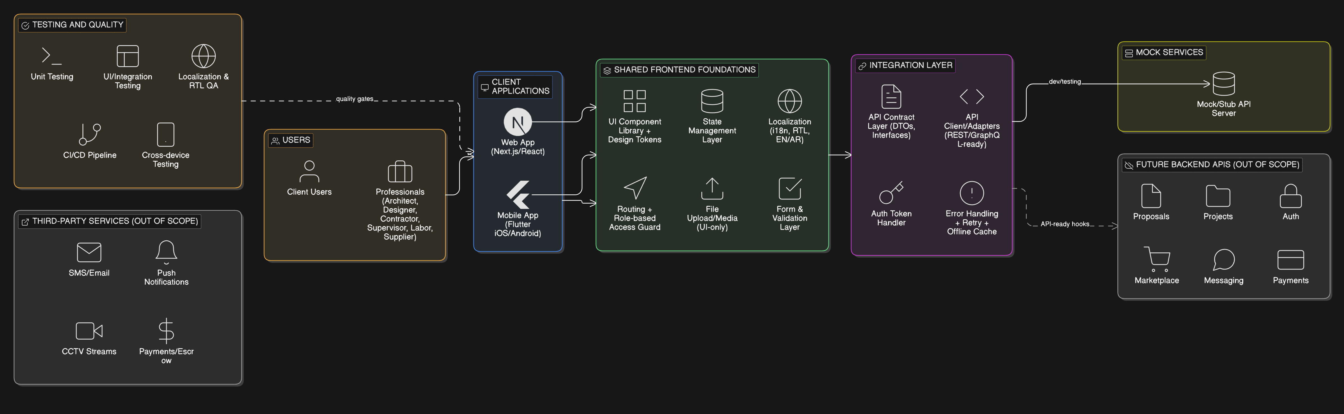
Figure 1: High-Level Frontend Architecture

Figure 2: Localization & RTL Handling Flow
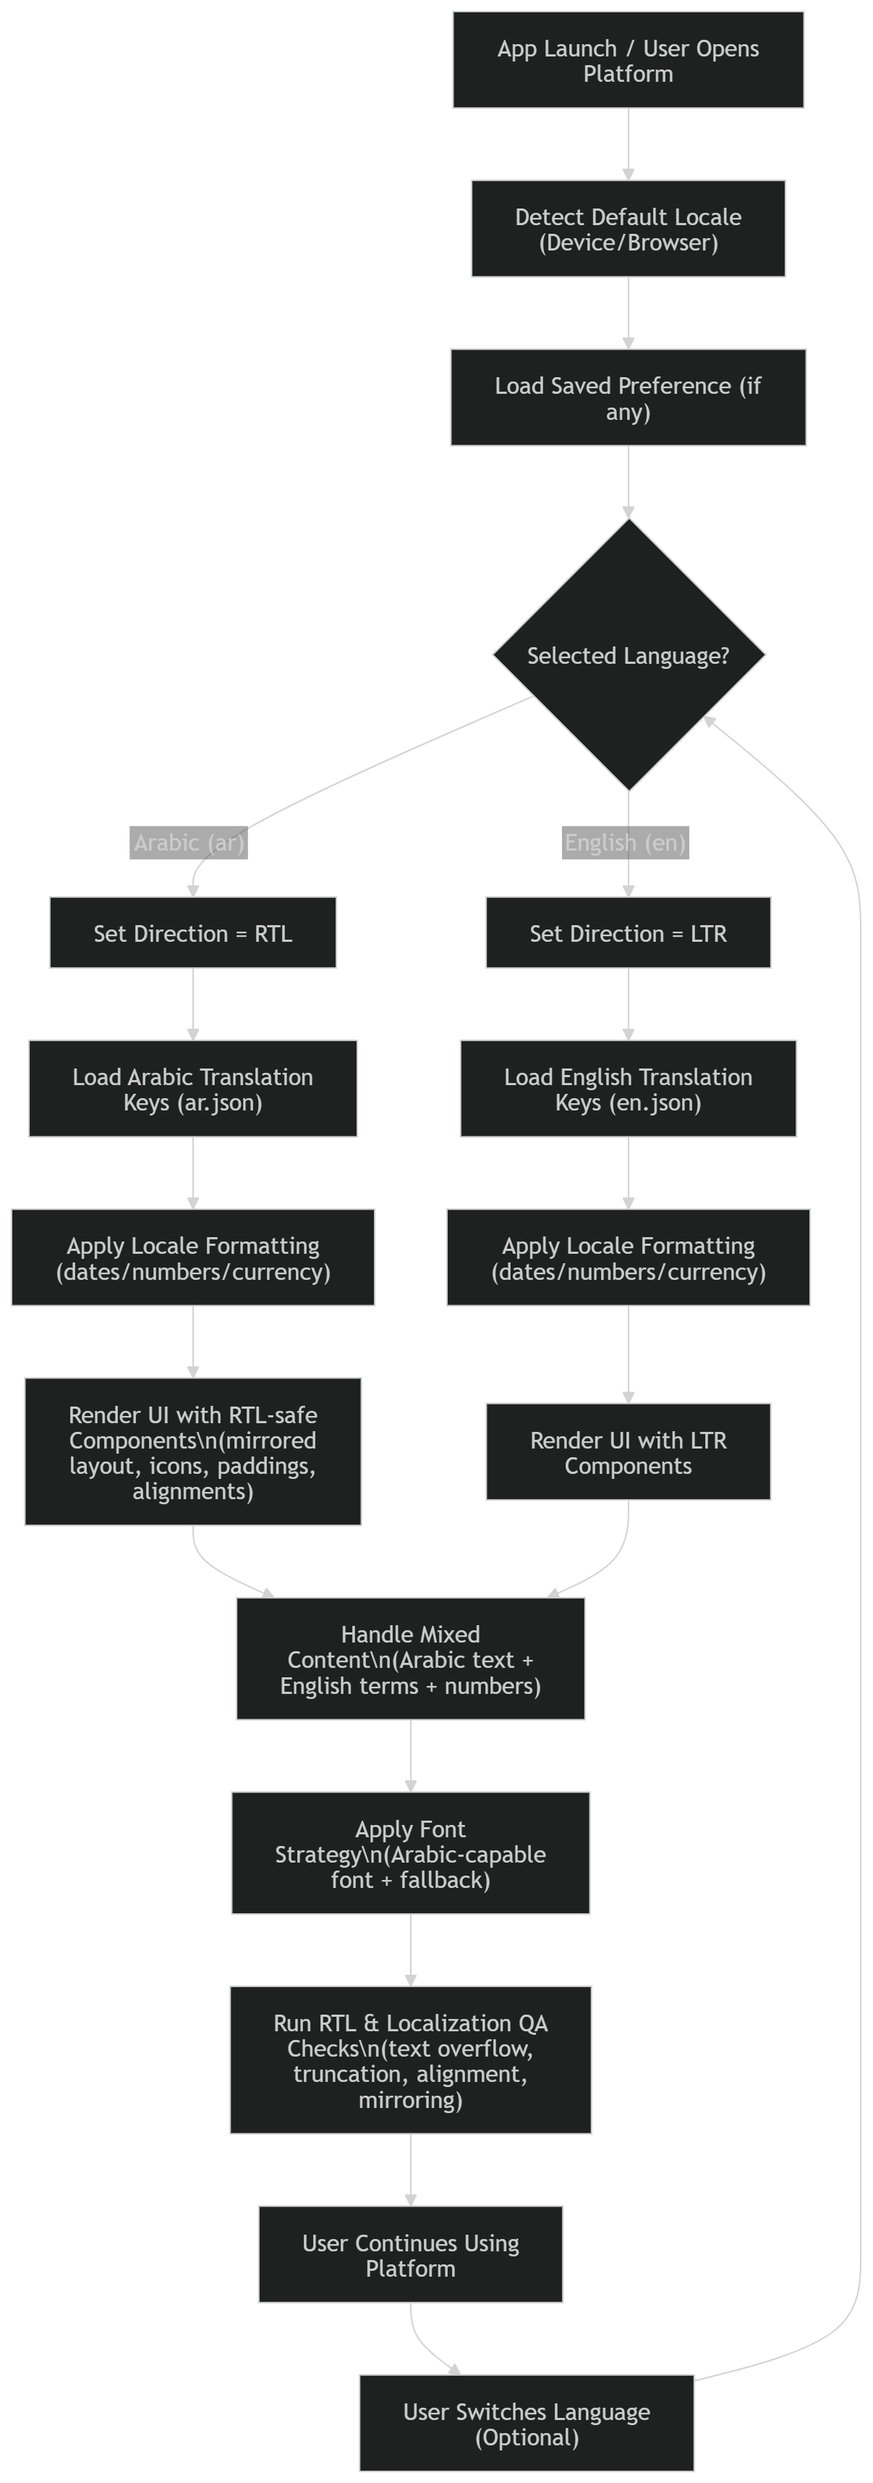

7. Testing and Quality Assurance
Quality will be ensured through continuous testing across sprints and formal acceptance gates.

7.1 Test Coverage
- Unit testing for business rules and calculation logic.
- API and integration testing for key workflows and connectors.
- UI testing for critical user journeys.
- Regression testing prior to UAT and go-live.



Fig: QA Test Process

8. Client Dependencies & Integrations
Since backend and portals are excluded, the following items are expected from the client or will be handled in a future scope:
- Backend APIs for authentication, user/role management, projects, proposals, messaging, payments, marketplace inventory, and orders.
- Any third-party services credentials/licenses (e-signature, payment/escrow, SMS/email, push notifications, m3u8 link/ API/ iframe for CCTV streams).
- Final Arabic and English content/terminology and translation approvals.
- Apple Developer and Google Play Console accounts for app publishing.

9. Delivery Methodology
- Agile, sprint-based delivery (2-week sprints) with backlog grooming and sprint planning.
- Design-to-dev alignment sessions using the provided UI references (no UI design deliverables).
- Demo at the end of each sprint and phase-level UAT with sign-off.
- Documentation: API contract document (frontend expectations), component catalog, and release notes per phase.

10. Financial Proposal (Phase-wise Development Estimation)
All costs are estimates for development-only scope (excluding UI/UX design, backend, admin/merchant portals, and third-party licenses).
Phase | Durations | Description | Cost (USD)
Phase 1 | 4 weeks | Foundation, Localization & Core Client Journey (Web Frontend) | $3,000
Phase 2 | 4 weeks | Multi-Role Workflows, Marketplace & Project Execution (Web Frontend) | $4,500
Phase 3 | 1.5 weeks | Hardening and Final Deployment | $1,500

11. Payment Terms
Each phase will commence upon receipt of advance payment. Payment structure per phase:
- 30% advance to initiate the phase
- 70% upon final delivery, UAT completion, and sign-off of the phase deliverables
- Subsequent phases begin after settlement of the previous phase

12 Change Request (CR)
Any additional requirements beyond the agreed scope will be managed through a Change Request process.
- CR estimation will be provided as man-days and an updated timeline impact.
- Indicative CR rate: USD 150 per man-day or USD 25 per man-hour.
- CR work will start only after written approval from the client.

13. Complimentary Support (1 Month)
After production launch and final handover, we will provide one (1) month of complimentary support focused on the delivered scope.
Included:
- Bug fixing for reproducible issues introduced by the delivered work.
- Minor adjustments within existing UI patterns and configurations (small layout/copy/config changes).
- Support for analyzing logs and error reports where access is provided.
Excluded:
- New features or major enhancements beyond the agreed scope.
- Changes due to third-party provider policy changes or credential delays.
- Content writing, translation work, or SEO content strategy execution.

14. Assumptions & Exclusions
- UI/UX design is excluded. Development will be based on the provided UI references/screens and finalized assets from the client’s design team.
- Backend development, admin/merchant portals, and database work are out of scope. Frontend will be delivered API-ready with integration hooks and mock services for testing.
- Payment/escrow, e-signature, SMS/email, and CCTV streaming integrations require third-party services and backend endpoints (client-provided).
- Content, legal terms, and Arabic/English translations will be provided/approved by the client.
- Any advanced AI features (e.g., AI quick match scoring, cost optimizer logic) are treated as UI presentation within this scope; AI computation requires backend services.

15. Conclusion
This phased approach delivers BuildConnect as a high-quality, scalable frontend platform with bilingual Saudi-market readiness. By prioritizing core client workflows first, then expanding to multi-role execution and marketplace modules, the project minimizes risk while building a strong foundation for future backend implementation and platform scale.

16. Relevant Project References (Selected Mobile Apps)
- Vimory – Slideshow & Video Maker (iOS): https://apps.apple.com/us/app/vimory-slideshow-video-maker/id1359573092
- eCook (iOS): https://apps.apple.com/us/app/ecook/id6450396013
- LENTHO – Online Community (iOS): https://apps.apple.com/de/app/lentho-community/id1602655332
- BMI Calculator – Weight Monitor (iOS): https://apps.apple.com/us/app/bmi-calculator-weight-monitor/id6475051596
- Augmi – AR Furniture App (Android): https://play.google.com/store/apps/details?id=com.riseuplabs.augmi
- X-Treme Basketball AR (iOS): https://apps.apple.com/am/app/x-treme-basketball-ar/id6444917346
- Sisimpur (Android): https://play.google.com/store/apps/details?id=apps.orangebd.sisimpur

