Technical Proposal

EUAS - WordPress/WooCommerce Product Operations Suite
(Duck Console + Import Pipeline + AI Extraction)

Prepared for | Client Stakeholders (EUAS)
Prepared by | RiseupLabs
Date | 18 February 2026

1. Background and Objectives
This proposal describes a from-scratch implementation of three admin-focused capabilities inside a WordPress + WooCommerce environment:
- Duck Console: founder-operable SKU intake interface using WooCommerce products and existing ACF field groups.
- Import Pipeline: CSV import pipeline for WooCommerce products and ACF intelligence fields.
- AI Extraction: admin tool to extract product specs from images/PDFs and write approved data into ACF fields.
The scope and constraints are derived from the provided RFQs. Key constraints include using WooCommerce products and ACF field groups, and avoiding custom database tables.

1.1 Project Goals
- Reduce SKU onboarding time by organizing product data capture into structured intake panels.
- Enable repeatable, validated bulk product intake via CSV with duplicate detection and clear reporting.
- Accelerate spec entry by extracting candidate field values from product documents and images, with human approval before writing to ACF.
- Keep the solution operable by non-technical founders within WordPress admin, aligned with WooCommerce conventions.

1.2 Success Criteria
- Founders can create, edit, and progress SKUs through an intake status workflow without touching ACF configuration screens.
- CSV imports support dry-run, validation errors, and safe create/update behavior with duplicate SKU detection.
- AI extraction suggests candidate values with confidence and provenance, and writes only approved data into ACF fields.
- No custom database tables are introduced; all persistence uses WooCommerce product data and post meta/ACF storage.

2. Proposed Solution Summary
We will deliver a single WordPress plugin (or a small set of tightly-coupled plugins) that adds admin tooling under a dedicated menu (e.g., 'Duck Console'). The plugin will leverage WooCommerce CRUD objects for product operations and ACF APIs for reading/writing field values.

2.1 High-Level Capabilities
Capability | What it provides | Primary users
Duck Console (SKU Intake) | Structured intake panels, checklist, intake status workflow, and product list filters | Founder / Ops
CSV Import Pipeline | Template, mapping, validation, duplicate detection, background processing, import report | Ops / Admin
AI Extraction Tool | Upload, extraction, candidate field mapping, review/confirm, write to ACF, audit log | Ops / Admin

3. Scope and Milestone Breakdown
Delivery is organized into three milestones aligned with the three RFQs. Each milestone ends with a usable increment and a formal acceptance checkpoint.

3.1 Milestone 1 - Duck Console (SKU Intake)
Objective: Founder-operable SKU intake interface inside WordPress admin using WooCommerce products and ACF field groups.
Deliverable | Description
ACF Field Group Audit and Map | Inventory current ACF product field groups, identify required fields, and define intake panel grouping
Duck Console Admin Menu | Admin menu entry and core pages (list + detail) for intake workflow
Structured Intake Panels | Render ACF fields in logical sections with guidance, required flags, and inline validation
Intake Status Workflow | Statuses (e.g., Draft -> In Review -> Ready -> Published) with transitions and audit trail
Compatibility and Hardening | WooCommerce compatibility checks, capability checks, nonce validation, sanitization

3.2 Milestone 2 - CSV Import Pipeline
Objective: CSV import pipeline for WooCommerce products and ACF intelligence fields.
Deliverable | Description
CSV Template | Standard template with required columns (SKU, name, price, key ACF fields, etc.)
Mapping Configuration | Column-to-field mapping UI and stored mapping profiles
Validation and Error Reporting | Field validation rules, required checks, and readable error report
Duplicate SKU Detection | Detect duplicates and define behavior (skip, update, create new)
Background Processing and Logs | Queue imports using Action Scheduler; store logs and downloadable report

3.3 Milestone 3 - AI Extraction (Image/PDF to ACF)
Objective: Extract product specs from images/PDFs, show candidates for confirmation, and write approved data into ACF fields.
Deliverable | Description
Upload Interface | Admin screen to upload image/PDF and select target product or SKU
Text Capture Layer | Extract text from PDFs/images using available server tools or cloud fallback
AI Field Extraction | LLM prompt + mapping to propose candidate values for known fields
Confirmation Screen | Side-by-side review (source snippet vs proposed value) with approve/reject per field
Audit and Re-run | Store extraction history per product and allow re-run with versioned results

4. Proposed Technical Approach

4.1 Architectural Principles
- Stay native to WordPress admin patterns for operability and low training cost.
- Use WooCommerce CRUD objects for product operations instead of direct meta writes, whenever applicable.
- Use ACF APIs to read/write field values (no direct DB manipulation).
- Avoid custom DB tables; store workflow, logs, and history using post meta, options, and/or custom post types where appropriate.
- Separate 'suggest' vs 'write': AI can only propose candidates; humans approve before data is persisted.

4.2 Functional Design Overview
- Duck Console pages: SKU list with filters, intake detail page with panels, status change controls, and validation feedback.
- Import Pipeline pages: template download, mapping builder, import upload + dry-run, job monitor, and import reports.
- AI Extraction pages: upload + product selection, extraction job status, candidate review, approve/write, and history.

4.3 Data Handling Strategy (No Custom Tables)
- Primary entity: WooCommerce Product (post type: product) - holds SKU and core commerce fields.
- Structured attributes/specs/intelligence: ACF fields attached to product.
- Workflow state: stored as ACF field or post meta on the product (e.g., intake_status, intake_owner, last_reviewed_at).
- Operational logs: stored as a Custom Post Type (e.g., euas_import_job, euas_ai_extraction) with meta for details, or as serialized options for small footprints.

5. Proposed Technology Stack
Layer | Proposed technologies
Platform | WordPress (latest supported) + WooCommerce
Custom Development | PHP 8.x, WordPress Plugin APIs, WooCommerce CRUD, WP REST/AJAX
Custom Fields | Advanced Custom Fields (ACF/ACF Pro)
Background Jobs | Action Scheduler (WooCommerce) / WP-Cron fallback
File Handling | WordPress Media Library, wp_handle_upload, secure download endpoints
Document/Text Extraction | Server: Imagick / pdftotext when available; Cloud fallback: OCR service
AI Layer | LLM API (vendor-agnostic; e.g., OpenAI/Azure OpenAI) + prompt templates
Quality and Tooling | Git, Composer (optional), PHP_CodeSniffer (WPCS), PHPUnit
Observability | WordPress debug log + plugin logs; optional Sentry/Datadog

6. Development Methodology and Implementation Plan

6.1 Delivery Method
We propose an iterative, milestone-based delivery with short weekly checkpoints. Each milestone includes: requirements validation, UI walkthrough, implementation, QA, and UAT sign-off.

6.2 Implementation Steps (applies to each milestone)
- Confirm detailed requirements and acceptance criteria (workshop + examples).
- Produce UI walkthrough for admin screens and validate with stakeholders.
- Implement core services (WooCommerce + ACF integration) and admin UI.
- Add validation, permissions, logging, and error handling.
- QA cycle (functional, regression, security checks) + bug fixes.
- UAT with founders/admins on staging and sign-off.
- Production release with versioning and rollback plan.

7. Technical Diagrams (Insert or Generate)
Figure 1: High-Level Architecture Diagram
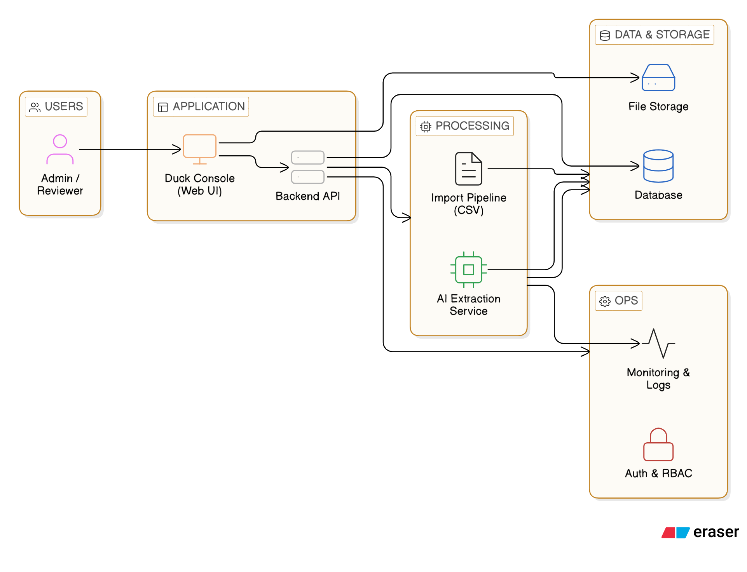

Figure 2: CSV Import Data Flow Diagram
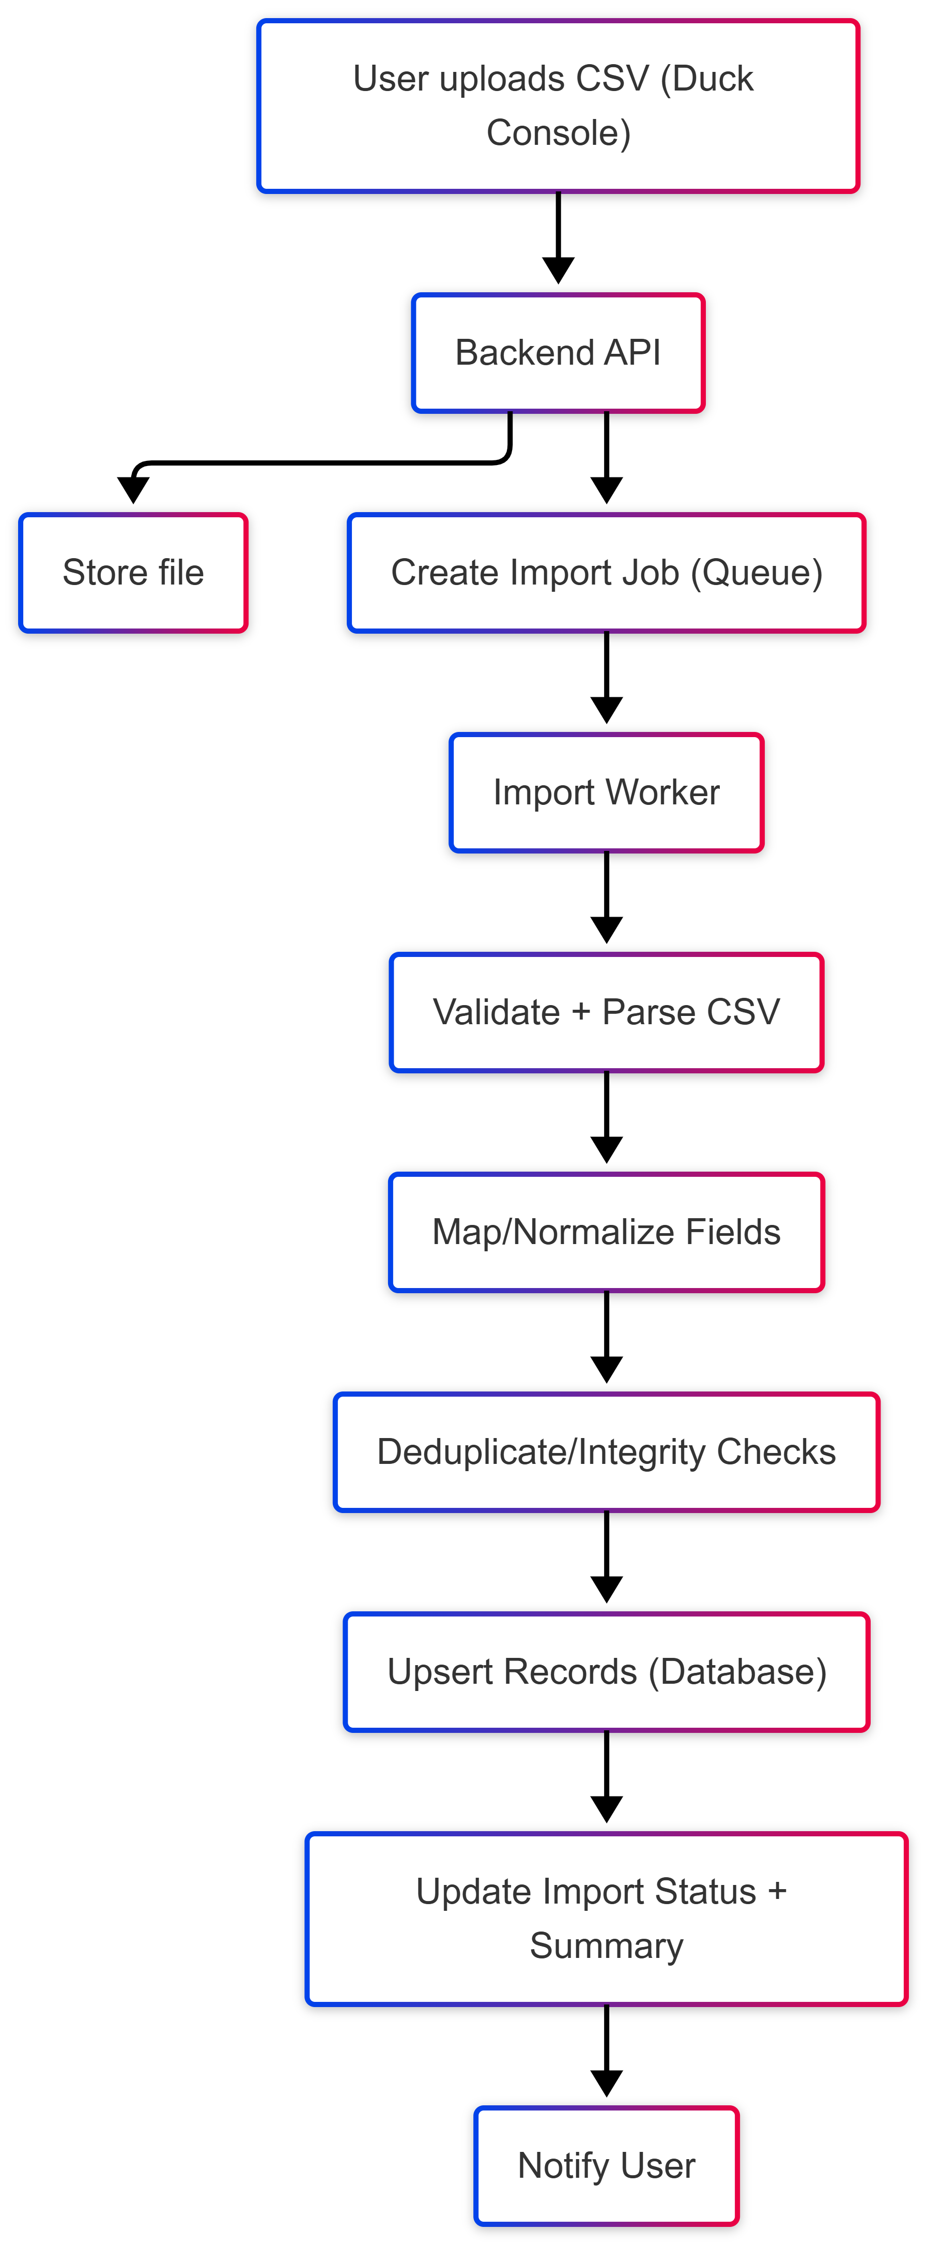

Insert Figure 3: Intake Status Workflow State Diagram
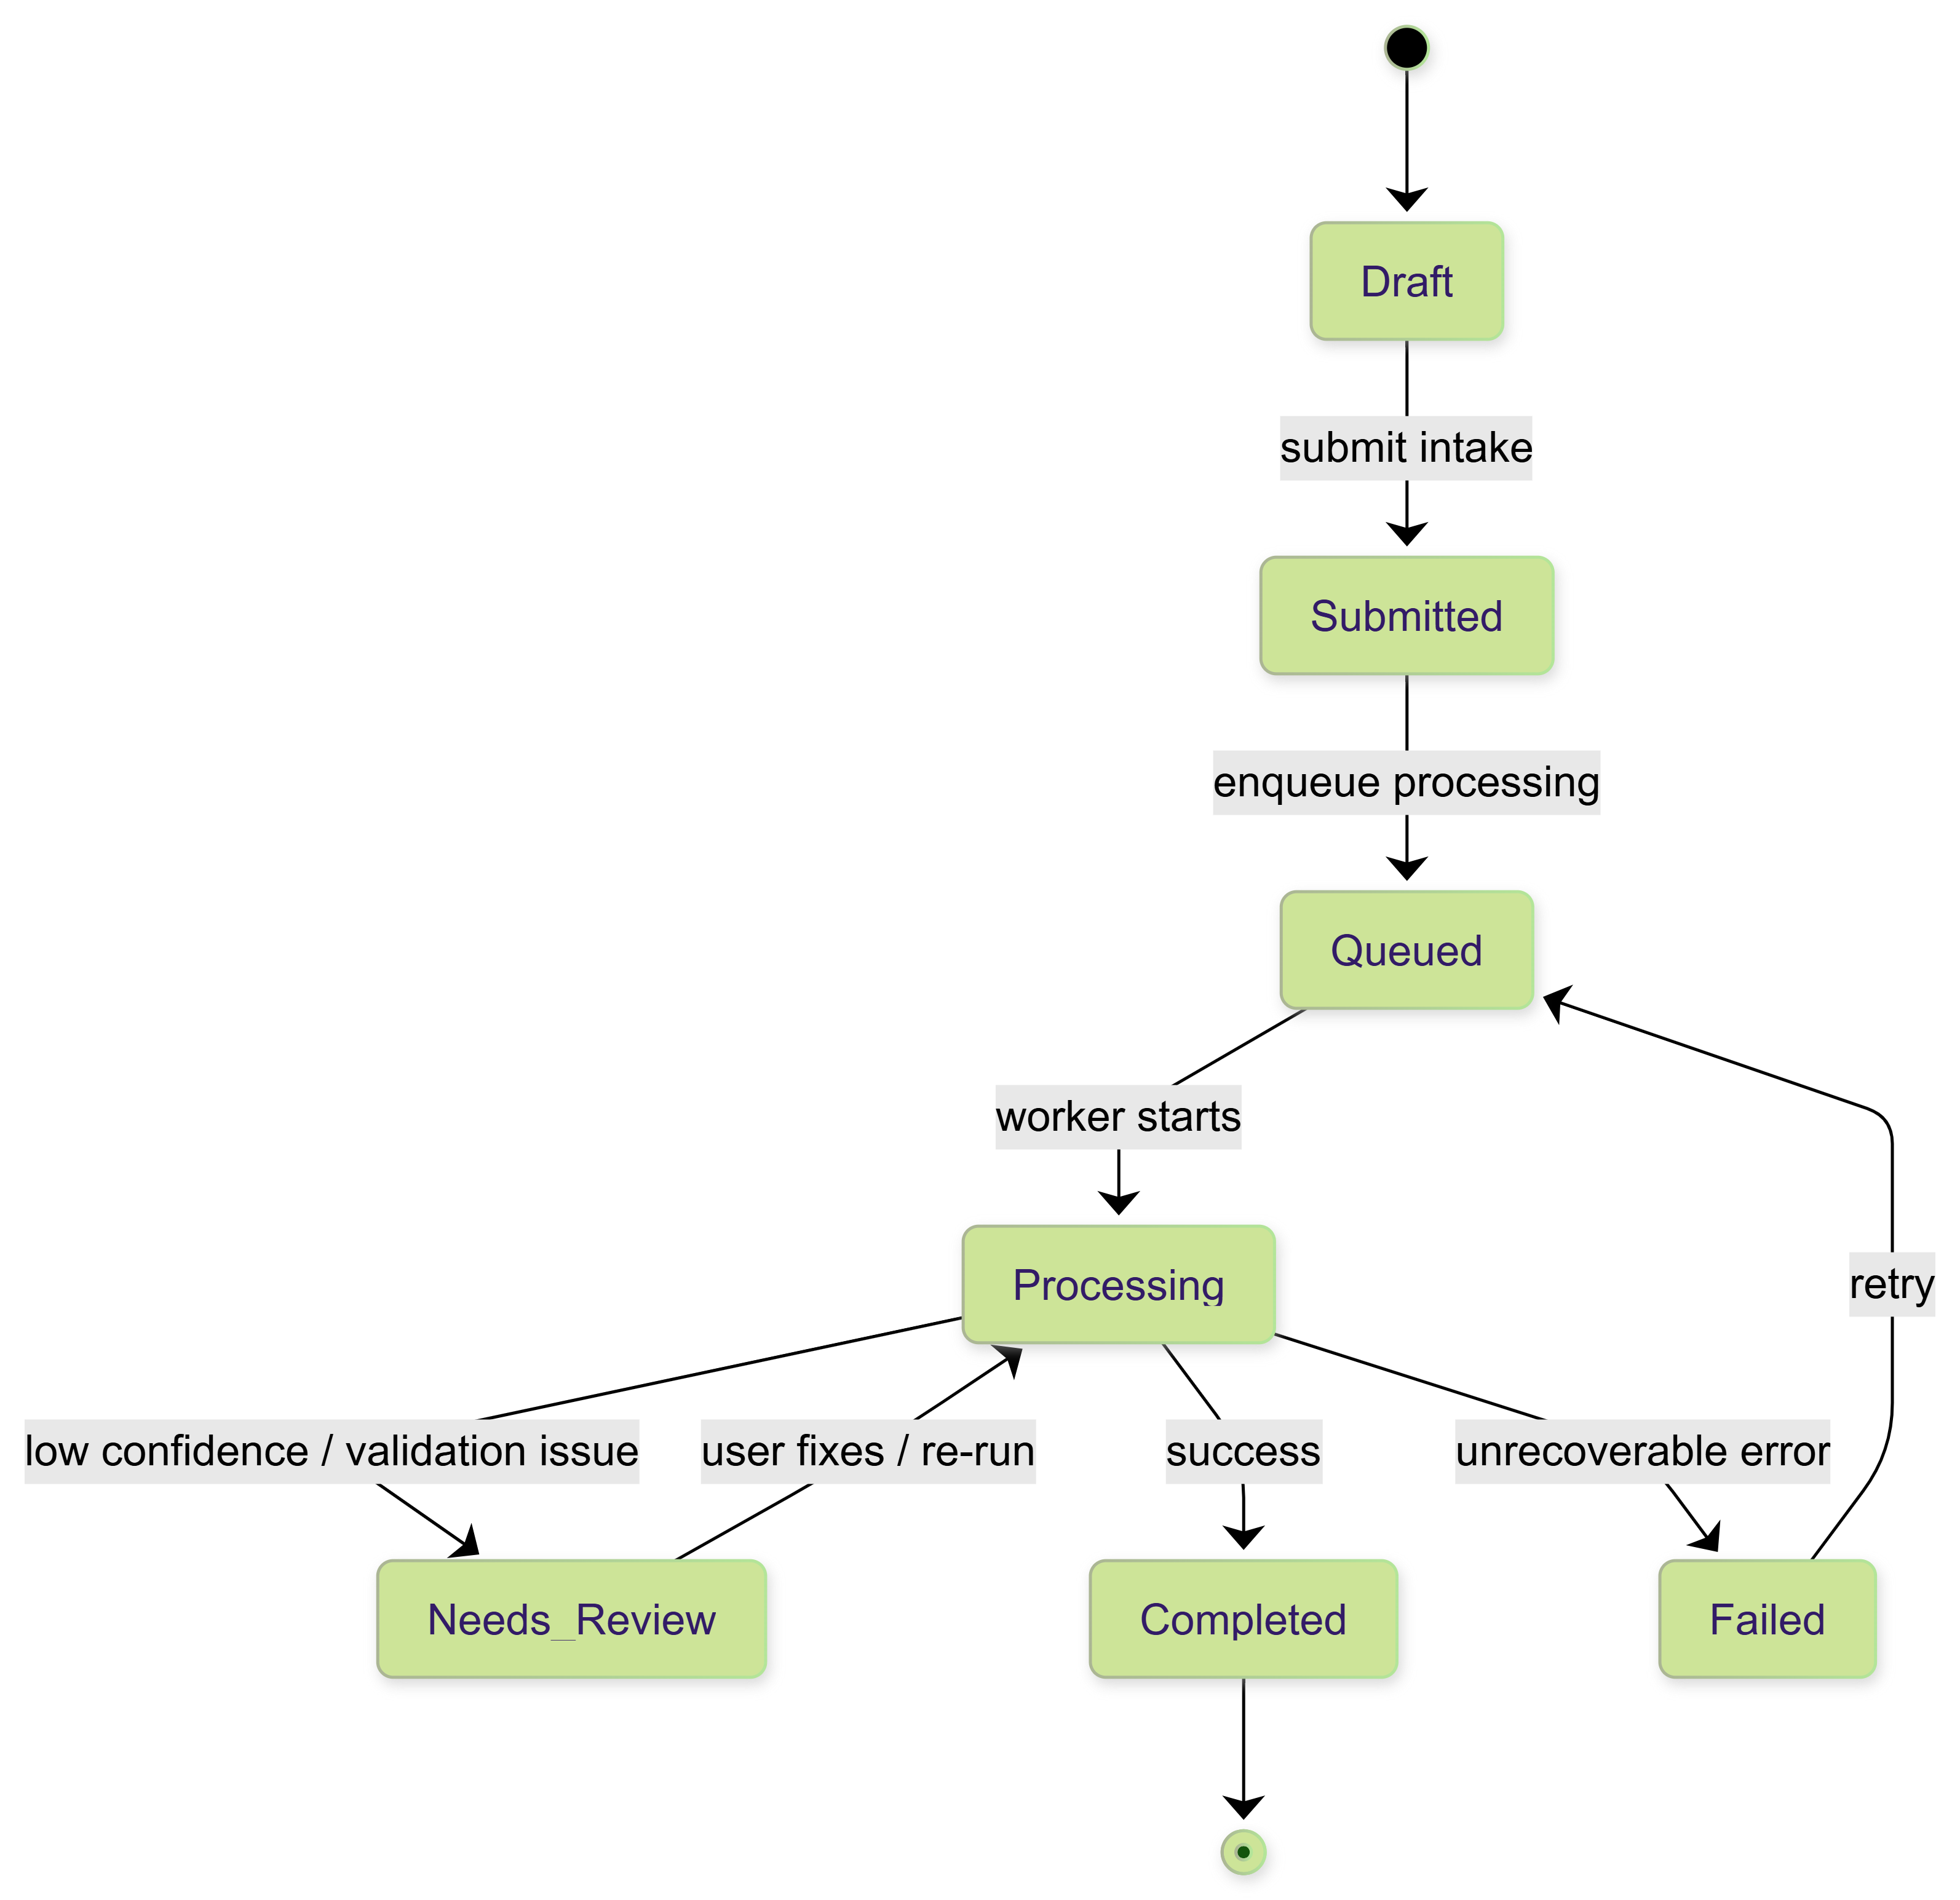

8. Testing and Quality Assurance Plan

8.1 Test Levels
- Unit tests: core mapping, validators, and helper utilities (PHPUnit).
- Integration tests: WooCommerce product create/update flows and ACF field writes on staging.
- End-to-end tests: admin workflows for intake, import, and AI extraction (manual scripts; optional automation if required).
- Security checks: nonce verification, capability checks, sanitization on input and escaping on output.
- Performance checks: import throughput, background job stability, and memory usage for large CSV/PDF.


Fig: QA Test Process

9. Deployment and Operations

9.1 Environments
- Local/dev: developer environment with sample WooCommerce data.
- Staging: mirrors production (plugins, theme, PHP version) for UAT.
- Production: controlled releases with backups and rollback.

9.2 Release and Rollback
- Plugin versioning (semantic versioning) and tagged releases.
- Pre-release checklist: backup DB + wp-content, verify WooCommerce/ACF versions.
- Rollback: deactivate plugin and restore backup or revert to prior plugin version if needed.

10. Assumptions, Dependencies, and Exclusions

10.1 Assumptions
- WooCommerce and ACF (and required field groups) are available and stable in the target environment.
- Client provides access to staging and sample data (products, SKUs, example CSVs, example PDFs/images).
- For AI extraction, client provides an API key and approves data handling policy for documents.
- Hosting supports required PHP version and allows background processing; if not, cloud fallback options will be used.

10.2 Dependencies
- ACF field group definitions and field keys/names used for mapping.
- WooCommerce product model and SKU uniqueness rules.
- Availability of server libraries (Imagick/pdftotext) or approval to use cloud OCR/extraction services.
- Timely feedback on UI walkthroughs and UAT testing.

10.3 Exclusions (Out of Scope)
- Front-end customer UX changes or storefront theme changes.
- Complex PIM features beyond intake/import/extraction (e.g., supplier portals, pricing rules engine).
- Automated publishing to external marketplaces unless separately agreed.
- Custom database tables (explicitly excluded by constraint).

10.4 Technical Constraints and Compliance
- No custom DB tables: persistence uses WooCommerce product data, post meta, options, and/or custom post types.
- All admin actions protected with capability checks and nonces; all inputs sanitized and outputs escaped.
- AI extraction runs only in admin context and stores minimal required artifacts; optional redaction is supported if required.

11. Risks and Mitigations
Risk | Impact | Mitigation
ACF field groups change during build | Mapping breaks; wrong fields populated | Freeze field group changes during implementation; maintain mapping config versioning
Large CSV files cause timeouts | Failed imports; partial writes | Use Action Scheduler background jobs; chunk processing; resumable imports
Document OCR quality is low | Poor extraction accuracy | Improve preprocessing; allow manual edits; support cloud OCR for better accuracy
AI hallucination or wrong values | Data quality issues | Human-in-the-loop confirmation; show source snippets; confidence thresholds; audit trail
Hosting limitations (no Imagick/pdftotext) | Extraction features blocked | Provide cloud fallback path; document prerequisites early

