Kwando — iOS & Android MVP With Flutter
Technical & Financial Proposal

Kwando — iOS & Android MVP (Flutter) Development (Technical & Financial Proposal)
Project: Kwando — iOS & Android MVP (Flutter) (Personal Calendar + Social Planning + Circles/Tracks)
Document Type: Technical & Financial Proposal (Development Only)
Design & UI/UX: Out of Scope (to be provided/approved separately).

1. Introduction
This proposal outlines the recommended technical approach, phased scope of work, timeline, and cost estimate to develop the “Kwando — iOS & Android MVP (Flutter)” from scratch. The MVP is calendar-first (personal utility) with optional social layers for inviting, RSVPs, planning-mode polling, event-based chat, and community organization via Circles and Tracks.
All requirements and constraints are derived from the provided PRD. This proposal focuses on development execution, backend services, quality assurance, and release readiness for Play store and App Store.

2. Project Scope Overview
Kwando is a privacy-first, mobile-first calendar platform designed to help users manage personal schedules and coordinate real-world plans with others—without becoming a social network. The MVP includes a lightweight guest web RSVP page.

2.1 In Scope (MVP)
• Cross-platform (Flutter) application implementing the MVP feature set described in the PRD.
• Backend services supporting event data, invites, RSVPs, polls, shared views, chat, circles/tracks, and notifications.
• Guest Web RSVP interface (mobile responsive) for non-app users, with one-time token invite links and revoke/resend capability.
• Security, privacy controls, moderation tools (host/circle admin), and audit-friendly logs for critical actions.
• QA, and release readiness for Play store and App Store submission.

2.2 Out of Scope (Explicit)
• UI/UX design, branding, illustrations, and user research (development will implement approved designs).
• Full web application (beyond the guest RSVP pages).
• Public feed/discovery of events or Circles; public browsing of events by location/interest.
• Payments/monetization (paid Circles, ticketing, subscriptions).
• Two-way external calendar sync (Google Calendar/iCal/Outlook).
• Direct messaging outside event/circle contexts and other post-MVP stretch features (unless re-scoped).

2.3 Delivery Approach
• Agile delivery with 1–2-week sprints, demo at the end of each sprint.
• Feature flags where appropriate (e.g., Circles/Tracks) to enable staged rollout and controlled testing.
• Privacy-by-default implementation: nothing shared unless explicitly enabled by the user.

3. Phase 1 – Foundation + Personal Calendar (Core Usability)

Feature Scope
• Project setup and baseline architecture and environments.
• Authentication & onboarding (Email/Password, Apple Sign-In).
• User profile basics (name, avatar) and settings scaffolding (notification + privacy settings placeholders).
• Personal calendar core: Day/Week/Month views; event list for upcoming items.
• Create/Edit personal events (private by default): title, date/time, location (search/manual), notes.
• Reminders: local notifications for personal events; basic repeat scaffolding (future-proofing).
• Data persistence: event storage tied to user; offline-first caching for calendar viewing.
• Basic analytics/logging for critical flows (opt-in, privacy-friendly).

Deliverables
• iOS & Android MVP (Flutter) build with personal calendar functionality and authenticated user accounts.
• Backend schema and security rules for Users and Personal Events.
• Dev/staging environment setup.
• Phase 1 test plan + test execution report.

Human Resources & Responsibilities
• Project Manager: Sprint planning, backlog grooming, acceptance criteria, stakeholder updates.
• Mobile App Developer(s): Implement calendar UI flows, event CRUD, local reminders, caching, accessibility basics.
• Backend/Cloud Engineer: Firestore data model, security rules, Cloud Functions scaffolding, environments.
• QA Engineer: Test cases, functional testing, regression suite creation, TestFlight smoke testing.
• DevOps/Release Engineer: CI/CD, signing, environment configs, optional crash reporting setup.

Suggested Timeline
Estimated duration: 4 weeks.

Key Assumptions
• Approved UI screens and interaction specs will be provided before development of each feature set.
• Calendar views will be Kwando-native (no external calendar sync in MVP).
• Time zone handling follows device time zone; event times stored in a normalized format with time zone metadata.
• MVP non-functional targets emphasize stability and usability; advanced optimization can be iterative post-MVP.

Acceptance Criteria
• User can sign up/login and reach calendar home reliably (no critical crashes).
• User can create, edit, and delete a private event and see it reflected in day/week/month views.
• Local reminder notifications trigger at configured times.
• Data is persisted securely and visible after app relaunch; basic offline viewing works for recently loaded data.

4. Phase 2 – Social Planning (Invites + RSVP + Planning Mode + Guest Web RSVP)

Feature Scope
• Social event creation enhancements: Date TBD (Planning Mode), RSVP deadline, guest visibility toggle.
• Invite Kwando users (search/select) and generate personalized external invite links per guest.
• RSVP tracking (Yes/Maybe/No) for users and guests; host dashboard to view status and engagement.
• Planning Mode polls: multiple-choice polls and calendar-based date voting; host finalize/lock date.
• Guest Web RSVP (responsive): view event basics; RSVP; add-to-calendar export (iCal/Google calendar link).
• Invite link lifecycle: one-time use, token-based; revoke/resend; link open tracking (basic).
• Notifications: invite sent, RSVP updates, poll updates/finalization (push + in-app where applicable).
• Abuse prevention basics: rate limiting for RSVP endpoints, token throttling, bot/scan resistance.

Deliverables
• iOS and Android build with social planning flows (invites + RSVP + planning mode).
• Guest web RSVP page deployed (token-based links, revoke/resend, calendar export).
• Backend services for Invites, RSVPs, Polls, and Notifications with security rules and audit logs for critical actions.
• Phase 2 QA report and TestFlight build.

Human Resources & Responsibilities
• Project Manager: Clarify invite edge cases, coordinate web RSVP content requirements.
• Mobile App Developers(s): Event creation enhancements, RSVP UI, host dashboard UI, poll interfaces.
• Backend/Cloud Engineer: Tokenized invite generation, RSVP APIs, poll aggregation, notification triggers.
• Web Engineer: Guest RSVP UI, calendar export, responsive behavior, link token validation.
• QA Engineer: End-to-end testing for invite→RSVP→poll→finalize flows; notification reliability checks.
• DevOps/Release Engineer: Deploy web RSVP, environment hardening, monitoring/alerts.
• Security Review (part-time): Threat review for invite links, PII handling, rate limit validation.

Suggested Timeline
Estimated duration: 4 weeks.

Key Assumptions
• SMS sending is not included unless an SMS provider and budget are confirmed; links can be shared via any channel.
• Guest RSVP requires no account; guests cannot access chat without installing the app.
• Resend issues a new token and invalidates the old one; revoked tokens can no longer RSVP.
• Notifications may be batched to avoid excessive alerts and reduce user fatigue.

Acceptance Criteria
• Host can invite a mix of Kwando users and external guests; each guest has a unique token link.
• Guest can RSVP successfully via web and the host sees the update in the app.
• Host can revoke a link; revoked links can no longer submit RSVP.
• Planning Mode date poll collects votes and host can finalize a date; participants receive an update notification.

5. Phase 3 – Shared Views + Event Chat + Circles & Tracks + Release Readiness

Feature Scope
• Shared Views: mutual request/accept flow; permission levels (full events / shared-only / busy-free); overlay toggles and color coding.
• Event-based chat (for RSVP Yes/Maybe only): text, emojis, links; push notifications for new messages.
• Chat lifecycle: archive/mute after event (auto-archive 24 hours post-event) with retention policy.
• Host moderation: remove participants, delete messages; basic anti-abuse controls (reporting hooks).
• Circles & Tracks: create circle, create tracks, join/approve membership (public/private), post events to tracks.
• Circle chat (single thread per circle) with admin moderation and mute controls.
• Release readiness: performance pass, baseline accessibility pass, crash-free stability, App Store and Play store checklist.

Deliverables
• iOS & Android MVP (Flutter) build with Shared Views, Event Chat, and Circles/Tracks modules enabled.
• Backend services for Views, Chat, Circles, Tracks, Memberships, and moderation actions.
• Data retention policies (TTL where applicable) and operational dashboards/alerts (basic).
• Final QA report, production release package, Play store and App Store submission-ready build.

Human Resources & Responsibilities
• Project Manager: Scope governance, rollout planning, release coordination.
• Mobile App Developers(s): Shared views overlays, chat UI, circles/tracks UI, privacy surfaces and settings.
• Backend/Cloud Engineer: Real-time chat data model, TTL/archive logic, membership workflows, security rules.
• Web Engineer (support): Minor guest web adjustments if required; deep links coordination.
• QA Engineer: Regression + exploratory testing, security/privacy checks, notification reliability matrix.
• DevOps/Release Engineer: Release builds, App Store technical checklist support, monitoring and backup policy.
• Security Review (part-time): Chat abuse mitigation review, privacy configuration validation, penetration-style checks on sensitive endpoints.

Suggested Timeline
Estimated duration: 4 weeks.

Key Assumptions
• Shared Views are targeted for small groups in MVP; large overlays may require further optimization post-MVP.
• Chat moderation is host/admin-based for MVP; automated moderation is optional for later phases.
• Circles discovery is limited/restricted; no public feed or broad discovery in MVP.

Acceptance Criteria
• Users can create/accept a Shared View, set permissions, and overlay calendars with correct visibility rules.
• Event chat is accessible only to RSVP’d users; guests cannot access chat without app onboarding.
• Chat auto-archives after event end (24 hours) and is muted by default; retention follows agreed policy.
• Circle admins can manage membership and post events to Tracks; only Track members are notified and can RSVP.
• Meets Play Store App Store technical requirements.

6. Recommended Technical Stack
6.1 Mobile Application (Flutter – Cross Platform)
Recommendation: Build the MVP as a single Flutter codebase targeting both iOS and Android platforms.
Key benefits include:
• Single shared codebase for iOS and Android, reducing development and maintenance effort.
• Near-native performance using Flutter’s compiled ARM code.
• Faster iteration and feature parity across platforms.
• Strong UI consistency and predictable rendering.
• Long-term scalability for future platforms.

6.2 Backend: Firebase (Firestore + Auth + Cloud Functions + FCM)
Recommendation: Use Firebase as the primary backend for MVP (serverless).

6.3 Guest Web RSVP Interface
• Responsive web page hosted on Firebase Hosting (lightweight React/Next.js or equivalent).
• Token-based invite links per guest, validated server-side via Cloud Functions.
• RSVP actions (Yes/Maybe/No) plus add-to-calendar export links (iCal/Google template).
• Host controls: revoke/resend links; resend issues a new token and invalidates the old one.

6.4 Supporting Tooling
• Monitoring: Firebase Crashlytics + Performance Monitoring (recommended).
• Code quality: PR-based code reviews.
• Environments: dev/staging/prod Firebase projects with strict access control.

7. Backend Scope & Data Model
The backend will cover (at minimum) the following domains:
• Users, Events, Invites, RSVP, Polls, Shared Views, Chat, Circles, Tracks, Memberships, Notifications.
High-level entity coverage:
• Users: profile, settings, device tokens, privacy preferences.
• Events: host, time/date or TBD state, location, notes, visibility settings.
• Invites: invitee (user/guest), guest token, status, openedAt, revokedAt.
• RSVP: status and timestamps; source (app/web).
• Polls/Votes: poll type, options, votes, finalization lock.
• Shared Views: participants, permissions, mutual acceptance.
• Chat: threads and messages; moderation and archive/TTL metadata.
• Circles/Tracks/Memberships: join policies, approvals, roles and event targeting.
• Notifications: event-driven logs for audit and retry.

7.1 Admin-like Controls (In-App)
• Host moderation for event chat (remove participant, delete message).
• Circle admin membership management (approve/deny, remove, promote admin).
• Track membership approvals where required (private/invite-only).

7.2 Security & Privacy Controls (Implementation)
• Tokenized invite links: per-guest, one-time use, revocable; avoid PII in URLs; do not log tokens.
• Abuse throttling on RSVP/token endpoints via Cloud Functions.
• Firestore Security Rules enforcing least-privilege access by participant membership and permission level.
• Privacy-first defaults across events and views; explicit opt-in prompts for sharing.
• Retention policy for chat (archive after event).

8. System Architecture Overview
The MVP uses a client–serverless architecture optimized for real-time collaboration and rapid iteration.

Figure 1 — System Architecture
• Mobile app ↔ Firebase Auth/Firestore for core data operations.
• Cloud Functions for token issuance/revocation, RSVP endpoints, rate limiting, and notification triggers.
• Guest Web RSVP hosted on Firebase Hosting with secure token validation.
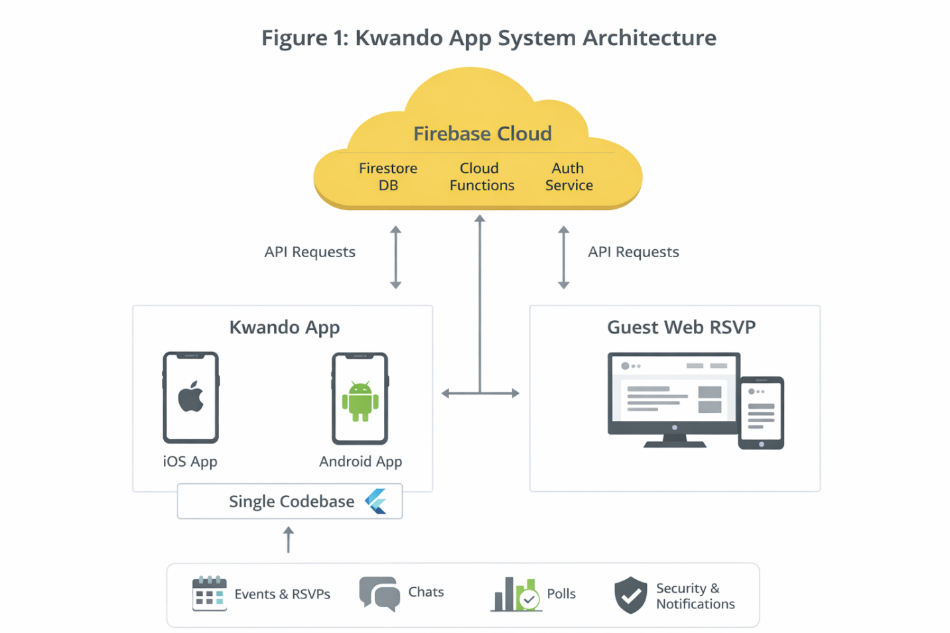

Figure 2 — Data Flow: Invite → RSVP → Poll → Finalize → Notify
• Host creates event and invites users + generates guest tokens.
• Guests/users RSVP → host dashboard updates → planning polls collect votes.
• Host finalizes date/time → event state updates → notifications delivered to participants.
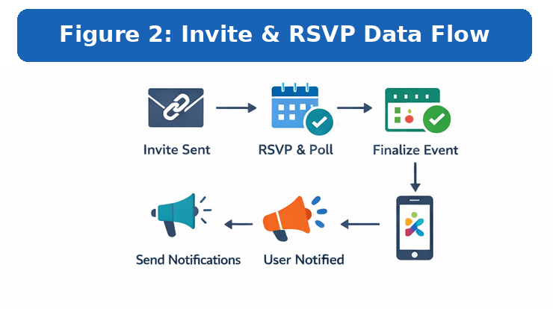

Figure 3 — High-Level ERD
• Entities: User, Event, Invite, RSVP, Poll, Vote, SharedView, Circle, Track, Membership, ChatThread, Message, Notification.
• Relationships: User–Event (owner/participant), Event–Invite/RSVP/Poll/ChatThread, Circle–Track targeting.
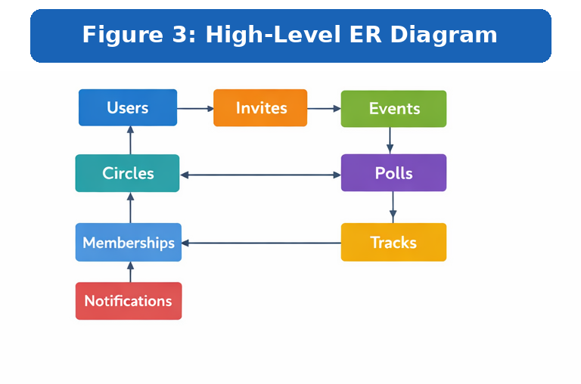

9. Security, Privacy, Risks & Mitigation

9.1 Security & Privacy Posture
• Privacy-first defaults: nothing shared without explicit user action and mutual consent for shared views.
• Least-privilege enforcement via Firestore Security Rules plus server-side validation for sensitive actions.
• Sensitive operations (token issuance, revoke/resend, membership approvals) executed in Cloud Functions.
• Transport security: HTTPS; secure headers on web RSVP; secrets managed securely in environment configuration.

9.2 Key MVP Risks & Mitigations
Risk | Mitigation
Invite link leakage/forwarding | Per-guest one-time token; revoke/resend; optional expiry; do not embed PII in links.
Privacy misconfiguration (Shared Views) | Safe permission presets; mutual consent; clear visibility indicators; quick revoke.
Notification reliability & device edge cases | Device token refresh handling; retry queue; avoid spam.
Chat abuse/moderation gaps | Host/admin moderation; reporting hooks; optional automated moderation later.
Scalability & Firestore cost spikes | Pagination; minimize fan-out; monitoring; retention/TTL for stale chat data.

10. Development Methodology, QA & Release Plan

10.1 Methodology
• Agile Scrum with 1–2-week sprints, weekly demos, and phase-level QA.
• Definition of Done includes code review, critical-flow testing, QA pass, and updated documentation.
• Source control with feature branches + pull requests; tagged releases per phase.

10.2 QA Strategy
• Functional testing for each module; end-to-end testing for invite/RSVP/poll flows.
• Regression test suite maintained and executed before each phase handover.
• Security/privacy checks (permissions, token misuse attempts, rate limit validation, PII review).
• Notification reliability testing (foreground/background, deep link routing, token refresh, retries).
• Device and version coverage through beta testing.

11. Deliverables
• Source code repositories (Flutter, web RSVP, Cloud Functions) and build/deploy documentation.
• Backend data model documentation (collections, indexes), security rules, and environment notes.
• Function/API documentation for invite, RSVP, poll, shared view, and notification workflows.
• QA artifacts: test cases, defect logs, and phase-wise test reports.
• Release artifacts: TestFlight builds, APK or AAB, production build, and deployment checklist.
• 3 months of complimentary frontend support after delivery (minor bug fixes, basic monitoring guidance, and performance-related frontend issues).

Complimentary Support (3 Months)
- Bug fixing for minor UI issues and crashes reproducible in supported environments.
- Basic performance tuning and UI responsiveness improvements.
- Assistance interpreting frontend logs and issues (requires Client to provide access to crash/analytics tools).
Note: Feature enhancements, new screens, or changes due to backend/API changes are excluded and treated as change requests.

12. Relevant Project References (Similar Delivery Experience):
U-Report UNICEF
app store: https://apps.apple.com/tt/app/u-report/id1598072043
play store: https://play.google.com/store/apps/details?id=org.unicef.ureport
- Lentho Community —
iOS: https://apps.apple.com/de/app/lentho-community/id1602655332
Android : https://play.google.com/store/apps/details?id=com.riseuplabs.lentho

13. Conclusion
This proposal delivers a phased, privacy-first MVP implementation aligned to the PRD: a strong personal calendar foundation, followed by social planning with guest RSVPs, then shared views, chat, and Circles/Tracks with release readiness. Cross-platform (Flutter) + Firebase is recommended to maximize quality and reliability while keeping MVP delivery fast and operationally lean.

Financial Proposal

A. Effort & Cost Summary (Phase-wise)
Estimates below are based on role-wise effort (man-days) and indicative rate ranges. Final pricing can be adjusted based on the agreed delivery model and team composition.
Phase | Scope Focus | Weeks | Estimated Cost (USD) | Parallel Development
Phase 1 | Foundation + Personal Calendar | 4 | $3,000 | Timeline: 8 Weeks
Phase 2 | Social Planning + Guest Web RSVP | 4 | $3,000 | Timeline: 8 Weeks
Phase 3 | Shared Views + Chat + Circles/Tracks + Release | 4 | $2,500 | Timeline: 8 Weeks

Complimentary Support: 3 months of post-deployment support (as described in Section 11).

C. Payment Terms (Phase-based)
• Each phase begins after scope confirmation for that phase and receipt of the phase advance payment.
• Payment schedule per phase: 30% advance to start the phase; 70% upon successful delivery.
• Next phase commences only after the previous phase payment is fully settled.

D. Inclusions, Exclusions & Change Request Policy
• Included: development, backend setup, QA, and Play Store and App Store technical release support per scope above.
• Excluded: UI/UX design work, copywriting, branding assets, and paid third‑party services unless specified.
• Change Requests: any request outside the approved scope will be estimated and scheduled via a formal change request.

E. Remarks
• Costs are indicative and provided as a range to avoid false precision; final commercial terms depend on final team mix and confirmed scope.
• Third‑party operational costs (Apple Developer Program, Google Play Console, domains, SMS fees, etc.) are not included unless explicitly stated.

