Technical & Financial Proposal
METT Holidays Website Redevelopment

1. Introduction
This proposal presents the technical and financial approach to redevelop the existing METT Holidays public website as a new, maintainable, and production-ready web platform. The scope covers development only: frontend, backend/admin panel, database, QA, deployment support, and launch preparation.
The supplied website audit identifies 23 website pages in total - 11 core pages and 12 tour detail pages - plus 2 downloadable PDF files. Several URLs currently return 404 and are therefore excluded unless later confirmed by the client.
• The website will be developed from scratch.
• Design and UI/UX are excluded from the scope.
• Only the audited pages and related public workflows are considered in scope.
• Third-party costs such as hosting, domain, SSL, email/SMTP, or paid services are excluded unless separately approved.
• Any additional requirement beyond the agreed scope will be handled through Change Request (CR).
2. Project Context & Existing Website Footprint
The audited website mainly consists of marketing pages, holiday/deal pages, tour listing and detail pages, visa pages, branch/contact information, and a registration/inquiry form. The redevelopment objective is to convert this footprint into a structured and manageable website with a proper backend foundation.
• Main pages identified in the audit include Home, About Us, Managing Director Message, Team, Deals, Global Visa Services, UAE Tourist Visa, Branches / Contact, Register, and Tours listing.
• Tour detail pages should be managed from the backend as repeatable content rather than hard-coded page by page.
3. Proposed Technical Approach & Methodology
To keep the solution cost-effective and maintainable, we propose a CMS-driven custom website built with Laravel as the primary application framework. This approach supports structured content management, secure form handling, straightforward deployment, and efficient long-term maintenance without unnecessary technical overhead.
3.1 Delivery Approach
• Modular delivery so that core pages, content models, tours, and inquiry workflows are completed in clear milestones
• Backend-first setup for content structure and forms, followed by frontend integration and QA
• Staging-based review and QA before production release
• Basic documentation and handover after launch

3.2 Environments & Governance
• Environment flow: Local -> Staging -> Production
• Version control: Git-based repository with controlled release process
• Release readiness: configuration management, backup readiness, and error logging
4. Proposed Technical Stack
Layer | Proposed Stack
Frontend | React.js
Backend | Laravel 11 / PHP 8.x
Database | MySQL
Admin Panel | Custom admin/content management panel within Laravel
Media & Files | Server-based file storage with downloadable PDF management
Forms | Secure inquiry/registration form handling with email notification and database storage
Hosting | Linux-based VPS / cloud hosting/AWS
QA & Release | Staging deployment, functional testing, regression testing, production deployment support
5. Scope of Work (Development Only)
The proposed scope is divided into two phases to control delivery, budget, and review cycles. The scope is limited to the audited website footprint and the supporting backend needed to manage it.
5.1 Phase 1 - Foundation, CMS, and Core Website Development
Phase 1 focuses on the technical foundation, backend/admin setup, and implementation of the core public website structure.
• Project setup, database design, and application architecture setup
• Backend admin setup for pages, tours, deals, visa services, branches, downloads, and inquiry submissions
• Reusable frontend layout components such as header, footer, menus, banners, cards, forms, and content sections
• Development of core pages identified in the audit, including Home, About Us, Managing Director Message, Team, Deals, Global Visa Services, UAE Tourist Visa, Branches / Contact, Register, and Tours listing
• Download management for E-Catalogue and Company Profile PDFs
• Inquiry / registration form submission with backend capture and notification setup
• Initial staging deployment
5.1.1 Human Resources for Phase 1
Role | Responsibility
Project Manager | Planning, scope control, milestone coordination
Technical Lead | Architecture, supervision, code review
Backend Developer | Backend, admin panel, database, forms
Frontend Developer | Page development and responsive implementation
QA Engineer | Functional testing and regression verification
DevOps Engineer | Staging setup, deployment support, release checklist
5.2 Phase 2 - Tour Detail Pages, Optimization, QA, and Production Launch
Phase 2 focuses on repeatable tour-detail content, end-to-end QA, production readiness, and launch.
• Development of all audited tour detail pages using a reusable detail-page template
• Backend management for tour detail content so that future tour entries can be maintained without code edits
• Refinement of deal/visa/tour content presentation within the approved scope
• Cross-browser and device testing
• Performance validation and security hardening for public forms
• QA support, production deployment, and post-launch handover

5.2.1 Human Resources for Phase 2
Role | Responsibility
Project Manager | QA coordination and acceptance support
Technical Lead | Optimization and production readiness
Backend Developer | Dynamic tour detail module and admin refinement
Frontend Developer | Page completion and responsive fixes
QA Engineer | Full regression and release testing
DevOps Engineer | Production deployment and release monitoring
6. Deliverables
• Production-ready website developed from scratch based on the approved audited footprint
• Admin/content management panel for pages, tours, deals, visa content, branches, downloads, and inquiries
• Configured database and structured content models for repeatable content management
• All audited core pages and tour detail pages implemented and integrated
• Inquiry / registration workflow with backend capture and notification setup
• Staging and production deployment support
• QA artifacts including test checklist and release-readiness validation
• Basic handover documentation and one content-management orientation session

7. Technical Diagram
Diagram 1: High-Level Solution Architecture
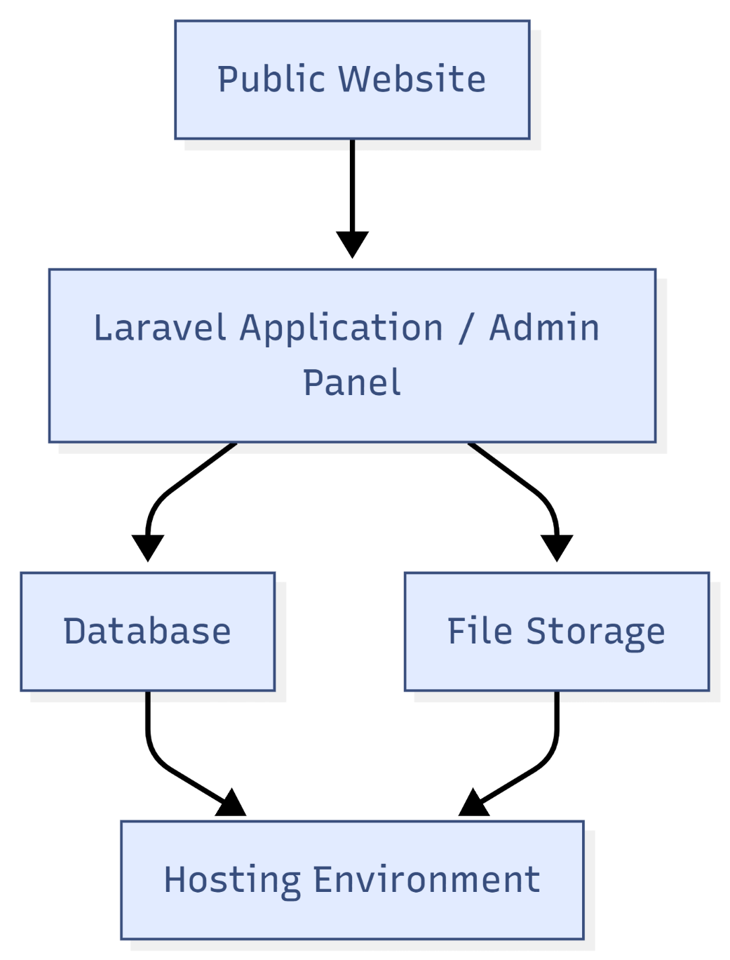

Diagram 2: Inquiry / Registration Submission Flow
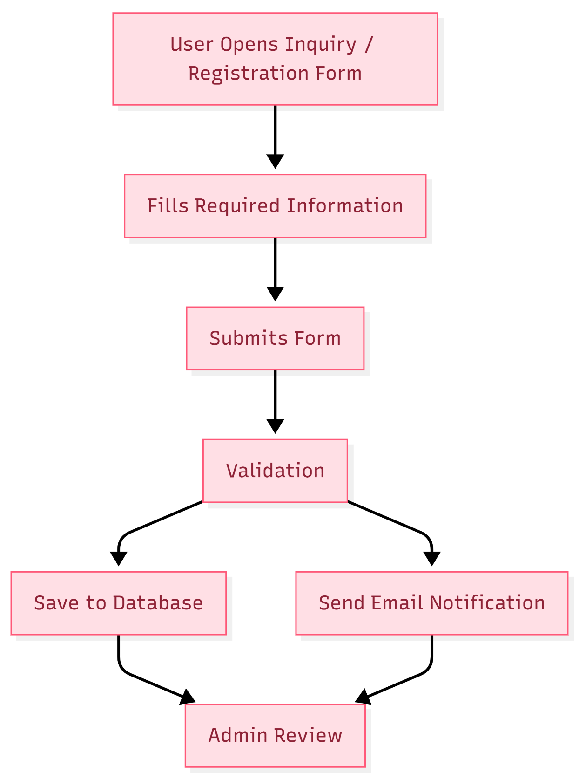

8. Complimentary Support (1 Month)
After production deployment and final handover, one (1) month of complimentary support will be provided for issues directly related to the delivered scope.
• Bug fixing for reproducible defects within the delivered modules
• Minor adjustment within the approved scope and existing layout pattern
• Deployment-related observation and issue review support during the support period
• Support excludes new features, new pages/modules, design change requests, or third-party service issues outside our codebase
9. Financial Proposal
The following commercial estimate is provided for the defined development scope only. This estimate excludes third-party licensing, hosting, domain, SSL, SMS/email gateway charges, content entry, translation, and post-scope enhancement requests.
Phase | Scope Summary | Timeline | Estimated Cost (USD)
Phase 1 | Frontend Foundation, admin/CMS, core pages, forms, staging setup | 2 Weeks | $2604
Phase 2 | Tour detail module, optimization, QA, go-live | 1 Weeks | $781
Total |  | 3 Weeks | $3385
9.1 Payment Terms
• 30% advance payment upon project kickoff
• 30% payment upon completion of Phase 1 and staging approval
• 30% payment upon completion of Phase 2 and QA sign-off
• 10% payment upon production deployment, final handover, and support commencement
9.2 Change Request (CR)
• Any requirement beyond the defined scope will be treated as a Change Request.
• Estimated CR rate: USD 150 per man-day or USD 25 per man-hour.
9.3 Assumptions & Remarks
• This proposal is based on the audited website footprint shared in the source document.
• Only development is included. Final design, UI/UX, copywriting, and branding assets are to be provided by the client.
• If additional pages/modules are required beyond the audited footprint, timeline and cost will need revision.
• Pages that currently return 404 are not considered in this estimate unless separately approved.
• Mass content entry is not included except for implementation support and data structure setup.
10. Proposed Out of Scope
• UI/UX design, wireframing, branding, and visual design creation
• New modules not reflected in the current audited website scope
• External integrations not explicitly listed in the approved scope
• Ongoing SEO/content marketing, blog operations, or campaign management
• Hosting, domain, SSL, and third-party recurring subscription charges
11. Acceptance & Sign-off
The project deliverables will be considered accepted once the agreed scope is implemented, reviewed on staging, passed through QA, and formally approved by the client. Production deployment will proceed after sign-off and subject to payment clearance in line with the agreed commercial terms.

