Technical Proposal & Financial Proposal — Mobility Infrastructure as a Service (MIaaS) App
Frontend Development Proposal (Mobile App + Web Admin Panel)
Prepared by: Riseup Labs

1. Introduction
This document presents a technical and financial proposal for the frontend development of the Mobility Infrastructure as a Service (MIaaS) application. The MIaaS platform aims to unify consumer (B2C) and corporate fleet (B2B) mobility service journeys—fueling, car wash, lubrication, parking, and EV charging—into a single mobile-first experience for Saudi Arabia with Arabic/English localization.
This proposal strictly covers frontend implementation only. UI/UX design, backend development, API development, database, hosting, and production operations are excluded at this stage.

2. Project Scope Overview

Delivery Scope (In-Scope)
- Flutter-based mobile application frontend for iOS and Android (single codebase).
- Frontend user interface development for B2C and B2B experiences.
- Payment gateway integration (frontend-side implementation only).
- Web admin panel frontend setup (Fleet + Service Provider operations panel).
- Localization: Arabic (RTL) and English (LTR), Saudi-specific formatting (currency/date), and accessibility basics.

Out of Scope (Explicit)
- UI/UX design, branding, and design system creation.
- Backend development or modifications (APIs, database, admin logic, reporting engines).
- Payment gateway backend setup, transaction processing, settlement, refunds, and compliance configuration.
- Hosting, DevOps for production, and cloud infrastructure (unless requested as future scope).

Scope Note (Future Support)
If backend development or backend-related support is required in the future (including API changes, database work, hosting, or payment settlement logic), it will be treated as additional scope and the project budget will be revised accordingly.

Primary User Segments (For UI Coverage)
- B2C Consumers: service discovery, wallet/subscription, loyalty, offers/ads, transaction history.
- B2B Fleet Operators: vehicle enrollment, fleet spend monitoring, reports, fraud-control views (UI), approvals.
- Service Providers: service listing/promotion management and monitoring (via web panel UI).

3. Phase 1 – Mobile App Foundation & Core B2C Journeys
Phase 1 focuses on establishing the Flutter app foundation and delivering the core B2C service discovery and account experience, including bilingual (Arabic/English) UI readiness.

Key Features:
- Project setup: Flutter architecture, state management, routing, environment configuration, and reusable UI components.
- Localization framework: Arabic RTL + English LTR, font handling, and locale switch.
- Onboarding: Sign-up / Login screens (UI), OTP/email/social placeholders (integration-ready), and basic profile setup.
- Vehicle registration (B2C): add/edit vehicle details (UI + validation).
- Service Finder: map & list views for nearby services (fuel, wash, parking, EV charging, lubrication).
- Service details: service info, amenities, pricing placeholders, open/close state (based on API).
- User preferences: favorites, saved locations, basic settings, and support/contact screens.
- Integration readiness: API client layer, response models, error handling, and loading/empty states (backend endpoints provided by Client).

Resources & Responsibilities:
- Project Manager — sprint planning, scope control, acceptance criteria, and stakeholder coordination.
- Flutter Tech Lead — app architecture, code standards, reusable components, integration approach.
- Flutter Developer — screen development, localization, UI state management, and integration wiring.
- QA Engineer — functional testing, device coverage (iOS/Android), localization/RTL checks, regression.
- Release/Configuration Support — build signing support, app flavor configs, and store-readiness checklists (frontend-side).

Timeline
Phase 1 Development time: 4 weeks

4. Phase 2 – Wallet, Subscription, Loyalty, Promotions & Ads UI
Phase 2 delivers the monetization and engagement layer of the consumer experience—wallet, subscription, loyalty program, and promotions—including frontend-side payment gateway flows and deep-linked notifications.

Key Features:
- Wallet UI: balance, transaction list, top-up flow, and invoices/receipts views (data from backend).
- Subscription UI: plan listing, enrollment, renewal status, and subscription history.
- Payment gateway integration (frontend-side): SDK/redirect flow integration, tokenization UI handling, success/failure states, and retry UX.
- Loyalty program UI: points balance, earning rules display, redemption catalog (UI), and redemption history.
- Offers & promotions UI: banners, offer detail pages, eligibility indicators, and “nearby offers” surfaces.
- Mobility-driven ads UI surfaces: static ad placements and dynamic ad slots (triggered by backend events).
- Push notifications (frontend): Firebase/APNs setup and notification preference UI.
- Performance enhancements: caching strategy (frontend), pagination, and optimized image handling.

Resources & Responsibilities:
- Project Manager — requirements grooming, scope alignment with payment/loyalty rules.
- Flutter Tech Lead — payment flow UX integrity, secure storage usage, and app performance tuning.
- Flutter Developer — wallet/subscription/loyalty screens, payment SDK integration, notification.
- QA Engineer — payment flow testing (sandbox), regression, edge cases (failure states), RTL validation.

Timeline
Phase 2 Development time: 4 weeks

5. Phase 3 – B2B Fleet Experience + Web Admin Panel Frontend + Release Readiness
Phase 3 delivers the corporate fleet experience and the web-based admin panel frontend required for fleet operators and service providers. It also includes release readiness activities for app store submissions (frontend deliverables).

Key Features:
- B2B mobile experience (UI): fleet driver mode, vehicle selection, usage restrictions indicators, transaction receipts, and history.
- Fleet operator web admin panel (frontend): dashboard, vehicle enrollment, driver/user management (UI), spend analytics & reports (UI), filters, exports (UI triggers).
- Service provider operations web panel (frontend): service listing management UI, promotions/ads upload UI, and monitoring dashboards (frontend views).
- Role-based access UI (RBAC-ready): admin roles and permission-based menu visibility (backend-enforced).
- Release readiness: device testing matrix, accessibility checks, crash-free baseline targets (frontend), store listing assets checklist (provided by Client).

Resources & Responsibilities:
- Project Manager — stakeholder alignment for fleet/admin workflows, acceptance sign-off, release coordination.
- Flutter Tech Lead — shared components reuse, B2B/B2C flow separation, performance and stability hardening.
- Flutter Developer — B2B flows, responsive layout.
- Frontend Developer (Web) – Web admin panel frontend, responsive layout.
- QA Engineer — web + mobile regression, cross-browser testing for admin panel.

Timeline
Phase 3 Development time: 4 weeks

6. Recommended Technical Stack
- Mobile App (iOS/Android): Flutter (Dart), single codebase.
- Web Admin Panel Frontend: React
- Maps & Location UI: Google Maps SDK.
- Push Notifications (Frontend): Firebase Cloud Messaging (FCM) with APNs support.
- Analytics (Frontend instrumentation): Firebase Analytics / Client-provided analytics SDK.
- CI/CD (Frontend): GitHub Actions or GitLab CI for build/test/signing pipelines.

7. System Architecture Overview
The frontend components will communicate with the Client’s in-house backend through secure APIs. This proposal delivers UI screens, navigation, state management, and integration wiring assuming the backend endpoints and credentials are provided by the Client.

Figure 1: System Context Diagram (Placeholder)
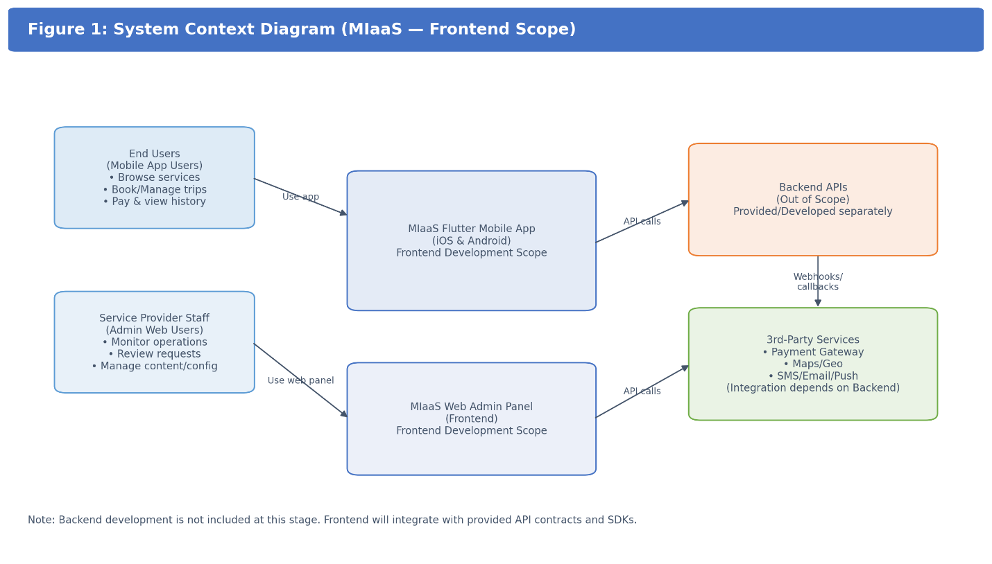
Mobile App (Flutter) and Web Admin Panel (Web) consume Client APIs and integrate with third-party SDKs such as maps, push notifications, and payment gateway (frontend-side).

Figure 2: Frontend Module Architecture (Placeholder)
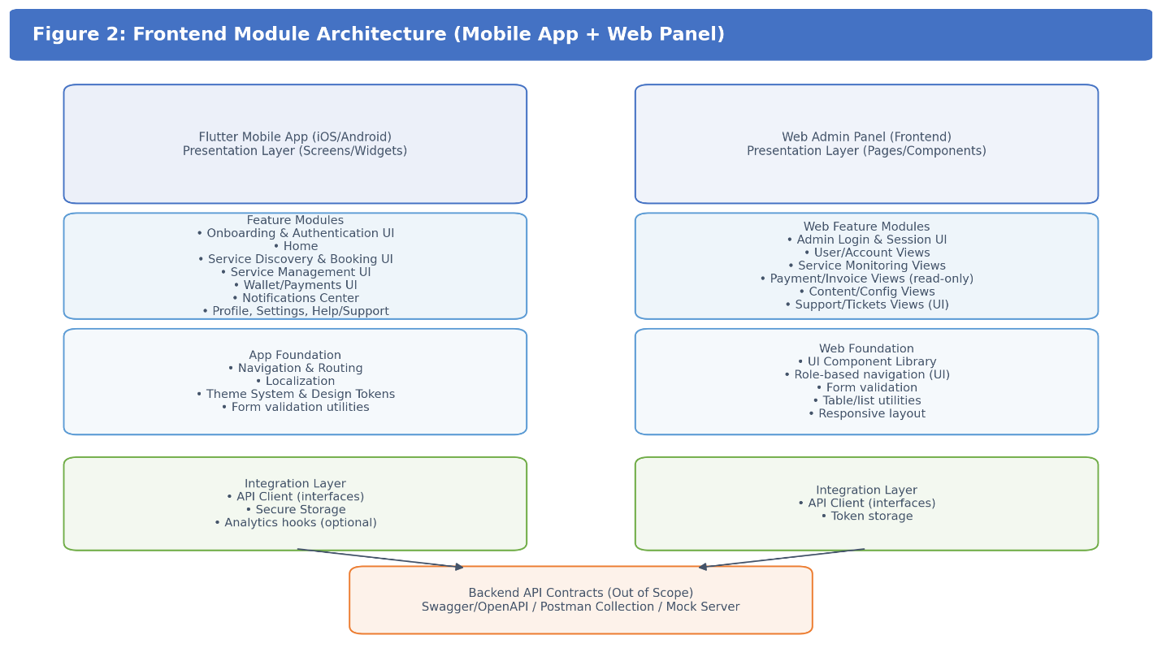
Presentation Layer (Screens) → State Management → Service/API Client Layer → Backend APIs. Shared UI components and localization sit across modules.

Figure 3: Payment Flow (Frontend-Side) (Placeholder)
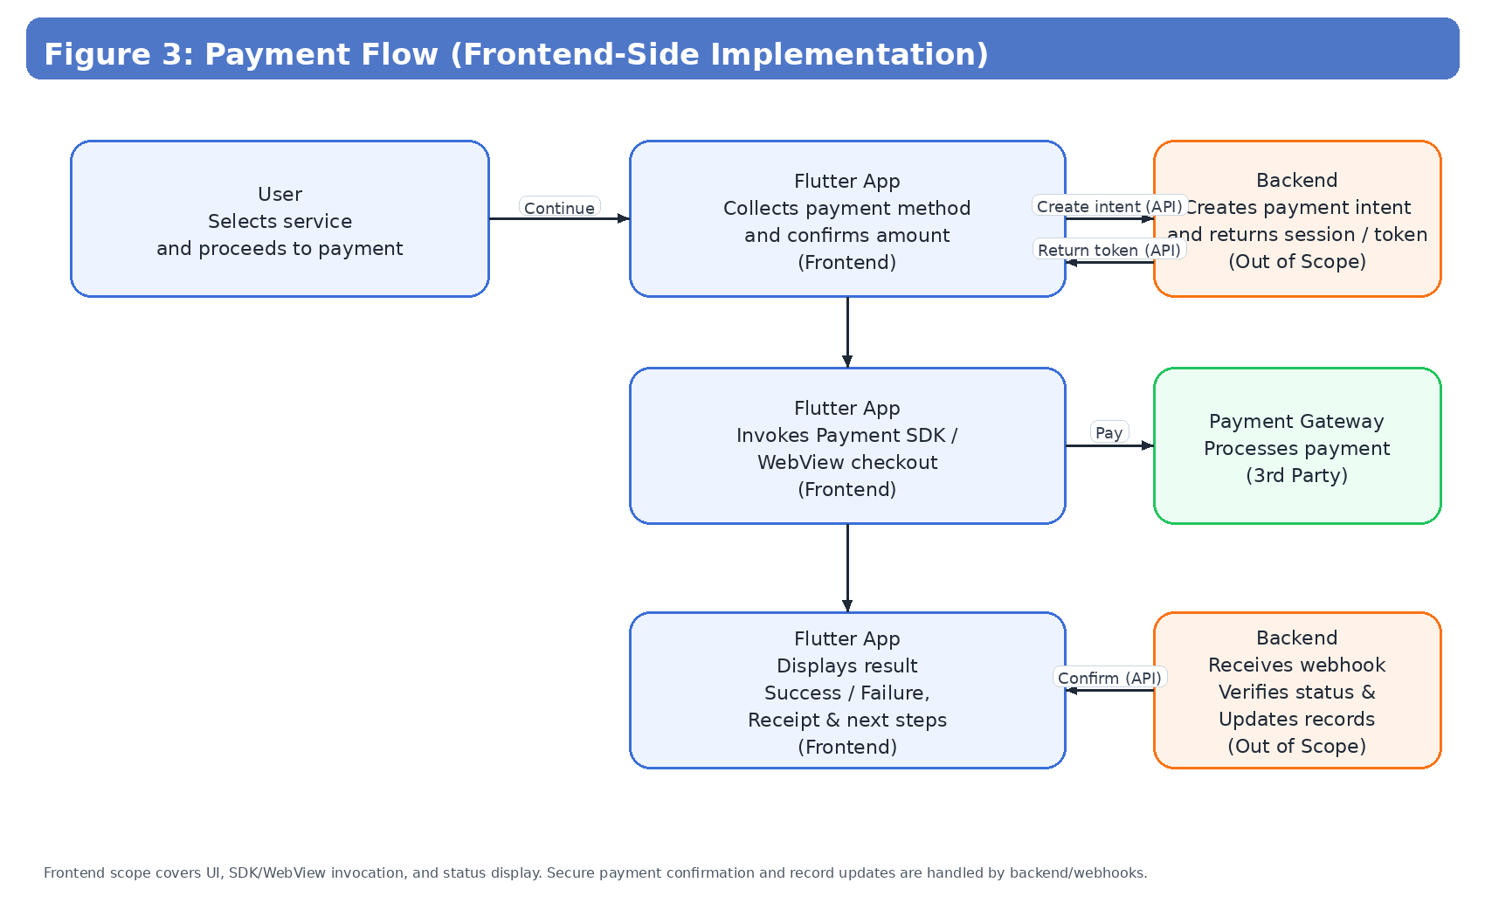
User initiates top-up/subscription → App triggers gateway SDK/redirect → Backend confirms transaction → App displays success/failure UI and receipt.

8. Security & Compliance (Frontend Focus)
- Transport security assumptions: backend APIs must enforce HTTPS/TLS and proper authentication (implemented by Client).
- Frontend input validation and safe error handling to reduce information leakage.
- Session management and logout controls; idle/session expiry UI handling (backend-enforced).
- Privacy-by-design UI: user consent screens where required (tracking/notifications), and preference controls.

9. Development Methodology
An Agile delivery approach will be followed (Scrum-style sprints). Each phase will be executed with sprint planning, development and QA before phase closure. Frontend integration will be performed against Client-provided API specifications and environments (Dev).
- Sprint cadence: 1–2 weeks per sprint (finalized at kickoff).
- Weekly demos and issue triage with Client stakeholders.
- Definition of Done: UI Development completed, tested, localized (AR/EN), and approval.
- Regression testing at the end of each phase.

10. Deliverables
- Flutter mobile app frontend source code (iOS/Android), including localization (AR/EN) and reusable UI components.
- Web admin panel frontend source code (Fleet + Service Provider operations panel).
- Frontend integration layer (API client, models, error handling) aligned to Client API contracts.
- Build & release artifacts for Production (Android AAB/APK and iOS IPA/TestFlight builds), plus web build artifacts for staging.
- Basic technical documentation: setup guide, environment configuration, and screen/module mapping.
- 3 months of complimentary frontend support after delivery (minor bug fixes, basic monitoring guidance, and performance-related frontend issues).

Complimentary Support (3 Months)
- Bug fixing for minor UI issues and crashes reproducible in supported environments.
- Basic performance tuning and UI responsiveness improvements.
- Assistance interpreting frontend logs and issues (requires Client to provide access to crash/analytics tools).
Note: Feature enhancements, new screens, or changes due to backend/API changes are excluded and treated as change requests.

11. Assumptions, Dependencies & Acceptance
- Client will provide final UI/UX designs, assets, and interaction specifications before each phase begins.
- Client will provide API documentation (Swagger/Postman) and authentication method
- Payment gateway provider selection, credentials, and sandbox environment will be provided by Client.
- Map provider keys/licensing and any Saudi-specific compliance requirements will be provided by Client.

12. Relevant Project References (Similar Delivery Experience):
- eCook —
iOS: https://apps.apple.com/us/app/ecook/id6450396013
Android: https://play.google.com/store/apps/details?id=com.riseuplabs.ecook
- WorkTok —
iOS: https://apps.apple.com/us/app/worktok%D9%84%D9%84%D8%AD%D8%B1%D9%81%D9%8A%D9%8A%D9%86/id1662766442
Android: https://play.google.com/store/apps/details?id=org.worktok.provider&hl=en
- Lentho Community —
iOS: https://apps.apple.com/de/app/lentho-community/id1602655332
Android: https://play.google.com/store/apps/details?id=com.riseuplabs.lentho

13. Conclusion
This proposal outlines a phased, frontend-only delivery approach for the MIaaS application using Flutter for iOS and Android, along with a web-based admin panel frontend for fleet operators and service providers. The phased rollout reduces risk, supports clear acceptance checkpoints, and enables a controlled path to full product readiness. Any backend development or backend-related support required in future will be treated as additional scope with a revised budget.

Financial Proposal
The following costs are estimated for frontend development only (mobile app + web admin panel frontend), including QA and release readiness. Final cost may be adjusted after confirming final UI designs, API contracts, and third-party SDK requirements.
Phase | Scope of Work | Weeks | Estimated Cost (USD) | Parallel Development
Phase 1 | Mobile App Foundation & Core B2C Journeys (Flutter) | 3 | $3,000 = $2500
Phase 2 | Wallet, Subscription, Loyalty, Promotions & Ads UI + Payment Flow (Frontend) | 3 | $3,000 = $2500 | Timeline: 8 Weeks
Budget:
Complimentary Support: 3 months of post-deployment frontend support (as described in Section 10).

Payment Terms
- Each phase will begin after finalizing the respective phase scope and receiving a 30% advance payment for that phase.
- Upon completion and successful handover of each phase, the remaining 70% payment for that phase must be cleared in full.
- The next phase will commence only after the payment for the previous phase has been fully settled.
- Example: Phase 1 (30% advance → work starts → delivery → 70% payment) → then Phase 2 begins.

Remarks
- Development time will start count after receiving the final UI files and backend API.
- This estimation covers frontend development only (mobile + web admin panel frontend) and excludes backend implementation and hosting.
- Payment gateway integration is included as frontend-side implementation (UI flows and SDK/redirect integration). Backend settlement, reconciliation, and compliance configuration are excluded.
- Any change in scope, additional third-party SDKs, extra languages, or major UI changes may require a revised estimate through mutual agreement.
- All deliverables will be shared with source code and build instructions upon payment clearance for each phase.
- If development phases are carried out in parallel, the project will be completed within the estimated timeline – 8 Weeks

