Technical & Financial Proposal
Modern Sportswear eCommerce Platform blended with OTT/VOD Experiences
(Mobile App iOS/Android, Web App, and Shared CMS - Development Only)

Prepared by: Riseup Labs
Date: February 05, 2026

1. Introduction
This document provides a technical and financial proposal to build a modern sportswear eCommerce platform blended with OTT/VOD-style experiences. The solution will be developed from scratch and delivered as Mobile Apps (iOS and Android), a Web App storefront, and a shared CMS for product and content operations.
Key constraints for this proposal:
- Scope is limited to development (frontend, backend, database, integrations, DevOps).
- Design and UI/UX (wireframes, visual design, branding) are out of scope. We will implement screens based on client-provided design assets.
- Third-party licensing and usage fees (payment gateway, SMS, video streaming/CDN, analytics, etc.) are excluded and will be billed directly to the client.
- Any new requirements outside the agreed phase scope will be handled via change request.

2. Project Scope Overview

2.1 In Scope (Development)
- Mobile apps: customer-facing sportswear shopping and OTT/VOD experiences (Android and iOS).
- Web app: responsive storefront and OTT/VOD experiences.
- Backend APIs: commerce, content, identity, engagement, and admin services.
- Shared CMS: product and content management, moderation, publishing workflows, and configuration.
- Database and storage: transactional data, media metadata, and object storage for assets.
- Integrations: payment, shipping/fulfillment hooks, notifications, analytics events (as per selected providers).
- Quality assurance: test planning, functional and regression testing, release readiness.
- Deployment: cloud environments, monitoring, logging, backups.

2.2 Product Concept Summary (Sportswear + OTT/VOD)
The platform blends classic eCommerce with entertainment-first discovery. Shoppable video and live sessions allow users to watch, engage (chat, polls, reactions), and purchase products directly within the viewing experience. This approach follows modern live commerce and shoppable video patterns (interactive tags, real-time chat, and one-click buying) and supports engagement loops such as gamification and community features.

3. Proposed Technical Approach & Methodology
We will implement a modular, API-first platform (headless-style) where Web and Mobile clients consume shared backend services. This enables consistent commerce rules and a shared content layer across channels, while allowing independent iteration on the mobile and web experiences.

3.1 Delivery Methodology
- Iterative delivery in controlled milestones per phase, with demos and acceptance at the end of each phase.
- Definition of Done per feature: API contract finalized, implemented, tested, and documented.
- Test-driven mindset for critical flows (checkout, order lifecycle, authentication, payment callbacks).
- Security-by-design: RBAC, audit logs for admin actions, secure secrets handling, and OWASP-aligned practices.

3.2 Key Engineering Principles
- Single source of truth: shared backend services and database for both web and mobile.
- Composable modules: Commerce, Content, Streaming, Engagement, and Analytics components can evolve independently.
- Resilience: retries and idempotency for payment and order operations, graceful degradation for streaming.
- Observability: centralized logging, metrics, and error tracking to speed up QA and production support.

4. Development Phases (3 Phases)
The scope is divided into three (3) phases to reduce delivery risk and allow incremental validation.

Phase 1 - Core Commerce Foundation (Web + Mobile + CMS Basics)
Goal: Launch a usable storefront experience with core shopping and order capabilities, ready for initial pilot.
In-scope features (based on shared scope sheet):
- User onboarding: welcome, sign-up/log-in, profile setup.
- Home page: hero section, featured products, navigation, search.
- Product listing: grid, filters, sorting, pagination.
- Product details: images, descriptions, size guide, reviews, related products.
- Cart and checkout: cart, shipping info, payment, order confirmation.
- User account: profile, address book, payment methods, order history, tracking, wishlist.
- Customer support: help center, contact form, live chat integration (provider-based).
- Additional: newsletter subscription, social sharing links.
Engineering scope:
- Backend services for catalog, pricing, inventory (basic), cart, checkout, orders, users.
- CMS modules for product management, categories, attributes (size, color), pricing, inventory (basic), banners.
- Web storefront (responsive) and mobile apps implementing the above flows.
- Payment gateway integration (one selected provider) with secure callback handling.
- Baseline analytics events (page views, product views, add-to-cart, purchase).
Human resources & responsibilities:
- PM/BA: scope confirmation, backlog, acceptance criteria, stakeholder coordination.
- Solution Architect/Tech Lead: architecture, standards, integration design, review.
- Backend Engineer(s): API development, DB design, integrations.
- Web Frontend Engineer(s): responsive storefront implementation, API integration.
- Mobile Engineer(s): iOS/Android app implementation, API integration.
- QA Engineer: test plan, test cases, functional and regression testing.
- DevOps Engineer (part-time): environments, monitoring baseline.
Suggested timeline: 4 weeks

Phase 2 - OTT/VOD Layer and Interactive Commerce
Goal: Add live streaming and on-demand content experiences with interactive and social features that drive engagement and conversion.
In-scope features (based on shared scope sheet):
- Live streaming: live event page (schedule, countdown), live player, live chat/comments, reactions.
- Event interaction: polls, surveys, Q&A sessions.
- On-demand content: content library (categories, search/filter), content detail page, ratings/comments.
- Interactive profiles: personal bio, activity feed.
- Community forums: discussion boards, topic categories.
- Engagement actions: like, comment, share, follow.
- Gamification: points system, leaderboards, badges/achievements.
- Notifications: in-app notifications, push notifications.
Engineering scope:
- Streaming integration (provider-based) for live and VOD playback, content metadata, and access control.
- Shoppable item: product tags CTA.
- Real-time features: chat, reactions, polls, Q&A using scalable messaging infrastructure (provider-based).
- CMS modules for content ingestion, live event scheduling, moderation, and content-to-product mapping.
- Recommendation rails (rule-based) for content and products (e.g., related items, trending).
Human resources & responsibilities:
- PM/BA: workshop for content and commerce rules, acceptance criteria.
- Tech Lead: streaming and realtime integration design, performance targets.
- Backend Engineer(s): engagement services, streaming metadata APIs, moderation APIs.
- Frontend Engineers (Web/Mobile): player integration, interactive UI, shoppable overlays.
- QA Engineer: scenario testing (live events), device matrix, regression and load test coordination.
- DevOps Engineer: realtime/streaming environment config, monitoring, scaling readiness.
Suggested timeline: 3 weeks

Phase 3 - Scale, Operations, and Production Hardening
Goal: Make the platform production-ready with operational tools, security hardening, performance optimization, and release processes.
In-scope features:
- CMS enhancements: role-based access control (RBAC), approval workflows, audit logs, content moderation queues.
- Commerce enhancements: promotions/coupons, advanced inventory rules (optional), returns/refunds hooks (provider-dependent).
- Search and discovery: improved search (full-text), filters, and merchandising controls.
- Analytics dashboards: sales, content engagement, conversion funnels, cohort and retention basics.
- Reliability: caching, rate limiting, background jobs, backup/restore, incident logging.
- Release readiness: App Store and Play Store submission support, production deployment and rollback plan.
Engineering scope:
- Security: OWASP checks, secure auth flows, token/session hardening, admin activity logging.
- Performance: CDN/caching for media and assets, DB indexing, API profiling, client performance improvements.
- Observability: dashboards for uptime, error tracking, audit and admin logs, alerting.
- Documentation and handover: system runbook, deployment guide, API docs, and admin user guide.
Human resources & responsibilities :
- PM/BA: sign-off plan, release checklist, stakeholder alignment.
- Tech Lead: hardening plan, security review coordination, performance targets.
- Backend Engineer(s): promotions, analytics APIs, RBAC/audit, performance tuning.
- Web/Mobile Engineers: optimization, bug fixes, final release builds.
- QA Engineer: full regression, support, release verification.
- DevOps Engineer: production hardening, monitoring, backup strategy.
Suggested timeline: 2 weeks

5. Proposed Technical Stack
Final stack can be aligned with client preference. Proposed baseline:
Layer | Suggested Choice
Mobile Apps | Flutter or React Native (single codebase) - iOS and Android
Web App | Next.js/React (SSR where needed)
Backend | Node.js (NestJS) or Laravel/Spring Boot (as per preference)
Database | PostgreSQL (transactional), Redis (cache)
Search (optional) | Meilisearch or Elasticsearch/OpenSearch
Media Storage/CDN | Cloud object storage + CDN (provider-based)
Streaming | Streaming provider SDK/APIs (HLS/DASH playback)
Realtime | WebSockets/managed messaging (provider-based)
Authentication | JWT/OAuth2, social login optional
Notifications | Firebase Cloud Messaging/APNS, email provider
DevOps | Docker, IaC optional
Observability | Centralized logging + APM + error tracking

6. Deliverables
- Mobile apps (iOS and Android) - source code and build artifacts per phase.
- Web app storefront - source code and deployed environments (staging and production).
- Backend APIs and database schema - source code, migrations, and API documentation.
- Shared CMS - operational modules, role configuration, and admin documentation.
- Test artifacts - test cases, test report, and regression checklist.
- Deployment artifacts - environment configs, monitoring baseline.
- Handover - technical walkthrough, runbook, and release notes.

7. Diagram Placeholders (To Be Added)
Diagram 1: High-Level Solution Architecture (Web and Mobile Apps -> Backend Services -> Database/Storage/Streaming -> CMS/Admin).
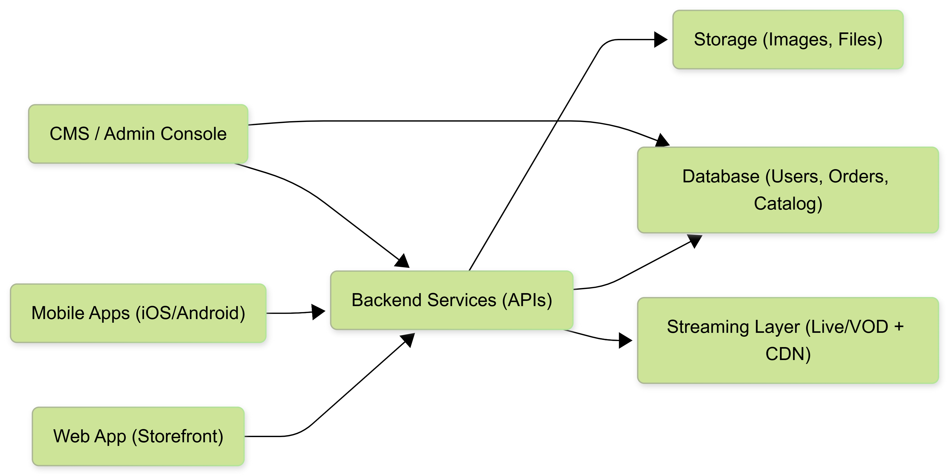

Diagram 2: Shoppable Video User Journey (Discover content -> Watch live/VOD -> Product tag -> Add to cart -> Checkout -> post-purchase engagement).
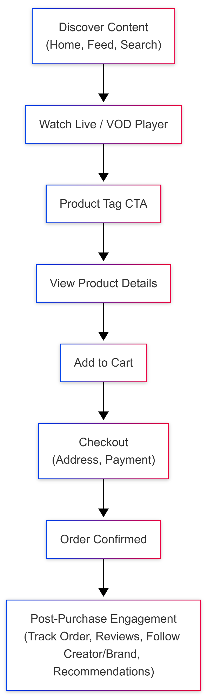

Diagram 3: Core Data Model Overview (Users, Products, Orders, Payments, Content, Live Events, Engagement, Rewards, Notifications).
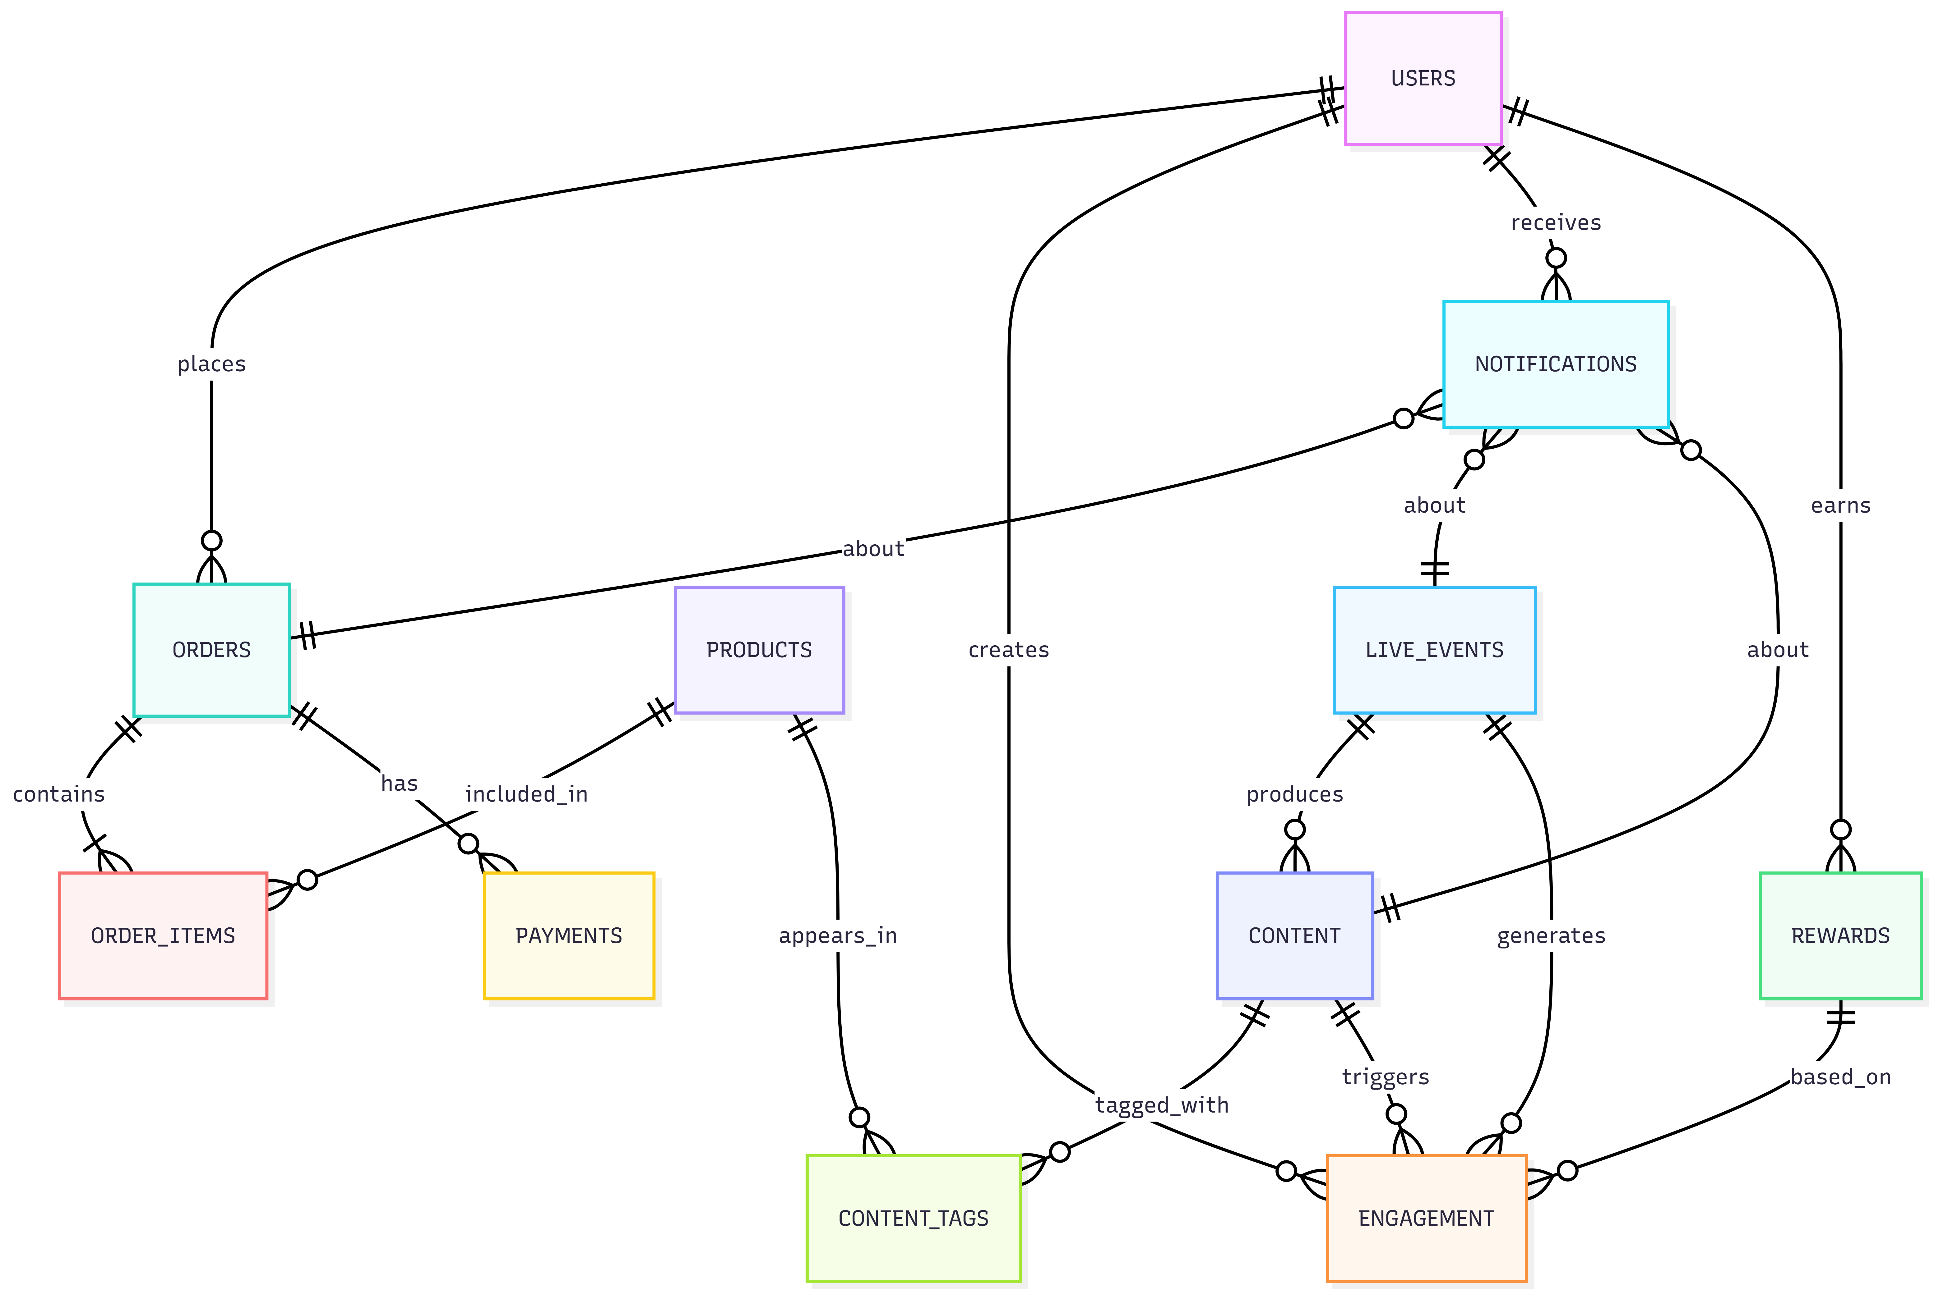

8. Complimentary Support (1 Month)
After completion of Phase 3 and final handover, we will provide one (1) month of complimentary support focused on the delivered scope.
Included:
- Bug fixing for issues introduced by the delivered changes (reproducible on supported devices/browsers).
- Minor adjustments within existing UI patterns (small alignment, copy, or configuration changes).
- Support in analyzing logs and error reports where access is provided.
Excluded:
- New features or major enhancements beyond the agreed scope.
- Changes required due to third-party provider policy changes or credential delays.
- Fixing pre-existing issues outside the delivered modules.

9. Financial Proposal
All costs are estimated in USD and based on end-to-end development (web, mobile, backend, CMS, QA, DevOps). Third-party licensing/usage costs are excluded.
Phase | Scope of Work | Timeline | Estimated Cost (USD)
Phase 1 | Core Commerce Foundation (Web + Mobile + CMS Basics) | 4 weeks | $4,000
Phase 2 | OTT/VOD Layer + Interactive Commerce | 3 weeks | $3,000
Phase 3 | Scale, Operations, Production Hardening + Release | 2 weeks | $2,000

Total Estimated Timeline: 9 weeks

9.1 Payment Terms
- 30% advance payment at the start of upon phase kickoff.
- 30% payment upon completion Phase 1
- 30% payment upon completion Phase 2
- 10% payment upon completion Phase 3

9.2.Change Request (CR)
CR Man-day Rate: USD-220 per man-day

9.3 Assumptions & Remarks
- Client will provide final UI designs and content guidelines before frontend implementation starts for each phase.
- Client will decide and provide access to required third-party providers (payment, streaming, SMS/email, chat, analytics).
- Any scope beyond the defined phase deliverables will be treated as a change request.
- Timelines may shift if provider credentials, API approvals.
- Security and compliance requirements (if any) will be finalized during kickoff and reflected in implementation checklists.

10. Proposed Out of Scope
- UI/UX design and visual redesign work (Figma, interaction design, branding, animations).
- Business operations outside the platform (warehouse operations, physical logistics execution).
- Dedicated studio/production services for video creation (shooting, editing) - only platform support is included.
- Any advanced AI personalization or recommendation engine beyond rule-based recommendations (can be proposed as an add-on).

11. Acceptance & Sign-off
Each phase will be considered accepted when the delivered build meets the agreed acceptance criteria and passes the agreed QA and regression checklist. Final production release will proceed after Phase 3 sign-off and completion of the release readiness checklist.

