Technical & Financial Proposal
RXS Mobile POD Application (Flutter Mobile + Backend API Development)
Prepared by: Riseup Labs
Date: January 28, 2026

1. Introduction
This document provides a technical and financial proposal to develop the RXS Mobile POD (Proof of Delivery) application from scratch. The solution targets driver/field operations for pickup and delivery workflows, including routing/manifest, scanning, POD/POP capture, exceptions, returns, and reliable execution with controlled synchronization.
Key constraints for this proposal:
• Design/UI/UX activities are out of scope. Development will follow the provided screens/UI and the client’s approved visual direction.
• Development includes both Mobile App (Flutter) and Backend API services required to support the app.
• Third‑party licensing/usage costs (maps, cloud storage, etc.) are excluded and will be handled by the client unless stated otherwise.
• The project is considered greenfield (from scratch), including codebase setup, environments, and deployment pipeline.

2. Project Scope Overview

2.1 In Scope (Development)
The following modules will be implemented as part of the development scope:
Mobile App (Flutter) – Key Screens/Modules:
• 1) Login & Device Verification
• 2) Home Dashboard (Today’s Work Snapshot)
• 3) Route / Manifest (Stop List)
• 4) Map & Navigation View
• 5) Stop / Order Details
• 6) Arrive / Scan (Operational Work Screen)
• 7) Proof of Pickup (POP)
• 8) Proof of Delivery (POD)
• 9) Exceptions / OS&D / Failed Delivery
• 10) Returns / Round Trip Proof (PODRT)
• 11) History / Completed Stops & Audit Trail

Backend Services (API + Data + Ops) – Key Capabilities:
• Authentication & authorization (driver login, device binding/verification, role-based access where required).
• Master data: company/branch, drivers/users, customers/consignees, service types, exception codes, return reasons.
• Route/manifest services: assignment, stop sequencing metadata, job/stop details, shared stops grouping.
• Operational event APIs: arrive/leave, scan events, status transitions (Assigned → Arrived → Scanned → Delivered/Failed) with audit trail.
• POD/POP evidence management: photo/signature capture metadata, file upload, secure storage, retrieval, and retention policy hooks.
• Reporting endpoints for completed stops and audit trail (export-ready).
• Notifications support (push via Firebase Cloud Messaging) for assignments/updates (optional where needed).
• Deployment artifacts: environment configuration, CI/CD pipeline, logging/monitoring hooks, and backup strategy.

2.2 Out of Scope
• UI/UX design, branding design, and any new visual exploration beyond implementing the provided screens/flows.
• Hardware procurement and management (barcode scanner devices, printers, rugged phones), unless explicitly added later.
• Complex route optimization engine development (if required, it will be treated as a separate module/integration).
• A full dispatch/admin web portal (can be proposed as an optional add-on if required by stakeholders).
• Integrations with external ERPs/WMS/TMS systems unless integration endpoints and mapping are clearly defined and approved.
• Any functionality not explicitly included in the provided screens/features will be treated as a change request.

2.3 Proposed Solution Context
• Mobile Framework: Flutter (Android and iOS)
• Backend Framework: Laravel (REST API)
• Architecture: Clean Architecture / MVVM style separation; API-first development with versioned endpoints
• Primary Focus: Driver workflow with robust synchronization and auditability

3. Proposed Approach & Methodology
We will follow an iterative, sprint-based delivery approach with early alignment on API contracts and ready UI to reduce rework and ensure field reliability.
Methodology Steps:
• Requirement & Flow Validation: confirm screen-by-screen behavior, status rules, data fields, and exception handling.
• Architecture & API Contract: define core entities, API endpoints, request/response payloads, error codes, and versioning strategy.
• Incremental Development (Sprints): deliver functional slices (backend + frontend) with demo checkpoints and change control.
• Quality Assurance: tests for critical logic, API testing, device testing (camera/GPS), online sync testing, and regression passes.
• Security & Compliance Basics: secure auth, least-privilege access, encrypted transport (TLS), and evidence access control.
• Go-Live: staging deployment, production release, and handover documentation.

4. Development Plan (2 Scopes)

Scope A – Backend Development (API + Data + Deployment)
Key Responsibilities:
• Design database schema and implement core services (auth, manifests, stops, events, evidence storage).
• Develop REST APIs with proper validation and error handling.
• Set up environments (dev/staging/prod), CI/CD pipeline, and basic monitoring/logging.
• Provide API documentation (Swagger/OpenAPI) and sample payloads for mobile integration.

Human Resources (Backend Scope):
Role | Responsibility
Backend Engineer (Laravel) | API development, business logic, unit testing
DevOps Engineer | CI/CD, environments, deployment, monitoring hooks
QA Engineer | API testing, integration testing, regression
Project Manager / BA | Sprint planning, requirement tracking, stakeholder sync
Suggested Timeline (Backend Scope): 2 Weeks

Scope B – Mobile App Frontend Development (Flutter)
Key Responsibilities:
• Implement the provided driver workflow screens and navigation structure in Flutter (Android & iOS).
• Integrate REST APIs for auth, manifests, stop details, status updates, and evidence submission.
• Implement device capabilities: camera for scanning/photo capture, location for tracking.
• Implement UX behaviors: connectivity indicator, queued actions, sync triggers, and retry patterns.
• Prepare store-ready builds (AAB for Android, IPA/TestFlight for iOS) and perform device QA.
Human Resources (Frontend Scope):
Role | Responsibility
Flutter Developer | UI implementation, API integration, offline cache/queue
QA Engineer | Device testing, offline scenarios, regression
Project Manager / BA | Backlog grooming, demos, UAT coordination
Suggested Timeline (Frontend Scope): 3 Weeks

5. Proposed Technical Stack (Development)
The following stack is proposed for implementing the RXS Mobile POD solution:
Layer | Proposed Choice
Mobile App | Flutter (Android & iOS)
State Management | BLoC or Riverpod (finalize during kickoff)
Architecture Pattern | Clean Architecture / MVVM separation
API Integration | REST (JSON), versioned endpoints
Maps & Location | Google Maps SDK; background location as needed
Notifications | Firebase Cloud Messaging (FCM)
Backend | Laravel (REST API)
Database | PostgreSQL (or MySQL based on client preference)
File Storage | S3-compatible object storage (evidence images/signatures)
CI/CD | GitHub / GitLab
Hosting | AWS / Azure / Client-provided infrastructure

6. Deliverables
Upon completion, the following deliverables will be handed over:
• Flutter mobile source code repository (Android & iOS) with build instructions.
• Backend source code repository (API services) with environment setup guides.
• Deployed environments: staging and production (subject to client infrastructure readiness).
• API documentation (OpenAPI/Swagger) and Postman collection for testing.
• Database schema + migration scripts and backup/restore notes.
• Test reports: functional test checklist and regression results for key flows.
• Release builds: Android (AAB/APK) and iOS (IPA/TestFlight) as applicable.
• Handover session and runbook (deployment, monitoring, common troubleshooting).

7. Diagram

Figure 1: High-Level System Architecture (Mobile App ↔ API ↔ Database ↔ Storage)

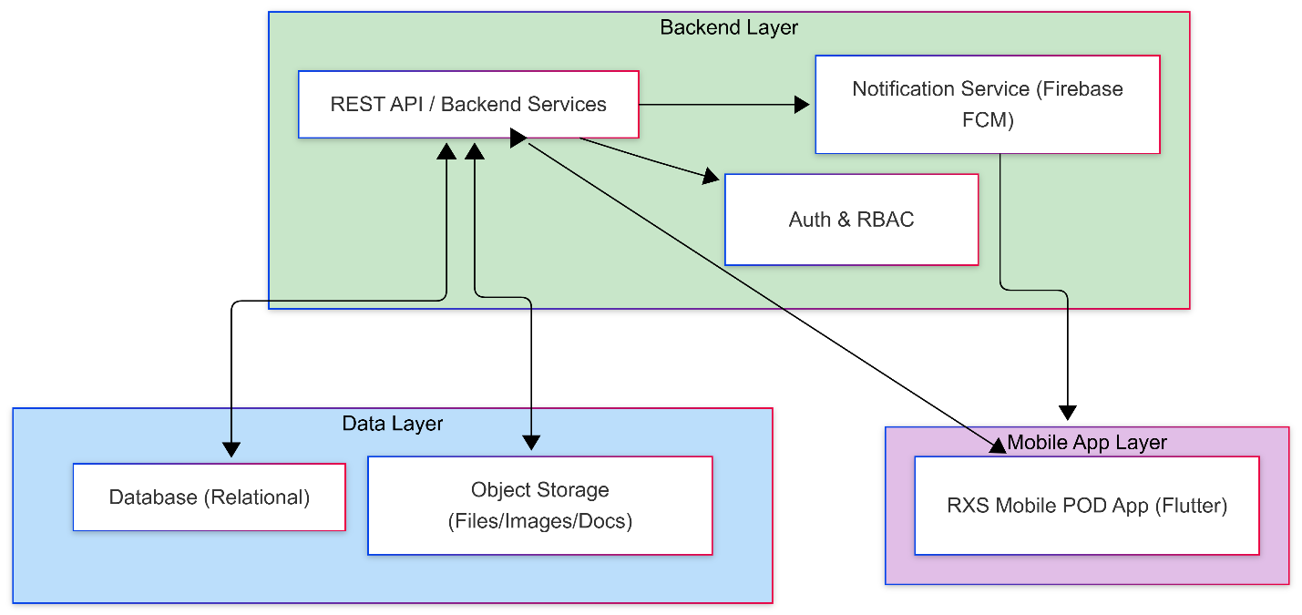

Figure 2: POD/POP Evidence Capture & Upload Sequence Diagram

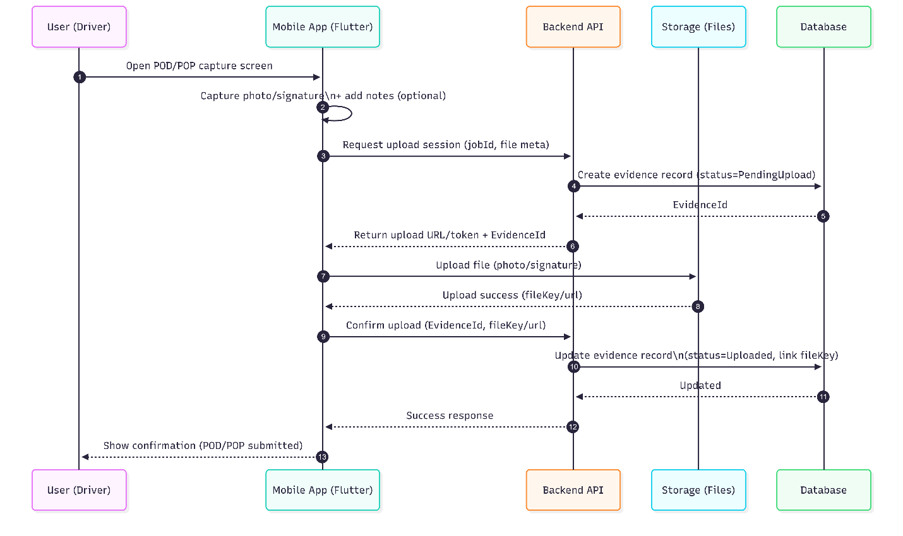

Figure 3: Core Database ERD (Drivers, Routes, Stops, Events, Evidence, Exceptions)

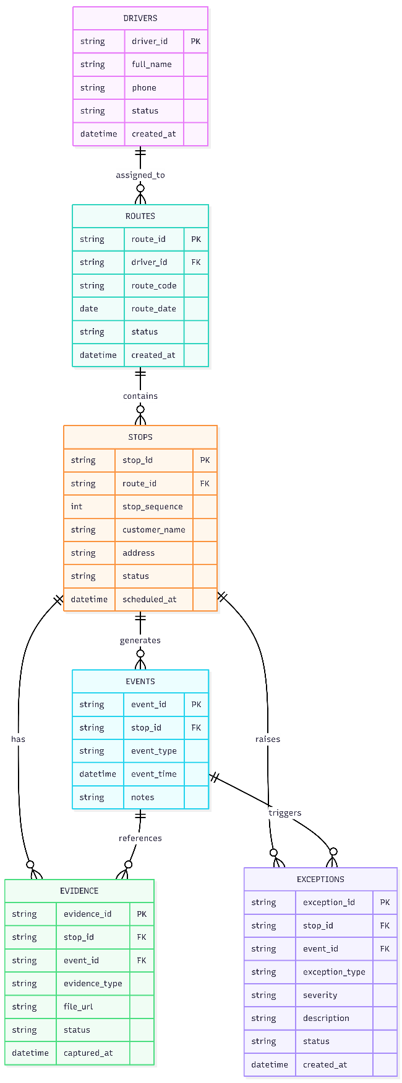

8. Complimentary Support (1 Months)
After production deployment and handover, Riseup Labs will provide 1 month complimentary support covering:
• Bug fixing for issues reproducible in the delivered scope.
• Minor adjustments that do not change core business logic or require new screens/modules.
• Assistance during early production monitoring and stabilization.
Any enhancement request or scope expansion during this period will be handled through a separate change request and estimation.

9. Financial Proposal
All costs are estimated in USD and are based on full-stack development (Flutter mobile app + backend API services). Third-party licensing/usage costs are excluded unless explicitly stated.
Scope | Scope of Work | Timeline | Estimated Cost (USD) | Parallel Development
Backend | API, DB, evidence storage, offline sync, deployment pipeline | 2 Weeks | $850 | 4 Weeks
Frontend | Flutter app (11 screens), device features, API integration | 3 Weeks | $1200 | 4 Weeks

9.1 Payment Terms
Payment will be collected scope-by-scope:
• 30% advance payment at the start of each scope (upon scope kickoff).
• 70% payment upon completion, delivery, and handover of that scope.
• Next scope/milestone will start after the previous payment is cleared.

9.2 Assumptions & Remarks
• Client will provide necessary accounts/keys: Google Maps API key, Firebase project (FCM), Apple Developer and Google Play accounts for publishing.
• Client will provide cloud infrastructure access (or confirm Riseup Labs-managed hosting) before deployment activities begin.
• Any delay in approvals, environment readiness, or scope clarifications may impact timelines.
• Data migration from legacy systems (if any) is excluded unless explicitly defined.
• Any additional modules (e.g., full admin/dispatch portal, advanced route optimization) will be estimated separately.

10. Acceptance & Sign-off
By approving this proposal, the client confirms agreement on the scope, approach, timelines, and payment terms described herein. Any changes will be handled through a formal change request process with impact assessment.

11. Relevant Project Experience
- eCook – Smart Recipe & Cooking App -
iOS: https://apps.apple.com/us/app/ecook/id6450396013
Android: https://play.google.com/store/apps/details?id=com.riseuplabs.ecook
- BMI Calculator – Health Tracking App- https://riseuplabs.com/bmi-calculator/
- Augmi – AR Furniture Application - https://riseuplabs.com/augmi/
- Sisimpur – Educational App - https://riseuplabs.com/sisimpur/
- Islamic Quotes – Motivation App - https://riseuplabs.com/islamic-quotes/

- Easy Salah Steps: Prayer Guide App - https://riseuplabs.com/easy-salah-steps-prayer-guide/

- Masnoon Dua & Tasbeeh Counter App - https://riseuplabs.com/masnoon-dua-tasbeeh-counter/

- myGov - https://riseuplabs.com/mygov/

- U-Report Bangla Version - https://riseuplabs.com/ureport-bangla-version/

