Technical & Financial Proposal
ReRack’d – MVP Enhancement, AI Integration & Marketplace Growth Development Project
Prepared by: Riseup Labs

1. Introduction
This document presents the technical and financial proposal for the phased enhancement and development of the existing ReRack’d mobile marketplace platform. This proposal focuses on development scope aligned with the product requirements.
ReRack’d is a trust-first fashion resale marketplace app for Gen Z users in the UAE. The brief confirms that the platform already has a working MVP and is currently built using React Native for the mobile app and Laravel for the backend. Existing functionality includes item listings, escrow-supported checkout, shipping integration, seller ratings, saved items functionality, and a basic marketplace feed.
The goal of this engagement is to build on that existing MVP foundation and evolve the product into a more engaging, intelligent, and growth-ready consumer marketplace through structured feature enhancement, AI integration, improved discovery, stronger reputation systems, and gamified engagement features.

Key Proposal Conditions
- The proposal is based only on the features and product direction mentioned in the shared brief
- The project will be executed as enhancement and extension of the existing MVP
- Existing source code, integrations, and reusable modules will be reviewed at project initiation
- Any requirement not mentioned in the brief is excluded from this estimate
- Third-party charges such as hosting, payment gateway fees, AI API usage, shipping fees, messaging charges, and analytics subscriptions are excluded unless separately mentioned
- Any scope beyond the approved requirement set will be handled through a formal Change Request process

2. Project Understanding & Objectives
ReRack’d is positioned as a fashion resale marketplace where wardrobes retain value and style circulates continuously. The app enables secure buying and selling through escrow-protected payments, integrated shipping, verified user profiles, and seller ratings and reputation systems.
The brief states that the current MVP works operationally, but the product experience needs to evolve significantly to improve engagement and marketplace liquidity.
The project objective is to transform the existing MVP into a highly engaging consumer marketplace product with strong behavioural engagement, intelligent automation, and improved conversion from browsing to listing and purchase.

Core Objectives from the Brief
- Make the platform more intuitive and frictionless
- Increase user engagement and retention
- Encourage frequent listing behavior
- Improve discovery and personalization
- Introduce light gamification elements that encourage repeat usage
- Integrate intelligent AI-powered features that reduce friction
- Build a modern, premium, culturally fluent, and habit-forming experience

Strategic Product Principles Mentioned in the Brief
The proposal scope is aligned with the following principles explicitly stated in the requirement document:
- Frictionless Listing
- Habit-Forming Engagement
- Discovery-First Product Experience
- Trust-First Commerce
- AI-Powered Product Intelligence

3. Proposed Technical Approach & Methodology
We propose an existing MVP enhancement approach based on the current ReRack’d technology foundation. Since the platform already exists and is operating on React Native and Laravel, the recommended approach is to review the current product, preserve reusable components where feasible, and implement the next stage of product evolution through structured phased development.
This approach helps avoid unnecessary redevelopment while allowing the client to deliver all features mentioned in the brief in a controlled implementation structure.

3.1 Development Methodology

Existing MVP Technical Review
The project will begin with a review of the current MVP codebase, backend structure, integration readiness, and reusable modules.

Phased Enhancement Delivery
Development will be divided into three phases so that foundation alignment, core feature implementation, and final release readiness can be delivered in an organized manner.

Controlled Optimization
The proposal assumes enhancement of the existing MVP, with refactoring or restructuring only where necessary to support the required features.

QA and Validation
Testing will cover both newly developed features.

Release Preparation
The final stage will include deployment support, handover, and complimentary support after launch.

3.2 Suggested Technical Stack
Layer | Proposed Technology
Mobile App | React Native
Backend | Laravel
Database | Existing database structure to be reviewed and optimized as needed
Authentication | Existing authentication flow review and enhancement as needed
File Storage | Existing or compatible cloud storage
Payment Integration | Existing escrow-supported payment flow / Stripe review and enhancement
Shipping Integration | Existing shipping integration review and enhancement
AI Integration | One External AI integration for required AI features
Notifications | Push, email, and event-based notifications
Hosting / Deployment | Existing deployment environment review

4. Three-Phase Scope Breakdown
To maintain implementation clarity, cost control, and delivery structure, we propose breaking the development work into three phases based only on the features and product requirements explicitly mentioned in the brief.

4.1 Phase 1 – Existing MVP Review, Core Foundation Alignment & Core Experience Implementation
This phase focuses on reviewing the current MVP and implementing the first layer of product improvements required by the brief.

Scope Includes
- Review of the existing React Native and Laravel MVP
- Technical assessment of reusable modules and dependencies
- Gap analysis between the current MVP and the updated brief
- Development alignment for the redesigned onboarding experience
- Onboarding implementation support to:
  - communicate platform value quickly
  - establish trust immediately
  - encourage users to list their first item
- Seller-focused onboarding support
- Quick product walkthrough support
- Wardrobe value estimation support within onboarding if included in final approved product flow
- Core trust-first commerce implementation improvements across:
  - onboarding
  - checkout
  - seller profiles
  - item pages
- Existing foundation preparation for discovery, listing AI, buyer flows, and gamification rollout

Phase 1 Human Resources & Responsibilities
Role | Short Responsibility
Project Manager | Planning, coordination, milestone tracking, client communication
Tech Lead | Existing MVP review, architecture direction, code review
Mobile App Developer | App-level implementation and enhancement
Backend Developer | API, logic, integration, and data handling enhancement
QA Engineer | Validation planning, regression preparation, functional testing
DevOps / Deployment Support | Staging alignment and deployment support

4.2 Phase 2 – AI Listing Assistant, Discovery Experience & Buyer-Seller Marketplace Flow Enhancement
This phase focuses on the core marketplace experience improvements and AI-powered listing flow explicitly requested in the brief.

Scope Includes

AI Listing Assistant
- User taps “List an Item”
- Upload 1 to 3 photos
- AI image analysis
- User confirms:
  - size
  - condition
- AI generates:
  - title
  - description
  - category
  - style / aesthetic tags
  - recommended resale price
- User reviews or publishes instantly
- Listing flow target aligned to a low-friction experience

Marketplace Discovery Feed
- Trending items section
- Personalized discovery feed
- Curated outfit boards
- Creator closets
- Saved collections
- Support for algorithmic recommendations and editorial-style curation

Seller Profiles
- Seller reputation score
- Number of items sold
- Follower system
- Curated closets
- Seller badges

Buyer Features
- Buyer offers and negotiation
- Item bundling from sellers
- Wishlists and saved items
- Personalized recommendations

Trust-First Commerce Flow
- Secure payments
- Buyer protection presentation
- Verified seller indicators
- Integrated shipping logistics presentation and support within user flow

Phase 2 Human Resources & Responsibilities
Role | Short Responsibility
Project Manager | Phase control, dependency management, review coordination
Tech Lead | Marketplace flow review, AI integration direction, technical governance
Mobile App Developer | Listing, feed, profile, buyer flow, and engagement-related mobile implementation
Ai Developer | AI orchestration, listing logic, personalization support,
Backend Developer | reputation logic, offer/buy flow support, Api
QA Engineer | End-to-end functional testing, regression testing, integration validation
DevOps / Deployment Support | Integration environment support and staging deployment

4.3 Phase 3 – Gamification, Additional AI Features, Performance Improvement, QA, Deployment & Handover
This phase focuses on the remaining product features mentioned in the brief, final optimization, production release support, and handover.

Scope Includes

Gamification & Engagement Systems
- Seller streaks
- Seller levels:
  - Closet Starter
  - Style Seller
  - Trend Curator
  - Marketplace Icon
- Leaderboards
- ReRack Score combining:
  - successful sales
  - response speed
  - buyer reviews
- Daily engagement streaks
- Progress indicators
- Marketplace milestones
- Engagement rewards

Additional AI Features Mentioned in the Brief
- Outfit styling suggestions using marketplace items
- Wardrobe value estimation from uploaded wardrobe photos
- Trend insights identifying trending fashion pieces across the platform
- Price intelligence suggesting optimal pricing strategies based on demand

Engineering Deliverables Mentioned in the Brief
- Implementation of redesigned UI in development
- AI Listing Assistant integration
- Performance improvements

Final Delivery Activities
- Regression testing of impacted MVP features
- End-to-end QA for all implemented modules
- Production deployment support
- Technical documentation and handover
- One-month complimentary support

Phase 3 Human Resources & Responsibilities
Role | Short Responsibility
Project Manager | Final milestone governance, sign-off coordination, release planning
Tech Lead | Final review, performance direction, technical sign-off
Mobile App Developer | Gamification, AI-connected flows, final issue resolution
Ai Developer | AI modules, scoring logic, trend and intelligence processing
Backend Developer | performance optimization, backend logic, Api
QA Engineer | Full regression, release readiness checks
DevOps / Deployment Support | Production deployment support and release checklist

5. Recommended Diagram Placeholders

5.1 High-Level Mobile Solution Architecture

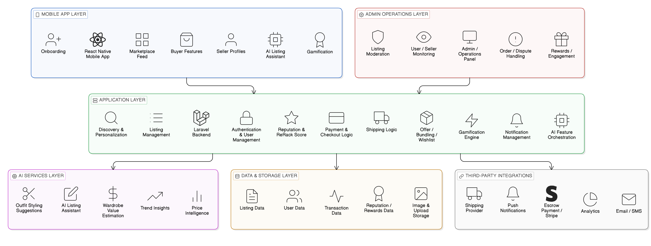

5.2 Core Listing-to-Transaction User Journey

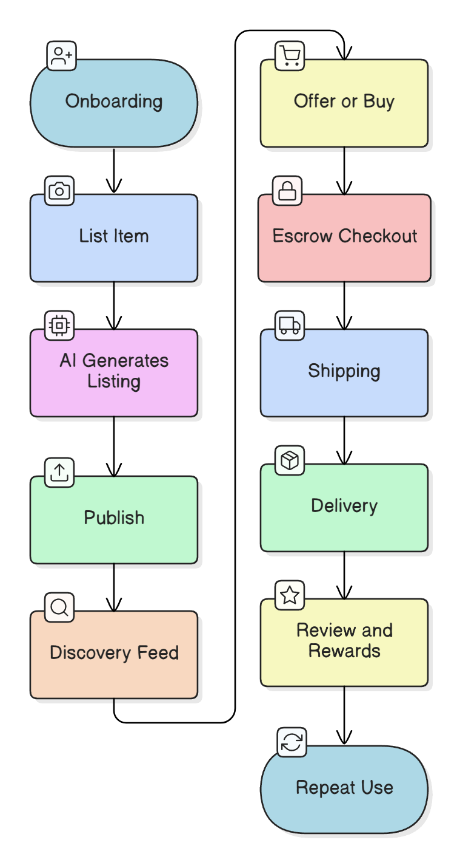

5.3 AI Listing Assistant Sequence Flow

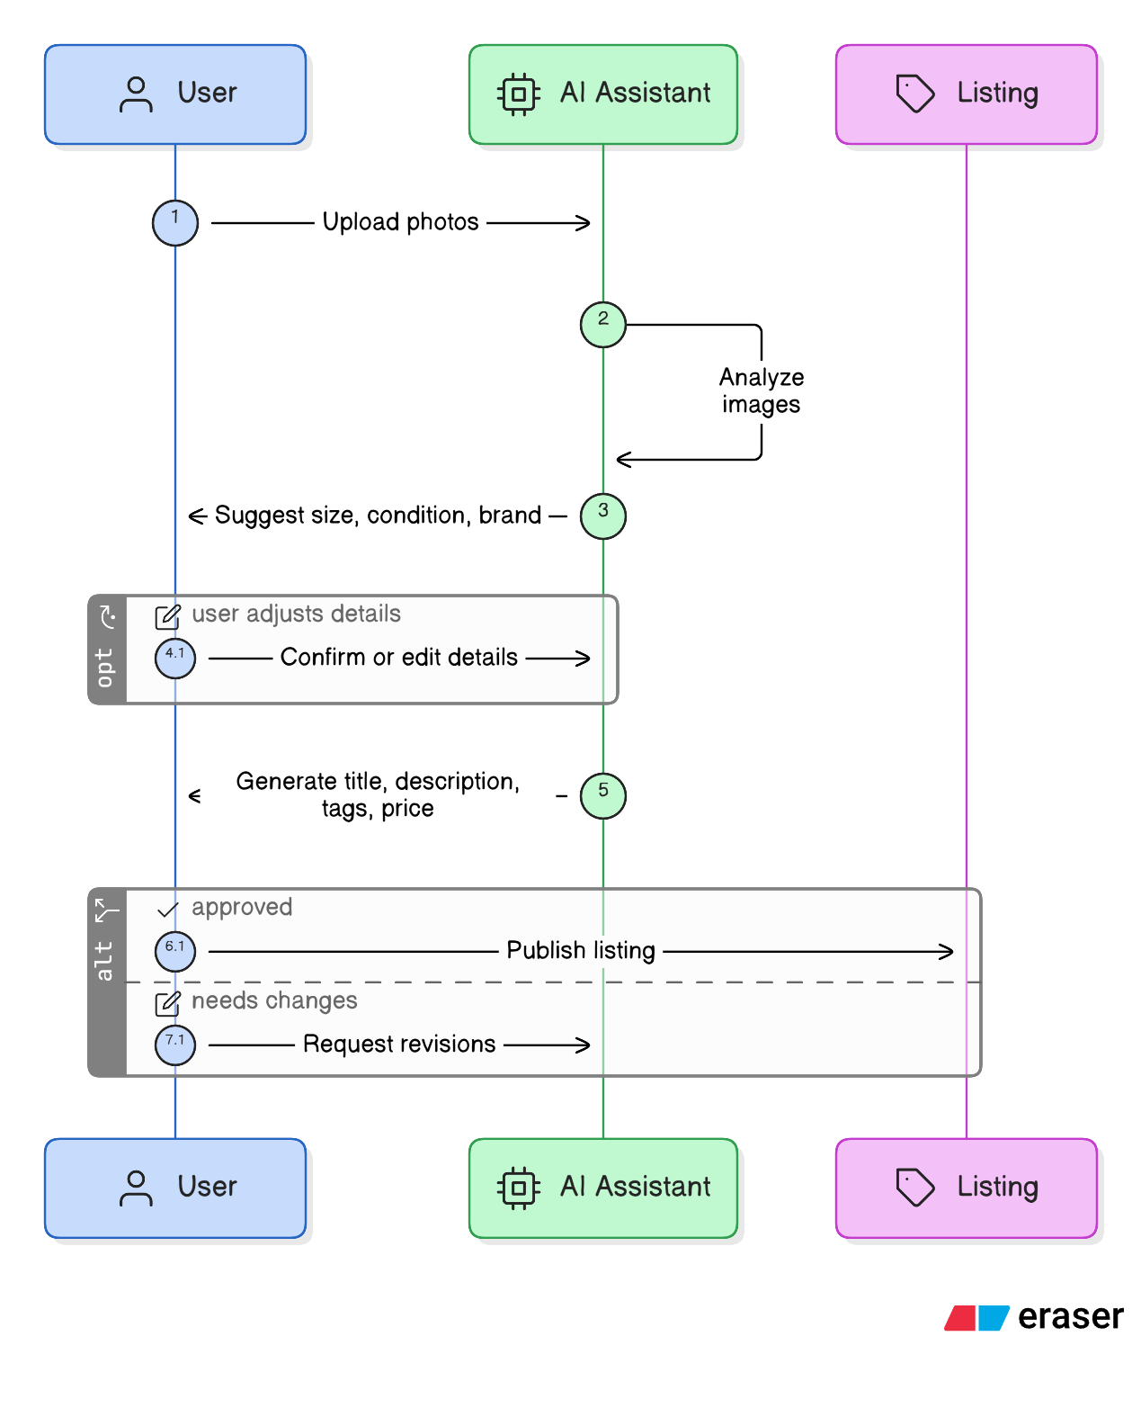

6. Testing, QA & Deployment Approach
Testing and quality assurance will focus on both the current MVP stability and the correctness of all features mentioned in the requirement brief.

QA Coverage Includes
- Functional testing of onboarding flows
- Functional testing of AI Listing Assistant flow
- Discovery feed testing
- Seller profile and reputation testing
- Buyer flow testing including offer, bundling, wishlist, and recommendation-related interactions
- Gamification and reward system testing
- Additional AI feature validation
- Payment and shipping flow testing
- Regression testing of impacted MVP features
- Production deployment support

7. Complimentary Support
One (1) month of complimentary post-launch support will be provided after production deployment and formal handover.

Included
- Bug fixing for delivered scope
- Technical clarification during the support window

Excluded
- New features beyond the approved scope
- Major workflow changes
- New third-party integrations not already in scope
- UI/UX redesign activities
- Third-party service charge changes

8. Financial Proposal
The following estimate is prepared based only on the ReRack’d Updated Brief and assumes phased enhancement of the existing MVP platform, including all features explicitly mentioned in the requirement document.
Phase | Scope Summary | Suggested Timeline | Estimated Cost (USD)
Phase 1 | Existing MVP review, onboarding, trust-first flow alignment, core foundation readiness | 2 Weeks | $1,900
Phase 2 | AI Listing Assistant, marketplace discovery, seller profile, buyer features, transaction flow enhancement | 3 Weeks | $2,962
Phase 3 | Gamification, additional AI features, performance improvement, QA, deployment, documentation, handover | 3 Weeks | $2,832

Total Estimated Cost: USD 7,694

8.1 Payment Terms
- 30% advance payment upon project kickoff
- 30% upon completion of Phase 1
- 30% upon completion of Phase 2
- 10% upon final delivery, deployment readiness, and handover

8.2 Change Request (CR)
Any requirement beyond the approved scope mentioned in the brief will be handled through a formal Change Request process. Commercial impact will be estimated separately based on effort and timeline impact.

9. Assumptions & Out of Scope
- The current MVP source code, technical access, and existing integration access will be provided by the client
- The proposal is based only on the shared requirement brief
- UI/UX design creation is out of scope for this proposal
- Any requirement not clearly stated in the brief is excluded
- Third-party usage and subscription costs are excluded
- Extended maintenance beyond one month complimentary support is excluded
- Any major architecture replacement required due to existing codebase limitations may require reassessment

10. Acceptance & Sign-Off
The project will be considered completed when:
- the agreed scoped deliverables are implemented
- production deployment support is completed
- Final deployment is handed over

