Technical & Financial Proposal
Richard Tapp Website 3.6 (Development Only)
Prepared by: Riseup Labs
Date: February 02, 2026

1. Introduction
This document provides a technical and financial proposal for developing the “Richard Tapp Website 3.6” as described in the provided briefs and questionnaire. The project is intended to be an ultra-minimal, high-performance website that showcases media (including WebGL/3D) while supporting a modular, “stackable sections / lego modules” approach.
Key constraints for this proposal:
- Scope is limited to development (frontend + backend + deployment) for the features described in the shared documents.
- Design/UI/UX creation is out of scope; development will follow client-provided design direction and any existing visual references.
- The website will be built from scratch as a modular system so that sections can be added, duplicated, toggled, and stacked over time.

2. Project Scope Overview
2.1 In Scope (Development)
Phase 1 delivery will include two templates delivered together: Employment and Store Front, built on a shared modular foundation.
In-scope capabilities include:
- Core modular section framework (config-driven modules that can be stacked, duplicated, and feature-toggled).
- Global navigation system (nested menu with hover/click/scroll/keyboard/mobile gesture triggers).
- Media container that can display full-screen video, 2D images, interactive elements, and WebGL/3D content.
- Employment template (portfolio library) with search/filter, item detail views, downloads, and contact/booking entry points.
- Store Front template with product catalog, product detail, cart/checkout, taxes/shipping/refunds, and digital downloads.
- Fundraising mode for Store Front (donation-based with progress bars and rewards text page for MVP).
- Lightweight “policy/FAQ/forum/questions/documents” pages or pop-ups (text-first, non-interactive for MVP).
- Upload/Download area for user-accessible files (FTP-like experience implemented as secure web downloads/uploads).
- Custom Admin Dashboard (CMS) for content entry and management (TypeForm-like ease of entry).
- Authentication foundation (admin users; optional customer accounts for Store Front and later modules).
- Deployment, environment setup, monitoring/logging basics, and release support.
2.2 Out of Scope
- UI/UX design, branding, visual exploration, or new design production.
- Full WebAR implementation in Phase 1 (MVP may store/host the augmentation file and/or link out to an AR program/app).
- Advanced 3D interactions (physics-heavy, complex scenes) beyond simple drag/rotate/click interactions for MVP.
- Full “Cooperatives” module implementation (not designed yet; can be planned as a later phase once requirements and UI are finalized).
- Any feature not described in the shared project documents, unless agreed via change request.
2.3 Key Functional Areas by Template
The following summarizes the required modules/templates and their development scope.
- Employment Template: A searchable portfolio/work library with filters (projects, tags, credits/specs; timeline if feasible), item detail pages, downloadable resume/blueprints/concepts, availability label, and contact actions (schedule a call, video meeting, email).
- Store Front Template: Product/catalog browsing, cart and checkout, payments (Stripe/PayPal/Shop Pay), multi-currency (EUR and USD), taxes/shipping configuration, refunds, and digital downloads. Includes a donation-based fundraising mode with progress bars and a simple rewards text page for MVP.
- Projects & Initiatives (Later): A social-style updates area. MVP expectation is to reflect interactions from existing social platforms rather than building a full internal social system. Midterm can add like/share/follow/comment with basic moderation.
- Freelance (Later): Customer-facing accounts, project phases/timeline, requests and revisions, document/contracts, confirmations, notifications/updates, and recurring payments for MVP (with milestone/project-based billing as a future enhancement).
- Subscription / Drops (Later): A free and paid tier model for membership perks, drops, discounts and sneak peeks, including renewal/cancellation management.
- Custom Page Template: A configurable page that can toggle features on/off to create promo pages, timed-unlock drops, countdowns, mini landing pages, and other special sections.

3. Proposed Approach & Methodology
We will follow an Agile delivery approach with short iterations, enabling early validation of the modular framework, performance behavior, and the two initial templates. Development will proceed “section-by-section”: first building a reusable module template (design system aligned to provided direction), then implementing Employment and Store Front using the same foundation.
Engineering principles applied during development:
- Build a single modular foundation that supports stacking sections (scroll-based or SPA-style transitions), with feature flags/presets per module.
- Prioritize smoothness: transitions/animations should be clean and stable, avoiding jarring motion, glitches, or UI blocking.
- Performance-by-device strategy: desktop full experience, tablet streamlined, and mobile minimal (adaptive rendering for WebGL/3D).
- Use reusable components and content schemas to reduce rework as new templates are added later.
- Security-first for payments, authentication, and file access (least-privilege, encrypted secrets, audit-ready logging).

3.1 Delivery Method
Delivery will be organized into phases with clear acceptance criteria and a demo/release at the end of each phase. Each phase includes requirement confirmation, backlog grooming, development, QA, and deployment to the agreed environment.

3.2 Quality Assurance Strategy
QA will include functional testing per feature, regression testing for shared components (navigation, media container, theming, checkout), cross-browser testing (Chrome/Safari/Firefox/Edge), and responsive validation across desktop/tablet/mobile. For WebGL components, we will test frame-rate stability and memory use on representative devices.

4. Development Plan
Modular Foundation + Employment & Store Front (MVP)
Goal: Deliver the first two templates together on a shared modular framework, with clean navigation and a media container capable of handling core media types.
In-scope work:
- Project setup, environments, repo, CI pipeline, staging deployment
- Modular section framework (stackable modules, presets, feature toggles)
- Nested navigation triggers (hover/click/scroll/keyboard/mobile gesture)
- Theme modes for MVP: Light, Dark, Transparent
- Media container: full-screen video, 2D image, interactive layer, basic WebGL/3D viewer
- Employment template: portfolio list + search/filter, details, downloads, contact/booking links
- Store Front template: catalog, product detail, cart, checkout, digital downloads
- Payments integration (Stripe/PayPal/Shop Pay), taxes/shipping/refund workflows
- Fundraising mode (donation-style) + progress bars + rewards text page
- Admin dashboard (MVP): manage portfolio items, products, specs/tags, media uploads, simple pages
- QA support + handover
Suggested timeline: 8–10 weeks
Content Operations + File Access + Stability Enhancements
Goal: Strengthen the admin/CMS workflow and operational tooling and refine performance and content management for ongoing additions.
In-scope work:
- Admin dashboard enhancements (TypeForm-like entry flows, bulk edits, drafts, publish/unpublish)
- Secure Upload/Download area (role-based access, signed URLs, file categorization)
- Lightweight policy/FAQ/documents pop-ups/pages (text-first) with admin-editable content
- Store front operational improvements (order management view, refund handling support screens)
- Performance tuning for WebGL content (adaptive quality settings, lazy loading, caching)
- QA + handover
Suggested timeline: 4–6 weeks
Additional Templates (Projects, Freelance, Subscription/Drops) + Future Readiness
Goal: Implement additional templates described in scope documents and prepare the platform for longer-term features such as WebAR and richer social/payment options.
In-scope work:
- Projects & Initiatives template (MVP: content updates + social embed/reflection; midterm options documented)
- Freelance template (MVP: client accounts, timeline/phases, docs, recurring billing; future options documented)
- Subscription/Drops module (free vs paid tiers, renewal and cancellation flows)
- Custom Page template features (timed unlock, countdown, promo layouts) as configured pages
- Augmentation file hosting/linking support (WebAR integration planned as a later enhancement)
- Final stabilization, security review, and release readiness support
Suggested timeline: 6–8 weeks

5. Proposed Technical Stack
The following stack is proposed to support a modular, high-performance website with WebGL/3D, commerce, and an admin dashboard.
Layer | Proposed Choice
Frontend Web | Next.js (React) with TypeScript
3D/WebGL | Three.js (WebGL) + optional model-viewer for simple previews
Backend APIs | Laravel (PHP) REST APIs
Admin Dashboard (CMS) | Laravel-based admin panel + React/Next.js admin UI (role-based)
Database | PostgreSQL
File Storage | AWS S3 (or equivalent object storage) with signed URL access
Caching | Redis (optional, for sessions/cache)
Search | PostgreSQL full-text search (MVP) or Algolia/Elastic (optional later)
Payments | Stripe + PayPal (Shop Pay via Stripe where applicable)
Auth | JWT + secure session management; RBAC for admin roles
Hosting/Infra | AWS (EC2/ECS), CloudFront CDN, Route53; or Vercel + managed backend hosting
CI/CD | GitHub / GitLab
Monitoring | Sentry + server logs; optional CloudWatch/Datadog

6. Human Resources & Responsibilities
A typical delivery team for this scope will include the following roles:
- PM: requirements clarification, backlog management, client coordination, acceptance criteria
- Tech Lead/Architect: architecture, code standards, performance strategy, technical risk management
- Frontend Engineer (Next.js): UI implementation, animations/transitions, responsive behavior
- WebGL/Three.js Engineer: 3D container, interaction logic, performance optimization
- Backend Engineer (Laravel): APIs, CMS/admin features, integrations, security
- QA Engineer: test plan, test cases, functional + regression testing, release verification
- DevOps Engineer (part-time): environments, deployment, monitoring setup

7. Deliverables
- Source code repositories for frontend, backend, and infrastructure scripts (as per agreed access model).
- Phase-wise deployments to staging (and production upon sign-off).
- Admin dashboard/CMS for managing content, products, media, tags/specs, and pages.
- Technical documentation: architecture notes, environment setup, content schema, API list, deployment runbook.
- QA artifacts: test cases, test reports, and release notes per phase.
- Handover session and walkthrough for the client team.

8. Technical Diagrams
The following diagrams are recommended for the final proposal and implementation documentation. Image placeholders can be inserted in the marked areas.
Diagram 1: High-Level Solution Architecture (Client Browser → Frontend → Backend APIs → Database/Storage/Payments)
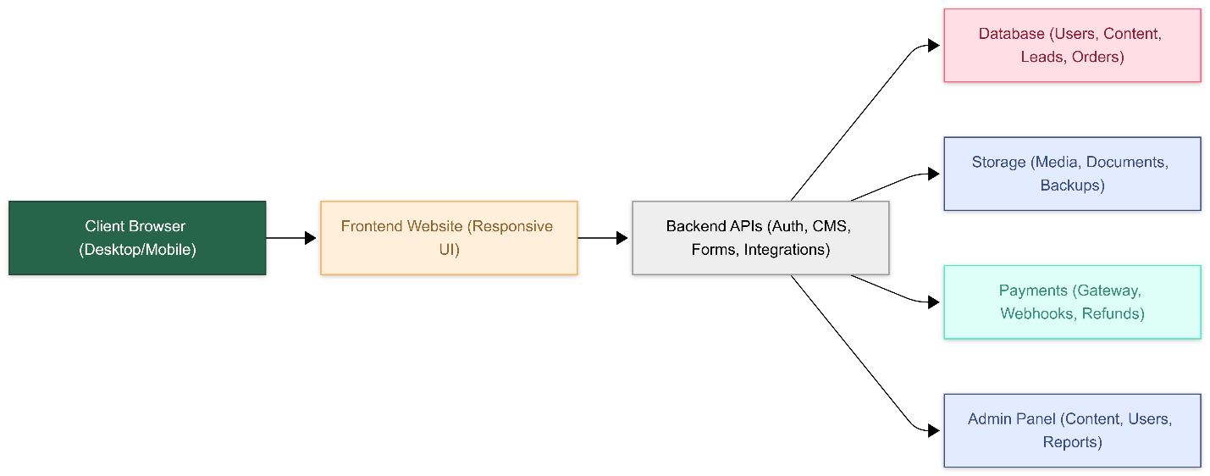
Diagram 2: Modular Template Composition (Stackable Sections / Presets / Feature Toggles)
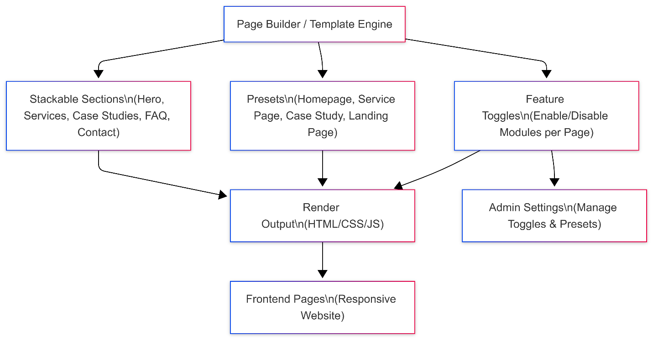

9. Complimentary Support (1 Month)
After final handover and production release, we will provide one (1) month of complimentary support focused on the delivered scope.
Included in complimentary support:
- Bug fixes for issues introduced by the delivered development scope (reproducible and confirmed).
- Minor adjustments such as small content/layout tweaks within the existing implementation patterns.
- Stability and performance fixes for the delivered modules (e.g., WebGL container tuning, caching adjustments).
- Support for deployment hotfixes if required (within the agreed hosting access model).
Excluded from complimentary support:
- New features, new templates, or major enhancements beyond the agreed scope.
- Changes driven by new design directions or rework of UX concepts.
- Third-party policy changes, payment provider requirement changes, or content migration outside agreed effort.

10. Financial Proposal
All costs are estimated in USD and are based on development only. Any third-party licensing/usage costs (payment provider fees, hosting, domain, etc.) are excluded and will be paid directly by the client.
Scope of Work | Timeline | Estimated Cost (USD) | Parallel Development
Modular foundation + Employment + Store Front (MVP) including CMS admin, payments, theming, media container, and fundraising MVP. | 8–10 weeks | $
CMS/admin enhancements + secure file access (upload/download) + operational pages + performance/stability improvements. | 4–6 weeks | $
Additional templates (Projects & Initiatives, Freelance, Subscription/Drops, Custom Pages) + final stabilization + future readiness. | 6–8 weeks | $

Estimated total: $
10.1 Payment Terms
Payment will be collected phase-by-phase as per the template:
- 30% advance payment at the start of each phase (upon phase kickoff).
- 70% payment upon completion, delivery, and handover of that phase.
- Next phase will start after the previous phase payment is cleared.
10.2 Assumptions & Remarks
- Client will provide access to hosting accounts, domain/DNS management, and payment provider accounts (Stripe/PayPal) for integration and testing.
- Any missing or changing requirements (e.g., exact content schemas, product catalog structure, donation/legal constraints) may impact estimates and will be handled via change request.
- Content (texts, product data, media assets, 3D files) will be provided by the client in agreed formats and timelines.
- MVP WebAR is treated as file hosting/linking; full in-browser WebAR is planned as a later enhancement.
- Security and compliance for payments will follow provider best practices (PCI handled by the payment provider via hosted checkout where applicable).

11. Acceptance & Sign-off
Each scope will be considered accepted when the delivered release meets the agreed acceptance criteria for that scope, passes the regression checklist, and is signed off by the client.
This proposal is intended for functional assessment and high-level estimation purposes. Final scope, timeline, and cost will be reconfirmed after a short discovery step during Phase 1 kickoff.

