Technical & Financial Proposal
Sunshine Land - Pediatric Dental Clinic Website

Prepared by: RiseupLabs
Date: February 23, 2026

1. Introduction
This document provides a technical and financial proposal to develop the Sunshine Land website from scratch for a pediatric dental clinic. The website will be modern, child-focused, visually engaging, and scalable for future expansion, following the provided UI designs and page layouts.
Key constraints for this proposal:
- Scope is limited to software development only (WordPress setup, theme implementation, CMS configuration, integrations, QA, deployment, documentation, and handover).
- Design and UI/UX are out of scope. Development will implement the client-provided designs and content structure.
- Third-party licensing and usage fees (hosting, domains, premium plugins, CRM licenses, analytics tools, CDN, SMS/email services, etc.) are excluded and will be billed directly to the client unless otherwise agreed.
- Any requirements beyond the agreed scope will be handled through a Change Request (CR) process.

2. Project Context & Objectives
Sunshine Land is a pediatric dental clinic website similar in structure to the reference site, but with a more modern, child-friendly experience. The platform will support bilingual content, SEO-friendly blog publishing, and lead capture through appointment/contact forms.
Primary objectives include:
- Deliver a responsive, fast, and secure public website aligned to the approved UI screens and content structure.
- Enable CMS-driven management for services, doctors, blog posts, and media by non-technical users.
- Provide a simple appointment request flow (form-based) and direct communication actions (WhatsApp and call buttons).
- Support bilingual content with SEO-friendly language structure (e.g., hreflang).
- Enable lead capture and optional integration with Zoho CRM via API for business and marketing analysis.

3. Proposed Technical Approach & Methodology

3.1 Architecture Approach
We propose a WordPress-based implementation using a lightweight, performance-optimized theme (custom or based on a clean starter theme) and structured content models. Core content entities (Services, Doctors, Blog Posts) will be implemented using WordPress post types, templates, and reusable components to keep the website maintainable and scalable.
Integrations (forms, WhatsApp/call actions, analytics, and optional Zoho CRM synchronization) will follow an API-first approach where applicable, avoiding heavy custom backend services to keep the solution cost-efficient.

3.2 Delivery Methodology
We will follow an iterative delivery model with phase-based acceptance checkpoints:
- Phase-wise backlog confirmation with acceptance criteria for each page type and module.
- Design-to-implementation workflow: implement pages based on provided UI designs and assets.
- Reusable templates and components for service pages, doctor profiles, blog pages, and utility pages.
- Definition of Done per phase: implemented, tested, content-entry verified, and deployed to staging.
- Change management: scope changes handled via CR estimation and timeline impact.

3.3 Testing and Quality Assurance
- Functional testing for all pages, navigation, forms, and CMS content workflows.
- Cross-browser and responsive testing (desktop, tablet, mobile).
- Multilingual testing (language switcher, translated URLs, and content parity).
- SEO baseline verification (metadata, sitemap, robots.txt, schema, canonical tags).
- Security hardening checklist (admin access control, brute-force protection, input validation, spam protection).
- Performance checks (page speed, image optimization, caching validation).

3.4 Environments, DevOps, and Governance
- Environments: Local/Dev, Staging, Production (separate configuration and credentials).
- Source control: Git repository with pull-request reviews and branch protections.
- Release governance: formal staging sign-off per phase before production deployment.
- Operations baseline: backups, uptime monitoring (provider-based), and basic error logging.

4. Proposed Technical Stack
The stack below is selected to support a scalable, budget-friendly website with strong CMS capabilities, multilingual support, and integration readiness for Zoho CRM.
Layer | Proposed Choice
Website Platform / CMS | WordPress
Theme / UI Implementation | Custom theme (lightweight starter theme) or block-based build (Gutenberg) aligned to provided UI
Programming Language | PHP 8.x (WordPress), JavaScript (where needed)
Database | MySQL 8.x (or managed equivalent)
Multilingual | WPML or Polylang (final choice at kickoff), SEO-friendly language URLs and hreflang
Content Modeling | Custom Post Types + Custom Fields (e.g., ACF) for Services and Doctors
Forms / Lead Capture | Gravity Forms / WPForms / Contact Form 7 (final choice at kickoff) with spam protection (reCAPTCHA)
CRM Integration | Zoho CRM integration via API (OAuth) or Zoho Forms plugin (as add-on where required)
SEO | Rank Math or Yoast SEO, XML sitemap, schema markup, Open Graph metadata
Analytics | Google Analytics 4 (GA4) + Google Tag Manager (GTM)
Performance | Caching plugin + image optimization; optional CDN depending on hosting
Security | SSL/TLS, WAF (hosting/provider), WordPress security hardening, backups
Hosting / Server | Managed WordPress hosting or VPS (Nginx/Apache). Client-provided or selected during kickoff
CI/CD (Optional) | Automated deployment to staging/production (Git-based) if hosting supports

5. Scope of Work
The scope below is organized into three (3) phases to align delivery, testing, and acceptance. UI/UX design activities are excluded; development will implement client-approved designs.

5.1 Phase Breakdown (3 Phases)
Phase | Key Scope | Primary Deliverables
Phase 1 - Foundation & Core Pages | WordPress setup and configuration, theme framework setup, base navigation and footer, core page templates, CMS foundation, bilingual framework, WhatsApp and call CTAs. | Staging environment; WordPress installed and configured; core page templates (Home, About, Contact/Book Appointment); Services and Doctors content models (CPT/fields) with archive and detail templates; bilingual switcher baseline; forms wired with email notifications; basic SEO setup.
Phase 2 - Content Modules & Integrations | Complete remaining page types and modules: Services landing and service detail template, Doctors archive and doctor profile template, Blog module, Insurance page, utility pages (404, Terms/Privacy). Implement analytics and optional Zoho CRM lead sync. | Completed templates for Services, Doctors, Blog (archive + single), Insurance, and utility pages; CMS workflows validated (create/edit/publish); GA4/GTM configured; optional Zoho CRM integration for form submissions (lead capture) on staging; content entry guide draft.
Phase 3 - QA, Optimization & Go-Live | Full QA, performance and security hardening, multilingual SEO checks, content population support (client-driven), deployment to production, handover and training. | Regression-tested production release; performance optimization (caching, images); security hardening; multilingual SEO baseline (hreflang, canonical); backups configured; admin training session; final documentation and source handover.

5.2 Website Scope Summary (Public Website)
Development will cover the following (non-exhaustive):
- Homepage with key sections (hero, value proposition, services highlight, team teaser, blog teaser, CTAs).
- About Us page.
- Services module: services overview page and reusable individual service page template (CMS-driven).
- Doctors module: doctors overview page and reusable individual doctor profile template (CMS-driven).
- Insurance page (static list, optional simple filter depending on final content).
- Contact / Book Appointment page with form submission and confirmation messaging.
- WhatsApp floating action button and click-to-call actions (mobile-friendly).
- Footer with service links and key contact information.
- Utility pages: 404 page and Terms of Use / Privacy Policy template pages.

5.3 CMS/Admin Scope Summary (Content Management)
- Role-based admin access for content editors and administrators.
- Media management (upload/organize images and documents).
- Blog publishing workflow with categories/tags, featured images, and SEO fields.
- CRUD workflows for Services and Doctors (custom fields, images, ordering).
- Basic content blocks/components setup for consistent editing (reusable sections where applicable).

5.4 Integrations Scope Summary
- Forms: appointment request and contact forms with email notification routing.
- Analytics: GA4 and basic conversion events (form submit, WhatsApp click, call click).
- CRM (Optional/Add-on): push lead data to Zoho CRM modules via API or supported integration method, subject to client-provided credentials and module mapping.

5.5 Essential Production Features
- SEO foundation: meta tags, Open Graph, sitemap.xml, robots.txt, structured data for organization and services (where applicable).
- Performance: caching configuration, lazy loading, and Core Web Vitals baseline improvements.
- Security: SSL, least-privilege admin roles, hardening, basic rate limiting/spam mitigation, and regular backup plan.
- Operational readiness: staging sign-off, production deployment checklist, and rollback plan.

5.6 Human Resources and Responsibilities
Role | Key Responsibilities
Project Manager | Planning, coordination, scope control, acceptance criteria, phase sign-offs.
Tech Lead | Architecture decisions, plugin/theme strategy, code review, security and performance oversight.
WordPress Full-Stack Developer | Theme implementation, templates, custom post types, custom fields, CMS workflows.
Frontend Developer | Responsive layout implementation, UI behavior, accessibility, cross-browser fixes.
Integration Engineer (part-time) | Zoho CRM API integration, webhook/data mapping, analytics tagging support.
QA Engineer | Test planning, functional and regression testing, responsive and multilingual QA, release checklist.
DevOps Engineer (part-time) | Staging/production setup, deployments, backups, monitoring baseline.

6. Deliverables
- Production-ready WordPress website aligned to the approved UI designs and page structure.
- CMS configuration for Services, Doctors, Blog, and media management.
- Bilingual framework with language switcher and SEO-friendly URL structure (languages to be confirmed).
- Appointment/contact form setup with notifications, spam protection, and conversion tracking events.
- Optional Zoho CRM lead synchronization (if included in final scope and credentials are provided).
- Staging and production deployments with backups and basic monitoring setup.
- QA artifacts: test checklist and release readiness confirmation.
- Documentation and handover: admin guide, content entry guide, deployment notes, and source code handover.
- Knowledge transfer and admin training session.

7. Technical Diagrams

Diagram 1: High-Level Website Architecture
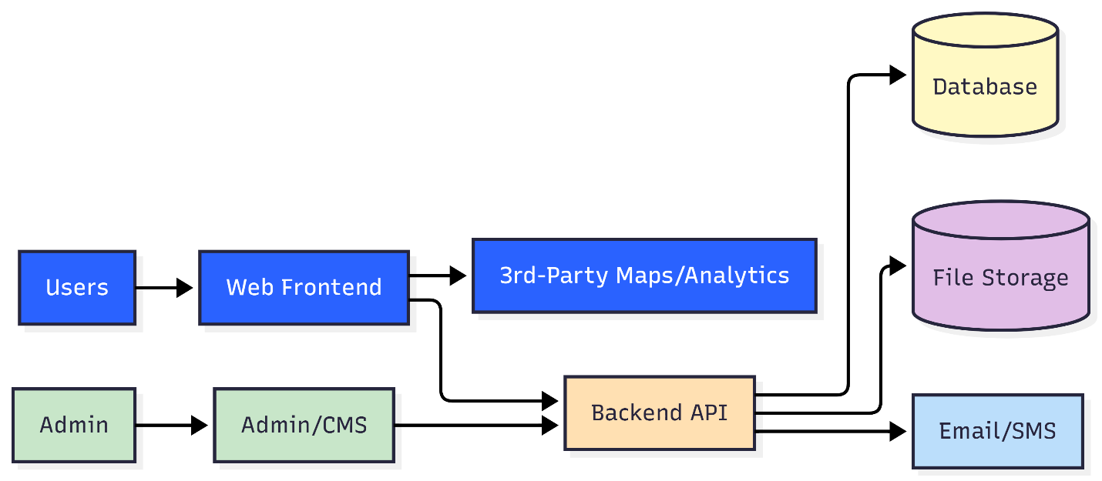

Diagram 2: Lead Capture and Zoho CRM Sync Flow
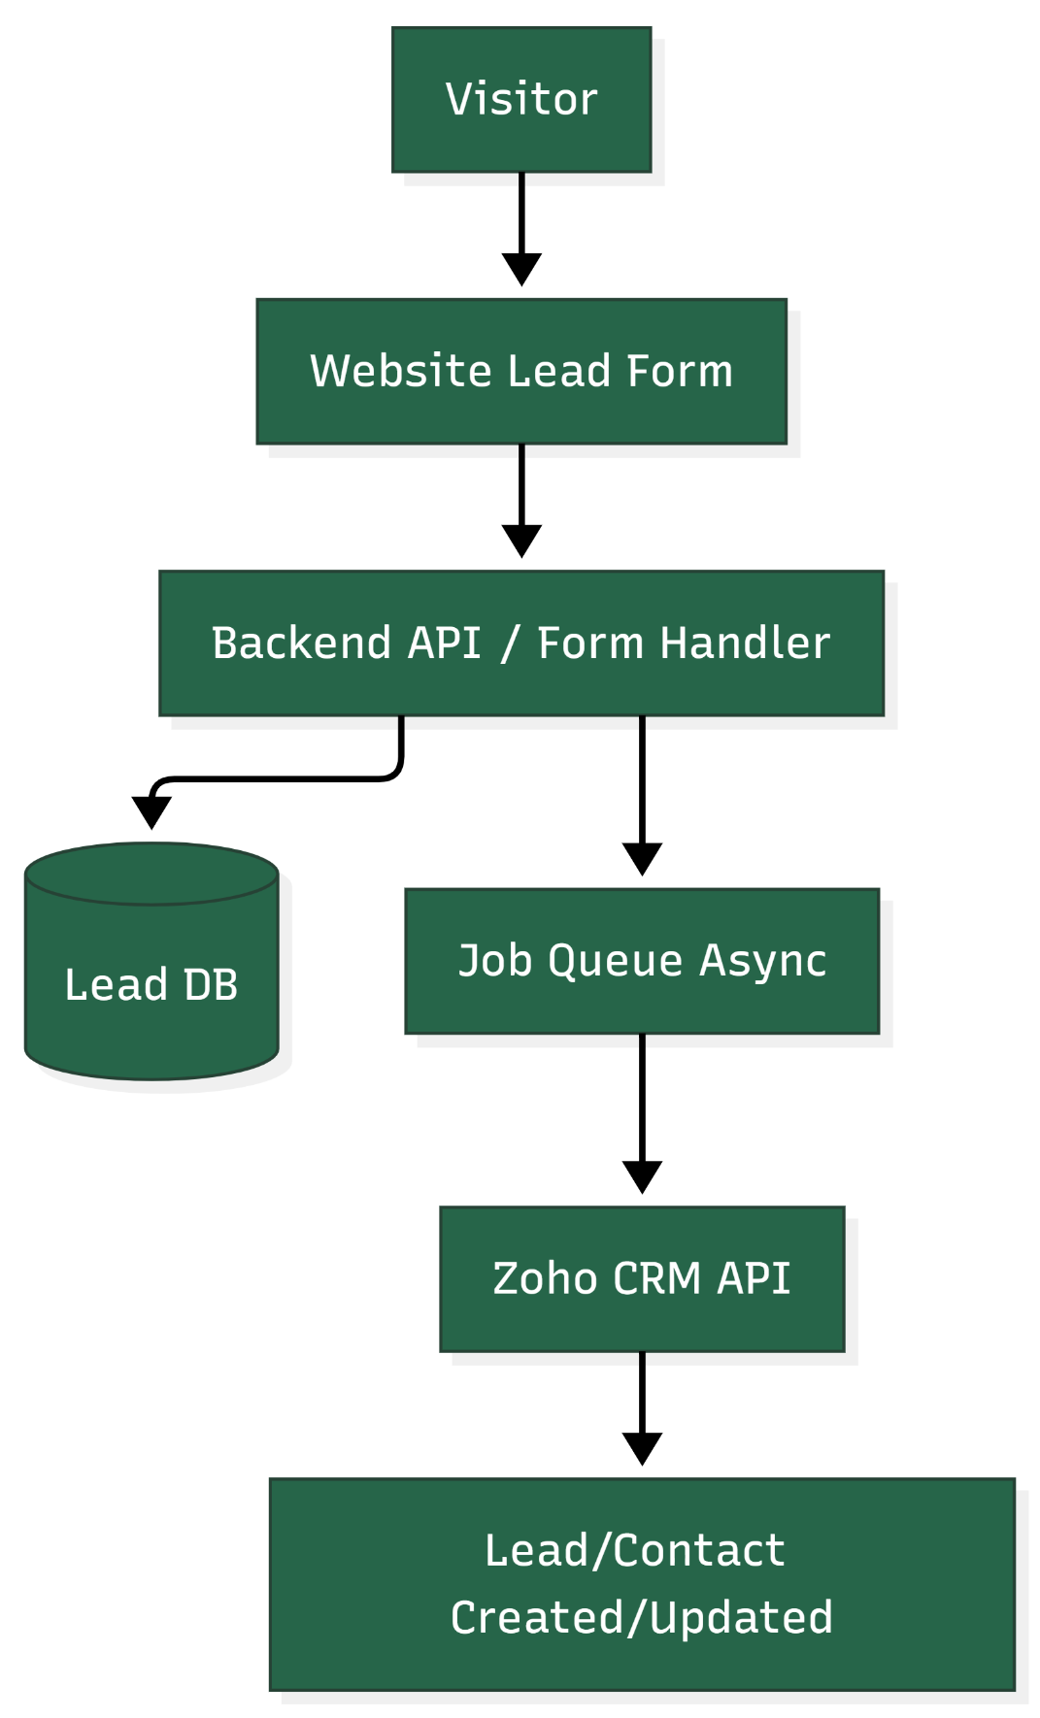

8. Complimentary Support (1 Month)
After production launch and final handover, we will provide one (1) month of complimentary support focused on the delivered scope.
Included:
- Bug fixing for reproducible issues introduced by the delivered work.
- Minor adjustments within existing UI patterns and configurations (small layout/copy/config changes).
- Support for analyzing logs and error reports where access is provided.
Excluded:
- New features or major enhancements beyond the agreed scope.
- Changes due to third-party provider policy changes or credential delays.
- Content writing, translation work, or SEO content strategy execution.

9. Financial Proposal
The financial estimate below is an indicative fixed-price estimate based on the confirmed page/module set and assumes development from scratch with the proposed stack. Final pricing may be adjusted after kickoff workshops and confirmation of hosting, multilingual requirements, and integration details.
Phase | Scope Coverage | Estimated Duration | Estimated Cost (USD)
Phase 1 | Foundation & Core Pages | 2.5 Weeks | 1,812
Phase 2 | Content Modules & Integrations | 2 Weeks | 1,525
Phase 3 | QA, Optimization & Go-Live | 1.5 Weeks | 1,233
Total |  | 5 Weeks | 4,570

9.1 Payment Terms
Payment terms will be structured in three (3) terms as follows:
- 30% upfront upon project kickoff and contract signing.
- 30% upon acceptance of Phase 2 deliverables on staging.
- 40% upon final delivery after acceptance of Phase 3 and production release handover.

9.2 Change Request (CR)
Any additional requirements beyond the agreed scope will be managed through a Change Request process.
- CR estimation will be provided as man-days and an updated timeline impact.
- Indicative CR rate: USD 150 per man-day or USD 25 per man-hour.
- CR work will start only after written approval from the client.

9.3 Assumptions & Remarks
- Client will provide final UI screens/assets, page content, and branding materials before relevant phase development begins.
- Client will provide hosting access, domain/DNS access, and required third-party credentials (Zoho CRM, analytics, reCAPTCHA).
- Bilingual languages, translation ownership, and URL structure preferences will be confirmed during kickoff.
- Zoho CRM license will be purchased by the client. Integration scope is limited to lead capture from website forms unless additional workflows are agreed.
- Any PMS revenue data integration depends on PMS API availability and is excluded unless explicitly defined.
- Timelines may shift if third-party credential approvals, content delivery, or domain/DNS changes are delayed.

10. Proposed Out of Scope
- UI/UX design, branding, illustration creation, and creation of design assets.
- Content writing, translation services, photography/videography, or ongoing SEO content strategy.
- Third-party subscription fees (hosting, premium plugins, CRM licenses, analytics tools, CDN).
- Complex appointment scheduling or calendar integration (unless requested as a change).
- Ongoing marketing operations, social media management, or ad campaign setup.

11. Acceptance & Sign-off
Delivery will be considered accepted when the agreed scope is implemented on staging, passes the QA checklist, and is formally signed off by the client for the respective phase. Production deployment will proceed after final sign-off and completion of the release checklist, followed by the one-month complimentary support period.

