Technical & Financial Proposal
THE CAEP EU - German Market Shopify Store
Prepared by: Riseup Labs

1. Introduction
This document provides a technical and financial proposal to develop a standalone Shopify store for THE CAEP EU, targeting Germany as the primary market and the broader EU as a secondary market. The proposal is based on the provided CAEP UX/UI estimation documents and design reference. The scope is strictly limited to development, Shopify configuration, integration setup, QA, deployment support and handover.
Key constraints for this proposal:
- Scope is limited to Shopify development and configuration. UI/UX design, visual design, Figma creation and brand redesign are out of scope.
- German native copywriting will be handled by the Musemind/client team as mentioned in the requirement documents.
- Third-party licensing, Shopify plan cost, legal service subscription, payment gateway charges, shipping app fees and 3PL service fees are excluded and will be paid directly by the client.
- Any requirement beyond the confirmed development scope will be handled through a Change Request (CR) process.

2. Project Context & Objectives
THE CAEP is a premium smartphone accessories brand offering MagSafe and iPhone cases, handmade straps and modular phone-wear systems. The business objective is to expand into Germany and the wider EU with a clean, premium and conversion-focused Shopify storefront that reflects the existing brand identity while supporting German localization and EU commerce requirements.

2.1 Target Store
Store / Market | Primary Language & Currency | Purpose
THE CAEP EU Store (thecaep.eu or .de) | German language, EUR currency | Standalone Shopify storefront for German customers with localized product experience, legal pages, payment and fulfillment setup.
Broader EU Market Readiness | German-first with EU-ready configuration | Support future EU market routing, EUR pricing and OSS/VAT readiness without rebuilding the storefront.

2.2 Core Objectives
- Build a standalone Shopify store aligned with the premium, minimalistic CAEP brand direction.
- Implement the custom Set Builder / product customizer as the key conversion flow for mixing straps, cases and accessories.
- Configure German localization including language, EUR currency, German date/number formatting and German address structure where Shopify allows.
- Set up legal compliance pages and integrate with a legal service such as Haendlerbund or Protected Shops, based on client preference and account availability.
- Configure EU VAT / German tax settings, OSS readiness, Shopify Payments and relevant fulfillment/shipping setup.
- Migrate or sync product catalog data from the existing US Shopify store, based on final product data structure and access.

3. Proposed Technical Approach & Methodology
We propose a Shopify-first implementation approach that uses Shopify Online Store capabilities, Shopify admin configuration, approved theme customization, and controlled app integrations. The solution will focus on a fast-loading, mobile-first storefront, a clear Set Builder flow, German localization and reliable commerce operations without adding unnecessary custom modules.

3.1 Delivery Methodology
- Requirement validation and scope lock based on the supplied overview, project summary, deliverables and design reference.
- Implementation in short delivery cycles: setup, page build, Set Builder, commerce configuration, QA and launch support.
- Definition of Done per feature: developed, configured, responsive, tested on staging and approved for release.
- Shopify-native first: use Shopify features and approved apps before considering custom development.
- Performance-first implementation: optimized images, lean theme structure, minimized app overhead and mobile-first QA.
- Compliance-aware setup: legal pages, cookie/privacy app configuration, VAT setup and data capture aligned with client-provided legal guidance.

3.2 Shopify Development Approach
- Theme implementation will follow the final approved design assets and brand guidelines provided by the design team.
- Page templates and reusable sections will be created for homepage, catalog, product details, account-related pages, FAQ, legal pages, how-it-works pages and customization flow pages.
- The Set Builder will be implemented using Shopify product/variant logic, custom theme sections, cart properties, metafields and/or a selected compatible Shopify app if required.
- German localization will use Shopify translation/localization capability or an approved translation app. Native German copy will be supplied by the client/Musemind team.
- Checkout will use Shopify-native checkout configuration. Deep checkout customization is not included unless the client confirms Shopify Plus and approves separate scope.

3.3 Environments & Governance
- Environments: Shopify development/staging theme first, then production theme deployment after approval.
- Source control: Git repository for theme code, configuration notes and controlled versioning.
- Access governance: client to provide Shopify admin, existing US store access, app credentials, legal provider access, payment setup access and 3PL/shipping details.
- Release governance: staging review, QA checklist, client sign-off, production deployment and handover.

4. Proposed Technical Stack
Layer | Proposed Choice / Setup
Commerce Platform | Shopify
Storefront Implementation | Shopify Online Store theme development, Liquid, JSON templates and reusable sections
Frontend Technologies | HTML5, CSS/SCSS, JavaScript, Shopify Liquid
Customizer / Set Builder | Shopify variants, metafields, cart properties, custom theme logic and/or approved Shopify app if required
Localization | Shopify Markets, Translate & Adapt / compatible localization app, German language, EUR currency and German formatting
Payments | Shopify Payments configured for EUR, subject to client account eligibility and German bank account details
Tax / VAT | Shopify EU tax settings, German VAT display and OSS-readiness configuration based on client tax/legal guidance
Legal Compliance Support | Legal page setup and integration support for Haendlerbund / Protected Shops or client-selected legal service
Shipping & Fulfillment | Shopify shipping profiles, German 3PL integration or shipping app configuration after provider confirmation
Analytics / Tracking | Shopify analytics and client-provided tracking pixels where confirmed
QA Tools | Browser/device testing, responsive checks, functional checkout test flow, performance review
Deployment | Shopify theme deployment with staging review and production release checklist

5. Scope of Work (Development Only)
The scope below is limited to development and Shopify configuration based on the provided requirement documents. No new feature beyond the supplied requirement has been added.

5.1 Shopify Storefront Development Scope

5.1.1 Core Storefront Capabilities
- Clean, premium and minimalistic theme implementation aligned with the existing CAEP brand identity.
- Mobile-first responsive implementation with tablet and desktop optimization.
- Subtle micro-interactions and interaction animations based on the approved design; custom motion design or 3D asset creation is excluded.
- Fast-loading storefront with optimized images, theme structure and reduced unnecessary app dependency.
- Reusable Shopify sections and page templates for maintainable content updates from Shopify admin.

5.1.2 Page-Level Build from Design Reference
The development scope will follow the supplied design reference, including the following page groups and states where applicable:
- Home / Landing page: hero, featured product grid, category navigation, trust banner and footer.
- Catalog: all products grid, category filter, price filter, combined filter, empty results state and loading skeleton state.
- Product Detail: product gallery, description, variation selection, quantity selector, price/minimum quantity indicators where applicable and Add to Cart / Buy Now CTA.
- Authentication: sign in, forgot password, registration method selection, email registration, OTP/resend/error state and success state where supported by selected authentication/OTP setup.
- Post-login home / personalized entry page as per approved design.
- Cart: item view, subtotal summary and empty cart state.
- Checkout support: delivery address entry/confirmation, order review and payment result states within Shopify checkout limitations.
- My Account: profile view/edit, saved addresses, add new address, notification preference, wishlist and logout flow.
- My Orders: active orders, completed orders, empty order state, order detail, status timeline, carrier/pickup city information and confirm receipt action where feasible within Shopify/app logic.
- Static/content pages: Wishlist, FAQ, legal pages and How It Works pages for MagSafe system, Classic Case System and Universal Hitch explainer.
- Strap Customization: strap type selection, customize, live preview, Add to Cart and saved designs where technically feasible within the confirmed Set Builder approach.

5.1.3 Frontend HR & Responsibilities
Role | Key Responsibilities
Project Manager / BA | Scope validation, task planning, communication, acceptance tracking and change control.
Shopify Tech Lead | Theme architecture, Set Builder approach, code review and technical decision-making.
Shopify Frontend Developer | Theme sections, page templates, responsive implementation, micro-interactions and cart integration.
QA Engineer | Responsive testing, functional testing, regression checks and bug reporting.

5.2 Shopify Admin, Commerce Configuration & Integrations

5.2.1 Store Setup & Localization
- Create/configure standalone Shopify store for the German/EU market, subject to client Shopify account access.
- Configure primary German language, EUR currency and German date/number formatting where supported by Shopify and selected apps.
- Set up collections, product structure, product metafields, variants and product media based on final catalog data.
- Migrate/import product catalog from the existing US Shopify store using export/import, Shopify data tools or approved sync method.
- Configure content pages, navigation, footer and admin-editable content sections.

5.2.2 Set Builder / Product Customizer
- Implement mix-and-match flow for straps, cases and accessories as the prioritized conversion feature.
- Support product option selection, compatibility guidance, live summary/preview and selected item add-to-cart flow based on final design and product data.
- Use Shopify variants, metafields, cart line-item properties and/or selected app logic to avoid unnecessary custom backend development.
- Maintain clarity in the builder flow to prevent customer confusion during personalization.

5.2.3 Payments, Tax, Legal & Fulfillment Setup
- Configure Shopify Payments for EUR checkout and payout setup, subject to client eligibility, account verification and German bank details.
- Configure EU VAT/German tax setup and OSS readiness based on client-provided legal/tax information.
- Create legal page templates and integrate client-selected legal compliance providers such as Haendlerbund or Protected Shops, if credentials are provided.
- Configure cookie/privacy banner through approved app or theme integration based on client legal preference.
- Configure German 3PL/shipping integration after the provider is confirmed. Native app configuration is included; custom API development is treated as CR if required.
- Support DHL Germany shipping label integration only if selected app/account credentials are provided and standard Shopify/app configuration is sufficient.

5.2.4 Backend / Integration HR & Responsibilities
Role | Key Responsibilities
Tech Lead | Commerce configuration strategy, app selection support, integration review and launch readiness.
Shopify Developer | Store settings, metafields, catalog import, Set Builder logic, app configuration and theme-code integration.
QA Engineer | Payment flow checks, cart/order validation, localization review, integration test cases and regression testing.
DevOps / Release Support | Domain/DNS support, theme deployment coordination, environment checklist and production release support.
Project Manager | Dependency tracking, credential follow-up, provider coordination and sign-off management.

5.3 Testing and Quality Assurance Scope
- Functional testing of homepage, catalog, product detail, Set Builder, cart, account, wishlist, order and content pages.
- Responsive testing across mobile, tablet and desktop breakpoints.
- Cross-browser testing on latest Chrome, Safari, Firefox and Edge.
- Localization review support for German text placement, EUR display and formatting based on supplied copy.
- Checkout/payment test flow in Shopify test mode or approved sandbox mode.
- Order creation, email notification and fulfillment/shipping configuration verification.
- Performance review for key storefront pages with image optimization and theme/app overhead checks.
- Regression checklist before production deployment.

6. Deliverables
- Production-ready standalone Shopify store for THE CAEP EU, deployed on the confirmed domain or client-approved domain.
- Responsive Shopify theme implementation based on final approved design assets.
- Implemented Set Builder / product customizer flow for mix-and-match straps, cases and accessories.
- Shopify catalog structure, product import/migration support and product configuration based on final data.
- German localization setup including language, EUR currency and admin-supported formatting configuration.
- Legal page templates and legal service integration support based on client-selected provider.
- Shopify Payments, VAT/OSS-readiness settings and standard shipping/3PL app configuration where credentials are provided.
- QA test checklist, bug report summary and release readiness checklist.
- Admin handover guide covering content updates, product updates, Set Builder maintenance notes and basic operational steps.
- One handover session with client stakeholders.

7. Technical Diagrams

Diagram 1: High-Level Solution Architecture
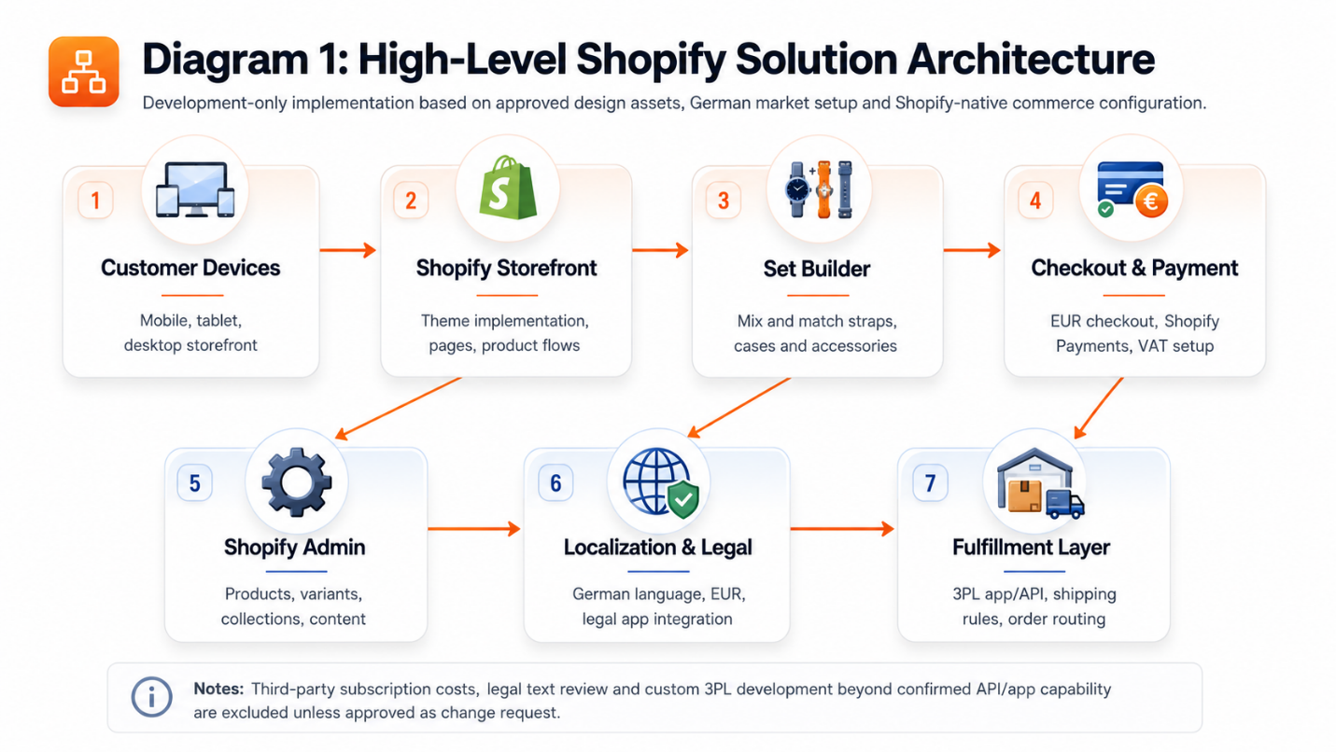

Diagram 2: Set Builder / Product Customizer Flow
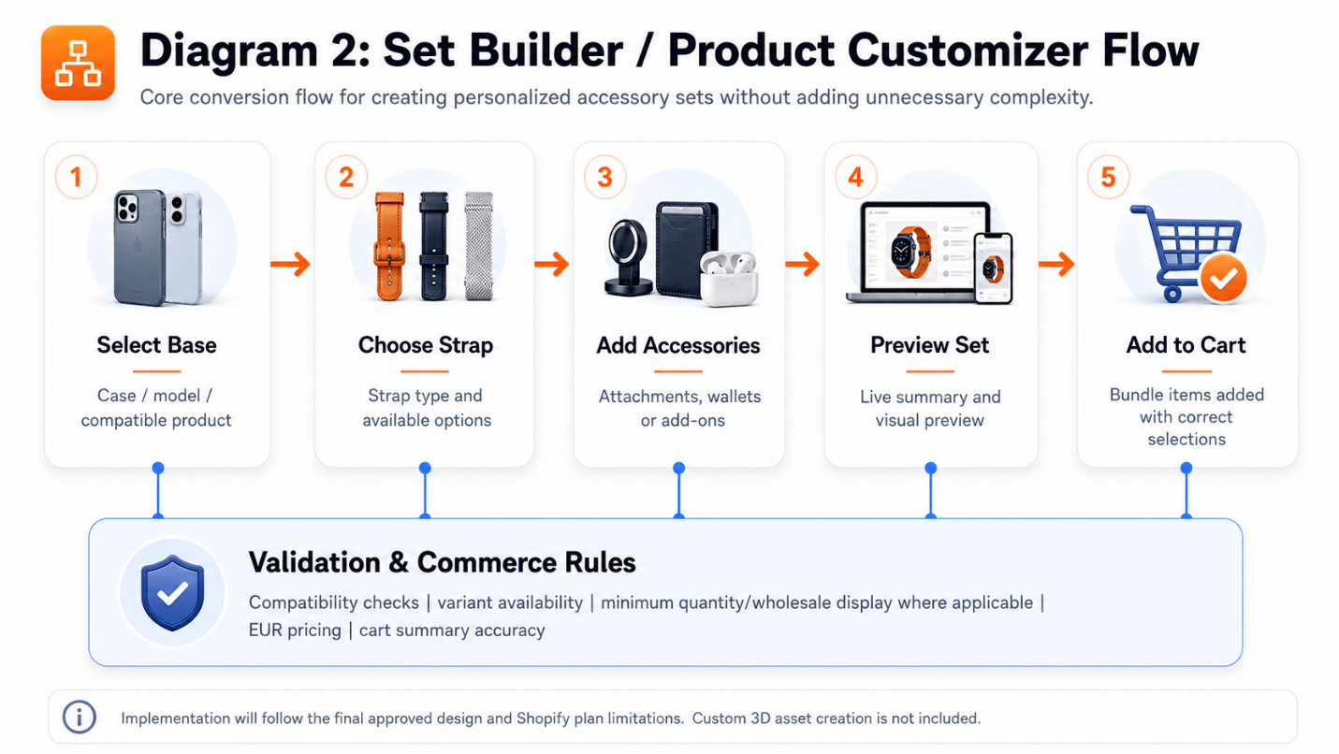

Diagram 3: Order, Payment & Fulfillment Workflow
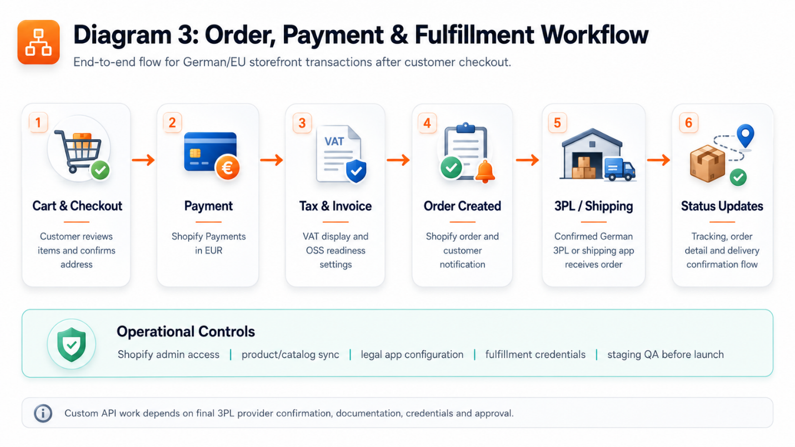

8. Complimentary Support (1 Month)
After production launch and final handover, Riseup Labs will provide one (1) month of complimentary support focused on the delivered development scope.
Included:
- Bug fixing for reproducible issues introduced by the delivered development work.
- Minor adjustments within existing UI patterns and delivered Shopify configuration.
- Support for analyzing order/payment/theme errors where the required access is provided.
- Small content/configuration corrections related to delivered pages and settings.
Excluded:
- New features, new page types or major enhancements beyond the agreed scope.
- New legal, tax, shipping or payment changes caused by third-party policy or client-side business changes.
- Ongoing content entry, German copywriting, marketing campaign setup or SEO content production.
- Third-party app fees, Shopify plan costs or support fees charged by third-party providers.

9. Financial Proposal
The following cost estimate is prepared for the development-only scope described in this proposal. Third-party costs are excluded and will be paid directly by the client.

9.1 Cost Summary
Scope | Scope of Work | Timeline | Estimated Cost (USD)
Shopify Storefront Development | Theme implementation, page templates, responsive development, content pages, account-related pages and basic animations based on approved design. | 1 Week | $1,000
Set Builder / Product Customizer | Mix-and-match product flow, product option logic, live summary/preview, compatibility guidance and cart integration. | .5 Week | $500
Commerce Configuration, Migration & QA | Localization, EUR setup, VAT/OSS readiness, legal app setup support, Shopify Payments setup support, standard shipping/3PL configuration, catalog import/sync and QA. | .5 Week | $500
Total Core Development Cost |  | 2 Weeks | $2,000

9.2 Payment Terms
- 30% advance payment upon project kickoff.
- 30% payment upon completion of Shopify store baseline, localization setup and core page implementation on staging.
- 30% payment upon completion of Set Builder, commerce configuration, catalog migration/sync and QA on staging.
- 10% payment upon production release and final handover.

9.3 Change Request (CR)
Any additional scope, new feature, custom app/API development, legal/tax requirement change, custom checkout requirement or third-party integration beyond the agreed scope will be handled through a formal Change Request process.
CR Man-day Rate: USD 150 per man-day or USD 25 per man-hour, unless a separate fixed estimate is agreed before implementation.

9.4 Assumptions & Remarks
- Client will provide final UI design/Figma assets before development starts.
- Client/Musemind team will provide final German copywriting, legal content and proofreading approval.
- Client will provide Shopify admin access, existing US Shopify store access, product export/data, brand assets and media assets.
- Client will confirm domain, German bank/payment details, tax/VAT/OSS information, legal service provider and 3PL/shipping provider.
- The 2-week timeline may shift if access, credentials, catalog data, legal approval, payment verification or 3PL integration details are delayed.
- Shopify plan limitations, especially checkout customization and advanced customer account customization, may affect implementation details. Any Shopify Plus-only requirement will require separate confirmation.
- Third-party subscription charges, Shopify plan fees, app fees, payment processing fees and shipping/3PL service fees are excluded.

10. Proposed Out of Scope
- UI/UX design, Figma design, visual redesign, brand redesign, logo refinement and creation of new design assets.
- Native German copywriting, translation, legal drafting, legal review or tax advisory services.
- Custom 3D modeling, complex motion design or new animation asset production.
- Custom Shopify app development unless separately approved through CR.
- Deep Shopify checkout customization unless Shopify Plus is confirmed and separately scoped.
- Custom 3PL API development if the confirmed provider does not support standard Shopify app/API workflows.
- Ongoing SEO content strategy, paid marketing, ads setup, email marketing automation or content production.
- Long-term maintenance beyond the 1-month complimentary support period.
- Third-party license/subscription fees and external provider support fees.

11. Acceptance & Sign-off
Delivery will be accepted when the agreed Shopify development scope is implemented on staging, passes the QA and regression checklist, and is formally signed off by the client. Production deployment will proceed after sign-off, completion of the release checklist and availability of required access/credentials.
Upon production release, Riseup Labs will provide the agreed handover materials and one (1) month of complimentary support for bug fixing and minor adjustments within the delivered scope.

