Technical & Financial Proposal
Awarid B2B Wholesale Platform
Frontend Development Only

Prepared by | Riseup Labs
Reference Scope | Awarid (Mohammad Noor) _ Design Estimation - Project Summary
Proposal Date | March 09, 2026

1. Introduction
This document presents the proposed technical and financial approach for implementing B2B wholesale capabilities within the existing Awarid B2C web platform. The engagement is intentionally limited to frontend development only. It covers React.js-based interface implementation, reusable component development, frontend integration with provided backend APIs, testing, release support, and production handover.
UI/UX design, backend development, API creation, database work, warehouse or payment middleware, and third-party subscriptions are outside this proposal and are assumed to be provided by the client or by a parallel delivery stream. Because the B2B experience will run inside the same platform as the current B2C site, the solution approach focuses on extending the React.js application in a way that preserves existing customer journeys while enabling a wholesale-specific experience for approved business users.
To reduce risk and keep rollout controlled, the implementation is divided into three delivery phases. The sequence starts with platform foundation and access control, moves into quote-to-order wholesale journeys, and ends with operations-facing screens, frontend hardening, and go-live readiness.
2. Project Context & Objectives
Based on the shared project summary, the target solution is a Saudi Arabia-focused B2B wholesale web platform for cosmetics and beauty supply, with an expected catalogue size of approximately 1,000 to 2,000 SKUs. Approved wholesalers must be able to browse products, request quotations instead of seeing public prices, and place orders once business terms are confirmed. Arabic with RTL layout is the primary language experience, while English is the secondary language option. The platform must remain fully responsive for desktop, tablet, and mobile usage.
2.1 Core Business Objectives
Objective | Implementation Intent
Extend the current platform | Add wholesale-specific user journeys within the existing React.js B2C application instead of creating a disconnected second site.
Support B2B buying logic | Present hidden pricing, quote requests, negotiated commercial terms, and post-approval order journeys suitable for wholesale customers.
Maintain operational control | Provide the frontend surfaces needed for business user approval status, quote visibility, order progress, and admin or operations workflows exposed through existing APIs.
Protect current performance | Introduce B2B functionality without degrading live B2C journeys by isolating routes, components, and feature state.

2.2 Delivery Principles
Principle | How It Is Applied
Frontend-only scope | All work is limited to React.js frontend implementation and UI integration against provided services.
Same-platform strategy | B2B features are developed as dedicated modules inside the current codebase or workspace structure.
API-ready execution | Frontend development proceeds against confirmed API contracts, sandbox endpoints, or mock schemas during early delivery.
Release by phases | Each phase ends with development completion, QA validation, staging review, and acceptance support.

3. Proposed Technical Approach & Methodology
The recommended approach is to build the B2B experience as a modular extension of the current React.js web application. Rather than creating a separate frontend stack, the wholesale layer should reuse shared application shell elements where practical, while keeping B2B business flows isolated through dedicated route groups, feature components, guards, translation resources, and state handling. This approach lowers long-term maintenance cost, preserves brand consistency, and reduces duplicate frontend effort.
3.1 Technical Approach
New wholesale pages should be introduced through lazy-loaded React.js feature areas so that B2B code is only loaded when required. This helps protect the performance of existing B2C journeys and keeps the release impact more controlled. The frontend should remain API-driven, with clearly separated service classes for authentication, product catalogue retrieval, quote operations, order operations, account approval status, and payment UI handoff.
From a UX behavior perspective, the frontend will distinguish between public visitors, newly registered wholesalers awaiting approval, approved wholesale buyers, and operations users. Hidden pricing rules, request-quote buttons, approval-state messaging, and negotiated-price visibility will all be reflected at the interface layer based on backend flags and user profile states exposed by existing services.
3.2 Delivery Methodology
Delivery will follow a sprint-based implementation model. Each phase will begin with scope confirmation, API alignment, and technical decomposition, then proceed through React.js development, internal code review, functional QA, responsive testing, RTL verification, staging deployment, and client review. Features will be treated as complete only when they are coded, integrated, tested, and ready the agreed environment.
3.3 Key Assumptions & Dependencies
The proposal assumes that client-approved UI designs, brand assets, Arabic and English content, and all required backend APIs will be available according to the agreed delivery plan. It also assumes access to the current React.js codebase, frontend environments, deployment pipeline, and any sandbox credentials required for payment or operational integrations. Delays in API readiness, content approval, or environment access may shift the suggested timeline.

4. Proposed Technical Stack
Layer | Proposed Choice | Reason for Recommendation
Frontend Framework | React.js | Aligns with the existing Awarid B2C platform and reduces re-platforming risk.
Language | TypeScript | Provides structured, maintainable code and fits standard React.js engineering practice.
UI Implementation | HTML5, SCSS, responsive component styling | Supports reusable components, mobile responsiveness, and RTL or LTR layout control.
Routing | React.js Router with lazy-loaded B2B feature areas | Keeps wholesale functionality modular and helps protect B2C bundle impact.
Forms | React.js Reactive Forms | Suitable for quote requests, registration, checkout inputs, and rich validation flows.
State & Data Flow | React.js Signals | Allows the project to extend the current application architecture without unnecessary rework.
Backend | Salla | API connectivity
Localization | Arabic-first RTL support with English secondary localization | Supports the required Saudi market experience while maintaining a single application structure.
Testing | React.js component testing plus Playwright or Cypress E2E | Provides coverage for core business flows, responsive states, and regression validation.
Build & Release | Existing React.js CI/CD pipeline and environment structure | Avoids unnecessary tooling divergence and supports the same deployment discipline as the live platform.

5. Scope of Work and Phase-wise Delivery
The frontend scope is organized into three logical phases to match business priority and implementation dependency. The first phase creates the B2B frontend foundation and wholesale entry points. The second phase delivers the commercial buying journey. The third phase covers operational screens, optimization, support, and production readiness.
5.1 Phase 1 - Foundation, Access Control & Catalogue Experience
Area | Details
Scope Focus | Establish the B2B frontend foundation inside the existing B2C platform and introduce wholesale-specific access and catalogue presentation.
Key Frontend Deliverables | Codebase assessment and setup, route planning, feature guards, B2B navigation entry points, wholesaler registration and login or access request screens, approval-state pages, responsive catalogue listing and detail pages, hidden pricing presentation, request-quote CTA pattern, RTL and English readiness, and reusable UI components.
Suggested Timeline | 2 weeks

Phase 1 - Human Resources & Responsibilities
Role | Qty | Short Responsibility
Project Manager | 1 | Planning, scope tracking, dependency follow-up, client coordination.
Tech Lead | 1 | Architecture setup, code standards, reusable component strategy, review.
React.js Frontend Developer | 2 | Implement screens, routing, forms, responsive layouts, RTL behavior.
QA Engineer | 1 | Prepare test scenarios and validate core flows during build.

5.2 Phase 2 - Quote-to-Order Wholesale Journey
Area | Details
Scope Focus | Deliver the commercial B2B journey for approved wholesale users from quote request through ordering and account history.
Key Frontend Deliverables | Quote request forms, quote list and detail screens, negotiated-price visibility based on API response, order placement UI, cart and checkout screens where applicable, address and shipping forms, payment option selection UI for the existing gateway flow, order confirmation and history pages, account dashboard widgets, and status messaging for quote, order, and payment states.
Suggested Timeline | 3 weeks

Phase 2 - Human Resources & Responsibilities
Role | Qty | Short Responsibility
Project Manager | 1 | Phase planning, review coordination, acceptance support.
Backend Developer | 1 | Flow design review, API contract alignment, code review.
React.js Frontend Developer | 2 | Implement quote, checkout, account, and transactional screens.
QA Engineer | 1 | Functional QA, responsive QA, RTL and regression coverage.

5.3 Phase 3 - Operations UI, Hardening & Go-Live Readiness
Area | Details
Scope Focus | Finalize operational frontend surfaces, optimize the application, complete, and prepare production release.
Key Frontend Deliverables | Admin or operations-facing frontend screens available within the agreed web scope for user approval, quote handling, and order view workflows; notification and status refinements; performance and bundle optimization; cross-browser hardening; B2C regression checks; deployment support; release notes; and handover documentation.
Suggested Timeline | 2 weeks

Phase 3 - Human Resources & Responsibilities
Role | Qty | Short Responsibility
Project Manager | 1 | coordination, release planning, risk follow-up, sign-off support.
Backend Developer | 1 | Performance tuning, final review, release readiness approval.
React.js Frontend Developer | 2 | Finalize operations UI, fix defects, polish responsive behavior.
QA Engineer | 1 | Regression, cross-device validation, release verification.
DevOps / Release Support | 1 | Build, staging, deployment, and rollback readiness support.

6. Overall Human Resources and Responsibilities
Role | Responsibility
Project Manager | Planning, schedule management, dependency follow-up, stakeholder communication, and milestone acceptance support.
Tech Lead | Technical direction, architecture consistency, code review, integration alignment, and release-quality control.
Backend Developer | Flow design review, API contract alignment, code review.
React.js Frontend Developers | Component development, page implementation, service integration, responsive behavior, and bug fixing.
QA Engineer | Test planning, functional and regression execution, responsive verification, and release validation.
DevOps / Release Support | Environment readiness, build support, staging deployment, and production release assistance.

7. Deliverables
Deliverable | Description
Frontend Source Code | React.js code for the approved B2B modules, components, forms, route guards, services, and page templates.
Frontend Test Artifacts | Test scenarios, defect logs, regression records, and release validation evidence.
Deployment & Handover Support | Staging deployment support, production release assistance, and technical handover notes.
Complementary Support | One month of post-launch bug fixing and minor adjustment support within the delivered scope.

8. Technical Diagram
To strengthen the proposal visually, the following three diagrams are recommended. Placeholder spaces are intentionally included below so the visuals can be inserted later without changing the document structure.
Diagram 1: Shared Frontend Solution Architecture

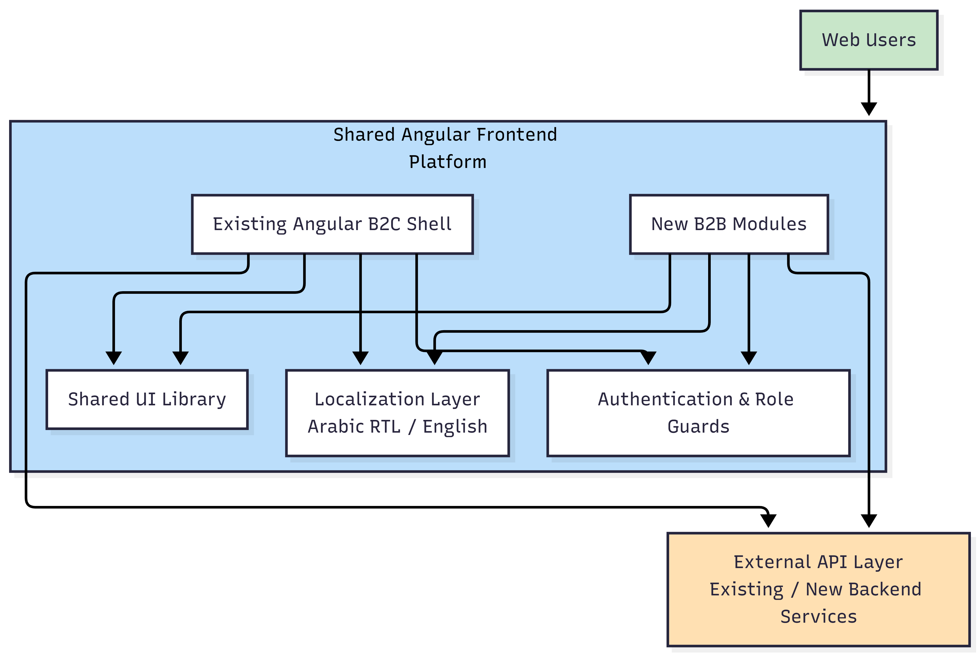

Diagram 2: B2B Registration, Approval, Quote and Order Journey

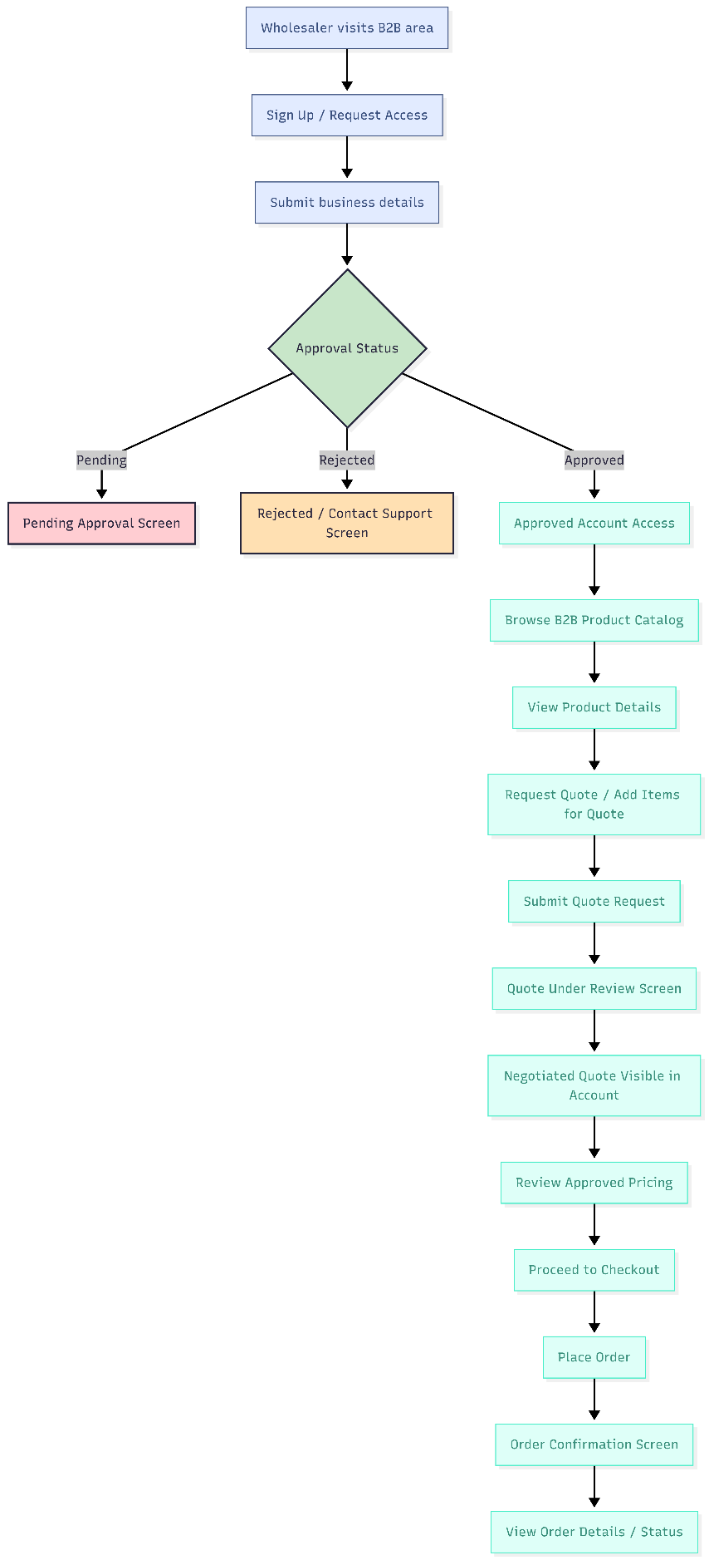
9. Testing and Quality Assurance
Because the B2B experience will be added to a live B2C platform, quality assurance must cover both the new wholesale journeys and regression risk on the current storefront. The QA approach will therefore combine feature validation with release protection for existing customer-facing paths.
Test Layer | Coverage Focus
Code Review & Static Checks | Branch review, coding standard compliance, and maintainability checks before merge.
Component Testing | Validation of reusable UI components, guards, form logic, and service-level frontend behaviors.
Functional Testing | Registration, approval-state experience, quote request, order flow, account history, and operational screens.
Responsive & Browser Testing | Desktop, tablet, and mobile validation across agreed browsers and common breakpoints.
RTL / Localization Testing | Arabic RTL layout, text handling, language switching behavior, and bilingual content placement.
Regression Testing | Protection of existing B2C journeys that share shell elements, components, or services with the new B2B scope.

10. Complimentary Support (1 Month)
After production release and approved handover, one month of complimentary support will be provided for the delivered frontend scope.
Included | Excluded
Bug fixing for reproducible defects in delivered frontend modules. | New features, major workflow changes, or any additional scope not included in this proposal.
Minor UI adjustments within the already approved layouts and user journeys. | Backend logic changes, new API creation, database changes, or middleware updates.
Deployment assistance for fixes related to the delivered frontend scope. | Third-party provider issues, pricing changes, policy updates, or unavailable client credentials.
Issue triage and fix validation on the agreed environment. | Changes caused by new designs, new content direction, or unsupported infrastructure modifications after handover.
11. Financial Proposal
The following commercial estimate is proposed for frontend-only delivery of the scoped B2B wholesale platform. The estimate excludes UI/UX design, backend development, middleware, third-party subscriptions, infrastructure consumption, content entry, and out-of-scope change requests. Amounts are presented in USD.
Phase | Scope of Work | Timeline | Estimated Cost (USD)
Phase 1 | Foundation, access control, catalogue experience | 2 weeks | $1,800
Phase 2 | Quote-to-order wholesale journey | 3 weeks | $2,700
Phase 3 | Operations UI, hardening, and go-live readiness | 2 weeks | $2,200
Total | Complete frontend development scope | 7 weeks | $6,700

11.1 Payment Terms
30 % upfront upon project kickoff, resource mobilization, and environment onboarding.
30 % upon completion of Phase 2 and acceptance of the core B2B wholesale buying journey on staging.
40 % upon final delivery, completion of Phase 3, handover, and production release readiness.
11.2 Change Request (CR)
CR man-day rate: USD 150 per man-day or USD 25 per man-hour.
12. Proposed Out of Scope
Out-of-Scope Item | Clarification
UI/UX Design | All design discovery, wireframes, visual design, prototypes, design system creation, and creative assets.
Backend Development | API development, business logic, database work, warehouse integration logic, payment backend handling, and admin middleware.
Data & Content Work | Bulk catalogue upload, copywriting, translation creation, and content operations outside frontend integration.
Third-Party Charges | Gateway fees, SaaS subscriptions, hosting usage, SMS, email, and any external licensing costs.
Unapproved Expansion | Any new modules or major changes outside the agreed three-phase scope.

13. Acceptance and Sign-off
A phase will be considered complete when the agreed frontend scope for that phase has been implemented, internally reviewed, functionally tested, deployed to staging, demonstrated to the client, and accepted against the agreed checklist. Final delivery will be considered complete when the full three-phase frontend scope has passed QA, the agreed handover materials have been delivered, and production release readiness has been confirmed.

