Technical and Financial Proposal

Manifestation App (Mobile - Flutter)
Prepared for: Client
Prepared by: Riseup Labs
Date: February 06, 2026

1. Introduction
This document provides a technical and financial proposal to develop a premium manifestation and personal alignment mobile application for Android and iOS. The application will be built from scratch using Flutter and will implement the complete user flows described in the shared requirements document, including onboarding, daily emotional check-in, visualization theater, affirmations and reminders, dream tracking and gamification, and a cost-controlled audio approach.
Key constraints for this proposal:
- Scope is limited to development (mobile app engineering, testing, deployment support). Design and UI/UX are out of scope; implementation will follow client-provided designs and visual specifications.
- AI generation can be delivered as a modular, pluggable layer with mock outputs in v1, so a real AI provider can be integrated later without reworking core screens.
- Audio must work end-to-end using a cost-controlled approach (device-native TTS + bundled ambient tracks in v1).
- Any requirements beyond the agreed scope will be handled through a Change Request (CR) process.

2. Project Context & Objectives
The goal is to deliver a high-quality, daily-use mobile experience that helps users self-regulate emotions, visualize desired outcomes, build repeatable affirmation habits, and track progress through gamified reinforcement. The solution is designed to be local-first (fast and private by default), while keeping the architecture modular for future cloud sync, analytics, and AI upgrades.

2.1 Product Outcomes
- First-launch onboarding that captures user personalization data (focus anchors, vision, limiting beliefs, soul circle, birth details).
- Daily emotional check-in gatekeeper with conditional coaching flow for low vs high mood states.
- Guided visualization theater with induction protocol, script generation, save/regenerate/play controls, and ambient layering with ducking.
- Vedic frequency module (intro + AI chat-based reading) and “cosmic alerts” on the home screen.
- Manifestation prompt flow that generates affirmations and supports saving/scheduling.
- Affirmation Lab and reminder scheduler (static time or “pattern interrupter” random pings) with personality toggle effects.
- Dream Tracker with progress, “Mark as Manifested” celebration, crystals, and techniques library.
- Persistent AI coach chat overlay and chat history management.

3. Proposed Technical Approach & Methodology
We propose a Flutter-first, modular architecture that separates UI, domain logic, and providers (AI, narration, notifications, storage). This aligns with the requirement to keep AI and audio pluggable and enables future expansion without rewriting core flows.

3.1 Development Methodology
- Phase-gated delivery with acceptance checkpoints (Phase 1 -> Phase 2 -> Phase 3).
- Definition of Done per feature: requirements confirmed, implemented, tested (unit/widget/integration), documented, and demoed on Android and iOS builds.
- Provider abstraction-first: AIProvider, NarrationProvider, NotificationService, StorageService interfaces defined early.
- Quality-first engineering: code review, static analysis, crash reporting readiness, and regression checklist per release candidate.
- Risk-managed delivery: early proof of audio pipeline and notifications to avoid late-stage blockers.

3.2 Environments & Governance
- Source control: GitHub/GitLab with PR-based reviews.
- Environments: Local -> Staging builds (internal) -> Production release (Play Store/TestFlight).
- CI/CD (recommended): automated build and distribution (e.g., GitHub Actions + Firebase App Distribution/TestFlight).
- Release governance: sign-off on staging build prior to store submission.

4. Proposed Technical Stack
Layer | Proposed Choice
Mobile Framework | Flutter (Android + iOS)
Language | Dart
State Management | Riverpod or Bloc (final choice based on team preference), with clean separation of UI/Domain/Data layers
Local Storage | Hive (structured offline data) + SharedPreferences (light settings)
AI Abstraction | AIProvider interface (Mock Provider in v1; future: hosted LLM or on-device model)
TTS/Narration | flutter_tts (device-native) behind NarrationProvider
Audio Playback | just_audio or audioplayers for ambient loops; ducking control in app layer
Notifications | flutter_local_notifications (local reminders and pattern interrupter)
Analytics/Crash (optional) | Firebase Analytics + Crashlytics (optional, client approval)
Testing | Flutter unit/widget/integration tests; device lab testing
CI/CD (recommended) | GitHub Actions for automated builds and distribution

5. Scope of Work (Development Only)
The scope is divided into three (3) development phases to reduce delivery risk and ensure clear acceptance milestones. Each phase includes deliverables, team responsibilities, and an estimated timeline.

5.1 Phase 1 - Foundation & Core Experience Shell
Objective: Establish the mobile app foundation, navigation shell, personalization storage, and the daily gatekeeper flow with modular AI and audio scaffolding.

5.1.1 Feature Scope
- Project setup: Flutter architecture (Clean Architecture), environments, base configs, app theming hooks (implementation of provided UI specs).
- Onboarding (first launch only): Focus Anchors, Vision, Shadow, Soul Circle, Vedic Calibration; persistence to local storage.
- Daily Emotional Feeling Gatekeeper (once per day): 5-point mood scale, conditional flow for mood 4-5 vs 1-3 (venting, clarifying questions, consent gate).
- Home screen shell: central moon area, constellation tabs structure, floating AI coach orb opening chat overlay (non-disruptive).
- Third party Chat foundation: persistent chat history, clear chat option, mock AI responses via AIProvider interface.
- Audio framework scaffolding: NarrationProvider interface, ambient track asset pipeline, basic playback controls (no autoplay).
- Baseline QA: device testing setup, smoke test checklist, and initial automated tests.

5.1.2 Deliverables
- Functional app build implementing onboarding + daily gatekeeper + home shell on Android and iOS.
- Local storage schema for user profile, mood logs, and chat history.
- Provider interfaces: AIProvider, StorageService, NarrationProvider, NotificationService (stubs where needed).
- Phase 1 demo build.

5.1.3 Human Resources & Responsibilities
Role | Key Responsibilities
Project Manager (PM) | Planning, backlog, acceptance criteria, stakeholder coordination
Mobile Tech Lead | Architecture, provider interfaces, code review, technical decisions
Backend Developer | Api and Feature Development
Flutter Engineer(s) | Feature development, storage integration, navigation, chat foundation
QA Engineer | Smoke testing, regression checklist, bug reporting
DevOps/Release Support | Build pipelines, signing configs, internal distribution

5.1.4 Suggested Timeline
Estimated duration: 3 weeks

5.2 Phase 2 - Core Modules, Audio Delivery, Reminders & Gamification
Objective: Implement the primary feature modules end-to-end with working audio playback, affirmation scheduling, and dream tracker gamification.

5.2.1 Feature Scope
- Inward Visualization Theater: duration selection (5/10/15), focus modes, script generation rules, save/regenerate/play flows.
- Mandatory Induction Protocol: timed narration steps with pauses before every script playback.
- Audio mixing and ducking: narration vs ambient volume control, voice and ambient selectors, looped ambient playback.
- Frequency (Vedic) module: intro screen, CTA to chat, birth detail capture logic, reading structure and disclaimers.
- Cosmic alerts on Home and deep-links to chat context.
- Manifestation module: intro content, prompt submission, affirmation generation, save to lab and schedule.
- Affirmation Lab: create/edit/list, assign to anchors, extract I AM statements after visualization, save prompts.
- Reminder scheduler: static time and pattern interrupter (3x/5x/10x daily), in-app notification center fallback if OS restrictions apply.
- Coach personality toggle affecting reminder tone (content rules implemented in generation templates).
- Dream Tracker: list, progress, mark manifested (confetti animation hook), crystals awarding rules; Techniques library framework.
- Expanded testing: widget tests for core flows, integration tests for notifications and audio pipeline.

5.2.2 Deliverables
- End-to-end working modules: Inward, Frequency, Manifestation, Affirmations, Dream Tracker, Techniques.
- Working audio pipeline using device-native TTS and bundled ambient tracks with ducking.
- Reminder scheduling operational on Android and iOS with documented limitations and fallbacks.
- Updated local storage schema and migration strategy (if needed).
- Phase 2 demo build.

5.2.3 Human Resources & Responsibilities
Role | Key Responsibilities
Project Manager (PM) | Phase coordination, planning, scope control
Mobile Tech Lead | Audio pipeline design, notification strategy, reviews
Backend Developer | Api and Feature Development
Flutter Engineer(s) | Module development, audio + reminders + storage
QA Engineer | Test plan execution, regression, device coverage
DevOps/Release Support | Automated builds, TestFlight/Play internal tracks

5.2.4 Suggested Timeline
Estimated duration: 5 weeks

5.3 Phase 3 - Stabilization, Store Readiness & Launch
Objective: Hardening, performance optimization, release readiness, and production deployment support.

5.3.1 Feature Scope
- Full regression testing and bug fixing across Android/iOS devices and OS versions.
- Performance and battery optimization (audio playback, background tasks, storage access).
- Accessibility and usability checks against provided UI specs.
- App store preparation: bundle IDs, signing, store metadata placeholders, screenshots checklist (client to provide assets), TestFlight and Play Store submissions support.
- Operational readiness: crash reporting integration (optional), logging strategy, and basic analytics events (optional).
- Documentation and handover: setup guide, build/release guide, and feature configuration notes.

5.3.2 Deliverables
- Release Candidate (RC) builds for Android and iOS.
- Production release support (submission assistance, rollout coordination).
- Technical handover pack: code walkthrough, configuration guide, and known limitations.

5.3.3 Human Resources & Responsibilities
Role | Key Responsibilities
Project Manager (PM) | Release planning, acceptance management, coordination
Mobile Tech Lead | Stability fixes, performance tuning, final reviews
Backend Developer | Api and Feature Development
Flutter Engineer(s) | Bug fixes, optimizations, store readiness tasks
QA Engineer | Regression, release checklist
DevOps/Release Support | Store submissions, build signing and distribution

5.3.4 Suggested Timeline
Estimated duration: 2 weeks

6. Deliverables
- Flutter mobile application (Android + iOS) implementing all specified screens and flows.
- Local-first persistence for user personalization, chat history, goals, affirmations, and progress tracking.
- Working audio playback: induction + script narration + ambient looping with separate volume controls and ducking.
- Reminder scheduler (static time + pattern interrupter) and in-app notification center (fallback).
- Test plan and QA artifacts: test cases, regression checklist, bug report log.
- Release artifacts: signed builds, store submission support, and handover documentation.

7. Technical Diagrams (Placeholders)
Insert images in the spaces below in the final version:

Diagram 1: High-Level Mobile Solution Architecture

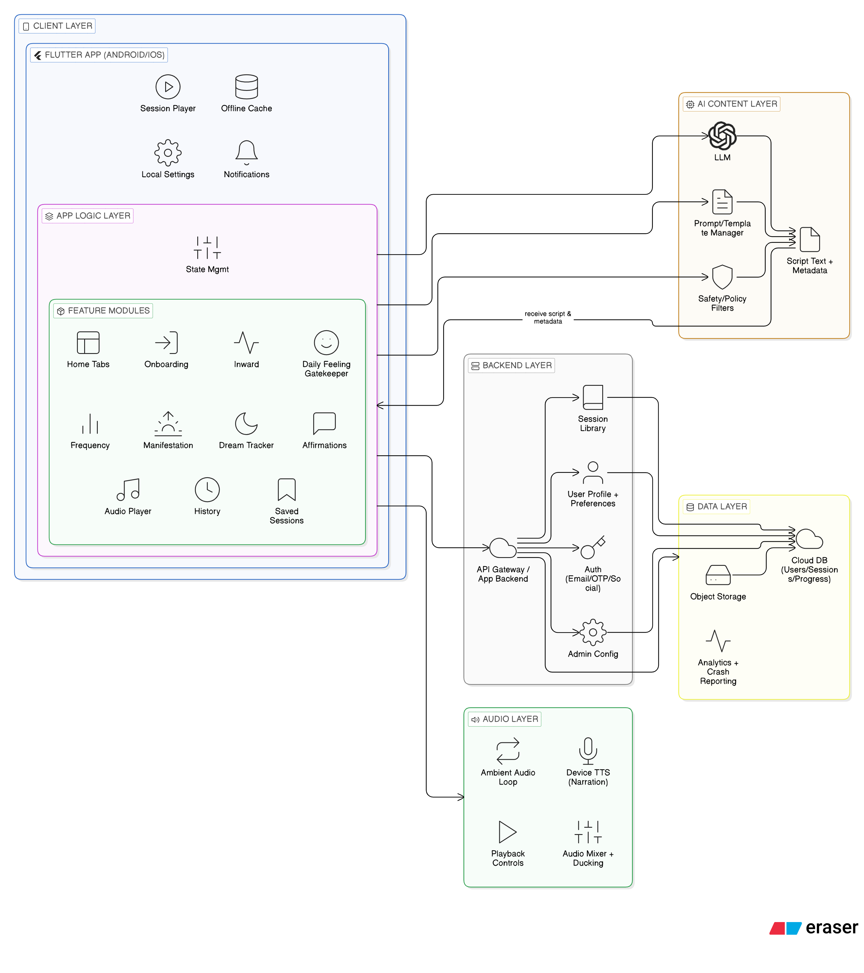

Diagram 2: Core User Journey & State Flow
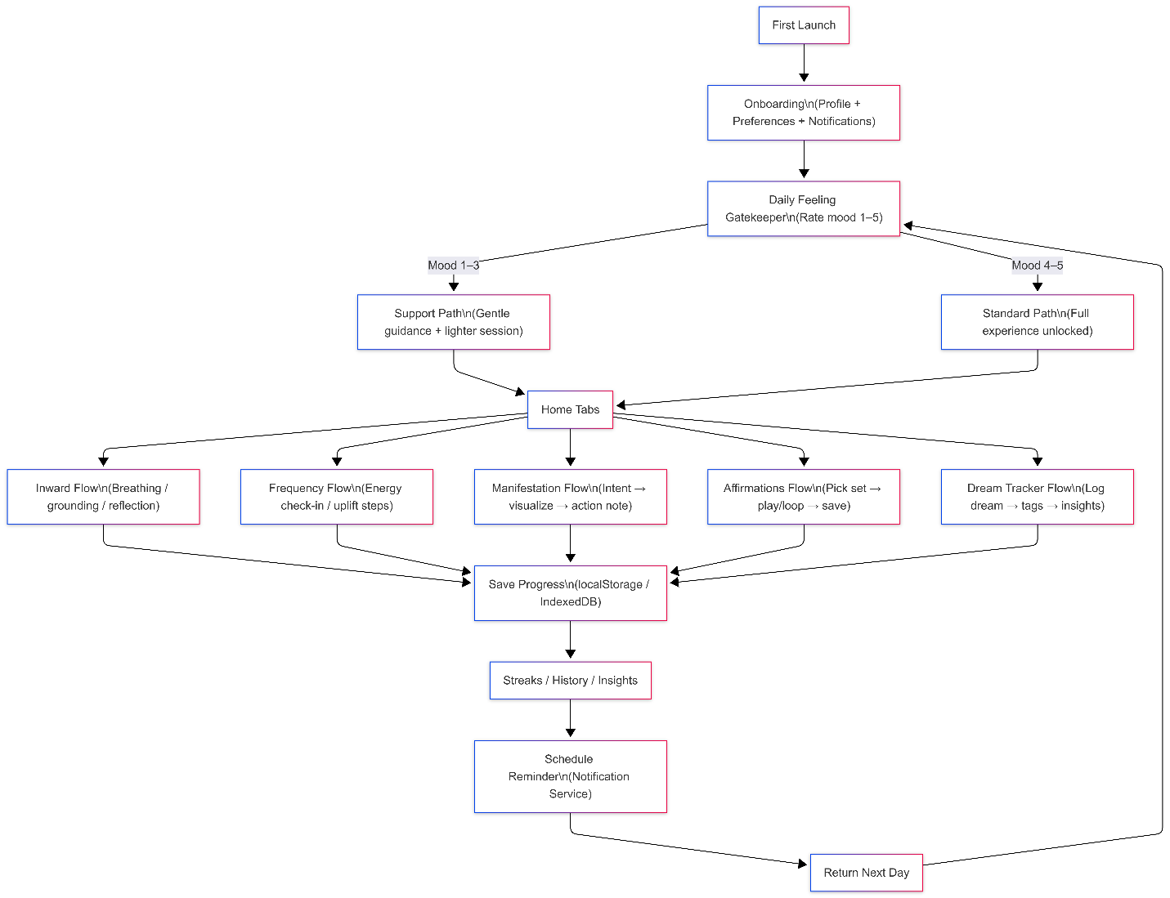

Diagram 3: Audio + AI Generation Sequence
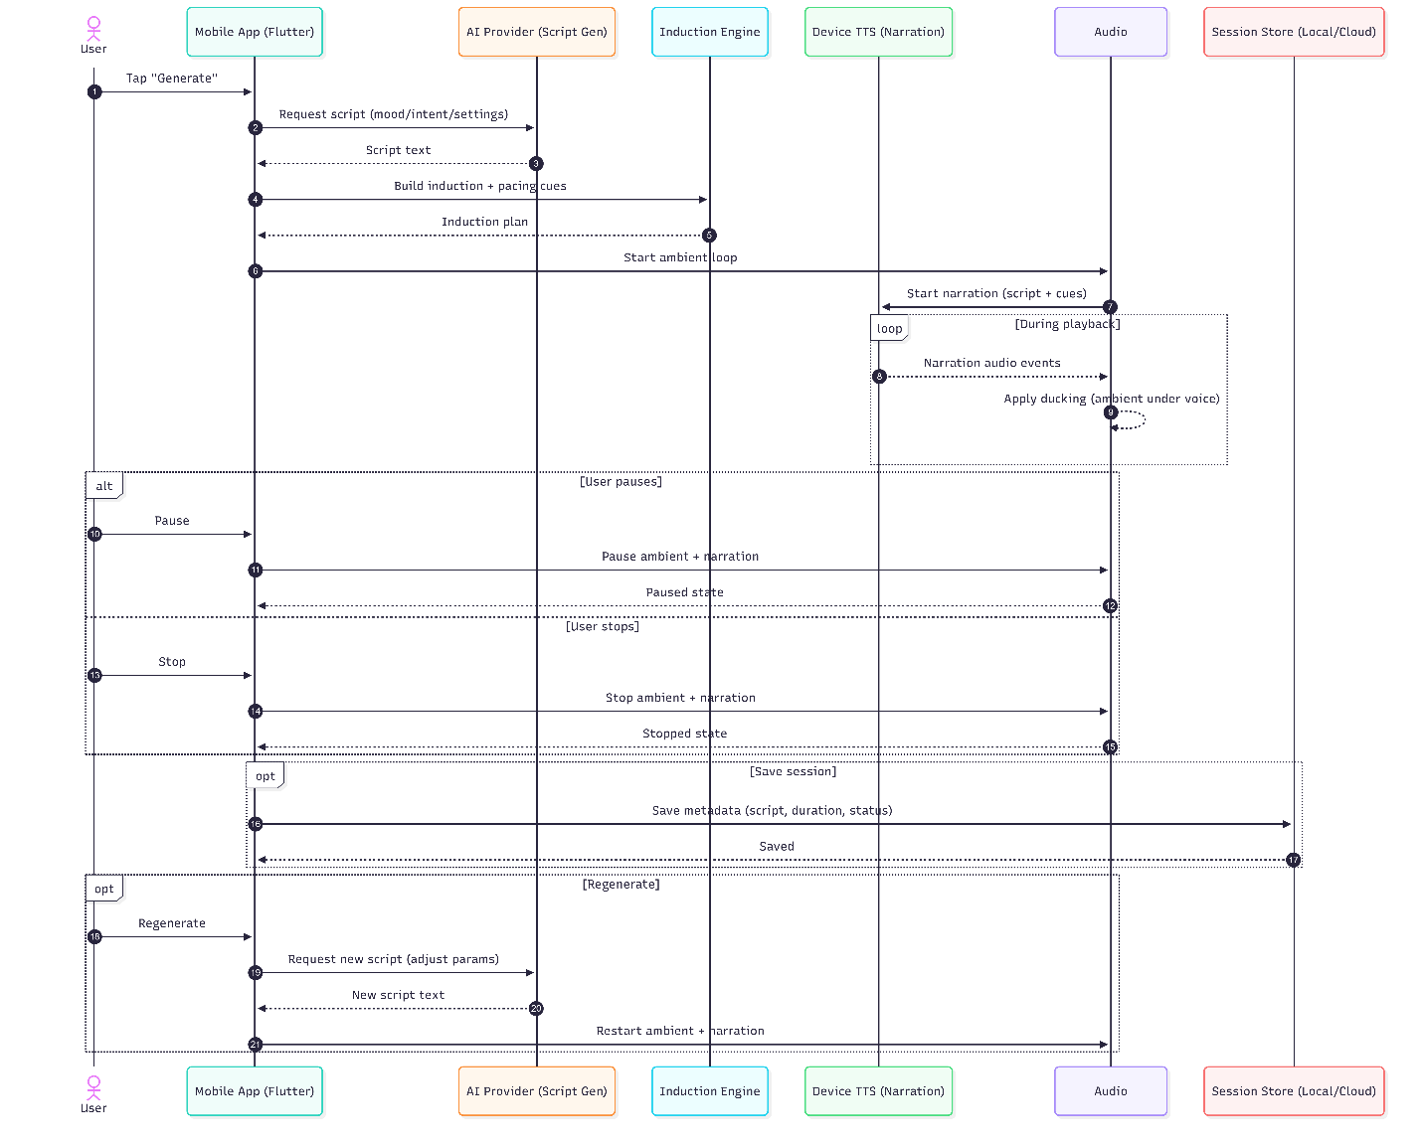

8. Complimentary Support (1 Month)
After production launch and final handover, we will provide one (1) month of complimentary support focused on the delivered scope.
Included:
- Bug fixing for reproducible issues introduced by the delivered work.
- Minor adjustments within existing UI patterns (small layout/copy/config changes).
- Support for analyzing logs and crash reports where access is provided.
Excluded:
- New features or major enhancements beyond the agreed scope.
- Major redesign or UI/UX changes.
- Third-party policy changes or OS behavior changes requiring re-architecture.

9. Financial Proposal
The estimates below are based on the provided requirements and an assumed local-first implementation (no mandatory backend in v1). Third-party fees (Apple Developer Program, Google Play Console, optional analytics/crash providers, etc.) are excluded and will be paid directly by the client.
Phase | Scope Summary | Timeline | Estimated Cost (USD)
Phase 1 | Foundation, onboarding, gatekeeper, home shell, AI/audio scaffolding | 3 Weeks | $2,500
Phase 2 | Core modules, audio pipeline, reminders, dream tracker, expanded QA | 3 Weeks | $2,500
Phase 3 | Stabilization, performance, store readiness, release & handover | 1 Weeks | $1,000
Total | All phases (end-to-end) | 7 Weeks | $6,000

9.1 Payment Terms
- 30% advance payment upon project kickoff.
- 30% payment upon completion and acceptance of Phase 1 deliverables (staging build).
- 30% payment upon completion and acceptance of Phase 2 deliverables (feature-complete build).
- 10% payment upon production release, store submission completion, and final handover.

9.2 Change Request (CR)
CR Man-day Rate: USD 150 per man-day or USD 25 per man-hour.

9.3 Assumptions & Remarks
- Client will provide final UI designs/brand assets and confirm any platform-specific design behaviors (animations, effects) before implementation of each major screen set.
- The v1 implementation is local-first. Optional features such as cloud sync, multi-device login, server-side analytics, or remote content management can be proposed as a separate add-on scope.
- Notification delivery can be affected by OS policies (battery optimization, focus mode, permissions). We will implement best-practice scheduling and provide documented fallbacks (in-app notification center).
- Timeline may shift if app store accounts, signing certificates, or review processes are delayed.
- Any additions beyond the stated scope will be handled through CR.

10. Proposed Out of Scope
- UI/UX design, visual redesign, branding, creation of design assets (Figma) - client responsibility.
- Content writing for long-form educational pages, or copywriting beyond implementation of provided text.
- Ongoing content operations after launch (unless separately contracted).
- Third-party subscriptions and usage costs (app store memberships, analytics providers, etc.).

11. Acceptance & Sign-off
Delivery will be considered accepted when the agreed scope is implemented in the staging build, passes the QA and regression checklist, and is formally signed off by the client. Production release will proceed after sign-off and completion of the release checklist.

